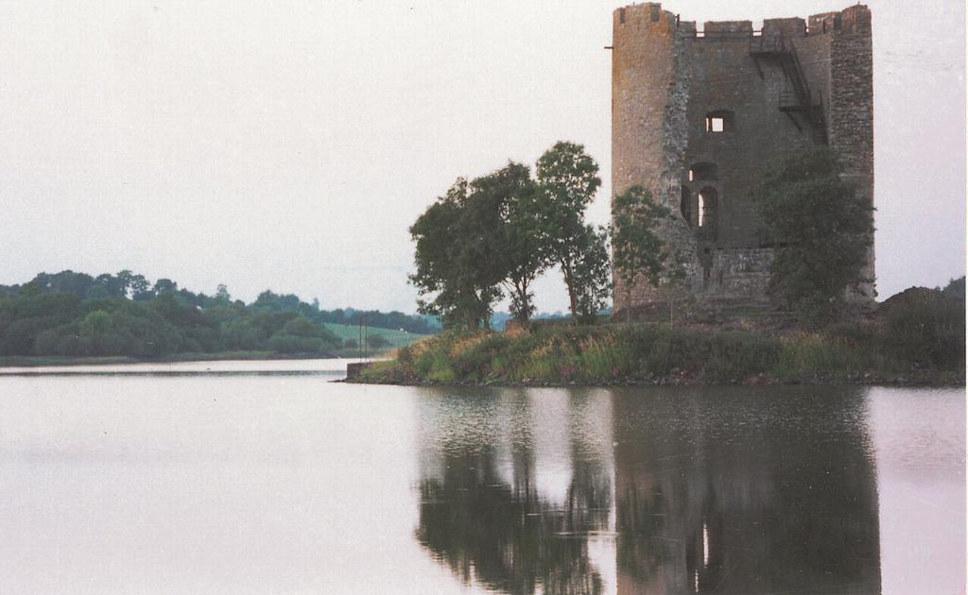

HAVING YOUR SAY……

REVIEW of the

CAVAN COUNTY DEVELOPMENT PLAN

Strategic Issues Paper

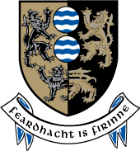

STRATEGIC ISSUES PAPER

INTRODUCTION
Cavan County Council which is the Planning Authority for County Cavan is reviewing the current Cavan County Development Plan (2008 – 2014) and preparing a new draft Development Plan to cover the period 2014 - 2020.

What is a Development Plan? A Development Plan is a document which details the overall strategy of the council for the proper planning and sustainable development of an area and generally consists of a written statement and accompanying maps. The plan usually includes the broad aims of the council with regard to issues such as: Housing, Infrastructure, Community facilities; Environment & Heritage etc. The plan will also result in a number of Policies and Objectives to support each of the issues.

What are Policies and Objectives? A Policy is an agreed position on a particular issue. An Objective is a specified action or project which the Council intends achieving over the life-time of the plan.

What should be included in a Development Plan? In accordance with the Planning & Development Act (2000-2010) there are a number of topics (also referred to as ‘mandatory objectives’) which the development plan must address in the form of policies and objectives, these include:
- A Core Strategy which demonstrates that the policies and objectives in the Development Plan are consistent, as far as practicable with National & Regional Development objectives set out in the National Spatial Strategy and the Regional Planning Guidelines;
- Zoning of land for particular uses;
- Provide or facilitate the provision of infrastructure including transport, energy and communication facilities;
- Encourage the management of features of the landscape, such as traditional field boundaries, which are important for the ecological coherence of the Natura 2000 network and essential for the migration, dispersal and genetic exchange of wild species;
- Conservation and protection of the environment including the archaeological and natural heritage;
- Promote compliance with environment standards and objectives for protection of surface water and groundwater, as contained in the River Basin Management Plans (RBMP’s);
- The integration of the planning and sustainable development of the area with the social, community and cultural requirements of the area and its population;
- The preservation of the character of the landscape where the proper planning and sustainable development of the area requires it, including the preservation of views and prospects and the amenities of places and features of natural beauty or interest;
- The protection of structures, or parts of structures, which are of special architectural, historical, archaeological, artistic, cultural, scientific, social or technical interest;
- The preservation of the character of architectural conservation areas;
- The development and renewal of areas in need of regeneration;
- Provision of accommodation for travellers;
- Preservation, improvement and extension of amenities and recreational amenities;
- Control of development for the purposes of reducing risk or limiting the consequences of a major accident (having regard to the Major Accidents Directive);
- Provision of services for Communities, including schools; crèches and other education and child care facilities;
- Provide for the protection of the linguistic and cultural heritage of the Gaeltacht;
- Promote sustainable settlement and transportation strategies in urban and rural areas, particularly with regard to location, layout and design of new development;
- The preservation of a public rights of way which may give access to seashore, mountain, lakeshore, riverbank or other place of natural beauty or recreational utility; and
- Consider the provision and development of a framework for the identification, assessment, protection, management and planning of landscapes.
Development Review Process: (we are here*) A Development Plan must be reviewed every 6 years. The process begins no later than 2 years before the expiry of the existing development plan. The time-span of the new development plan will be 2014 – 2020. This Strategic Issues Paper forms part of the first stage, as illustrated in the table below. The parts of the process which involve public participation are highlighted in red.

Direction from members to prepare Draft
Plan

Public Consultation workshops

*Pre -Draft Stage
(including Public Consultation)
STAGE 1: Pre-Draft

STAGE 2:
Preparation of Draft Plan

STAGE 3: Making of Development Plan
Prepare Manager’s report on consultation
Preparation of proposed Draft Development Plan

Public Display of Draft Development Plan

Manager’s report on public submissions

Consideration of Manager’s report by the Members

Prepare amendments to Draft Plan

Public Display of amendments to the Draft Plan

Manager’s report prepared on public submissions

Consideration of Managers’ Report

Adoption of the Development Plan

Purpose of the Strategic Issues paper: is to stimulate debate and encourage interested and affected persons, individuals and representatives of groups or organizations within the County to have their say in formulating policies for the new plan. Throughout the document you will see reference to the main planning issues under a number of headings, such as Population, Housing, Physical Infrastructure, Heritage and Community Facilities. We have attempted to highlight the most significant areas of potential interest to you. It is important that the final document does not consist of a wish list but rather reflects the needs and desires of the people of Cavan with regard to the Development of your County. The building of a better society requires the input of many players, accordingly the contribution of a diverse range of organizations, communities and individuals into the process is not only desirable but necessary. In addition, submissions are also invited from children or groups representing the interests of children.
Note: Planning legislation states that proposals for zoning of a particular land for any purpose will not be considered at this stage.

HOW TO MAKE A SUBMISSION: Having Your Say - What Planning Issues Would You Like To Raise? It is important to have your input from the beginning so that we can make sure that the final Plan reflects your concerns and ideas, as well as Government strategies and guidelines. Submissions and observations should be made in writing and sent to one of the following by the 5th of December, 2012:
- By Post to: Forward Planning Section, Planning Department, Cavan County Council, Farnham Centre, Farnham Street, Cavan.
- By Email to: plan@cavancoco.ie

The Planning Authority will conduct a series of public consultation exercises in the form of public meetings, workshops, and consultations with individuals and groups. You can find more about the Development Plan and how it is progressing, at the following locations;
- Website at www.cavancoco.ie.
- Our Facebook pages: : www.facebook.com/cavancoco & www.facebook.com/CavanCountyDevelopmentPlan
- Twitter: twitter.com/cavancoco

The location, venue and times for the initial stage of public consultation are detailed in the table below:
Venue | Date | Time | Location
Cavan County Library: Events space | Tuesday, 6th November | 18:00 – 20:00 | Cavan Town
County Museum: Meeting room | Wednesday, 7th November | 18:00 – 20:00 | Ballyjamesduff
Ballyconnell, The Courthouse | Wednesday, 14th November | 18:00 – 20:00 | Ballyconnell
Bailieborough Library | Tuesday, 20th November | 18:00 – 20:00 | Bailieborough

CREATING A VISION FOR YOUR COUNTY

The Planning Authority are seeking the help of all citizens in creating a VISION for the future development of County Cavan. This vision will be formulated from a combination of the responses to this Strategic Issues Paper particularly responses to the questions set below, as well as, the findings of the initial public consultation which will challenge attendees to formulate their VISION for the county. The suitability of this VISION for the County will be tested at subsequent public consultation meetings.

VALUES

DARE TO DREAM

DIRECTION

FRAMEWORK

POSITIVE

INSPIRATION

VISION
STATEMENT

CONSIDER THE FOLLOWING QUESTIONS

What do you think the Vision for the future development of the County should be?

Why do you think people wish to live in County Cavan?

CONSIDER THESE QUESTIONS

What do you think the Vision for the future development of the County should be?

Why do you think people wish to live in County Cavan?

KEY THEMES

POPULATION, SETTLEMENT STRATEGY AND HOUSING

Where is County Cavan? Our County is located in the province of Ulster and is bounded by 6 counties: Fermanagh in Northern Ireland, along with Monaghan, Meath, Westmeath, Longford and Leitrim. The National Spatial Strategy (2002 – 2020) introduced the concept of more balanced development with the creation of Regions. The Strategy also identified urban areas that, through specific functions, would lead and support more regionally balanced growth and development.

The regions were created as a response to the changing socio – economic profile of the country which had resulted in unbalanced development. For example, increasing levels of economic prosperity and population growth were being unevenly located in larger urban areas such as Dublin, Cork, Limerick/Shannon, Galway and Waterford and their associated regions. Each of the regions were charged with the development of ‘Regional Planning Guidelines’ specifically for their region. Cavan is in the Border Region along with Donegal, Leitrim, Louth, Monaghan and Sligo. The current Border Regional Planning Guidelines cover the period 2010 – 2022.

The map below is taken from the National Spatial Strategy, it outlines the general strategic vision for the development of the Border Region:
What is Cavan’s role in the Border Region?
In terms of population growth Cavan has the third largest population in the Border Region and has had the highest population growth for the last two census periods. Between 2002 and 2006 the population grew by 13.2% and between 2006 and 2011 it grew by 14.3%. The table below shows this growth compared to the population increase of other counties in the border region and the growth of Ireland itself which remains steady at 8.2%.

Counties | 2002 | 2006 | % Change  2002 – 2006 | 2011 | % Change  2006 - 2011
Donegal | 137,575 | 147,264 | 7 | 161,137 | 9.4
Louth | 101,821 | 111,267 | 9.3 | 122,897 | 10.5
Cavan | 56,546 | 64,003 | 13.2 | 73,183 | 14.3
Sligo | 58,200 | 60,894 | 4.6 | 65,393 | 7.4
Monaghan | 52,593 | 55,997 | 6.5 | 60,483 | 8
Leitrim | 25,799 | 28,950 | 12.2 | 31,798 | 9.8
State | 3,917,203 | 4,239,848 | 8.2 | 4,588,252 | 8.2

Population of County Cavan: It is hard to imagine County Cavan having a population of over 200,000 but in 1841 the census recorded a population of 243,158 for the county. Since then the population has been steadily dropping until it hit an all time low of 52,618 in 1971. Between 1971 and 1996 the population stayed below 54,000 until the boom brought with it an influx of new residents, as well as, a bit of a ‘baby boom’. In more recent times the population has been steadily rising, in the 2002 census it was 56,546 and in 2006 it was 64,003. The population now stands at 73,183 people. It is uncertain whether or not this population growth will continue. The County Development Plan will seek to cater for a more modest level of growth into the future and ensure that sufficient land is available to cater for the needs of existing and future populations.

Our Population in Context: The map below illustrates the population of Cavan as it is distributed throughout the county. Each area represents an Electoral Division. Electoral Divisions (EDs) are the smallest legally defined administrative areas in the state, typically any one ED may contain several townlands. There are 3,440 EDs in Ireland and 93 in County Cavan. In the map the darker colors represent EDs with larger populations and the lighter colour those with less. It is clear that the greatest concentration of population in the county is located in the east around the towns of Virginia and Mullagh, Ballyjamesduff, Kingscourt, Shercock and Cootehill. In the more central part of the county the populations appear to be concentrated around Cavan Town, Ballinagh and interestingly Killeshandra, a town which, we will see later, has experienced significant falls in population. As we move west, the population of the county falls to much lower levels with some concentration of populations around the towns of Belturbet and Ballyconnell.

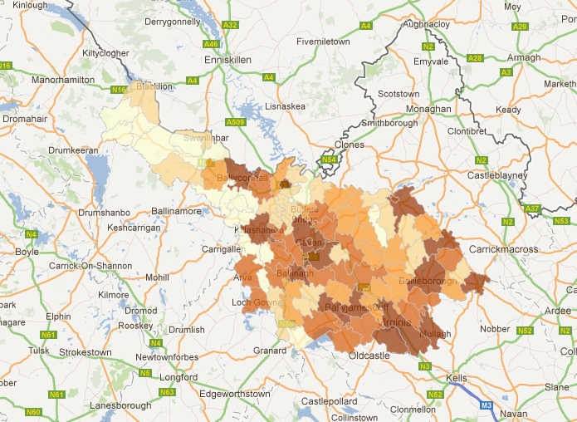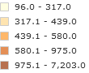
Source: http://census.cso.ie/sapmap/

Settlement Strategy: Essentially the Settlement Strategy aims to set an overall strategy for the spatial development of the county in a way that is consistent with the values of proper planning and sustainable development. In simple terms it aims to identify where we should and should not allow development, how we guide this development and how we link areas physically. The settlement strategy will form part of the Core Strategy of the Development Plan setting a framework for the development of the county over the plan period. It will respond to and reflect other policy documents, guidelines and plans such as the Border Regional Planning Guidelines 2010 – 2022, the National Spatial Strategy, National Development Plan, Water Framework Directive and so forth.

Housing Strategy: A Housing Strategy will be prepared for the period of the development 2014 – 2016. The Housing Strategy aims to ensure:
- That sufficient zoned and serviced land is made available to meet future and existing housing needs.
- That a mixture of house types and sizes are provided to meet the needs of different categories of households, including the special requirements of elderly persons, persons with disabilities, as well as, different levels of income.
  - Counteract undue segregation between persons of different social backgrounds.

The significant changes in the housing market along with the economic downturn have resulted in a shifting of emphasis away from home ownership towards providing good quality housing in suitable locations. While home ownership is likely to remain a strong feature in Irish housing provision the onus will be on policy makers to ensure that those in the greatest housing need are catered for. A number of new options have emerged as methods of housing provision such as; Local Authority Social Housing, the ‘Rental Accommodation Scheme’, Voluntary and Co-Operative Housing Sector, The Traveller Accommodation Programme 2009 – 2013

POPULATION, SETTLEMENT STRATEGY, HOUSING
HAVE YOUR SAY!!!
PLEASE CONSIDER THE FOLLOWING QUESTIONS

What to you think County Cavan’s role is in Ireland?
How do you think County Cavan has changed economically, physically and socially in the past 5 or 6 years?
What do you think the impact of Cavan being located in the Border region is it good or bad?
What do you think Cavan County’s role in the Region should be?
Why has Cavan experienced such rapid population growth and what is your opinion of this growth?
How do you consider that balanced growth can be achieved?
Where should social housing be provided?
How will we cater for all the different housing needs in the county?
Why do we think there is such a difference between the populations of the West and East of the county?
What is your opinion of this difference?
Is there anything we should learn from these figures?

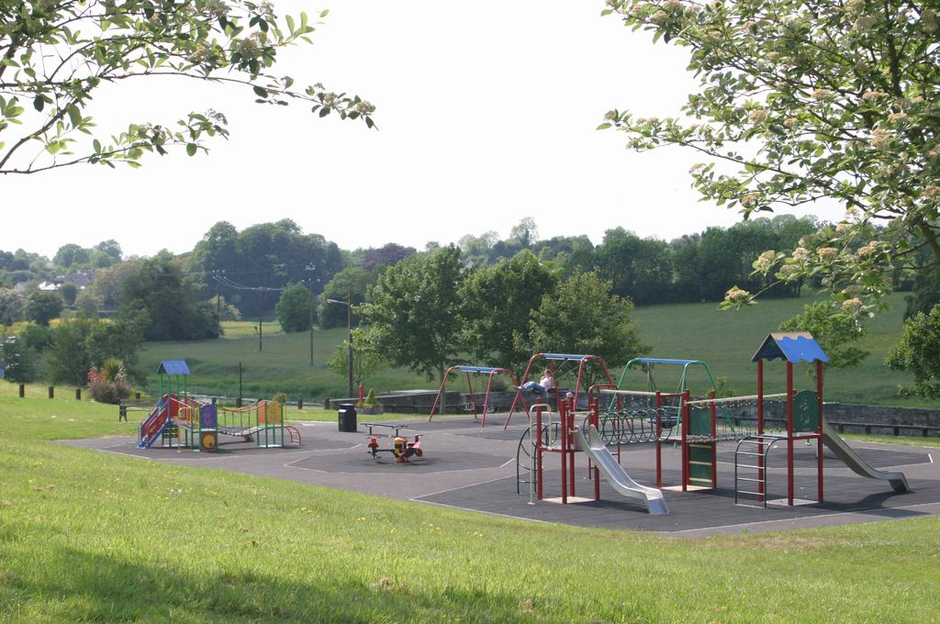
COMMUNITY, RECREATION AND PUBLIC OPEN SPACES
Community Facilities: Social, Community and Cultural Development are factors that contribute to the creation of a good quality of life for all. We at Cavan Local Authorities aim, where possible, to respond to individual communities and their needs through facilitating the provision of schools, crèches, other child/youth services, sporting, recreation facilities etc. This is supported through policies and objectives of the County Development Plan.
Our aim is the creation of a society where quality of life is essential and social inclusion a must. Social exclusion occurs when people are marginalized from society due to issues such as: unemployment, poverty and discrimination. It also concurs when people can not access services. Social inclusion, as a concept, seeks to achieve a fairer and more inclusive society. In terms of planning, this can be achieved through the provision of social and affordable housing, the creation of employment, educational and recreational opportunities, health services and public transportation facilities and ensuring all member of society can access services.
The Cavan Local Authorities, ‘Social Inclusion Plan (2011-2012)’ sets out actions for the delivery of social inclusion measures which would include the requirement that all policies and objectives of the Development Plan are socially inclusive.
The Local Authority facilitates the provision of Public, Community and Educational uses through its polices and the zoning of sufficient lands for these purposes.

Public Open Space and Recreational Facilities: The provision and quality of public open space and recreation facilities have an essential role in creating places and communities that people enjoy and wish to live in. They are major factors in the creation of a ‘good quality of life’. The role of such facilities in the community needs to occur in a socially inclusive manner such that all members of a community can and want to access all facilities. Such spaces and facilities would include; Public Parks (including playgrounds), Green areas in residential housing estates, Public rights of way e.g. walking routes, amenity areas at lakes and rivers, playgrounds, sports fields e.g. football fields, tennis courts, rugby fields and indoor facilities such as tennis courts, basketball court, swimming pools etc.
There have been a number of new facilities developed throughout the county in recent years, primarily due to availability of funding and increased demand.

COMMUNITY, RECREATION AND PUBLIC OPEN SPACE
HAVE YOUR SAY!!!
PLEASE CONSIDER THE FOLLOWING QUESTIONS

Would you consider that the existing playgrounds; parks and amenity areas throughout the County are adequate? If not, where should new ones be located and what can be done to improve existing?
What is your experience of Public Open Spaces in new Housing Estates?
Do we have enough Sporting Facilities in Cavan? What suggestions could you make to improve or add to these?
What is your opinion of Multi-Purpose Sports and Community Facilities and where should these be located?
Do you think there are groups which are socially excluded in the County?
Are there adequate Health Care and Child Care facilities in the County and are they accessible?
What Community Facilities do you think are lacking in your area?

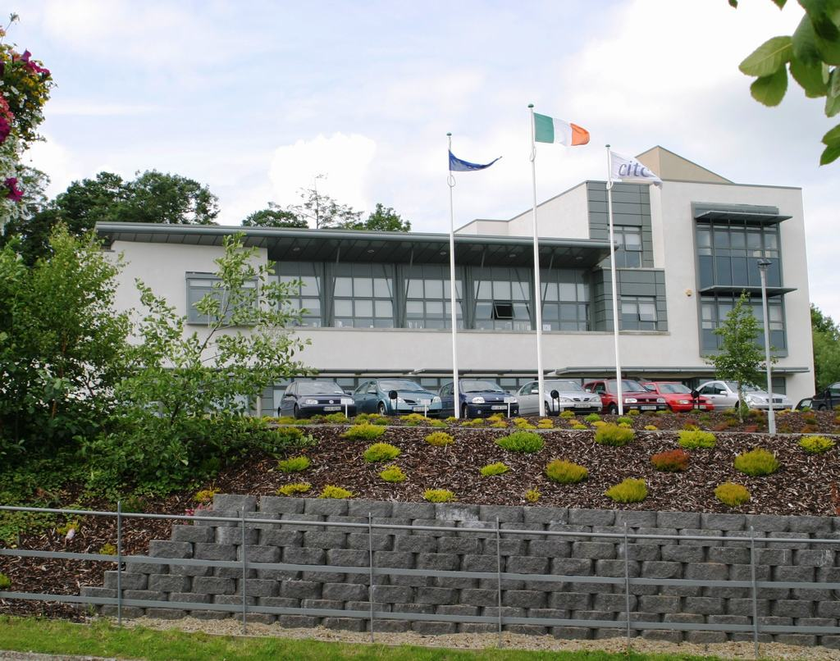
ECONOMIC DEVELOPMENT AND EMPLOYMENT
Enterprise and Employment: The Development Plan has an important role to plan in supporting the development of our employment and enterprise sectors. Essentially, the role of the plan will be to identify suitable land uses and create policies and objectives which will help guide future development of employment related activities. It will also seek to ensure that there are policies and objectives which enable the provision of essential support infrastructure such as roads, water services, public transport and communication systems. The plan aims to respond to the key business opportunities and trends in the county.
The county faces a number of challenges due to the current economic climate. Like much of the Country, Cavan has experienced a rise in unemployment, significant downturn in the construction industry, as well as, the challenges of being located so close to Northern Ireland.

County Cavan is in a strategic location in the Country, it is a gateway to and from northern Ireland, on the junction of two national routes to Dublin and Belfast and on an important point of the east-west route to be developed between Dundalk and Sligo. The county is reliant on indigenous development as the main source of wealth and job creation, however, there are also a number of international companies located in the county. IDA Ireland promotes the County as a location for overseas investment and Enterprise Ireland focuses on the development of Irish owned companies.

The following factors are essential for developing enterprise and attracting investment into the county.
- Access to a skilled and educated work force.
- Access to business and enterprise networks and interlinkages between firms, higher education institutes and government bodies.
- Access to Innovations and Research & Development.
- Quality of life which will attract both new employers and business and a good incentive to potential investors.
- Support services and infrastructure
- Physical and electronic access to markets and customers
The Development Plan shall seek through policies and objectives to enable the development of an environment which would ensure the creation of such factors in the county.

Existing and potential areas for future growth and development in the Border Region include:
- Agri-Food Sector – The principle activities in this sector are meat, poultry and dairy.
- Renewable Energy Sector – This sector has grown significantly in response to a need for more environmental friendly energy production along with the growing cost of fossil fuels. The ‘Green Economy’ has the potential to stimulate economic development of rural areas.
- Tourism – This would include both existing and potential tourist destinations and activities centered around our lakes, rivers and our landscape in general.
- Retail Sector – This sector is important as a provider of employment and as an important element in creating strong, vibrant towns and villages.

We must encourage the development of our enterprise and employment sector whilst at the same time protecting our greatest assets, our environment and landscape. In doing so our landscape retains its function as a resource whilst at the same time creates an attractive environment in which to live, work and play.

ECONOMIC DEVELOPMENT AND EMPLOYMENT
HAVE YOUR SAY!!!
PLEASE CONSIDER THE FOLLOWING QUESTIONS

How can County Cavan adapt to the economic changes in the Country?
What are the county’s strengths with regards to employment and enterprise and how can these be used to their best advantage?
What is the county’s weakness with regards to employment and enterprise and how can these be overcome?
What is your opinion of retail provision in the County?
What are the key business opportunities in Cavan County and how can they be developed?
What are the main barriers in the development of our tourist potential?
What are the main opportunities in the development of our tourist potential?
In your opinion what are the future opportunities for our county?

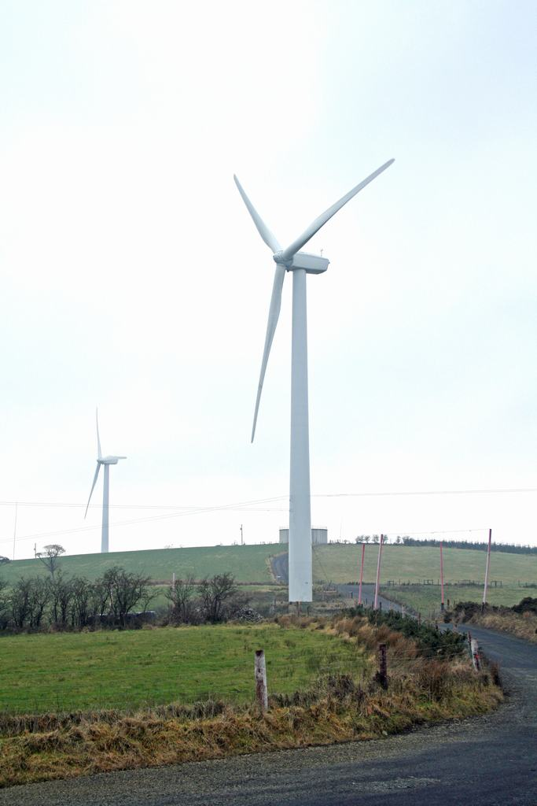
PHYSICAL INFRASTRUCTURE
The provision of physical infrastructure for the management of: water, wastewater, waste, energy and telecommunications is key to the sustainable development of the County. Some of the key projects by the Government, the County Council and private business which have contributed to the improvement of infrastructure in the County in recent years, has included the following:

Road schemes: Some roads schemes have included the;
- Belturbet Bypass,
- Ballyconnell Inner-relief road
- Belturbet to Ballyconnell, upgrade
- Upgrading and realignment of certain areas along the N55 and maintenance and improvement of local roads throughout the county.

Water and Wastewater: The Water Services Investment Programme (WSIP) 2010-2012 has also seen the upgrading of water treatment plants in Cootehill, Kingscourt, Ballyconnell, Belturbet and Cavan Town. The programme aims to supply wastewater and water supply infrastructure to areas which have come under pressure for development. This has also been in response to EU and National government policies on drinking water; the EU Water Framework Directive; the control of pollution through waste water discharge licenses; Sustainable Urban Drainage Systems (SUDS) which addresses flood risk management.

Broadband: The National Broadband Scheme has delivered a number of key telecommunications projects throughout the county which has improved the networks for broadband communications in areas where previously there was no coverage.
Waste Management: The North East regional Waste Management Plan (2005-2010) sets out a comprehensive strategy for the management of waste in the counties of Cavan, Louth, Monaghan & Meath. The expiry date for current North East Region Waste Management Plan 2005-2010 has been extended to 31st December 2012. This plan is currently being evaluated and revised and a new North East Region Waste Management Plan will be implemented before 31st December 2012. The Plan sets out proposals to manage waste over a 15 year period from 2001 and includes an analysis of the current waste management situation in the North East Region. The plan created a hierarchy for the management of waste, these are: prevention, minimization, re-use, recycle/recover and disposal of waste. Some of the aims of this strategy have already been implemented in the county including the provision of 30 bring centres, 3 recycling centres and a licenced landfill facility, along with an active waste enforcement section.

Cavan County Council also has a Litter Management Plan (2008) which sets out a strategy for tackling the problem of litter. The Development Plan will aim to identify issues around the provision of waste management services in the county as well as support the existing waste management strategies already in place. Underpinning, all the progress that has taken place in waste infrastructure, is the ongoing environmental awareness work. This promotes the sustainable management of waste in a variety of ways including schools programmes, seminars, information leaflets and booklets and use of the Cavan County Council website.

Renewable Energy: Cavan has a large number of windfarms located in the north-west of the county and to the north-east of the county. In recent years there has been an increase in the number of planning applications to extend existing windfarms or develop new windfarms around Bailieborough and Kingscourt, as well as, the Carrickallen areas. In addition, there has been some interest in the erection of domestic wind turbines and single wind turbines to serve large commercial sites.

Electricity: The ESB has, through Eirgrid, provided improved infrastructure for electricity supply throughout the County, and in particular the construction of the Arva – Shankill 110kV line. The Council will continue to support the provision of sustainable forms of energy supply such as: solar power, wind energy; gas and electricity, subject to proper planning and sustainable development.

PHYSICAL INFRASTRUCTURE
HAVE YOUR SAY!!!
PLEASE CONSIDER THE FOLLOWING QUESTIONS

What are the main issues around service provision/investment in the County? How does this affect your town/community?
What is your opinion of sustainable energy development, such as wind turbines, solar panels, in County Cavan? What do you think about hydro-electric power as an alternative energy source?
Should wind energy development be accommodated in other locations in the County and if so, where?
What is your opinion on the development of waste water treatment systems for housing, agricultural development and commercial development in the countryside?
How can we best communicate issues around waste minimization, reduction, re-use, recycle and recovery within the county?
What is your opinion on overhead electricity powerlines?
Are there adequate recycling facilities throughout the County? In your opinion where should they be located?
Do we have sufficient waste recycling or civic amenity sites throughout the county?
What are the issues around litter management in this county?

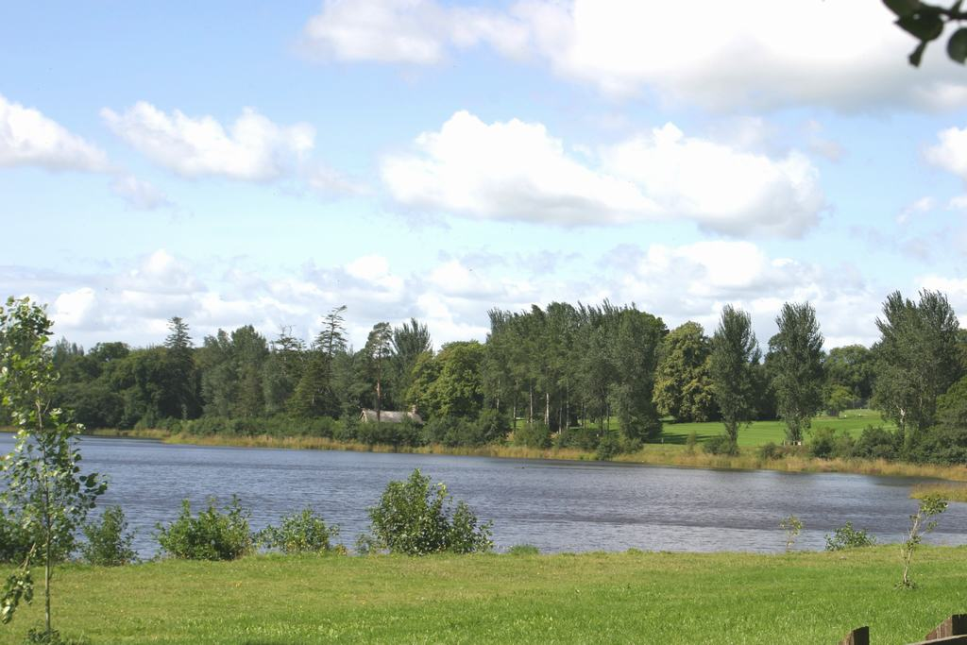
RURAL AREAS
County Cavan is still considered a rural county, almost 70% of the population of Cavan still resides in rural areas (including: the countryside; small towns and villages). The current County Development Plan identified three rural area types;
Structurally Weak: These areas are generally sparsely populated.
Areas Under Urban Influence: These areas are close to the larger towns in the County.
Urban Buffer Areas: These areas are defined by their proximity to Cavan Town and to the eastern border of the County which is closer to the Greater Dublin Area.

The boom years brought with them a significant increase in the amount of development in rural areas especially in the construction of dwellings.
Over the past decade a new phenomenon of rural dwellers with no direct links to agriculture activities has occurred. The implications for the sustainability of Rural Areas is an issue which needs to be addressed, this new lifestyle brings with it a high dependence on the car in order to access employment, shops and other services.

Rural Areas have an important role as location for a diverse range of activities such as food production, renewable energy generation, and tourism especially eco tourism. Such activities must be supported by the development of essential links and infrastructure such as roads, broadband etc provided that the landscape and quality of the environment is not harmed.

RURAL AREAS
HAVE YOUR SAY!!!
PLEASE CONSIDER THE FOLLOWING QUESTIONS

What are the impacts of increased traffic on rural roads?
What are the visual impacts of buildings and structures on the landscape?
Should we encourage increased urbanization? If so why?
What is your opinion of the development which has occurred in rural areas?
What types of businesses or enterprises are suitable in rural areas?
What types of infrastructure are necessary to support enterprise and economic development in rural areas?

URBAN AREAS
Town | Pop  2002 | Pop  2006 | % Pop Growth 2002- 2006 | Pop  2011 | % Pop Growth 2002-2006
Cavan | 6,098 | 7,883 | 29.3 | 10,205 | 29.4%
Ballyjamesduff | 871 | 1,690 | 94% | 2,568 | 52%
Bailieborough | 1,660 | 1,966 | 18.4% | 2,530 | 28.7%
Kingscourt | 1,307 | 1,748 | 33.7% | 2,326 | 33.1%
Virginia | 1,093 | 1,734 | 58.6% | 2,282 | 31.6%
Cootehill | 1,744 | 1,892 | 8.5% | 2,123 | 12.2%
Belturbet | 1,295 | 1,411 | 8.9% | 1,407 | -.3%
Mullagh | 479 | 679 | 41.8% | 1,137 | 67.5%
Ballyconnell | 572 | 747 | 30.6% | 1,061 | 42%  While Cavan remains predominantly a rural county it is becoming more and more urbanized. In 2002 the census showed that 16.8% of the population lived in urban areas, in 2006 it was 26.4% and then in the 2011 census it had risen to just over 30%.  The table illustrates the population of the main towns and larger villages in the county. The figures have been obtained from both the 2006 census of population and the most recent 2011 census.
Ballinagh | 502 | 675 | 34.5% | 766 | 13.5%
Ballyhaise | 530 | 597 | 12.6% | 620 | 3.9%
Shercock | 454 | 461 | 1.5% | 531 | 15.2%
Kilnaleck | 305 | 334 | 9.5% | 384 | 15%
Arva | 357 | 364 | 2% | 380 | 4.4%
Kileshandra | 417 | 411 | -1.4% | 364 | -11.4%
Butlersbridge | 182 | 182 | 0% | 282 | 54.9%
Blacklion | 166 | 174 | 4.8% | 229 | 31.6%
Swanlinbar | 223 | 266 | 19.3% | 211 | -20.7%
Loch Gowna | - | 123 | - | 161 | 30.9%

It is interesting to examine this table to see how the population of your town or village has grown or indeed shrunk since 2002. Most towns and villages in the County have experienced growth with some growing at a very rapid rate.
Look at Ballyjamesduff for example in 2002 it had a population of 871 and was the town with the seventh highest population now it has the second highest population surpassed only by our County Town. In 2002 Mullagh was a small town with a population of less than 500 now its population is well over 1,000. Then there are the towns whose populations have fallen Swanlinbar which had a population of 223 in 2002 and increased in the 2006 census has now experienced a fall down to 211 persons. Killeshandra has fallen from a population of 417 down to 411 in the 2006 census and a further drop in the 2011 census to 364 people. Belturbet one of our larger towns had the fifth highest population in 2002 and now has taken Ballyjamesduff’s place as the seventh highest. Belturbet has experienced very slow growth relative to the other towns with a slight population drop in the 2011 census. The map below gives you an idea of where each of these towns and villages are located
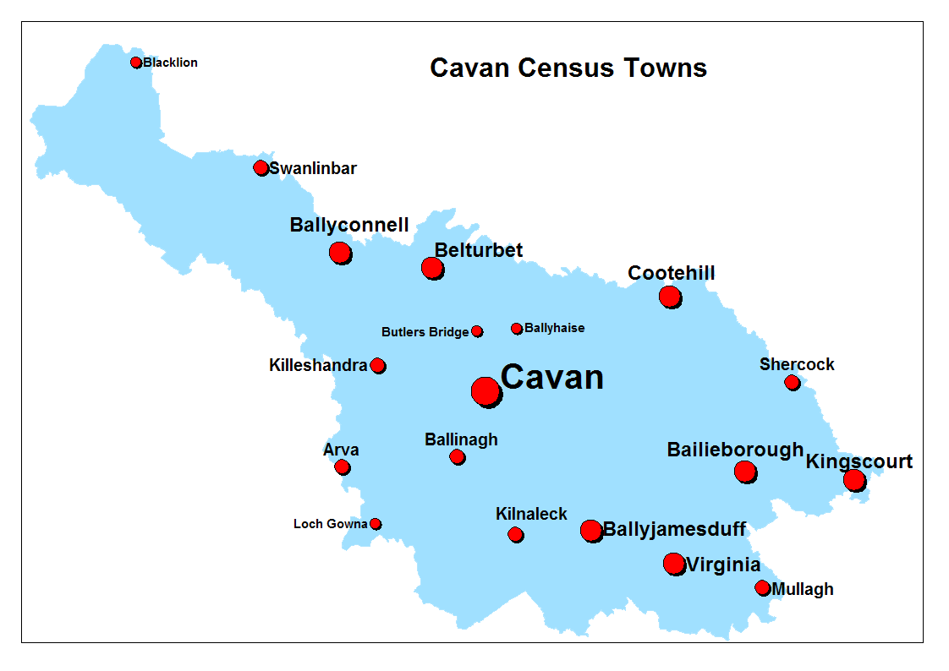

Our towns and villages have an important role to play as service providers, sources of employment, retail centers, as well as, being the main locations for educational, social and community facilities. They support both their own population, as well as, that of the rural hinterlands. The creation of strong, vibrant and viable towns is essential in the creation of ‘quality of life’ and in ensuring sustainable development. By centralising services, retail, schools and so on we reduce the need for multi-trips and thus reduce car use.

One of the most important elements of our towns are the creation of town centres and ensuring they have a good mix of services, employment, retail and perhaps some residential, laid out in a pleasing manner with good linkages both vehicular and pedestrian to other parts of the town. The challenge is to ensure that towns develop in a sustainable fashion where new uses add to the vitality of the town and do not detract from existing uses.
It is essential that town centres have a suitable level of retail development. The new ‘Retail Planning Guidelines for Planning Authorities’ issued in April 2012 promote a sequential approach to development and emphasize the importance of developing vibrant town centers.
The towns and villages in the County have been transformed in terms of their physical development, as well as, many social changes with increased population and an influx of new residents.

URBAN AREAS
HAVE YOUR SAY!!!
PLEASE CONSIDER THE FOLLOWING QUESTIONS

When you look at these population figures is this how you imagined the population of your town or village?
How have these changes in population affected you, your family and your town or village?
What policies should appear in development plans and local area plans to ensure that changes in population are dealt with in a positive way.
How can we make our town centres more attractive for shopping, leisure and residential activities?

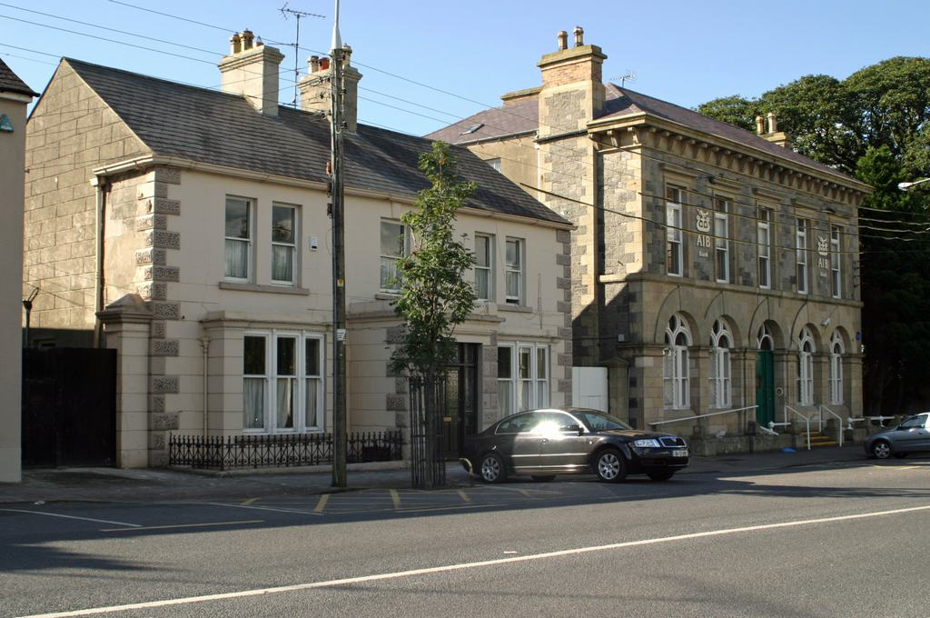
CONSERVATION OF OUR BUILT HERITAGE
Our shared past, the unique and special nature of an area and our feeling of belonging to a community with a shared past contribute to the creation of places in which people wish to live. The protection of our built heritage is one of the aims of the County Development Plan and of extreme importance from an international, national and local perspective. It is essential that our built heritage, especially structures that appear in the Record of Protected Structures, as well as our Archaeological Monuments and Architectural Conservation Areas are protected.

What is a Protected Structure? A protected structure is any structure which is included in the Record of Protected Structures (RPS). The purpose of the RPS is to protect structures or parts of structures, which form part of the historical, archaeological, artistic, cultural, scientific, social or technical interest. Each owner or occupier of a protected structure is legally obliged to ensure that the structure is preserved. The Development Plan will contain a comprehensive and updated list all protected structures throughout the county. A protected structure is defined as:
“any building, structure, excavation, or other thing constructed or made on, in or under land, or any part of a structure so defined, and-
in relation to a protected structure, includes:
  - the interior of the structure,
  - the land lying within the curtilage of the structure
  - any other structures lying within that curtilage and their interiors, and
  - all fixtures and features which form part of the interior or exterior of any structures

Older Buildings: There are number of older buildings in the County that are not protected structures but are of local architectural, historical, archaeological, artistic, cultural, scientific, social or technical value and would warrant retention and sympathetic reuse. The retention, rehabilitation and reuse of older buildings can play a pivotal role in the sustainable development of the County. They contribute, both individually and collectively, to the unique character, heritage and identity of the County.

What is an Architectural Conservation Area? ‘The Architectural Heritage Protection; Guidelines for Planning Authorities’ defines an Architectural Conservation Area (ACA) as; “A place, area, group of structures or townscape, taking account of building lines and heights, that is of special architectural, historical, archaeological, artistic, cultural, scientific, social or technical interest or that contributes to the appreciation of a Protected Structure, and whose character it is an objective of a development plan to preserve.”

Archaeological Heritage: Is the surviving remains of human presence in our County from early times. Any objects, materials, sites and structures from past times are all part of our Archaeological Heritage. Our archaeological heritage consists of known and as yet unidentified sites, monuments, objects and environmental evidence and includes round towers, high crosses, burial sites, ringforts, tower houses, Fulacht Fia, Raths, Court Tombs, Portal Tombs, Wedge Tombs, Cairns, Earthworks, Abbeys and souterraines. The main concern for Planning Authorities will be the protection of monuments and sites. Archaeological remains help us understand our origins as a society, are a connection to our distant past, an educational tool, as well as, a tourist resource.

CONSERVATION OF OUR BUILT HERITAGE
HAVE YOUR SAY!!!
PLEASE CONSIDER THE FOLLOWING QUESTIONS

Do you think it is a good idea to protect older buildings and structures in the County?
How do we increase awareness, understanding and access to heritage in County Cavan?
What benefits do you or your community experience from Heritage in the County?
Should we improve the profile of Heritage in the county?

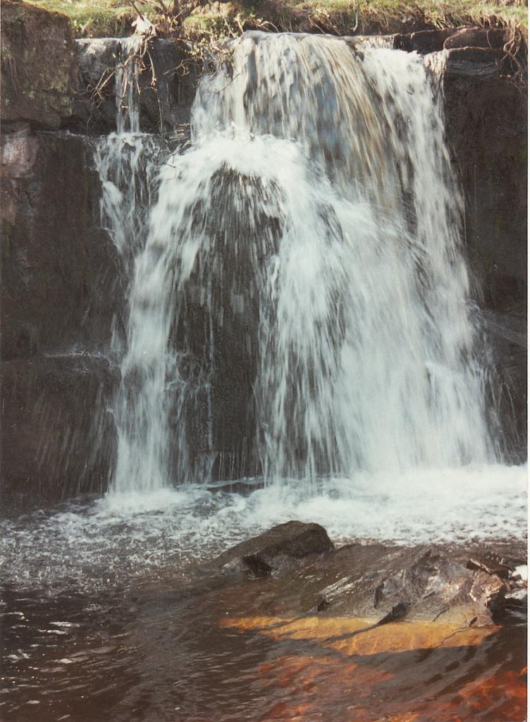
NATURAL HERITAGE
What do we mean by Natural Heritage? Our natural heritage includes the variety of life all around us and includes: flora, fauna, wildlife habitats, landscapes, seascapes, wrecks, geology, inland waterways, heritage gardens and parks.

What is Biodiversity? It is the biological diversity, which is the diversity of plants and animals (including: genetic diversity) and the habitats or landscape where they are found. Biodiversity plays a vital role in human health as we are dependent on the natural environment to provide us with the essentials of life, such as food, medicine, fresh water clean air, recycling of nutrients and places to visit to enhance our spiritual wellbeing.

County Cavan has a landscape filled with a rich and varied flora, fauna, wildlife habitats, heritage gardens, parks, inland waterways and a unique geological makeup. Our natural heritage is valuable for its social, educational and recreational benefit also as a major resource for the development of tourism and economic development, whilst contributing to the quality of life for the people of Cavan and visitors alike.
CONSERVATION OF OUR NATURAL HERITAGE
HAVE YOUR SAY!!!
PLEASE CONSIDER THE FOLLOWING QUESTIONS

What do you think natural heritage is?
Is our natural heritage important?
How do we respond to development pressures on our high amenity areas?

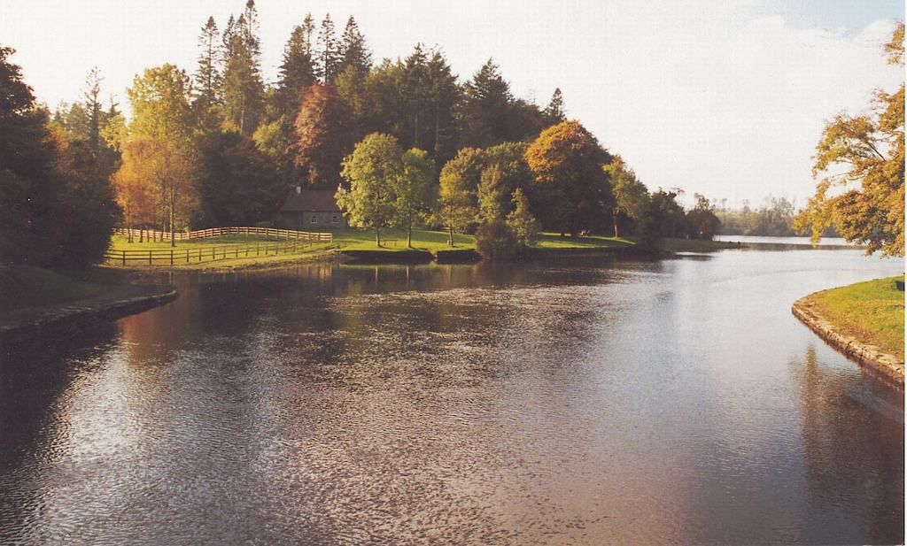
ENVIRONMENT

Habitats Directive: An Appropriate Assessment (AA) which is an assessment, based on best scientific knowledge, of the potential impacts of the Development Plan on the conservation objectives of any Natura 2000 site. Natura 2000 sites are Special Areas of Conservation (SAC’s) and Special Protection Areas (SPA’s) which are wildlife sites of European importance. The AA may include mitigation or avoidance measures to prevent negative effects on these Natura 2000 sites. Screening exercises during the preparation of the new plan will be carried out to determine the potential for impacts.

Strategic Environmental Assessment (SEA): The preparation of an SEA is a requirement under European Law, transposed into Irish Law, which measures the effects of proposals in the development plan on the environment. If significant impacts are identified the SEA will indicate what mitigation measures should be applied to the plan and how environmental issues can be monitored. An environmental report relating to the SEA will be made publicly available and comments invited on it at the same time as the Draft Development Plan.

Climate Change: This is an issue of significant local, national and international concern. At a national level, the Government has published ‘The National Climate Change Strategy 2007 – 2012’ which highlights the importance of climate change as an issue which must be addressed. One of the major impacts which the county faces will be potential increases in the frequency and severity of flooding. The Cavan County Development will consider the EU Floods Directive and the ‘Planning System and Flood Risk Management Guidelines for Planning Authorities’. The development plan will seek to respond to these issues through suitable strategies and policies.

Water Framework Directive: The EU Water Framework Directive came into force in 2003 and applies to all water bodies, requiring us to manage our water systems and protect water quality. The main aim is to ensure that our rives, lakes, esturaries, coastal waters and groundwater achieve ‘good ecological’ status by 2015. The Water Framework Directive in Ireland will be implemented through River Basin Districts and River Basin Management Plans. The Development Plan will seek to implement these plans.

Renewable Energy: The environment is an asset and has the potential to be an alternative source of energy thorough wind, solar and geothermal energy.

ENVIRONMENT
HAVE YOUR SAY!!!
PLEASE CONSIDER THE FOLLOWING QUESTIONS

What in your view, are the main environmental issues facing the County?
How can the Development Plan effectively address issues such as Climate Change?
How can the council manage pressure for development in areas at risk of flooding?
What are the issues in relation to drainage and flooding in your area?

HAVING YOUR SAY!!!!
Review of the
CAVAN COUNTY DEVELOPMENT PLAN

HOW TO MAKE A SUBMISSION: Having Your Say - What Planning Issues Would You Like To Raise? It is important to have your input from the beginning so that we can make sure that the final Plan reflects your concerns and ideas, as well as Government strategies and guidelines. Submissions and observations should be made in writing and sent to one of the following by the 5th of December, 2012:
- By Post to: Forward Planning Section, Planning Department, Cavan County Council, Farnham Centre, Farnham Street, Cavan.
- By Email to: plan@cavancoco.ie

The Planning Authority will conduct a series of public consultation exercises in the form of public meetings, workshops, and consultations with individuals and groups. You can find more about the Development Plan and how it is progressing, at the following locations;
- Website at www.cavancoco.ie.
- Our Facebook pages: : www.facebook.com/cavancoco & www.facebook.com/CavanCountyDevelopmentPlan
- Twitter: twitter.com/cavancoco

The location, venue and times for the initial stage of public consultation are detailed in the table below:
Venue | Date | Time | Location
Cavan County Library: Events space | Tuesday, 6th November | 18:00 – 20:00 | Cavan Town
County Museum: Meeting room | Wednesday, 7th November | 18:00 – 20:00 | Ballyjamesduff
Ballyconnell, The Courthouse | Wednesday, 14th November | 18:00 – 20:00 | Ballyconnell
Bailieborough Library | Tuesday, 20th November | 18:00 – 20:00 | Bailieborough

