Review of the Cavan County Development Plan and Cavan Town and Environs Development Plan 2014-2020.

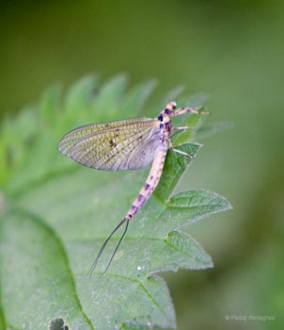

Strategic Environmental
Issues Paper
October 2012

What is a Strategic Environmental Assessment (SEA)?

An SEA is a formal evaluation of the likely significant effects on the environment of implementing a plan or programme before the decision to adopt that plan or programme is made. SEA is required under European Law, which was transposed into Irish Law. SEA is intended to benefit the environment by influencing the decision maker at an early stage in plan or project making process. It leads to more sustainable development through systematic appraisal of policy options. The SEA process will improve the process of making this new Development Plan by:-

- Facilitating the identification and appraisal of alternative plan strategies
- Raising the awareness of the environmental impacts of the plans
- Encouraging the inclusion of measurable targets and indicators

SEA is an ‘Environmental Assessment’ of a Development Plan and must examine the significant effects of the proposed plan on the environment and include short, medium and long-term effects, permanent and temporary effects, positive and negative effects, and secondary, cumulative and synergistic effects on issues including:

Biodiversity | Flora and Fauna
Population and Human Health | Flora
Soil and Water | Air/Noise/Climate
Material Assets | Cultural Heritage
Interrelationships of the above

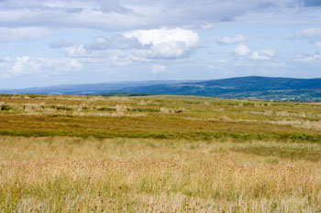

What is an Appropriate Assessment (AA)?

An obligation under Article 6(3) of the Habitats Directive: ‘Any plan or project not directly connected with or necessary to the management of the site (a Natura 2000 site) but likely to have a significant effect thereon, either individually or in combination with other plans or projects, shall be subject to appropriate assessment of its implications for the site in view of the site’s conservation objectives’. A Natura 2000 site is a protected site that is of particular importance for rare, endangered or vulnerable habitats and species within the EU and in Ireland is made up of Special Areas of Conservation (SAC), Special Protection Areas (SPA), candidate Special Areas of Conservation (cSAC), proposed Special Protection Areas (pSPA).

Scoping Issues Paper – What is the Scoping Issues Paper?

The purpose of this paper is to broadly define the (1) scope of the environmental issues which are to be dealt with by the SEA together with the (2) level of detail to which these issues will be addressed. The scope of the SEA will be refined as the Development Plan process progresses as a result of consultation with interested parties.

What happens next?

It is proposed that additional environmental baseline data will be collected which will contribute to the identification of sensitive environmental issues. Alternatively, development scenarios will be developed to ensure that the County Development Plan will have objectives and policies which minimise the potential for significant environmental effects due to the plans implementation.
What stages are we at?
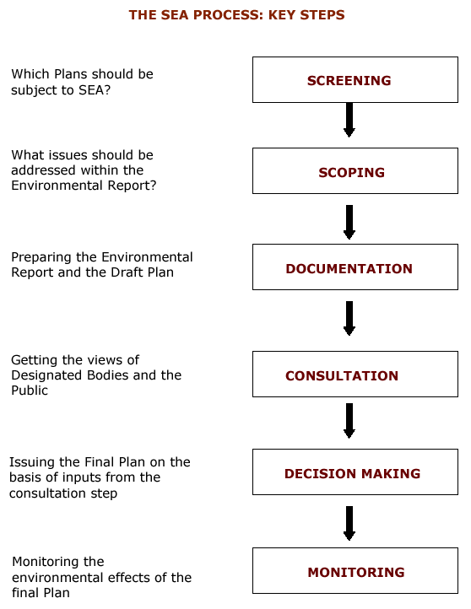
THE SEA PROCESS: KEY STEPS
1. Should the Development Plan be subject to a full SEA?Answer: Yes
2. What issues, scope and level of detail should be addressed within the Environmental Report?
3. Preparing the Environmental Report and the Development Plan

4. Getting the views of Designated Bodies and the Public

5. Issuing the New County Development Plan on the basis of inputs from the consultation step

6. Monitoring the environmental effects of the
County Development Plan
MONITORING
DECISION MAKING
SCOPING
SCREENING
ENVIRONMENTAL REPORT
CONSULTATION

What key issues will be addressed in the new development plan?
- Settlement Strategy and Housing
- Community, Recreation and Public Open Space
- Economic Development and Employment
- Physical Infrastructure
- Rural and Urban Areas
- Conservation of Our Built Heritage
- Protection of our Environment and our Natural Heritage

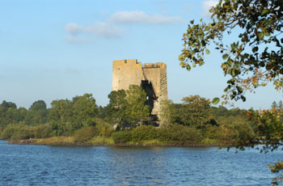

What are the Main Environmental Issues facing Cavan between now and 2020?

Environmental Considerations | Potential  Impacts | Issues
Biodiversity- the variety of life on earth which includes people, plants, animals, fungi, micro-organisms. | New developments could potentially impact on biodiversity i.e. habitat destruction, human health, species destruction | What do you think are the main threats to Biodiversity in Co. Cavan?  How can we best accommodate development whilst managing biodiversity?
Flora and Fauna -flora is plant life naturally occurring in an area, whilst fauna is animal life occurring in an area. | New developments could potentially impact on flora and fauna. | Some of these species are protected under the European Habitats Directive and Irish Law and so how can we manage development whilst ensuring flora and fauna is not compromised.
Population and Human Health – human activities and settlement patterns are reflected in Cavan’s built and natural heritage. The natural environment has supported Cavan’s residents for generations whilst the built environment has facilitated settlement patterns throughout the county. | The utilisation of natural and built resources has the potential to impact on water, air, soil, climate and therefore impact negatively on human health. | How can we ensure the future sustainable development of the County?
Soil and Water – soil is the top layer of the earth’s surface consisting of rock and mineral particles mixed with organic matter. Water is a major resource in Co. Cavan with its lakes, rivers and streams. | Development has the potential to impact on landscape, geology and soils such as windfarm, extractive industries, forestry, agriculture, industry, commercial development, rural dwellings and road projects. Water is not only important from an ecological perspective but it is also provides a source of drinking water. | What is best practice for the removal of soil in the development of Greenfield sites?  How can we ensure existing and proposed developments do not compromise water quality for residents and visitors to the County?  Can we ensure the ecological balance of water is maintained to ensure human health and biodiversity are not negatively impacted upon?
Air/Noise/ Climate - | Potentials impacts on air and climate arise from transport and industrial emissions.  Increased in noise levels from development can impact on humans and wildlife.  Increased greenhouse gas emissions have been linked to Climate Change. | What can be done to reduce the pressures on the atmosphere?  How can we accommodate renewable energy provisions in the County like windfarms, etc?  What policies should be considered to reduce climate change and its impact on our county like flash flooding, soil erosion etc?
Material Assets – comprises of built environment, infrastructure and natural assets. | The utilisation of the County’s material assets leads directly and indirectly to potential environmental impacts. | How can we best manage County Cavan’s material assets sustainably?
Cultural Heritage including Architectural and Archaeological- our heritage is what has been passed down to us from previous generations and we must consider what we will be able to pass onto future generations. The Heritage of Cavan is a unique resource which has shaped our cultural identity and defines the society in which we live. | Pressures can arise from developments and activities close to heritage sites. Natural and Built Heritage may be placed under pressure from development. | How can the value of our natural heritage, built heritage, cultural heritage and archaeological heritage be best protected and improved?
Inter-Relationships of the above - Cumulative impacts and interaction of the above mentioned items can give rise to increased pressure on the environment. | The impacts and interactions will vary in extent and nature. | What do you think are the main environmental issues facing County Cavan?

Have your say…..

HOW TO MAKE A SUBMISSION: Having Your Say - Submissions and observations should be made in writing and sent to one of the following by the 5th of December, 2012:
- Post: Forward Planning Section, Planning Department, Cavan County Council, Farnham Centre, Farnham Street, Cavan.
- Email: plan@cavancoco.ie

The Planning Authority will conduct a series of public consultation exercises in the form of public meetings, workshops, and consultations with individuals and groups. You can find more about the Development Plan and how it is progressing, at the following locations;
- Website at www.cavancoco.ie.
- Our Facebook pages: : www.facebook.com/cavancoco & www.facebook.com/CavanCountyDevelopmentPlan
- Twitter: twitter.com/cavancoco

The location, venue and times for the initial stage of public consultation are detailed in the table below:
Venue | Date | Time | Location
Cavan County Library: Events space | Tuesday, 6th November | 18:00 – 20:00 | Cavan Town
County Museum: Meeting room | Wednesday, 7th November | 18:00 – 20:00 | Ballyjamesduff
Ballyconnell, Market House | Wednesday, 14th November | 18:00 – 20:00 | Belturbet
Bailieborough Library | Tuesday, 20th November | 18:00 – 20:00 | Bailieborough

