Appendix 20 – Draft Indicative Forest Strategy

The overall aim of the Indicative Forest Strategy (IFS) is to provide high-level, national guidance in relation to the suitability of land for afforestation. The Draft Indicative Forest Strategy provides high-level, national guidance in relation to the suitability of land for afforestation and facilitates the establishment of high quality forests serving a variety of purposes including timber production, enhancement of the environment, mitigation of climate change, forest industry development, creation of alternative off farm incomes and opportunities for tourism and amenity use.

The Draft Indicative Forest Strategy is a GIS based system that identifies areas most suitable for planting primarily on the basis of environmental considerations and soil-productivity. The map based environmental constraints have been supplied from a variety of state organisations, such as the National Parks and Wildlife Service, the Fisheries Boards, the EPA and the Planning Authorities. The forest productivity map was compiled in co-operation with Teagasc and is based on soils and elevations, displaying the potential of growth for tress throughout the country.

The various categories described in the Indicative Forest Strategy are described below. Please refer to the Department of Agriculture and Food’s website for most up-to-date version as the following is in draft form.

Description of Policy Categories, Environmental Designations and the Process associated with each Policy Category
Policy  Category | Description | Environmental Designations | Applications Process¹
Category 1  “Suitable for a range of forest types” | Areas identified as being the most suitable for future forest development, where no environmental designations exist and where soil types indicate that trees will grow satisfactorily. | Area with no environmental constraints². | - Forest Service Inspection Procedure  - Adherence to the Code of Best Forest Practice, Forestry Schemes Manual and Forest Service Environmental Guidelines.  - Consult with DoEHLG if archaeological records of monuments and places are recorded or discovered.  - Consult with Local Authority in areas of 25 ha or more.  - Full EIA screening procedure (EIA at discretion of Forest Service - mandatory on areas of 50 ha or more).
Category 2  “Suitable for certain types of forest development” | Areas where at least one environmental designation (such as a fisheries sensitive areas) exist. For more details on the consultation system associated with specific environmental designations see Appendix 1. | - Acid sensitive areas.  - Areas sensitive for fisheries.  - Catchment areas of local authority water schemes.  - REPs areas.  - Archaeological sites or monuments  - Areas of moderate landscape sensitivity. | - Process as for “Suitable for a range of forest types” and, in addition:  - consultation with relevant authority (such as Regional Fisheries Boards, National Parks and Wildlife Service, Local Authority).
Category 3  “Suitable, where appropriate, for nature conservation and/or amenity forests“ | Areas where environmental designations (such as Special Areas of Conservation) exist. For more details on the consultation system associated with specific environmental designations see Appendix 1. | - pNHAs, SACs, SPAs and National Parks.  - Archaeological sites or monuments with intensive public use.  - Areas of high landscape sensitivity identified in county development plans or listed in the Inventory of Outstanding Landscapes. | - Process as for “Suitable for a range of forest types” and, in addition:  - consultation with the relevant authority (such as Regional Fisheries Boards, National Parks an Wildlife Service, Local Authority); and  - formal public consultation by way of newspaper advertisement
Category 4  “Unsuitable, unproductive or unplantable” | Areas where it is considered that trees are unlikely to grow satisfactorily including soil fertility, exposure etc. These areas also include unplantable areas i.e. waterbodies, urban areas and areas of existing forest. Applications for new forest development may be submitted to the Forest Service for consideration where an approved Forester certifies that the site is suitable for growing trees. | N/A | N/A

¹ All applications for grant assistance towards new afforestation must be completed by a qualified forester whose name appears on The Register of Foresters maintained by the Forest Service.
² Sites of archaeological interest occur in each category and advice is sought from the Department of the Environment, Heritage and Local Government, whenever a site listed on the Records of Monuments and Places (RMP) is situated within an area proposed for planting.

It is envisaged that a Draft Indicative Forest Strategy will be available in 2008.

Source: http://www.agriculture.gov.ie

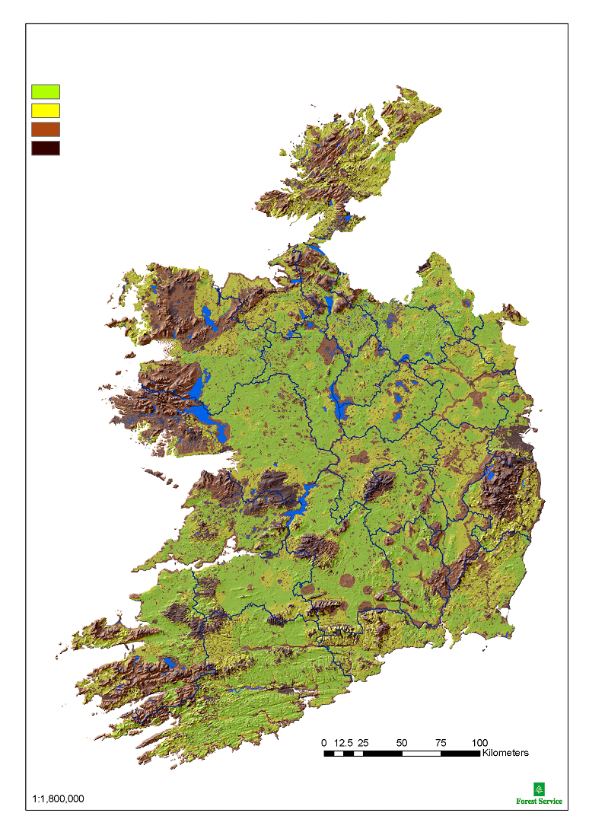
Draft Indicative Forest Strategy
Policy Category Map
Category 1 -Suitable for a wide range of forest types
Category 2 -Suitable for certain types of forest development
Category 3 - Suitable, where appropriate, for nature conservation
Category 4 - Unsuitable, unproductive or unplantable areas
and/or amenity forests

