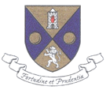

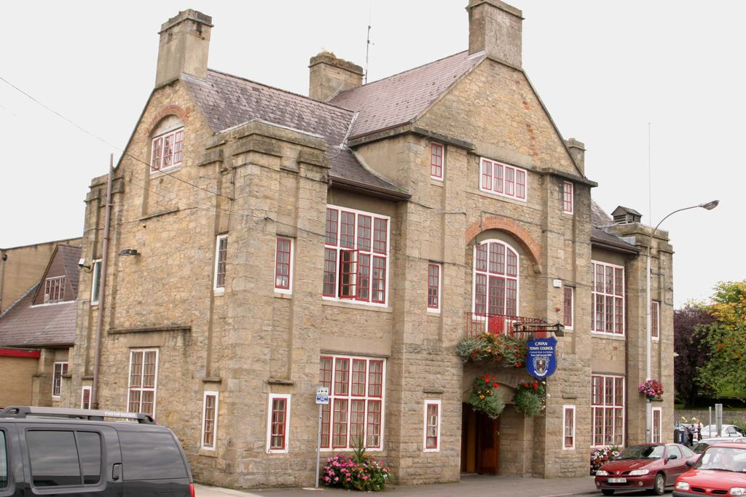

HAVING YOUR SAY…….

REVIEW of the

CAVAN TOWN AND ENVIRONS DEVELOPMENT PLAN

Strategic Issues Paper

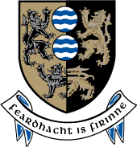

STRATEGIC ISSUES PAPER

INTRODUCTION
Cavan County Council which is the Planning Authority for Cavan Town Environs and Cavan Town Council which is the Planning Authority for Cavan Town (Urban Area) is reviewing the current Cavan Town and Environs Development Plan and preparing a new draft Development Plan to cover the period 2014 - 2020.

What is a Development Plan? A Development Plan is a document which details the overall strategy of a Planning Authority for the proper planning and sustainable development of an area and generally consists of a written statement and accompanying maps. The plan usually includes the broad aims of the council with regard to issues such as: Housing, Infrastructure, Community Facilities, Environment & Heritage etc. The plan will also result in a number of Policies and Objectives to support each of the issues.

What are Policies and Objectives? A Policy is an agreed position on a particular issue while an Objective is a specified action or project which the Council intends achieving over the life-time of the plan.

What should be included in a Development Plan? In accordance with the Planning & Development Act (2000-2010, as amended) there are a number of topics (also referred to as ‘mandatory objectives’) which the development plan must address in the form of policies and specific objectives, these include:
- A Core Strategy which demonstrates that the policies and objectives in the Development Plan are consistent, as far as practicable with National & Regional Development objectives set out in the National Spatial Strategy and the Regional Planning Guidelines;
- Zoning of land for particular uses;
- Provide or facilitate the provision of Infrastructure including transport, energy and communication facilities;
- Encourage the management of features of the landscape, such as traditional field boundaries, which are important for the ecological coherence of the Natura 2000 network and essential for the migration, dispersal and genetic exchange of wild species;
- Conservation and protection of the environment including the archaeological and natural heritage;
- Promote compliance with environment standards and objectives for protection of surface water and groundwater, as contained in the River Basin Management Plans (RBMP’s);
- The integration of the planning and sustainable development of the area with the social, community and cultural requirements of the area and its population;
- The preservation of the character of the landscape where the proper planning and sustainable development of the area requires it, including the preservation of views and prospects and the amenities of places and features of natural beauty or interest;
- The protection of structures, or parts of structures, which are of special architectural, historical, archaeological, artistic, cultural, scientific, social or technical interest;
- The preservation of the character of architectural conservation areas;
- The development and renewal of areas in need of regeneration;
- Provision of accommodation for travellers;
- Preservation, improvement and extension of amenities and recreational amenities;
- Control of development for the purposes of reducing risk or limiting the consequences of a major accident (having regard to the Major Accidents Directive);
- Provision of services for Communities, including schools; crèches and other education and child care facilities;
- Provide for the protection of the linguistic and cultural heritage of the Gaeltacht;
- Promote sustainable settlement and transportation strategies in urban and rural areas, particularly with regard to location, layout and design of new development;
- The preservation of a public rights of way which may give access to seashore, mountain, lakeshore, riverbank or other place of natural beauty or recreational utility; and
- Consider the provision and development of a framework for the identification, assessment, protection, management and planning of landscapes.

Development Review Process: (we are here*) A Development Plan must be reviewed every 6 years. The process begins no later than 2 years before the expiry of the existing development plan. The time-span of the new development plan will be 2014 – 2020. This Strategic issues paper forms part of the first stage, as illustrated in the table below. The parts of the process which involve public participation are highlighted in red.

Direction from members to prepare Draft
Plan

Public Consultation workshops

*Pre -Draft Stage
(including Public Consultation)
STAGE 1: Pre-Draft

STAGE 2:
Preparation of Draft Plan

STAGE 3: Making of Development Plan
Prepare Manager’s report on consultation
Preparation of proposed Draft Development Plan

Public Display of Draft Development Plan

Manager’s report on public submissions

Consideration of Manager’s report by the Members

Prepare amendments to Draft Plan

Public Display of amendments to the Draft Plan

Manager’s report prepared on public submissions

Consideration of Managers’ Report

Adoption of the Development Plan

Note: Planning legislation states that proposals for zoning of a particular land for any purpose will not be considered at this stage
Purpose of the Strategic Issues paper: The purpose of this Paper is to stimulate debate and encourage interested and affected persons, individuals and representatives of groups or organizations within the County to have their say in formulating policies for the new plan. Throughout the document you will see reference to the main planning issues under a number of headings, such as Population, Housing, Physical Infrastructure, Heritage and Community Facilities. We have attempted to highlight the most significant areas of potential interest to you. It is important that the final document does not consist of a wish list but rather reflects the needs and desires of the people of Cavan with regard to the development of your Town. The building of a better society requires the input of many players, accordingly the contribution of a diverse range of organizations, communities and individuals into the process is not only desirable but necessary. In addition, submissions are also invited from children or groups representing the interests of children.

HOW TO MAKE A SUBMISSION: Having Your Say - What Planning Issues Would You Like To Raise? It is important to have your input from the beginning so that we can make sure that the final Plan reflects your concerns and ideas, as well as Government strategies and guidelines. Submissions and observations should be made in writing and sent to one of the following by the 5th of December, 2012:
- By Post to: Forward Planning Section, Planning Department, Cavan County Council, Farnham Centre, Farnham Street, Cavan.
- By Email to: plan@cavancoco.ie

The Planning Authority will conduct a series of public consultation exercises in the form of public meetings, workshops, and consultations with individuals and groups. You can find more about the Development Plan and how it is progressing, at the following locations;
- Website at www.cavancoco.ie.
- Our Facebook pages: www.facebook.com/cavancoco & www.facebook.com/CavanCountyDevelopmentPlan
- Twitter: twitter.com/cavancoco

The dates, times and venues for the initial stage of public consultation are detailed in the table below:
Venue | Date | Time | Location
Cavan County Library: Events space | Tuesday, 6th November | 18:00 – 20:00 | Cavan Town
County Museum: Meeting room | Wednesday, 7th November | 18:00 – 20:00 | Ballyjamesduff
Ballyconnell, The Courthouse | Wednesday, 14th November | 18:00 – 20:00 | Ballyconnell
Bailieborough Library | Tuesday, 20th November | 18:00 – 20:00 | Bailieborough

CREATING A VISION FOR YOUR TOWN

The Planning Authority are seeking the help of all citizens in creating a VISION for the future development of Cavan Town & Environs. This vision will be formulated from a combination of the responses to this Strategic Issues Paper particularly responses to the questions set below, as well as, the findings of the initial public consultation which will challenge attendees to formulate their VISION for the Cavan. The suitability of this vision will be tested at subsequent public consultation meetings.

VALUES

DARE TO DREAM

DIRECTION

FRAMEWORK

POSITIVE

INSPIRATION

VISION
STATEMENT

PLEASE CONSIDER THESE QUESTIONS

What role does Cavan town have in the county?
Why do you think people wish to live in Cavan Town?
How should Cavan town develop in the future?

KEY THEMES

POPULATION, SETTLEMENT STRATEGY AND HOUSING

Our Town: Cavan Town is the largest town and administrative centre of the county. It is located in the centre of the County and has good linkages to the other main towns. Cavan Town is made up of the town council area, as well as, the environs of the Town. The town has been identified as a Hub Town in the National Spatial Strategy (NSS) and Border Regional Planning Guidelines (BRPG). The most recent census (2011) identifies the town as being a large town because its population is over 10,000.

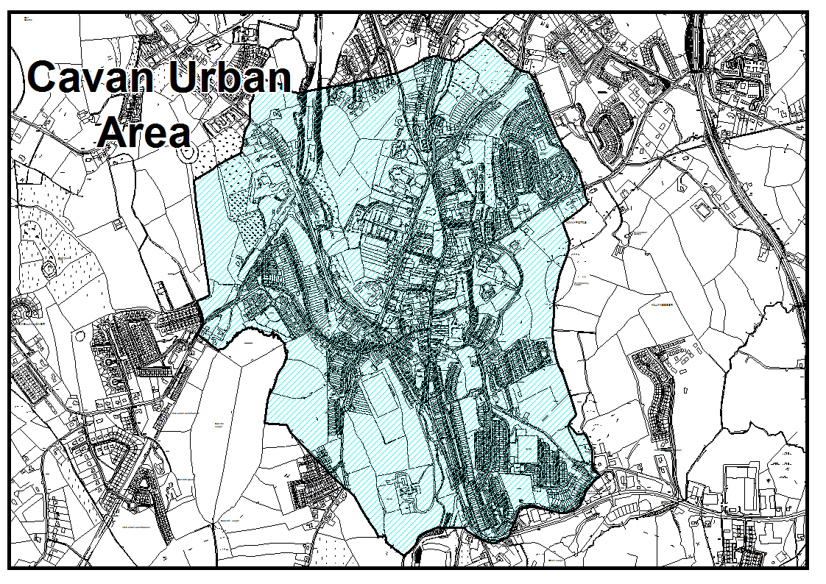
Town and Environs: Cavan Town Council is the Local Authority for Cavan Urban Area which includes the town centre and the main urban elements of the town, the map below illustrates the urban boundary. The town has grown beyond the urban boundary, as we can see from the map. There are a number of important elements of Cavan Town which are located outside the urban boundary including, a number of housing estates, retail parks on the Dublin Road, Cavan General Hospital, a number of Primary and Secondary Schools etc. The County Council is the Local Authority for the Environs of Cavan Town.

Hub Town: The National Spatial Strategy (NSS) introduced the concept of balanced regional growth and established eight regions. The regions were created as a response to the changing socio – economic profile of the country which had resulted in unbalanced development. For example, increasing levels of economic prosperity and population growth were being unevenly located in larger urban areas such as Dublin, Cork, Limerick/Shannon, Galway and Waterford and their associated regions. Each of the regions were charged with the development of ‘Regional Planning Guidelines’ specifically for their region. Cavan is in the Border Region along with Donegal, Leitrim, Louth, Monaghan and Sligo. The current Border Regional Planning Guidelines cover the period 2010 – 2022.
The Border Regional Planning Guidelines was prepared in response to the NSS with the aim of achieving balanced regional growth. This growth will be facilitated and supported through the identification of urban centers that would become drivers of development at national level and within their own regions. Cavan Town has been identified as a Hub Town within the region. Its role is to support, as well as, to be supported by the Gateways which in the Border Region are Letterkenny, Sligo and Dundalk, to drive the development of rural areas and to contribute to achieving the goal of balanced regional development. Cavan town is identified as being on a strategic linking corridor providing access into and within the Border Region.

The map below is taken from the National Spatial Strategy, it outlines the general strategic vision for the development of the Border Region:

Population and Growth: With a population of over 10,205 000 Cavan town is now a large town. As the table demonstrates, Cavan Town has experienced and overall growth of 29.4% between 2006 and 2011. This is much greater than the growth of the Border Region and of the Country. It is interesting to note to note that the population of the Cavan Urban area has actually dropped between the 2006 and 2011 census. The environs of Cavan Town has experience a 66% increase in population and a corresponding increase in the construction of housing, there are now a significant number of housing estates in the town environs. A large number of these dwellings are rental properties.
County, Region or State |  | 2006 | 2011 | % Change  2006 - 2012
Cavan Town | Cavan Urban | 3,934 | 3,649 | -7.2%
Cavan Town | Environs | 3,949 | 6,556 | 66%
Cavan Town | Total | 7,883 | 10,205 | 29.4%
Cavan County |  | 64,003 | 73,183 | 14.3%
Border Region |  | 468,375 | 514,891 | 9.9%
Ireland |  | 4,239,848 | 4,588,252 | 8.2%

POPULATION, SETTLEMENT STRATEGY, HOUSING
HAVE YOUR SAY!!!
PLEASE CONSIDER THE FOLLOWING QUESTIONS

What to you think Cavan Towns role is in the County?
Why do you think the Urban Area has experienced a fall in population even though overall the town population has grown?
What do you think are Cavan Towns Strengths and Weaknesses?

KEY THEMES

COMMUNITY, RECREATION AND PUBLIC OPEN SPACES
Community Facilities: Social, Community and Cultural Development are factors that contribute to the creation of a good quality of life for all. We at Cavan Local Authorities aim, where possible, to respond to individual communities and their needs through facilitating the provision of schools, crèches, other child/youth services, sporting, recreation facilities etc. This is supported through policies and objectives of the Cavan Town & Environs Development Plan.

Social inclusion: Our aim is the creation of a society where quality of life is essential and social inclusion a must. Social exclusion occurs when people are marginalized from society due to issues such as: unemployment, poverty and discrimination. It also occurs when people can not access services. Social inclusion, as a concept, seeks to achieve a fairer and more inclusive society. In terms of planning, this can be achieved through the provision of social and affordable housing, the creation of employment, educational and recreational opportunities, health services and public transportation facilities and ensuring all member of society can access services.
The Cavan Local Authorities, ‘Social Inclusion Plan (2011-2012)’ sets out actions for the delivery of social inclusion measures which would include the requirement that all policies and objectives of the Development Plan are socially inclusive. The Local Authorities facilitate the provision of Public, Community and Educational uses through its polices and the zoning of sufficient lands for these purposes.

Public Open Space and Recreational Facilities: The provision and quality of public open space and recreation facilities have an essential role in creating places and communities that people enjoy or wish to live in. They are major factors in the creation of a ‘good quality of life’. The role of such services in the community needs to occur in a socially inclusive manner such that all members of a community can and want to access all facilities. Examples of these spaces and facilities in Cavan Town are Con Smith Park which includes a children’s playground and outdoor gym, Green areas in residential housing estates, public rights of way e.g. walking routes, amenity areas at lakes and rivers, playgrounds, sports fields. Cavan Town has several sports facilities such as: GAA football clubs, tennis courts, Cavan Rugby club and indoor facilities such as the Equestrian Centre, the Cavan Swimming pool and leisure centre.

COMMUNITY, RECREATION AND PUBLIC OPEN SPACE
HAVE YOUR SAY!!!
PLEASE CONSIDER THE FOLLOWING QUESTIONS
Would you consider that the existing playgrounds; parks and amenity areas in Cavan Town, are adequate? If not, where should new ones be located and what can be done to improve existing?
What is your experience of Public Open Spaces in new Housing Estates?
Do we have enough Sporting Facilities in Cavan Town? What suggestions could you make to improve or add to these?
What is your opinion of Multi-Purpose Sports and Community Facilities and where should these be located?
Do you think there are groups which are socially excluded in Cavan Town?
Are there adequate Health Care and Child Care facilities in Cavan Town and are they accessible?
What Community Facilities do you think are lacking in Cavan Town?
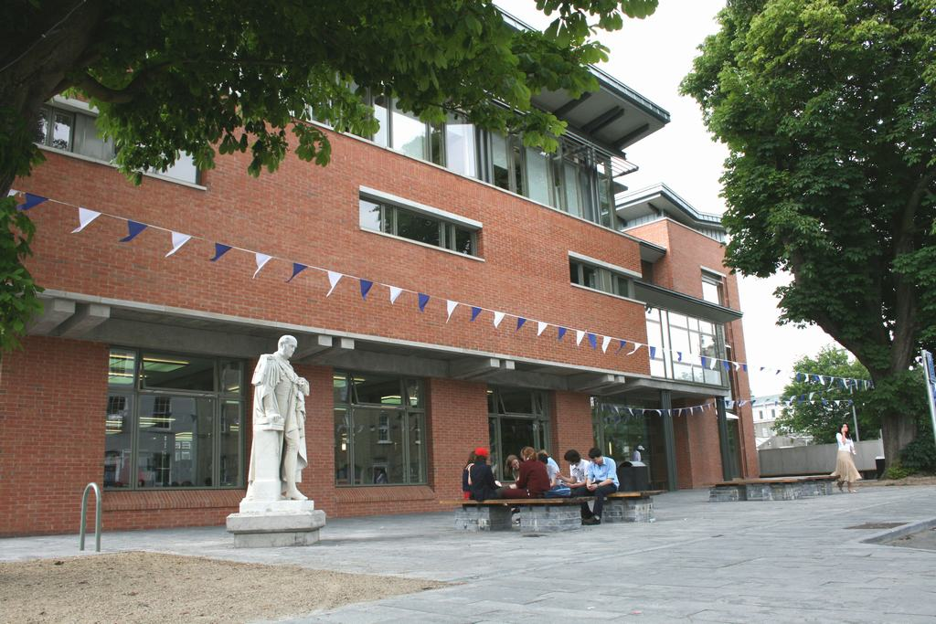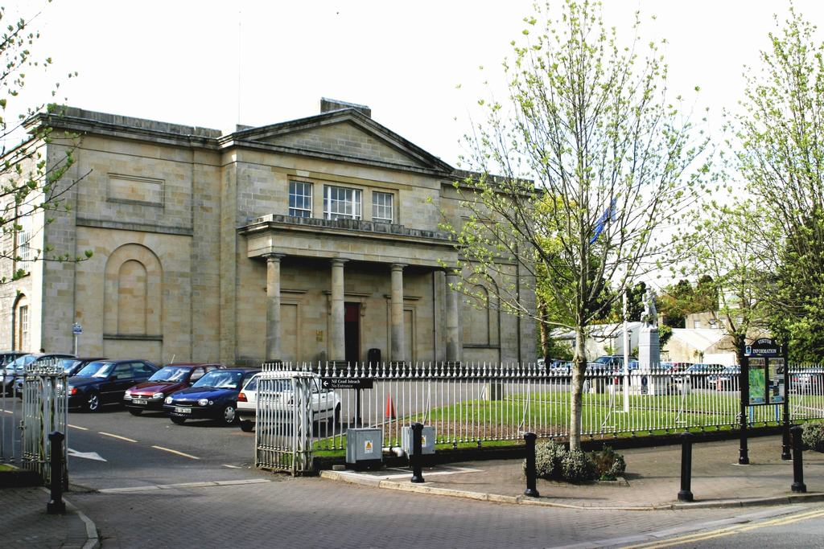

ECONOMIC DEVELOPMENT AND EMPLOYMENT
Enterprise and Employment: The Development Plan has an important role to plan in supporting the development of our employment and enterprise sectors. Essentially, the role of the plan will be to identify suitable land uses and create policies and objectives which will help guide future development of employment related activities. It will also seek to ensure that there are policies and objectives which enable the provision of essential support infrastructure, such as roads, water services, public transport and communication systems. The plan aims to respond to the key business opportunities and trends in the Town.
The town and environs faces a number of challenges due to the current economic climate. Like much of the Country, Cavan has experienced a rise in unemployment, significant downturn in the construction industry, as well as, the challenges of being located so close to Northern Ireland.

Cavan Town is located at a strategic location within the county, on the junction of two national routes (the N3 and the N55) to east-west route, Dublin to Sligo and along the north-south axis between Northern Ireland and the Midlands town of Athlone. The county is reliant on indigenous development as the main source of wealth and job creation, however, there are also a number of international companies located in the county. IDA Ireland promotes the County as a location for overseas investment and Enterprise Ireland focuses on the development of Irish owned companies.

The following factors are essential for developing enterprise and attracting investment into the county and its major town:
- Access to a skilled and educated work force.
- Access to business and enterprise networks and inter-linkages between firms, higher education institutes and government bodies.
- Access to Innovations and Research & Development.
- Quality of life which will attract both new employers and business and a good incentive to potential investors.
- Support services and infrastructure
- Physical and electronic access to markets and customers

The Development Plan shall seek through policies and objectives to enable the development of an environment which would ensure the creation of such factors in the county.
Existing and potential areas for future growth and development in the Border Region include:
- Agri-Food Sector – The principle activities in this sector are meat, poultry and dairy.
- Renewable Energy Sector – This sector has grown significantly in response to a need for more environmental friendly energy production along with the growing cost of fossil fuels. The ‘Green Economy has the potential to stimulate economic development of rural areas.
- Tourism – This would include both existing and potential tourist destinations and activities centered around our lakes, rivers and our landscape in general.
- Retail Sector – This sector is important as a provider of employment and as an important element in creating strong, vital towns and villages.
ECONOMIC DEVELOPMENT AND EMPLOYMENT
HAVE YOUR SAY
PLEASE CONSIDER THESE QUESTIONS
What are Cavan Town’s strengths with regards to employment and enterprise and how can these be used to their best advantage?
What is the Town’s weakness with regards to employment and enterprise and how can these be overcome?
What is your opinion of retail provision in the County Town of Cavan?
What are the key business opportunities in Cavan town and how can they be developed?
What are the main barriers in the development of our tourist potential?
What are the main opportunities in the development of our tourist potential?
In your opinion what are the future opportunities for Cavan Town?
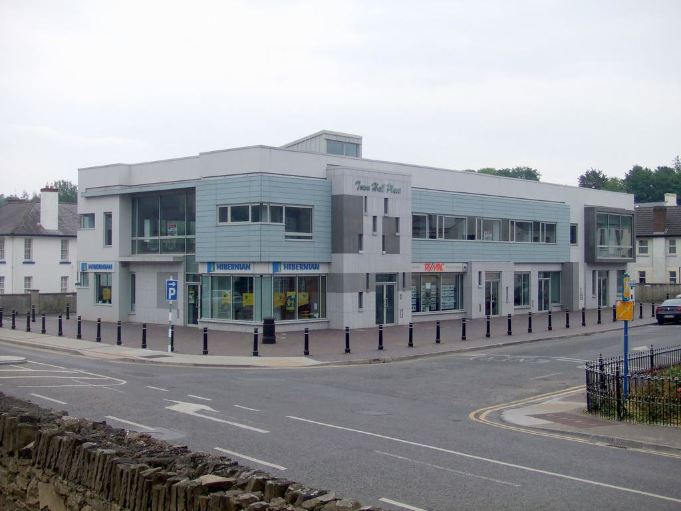

TRANSPORT
The current modes of transport within Cavan Town & Environs are primarily via the existing road network (i.e. the private car and business vehicles), private bus and taxi services and the Bus Eireann Bus Service from central Cavan.
The Cavan Town and Environs Integrated Framework Plan; Transportation Study (2020), identified some key roads projects, some of which have already been commenced. These include: the upgrading of the Dublin road to include new roundabout, footpaths and cycle lanes and the construction of the New Eastern Link road which aims to alleviate traffic congestion around the town core. The Development Plan is now required to embrace the principles of Transport 21

TRANPSORT
HAVE YOUR SAY!!!
PLEASE CONSIDER THE FOLLOWING QUESTIONS:

Can we provide for better co-ordination and integration between different modes of travel for example between bus and cycling?
What is our private transport network missing?
What forms of sustainable transport would you consider appropriate for Cavan Town?
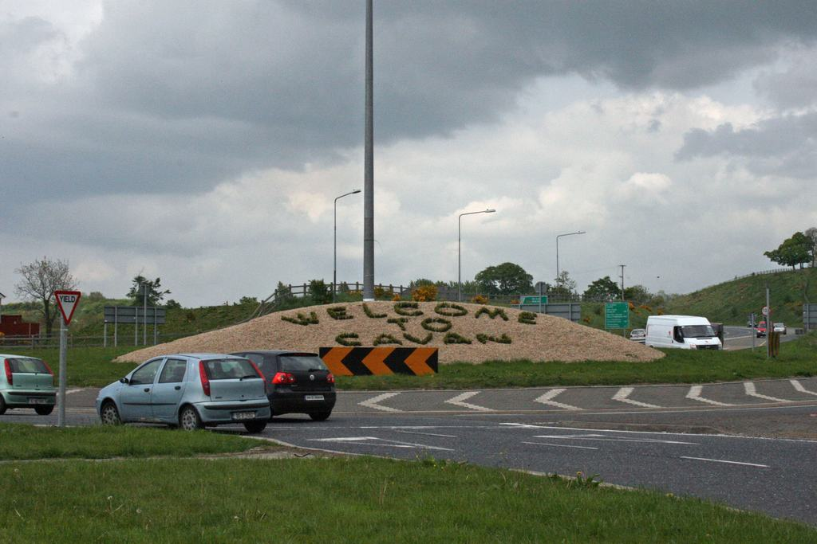
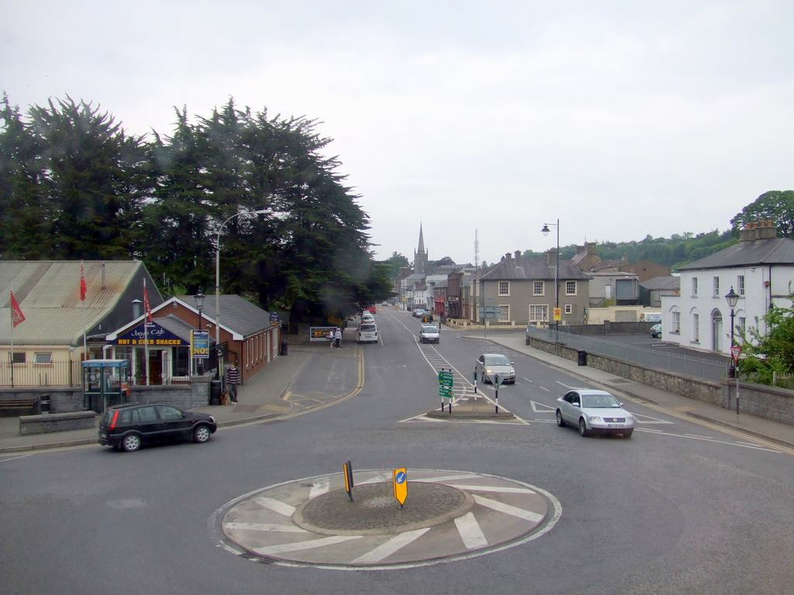

PHYSICAL INFRASTRUCTURE
The provision of physical infrastructure for the management of: water, wastewater, waste, energy and telecommunications is key to the sustainable development of Cavan Town. In order to support the role of Cavan town as a regionally important employment, retail and service centre in the county, there is a need to provide for and enhance existing infrastructure. Some of the key projects by the Government, the Local Authority and private business which have contributed to the improvement of infrastructure in Cavan Town in recent years, has included the following:

Road schemes: Some roads schemes for the Town & Environs have included the;
Commencement of the North-Eastern Access Road which will alleviate traffic congestion around Cavan Town Centre and allow easy access to the Town Core: the upgrading of Dublin road to include: cycling lanes; roundabouts and footpaths.

Water and Wastewater: The Water Services Investment Programme (WSIP) 2010-2012 has also seen the upgrading of water treatment plant in Cavan Town. The programme aims to supply wastewater and water supply infrastructure to areas which have come under pressure for development, this has also been in response to EU and National government policies on drinking water; the EU Water Framework Directive; the control of pollution through waste water discharge licenses; Sustainable Urban Drainage Systems (SUDS) which addresses flood risk management.

Broadband & Telecommunications: The National Broadband Scheme (NBS) has delivered a number of key telecommunications projects throughout the county which has improved the networks for broadband communications in areas where previously there was no coverage. Cavan Local Authorities are committed to placing the Town and County at the leading edge in terms of access to Information Communication Technology (ICT).

Electricty & Renewable Energy: The main sources of renewable energy are: wind, solar (the sun), hydro (water), geothermal (heat from the earth) and biomass (wood, energy crops). The plan would support the idea of renewable energy in all its forms, which should be explored further in the context of Cavan Town & Environs as an urban centre.

Waste Management: The North East regional Waste Management Plan (2005-2010) sets out a comprehensive strategy for the management of waste in the counties of Cavan, Louth, Monaghan and Meath. The expiry date for current North East Region Waste Management Plan 2005-2010 has been extended to 31st December 2012. This plan is currently being evaluated and revised and a new North East Region Waste Management Plan will be implemented before 31st December 2012.
The Plan sets out proposals to manage waste over a 15 year period from 2001 and includes an analysis of the current waste management situation in the North East Region. The plan created a hierarchy for the management of waste, these are: prevention, minimization, re-use, recycle/recover and disposal of waste. Some of the aims of this strategy have already been implemented in the county including the provision of 30 bring centres, 3 recycling centres and a licenced landfill facility, along with an active waste enforcement section. Cavan County Council also has a Litter Management Plan (2008) which sets out a strategy for tackling the problem of litter. The Development Plan will aim to identify issues around the provision of waste management services in the county as well as support the existing waste management strategies already in place. Underpinning, all the progress that has taken place in waste infrastructure, is the ongoing environmental awareness work. This promotes the sustainable management of waste in a variety of ways including schools programmes, seminars, information leaflets and booklets and use of the Cavan County Council website.
PHYSICAL INFRASTRUCTURE
HAVE YOUR SAY!!!
PLEASE CONSIDER THE FOLLOWING QUESTIONS
What are the main issues around service provision/investment in Cavan Town?
What is your opinion of sustainable energy development such as wind turbines, solar panels, thermal energy?
Should wind energy development be accommodated within the urban location of Cavan Town & Environs? If so, where do you consider this would be appropriately located?
Are there adequate recycling facilities located in Cavan Town? In your opinion where should they be located?
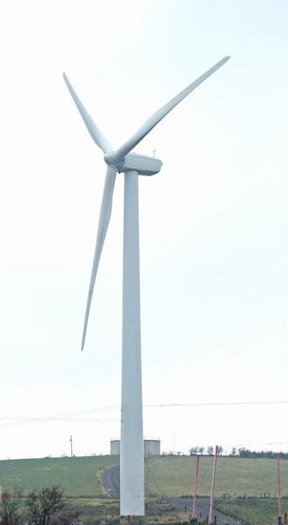
What are the issues around litter management in Cavan? How can
we best inform people about waste reduction, re-use, recycle and
recovery?

TOWN CENTRE: RETAIL AND REGENERATION
Cavan Town as the largest town in the county and as a hub town, has an important role to play as a service provider, a main source of employment, the major retail centre in the County, as well as, being the main location for educational, social and community facilities. The creation of strong, vibrant and viable towns is essential in the creation of ‘quality of life’ and in ensuring sustainable development. By centralising services, retail, schools and so on we reduce the need for multi-trips and thus reduce car use.

One of the most important elements of our town is the creation of a vibrant town centre which has a good mix of services, employment, retail and perhaps some residential, laid out in a pleasing manner with good linkages both vehicular and pedestrian to other parts of the town. The challenge is to ensure that towns develop in a sustainable fashion where new uses add to the vitality of the town and do not detract from existing uses.
It is essential that town centres have a suitable level of retail development. The new ‘Retail Planning Guidelines for Planning Authorities’ issued in April 2012 promote a ‘sequential approach’ which encourages the development of Town Centres from the centre outwards. There is also an emphasis on the importance of protecting the viability and vitality of Town Centres. This will be supported in the Core Strategy for the new Development Plan for Cavan Town & Environs.
TOWN CENTRE
HAVE YOUR SAY!!!
CONSIDER THE FOLLOWING QUESTIONS

What policies should appear in the Development Plan to ensure that changes in population are dealt with in a positive way?
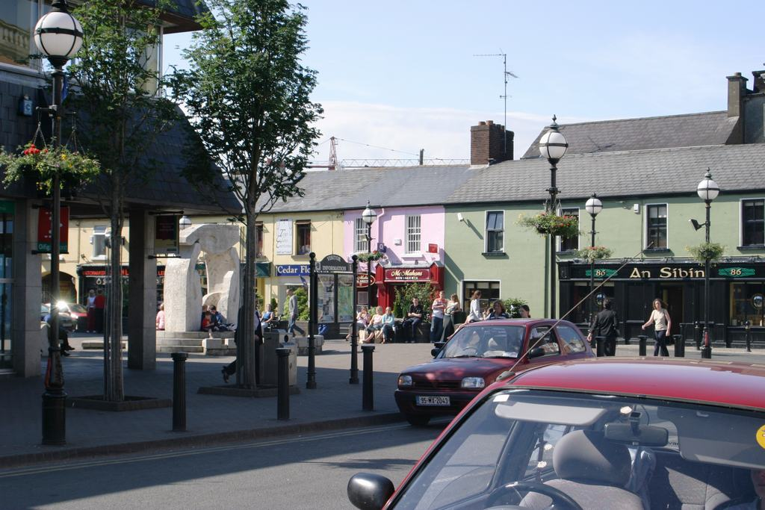
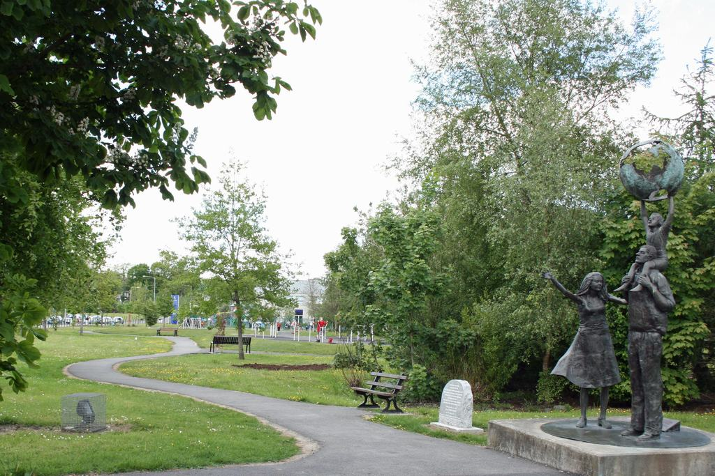
How can we make Cavan Town Centre more attractive for shopping, leisure and residential activities?

CONSERVATION OF OUR BUILT HERITAGE
Our shared past, the unique and special nature of an area and our feeling of belonging to a community with a shared past contribute to the creation of places in which people wish to live. The protection of our built and natural heritage is one of the overarching aims of the County Development Plan which is of extreme importance from an international, national and local perspective. It is essential that our built heritage, especially structures that appear in the Record of Protected Structures, as well as, our Archaeological Monuments and Architectural Conservation Areas are protected.

What is a Protected Structure? A protected structure is any structure which is included in the Record of Protected Structures (RPS). The purpose of the RPS under section 51 of the Planning and Development Act is to protect structures or parts of structures, which form part of the historical, archaeological, artistic, cultural, scientific, social or technical interest. Each owner or occupier of a protected structure is legally obliged to ensure that the structure is preserved. The Development Plan will contain a comprehensive and update list all protected structures throughout the county. A protected structure is defined as:
“any building, structure, excavation, or other thing constructed or made on, in or under land, or any part of a structure so defined, and-
in relation to a protected structure, includes:
  - the interior of the structure,
  - the land lying within the curtilage of the structure
  - any other structures lying within that curtilage and their interiors, and
  - all fixtures and features which form part of the interior or exterior of any structures

Older Buildings: There are a number of older buildings in the County that are not protected structures but are of local architectural, historical, archaeological, artistic, cultural, scientific, social or technical value and would warrant retention and sympathetic reuse. The retention, rehabilitation and reuse of older buildings can play a pivotal role in the sustainable development of Cavan town. They contribute, both individually and collectively, to the unique character, heritage and identity of the County.

What is an Architectural Conservation Area? ‘The Architectural Heritage Protection; Guidelines for Planning Authorities’ defines an Architectural Conservation Area (ACA) as; “A place, area, group of structures or townscape, taking account of building lines and heights, that is of special architectural, historical, archaeological, artistic, cultural, scientific, social or technical interest or that contributes to the appreciation of a Protected Structure, and whose character it is an objective of a development plan to preserve.” To date, Cavan Town does not have an (ACA), although this may be considered in the new plan.

Archaeological Heritage: Is the surviving remains of human presence in our County from early times. Any objects, materials, sites and structures from past times are all part of our Archaeological Heritage. Our archaeological heritage consists of known and as yet unidentified sites, monuments, objects and environmental evidence and includes round towers, high crosses, burial sites, ringforts, tower houses, Fulacht Fia, Raths, Court Tombs, Portal Tombs, Wedge Tombs, Cairns, Earthworks, Abbeys and souterraines. The main concern for Planning Authorities will be the protection of monuments and sites. Archaeological remains help us understand our origins as a society, are a connection to our distant past, an educational tool, as well as, a tourist resource.
CONSERVATION OF OUR BUILT HERITAGE
HAVE YOUR SAY!!!
PLEASE CONSIDER THE FOLLOWING QUESTIONS

How do we increase awareness, understanding and access to heritage in Cavan Town?
What benefits do you/your community experience from Heritage in the County? Are these measurable economically?
How do we improve the profile of Heritage in the county?
Are there any sites or buildings which should be included or omitted from the list?
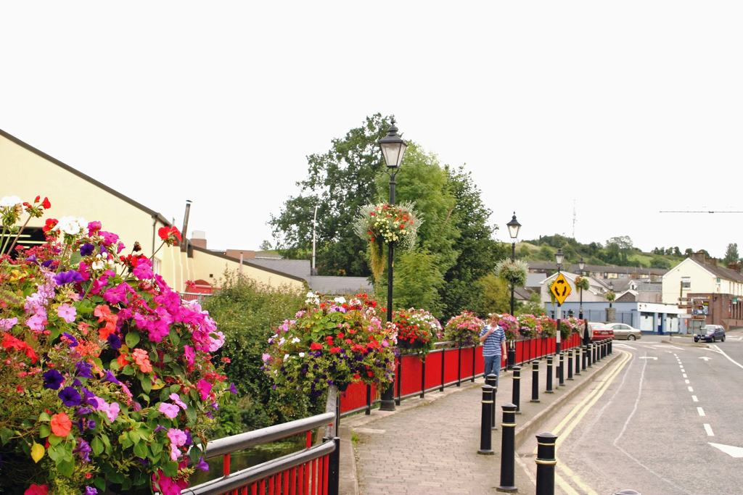
Do you think the policies are too lenient or onerous for the protection of these structures?
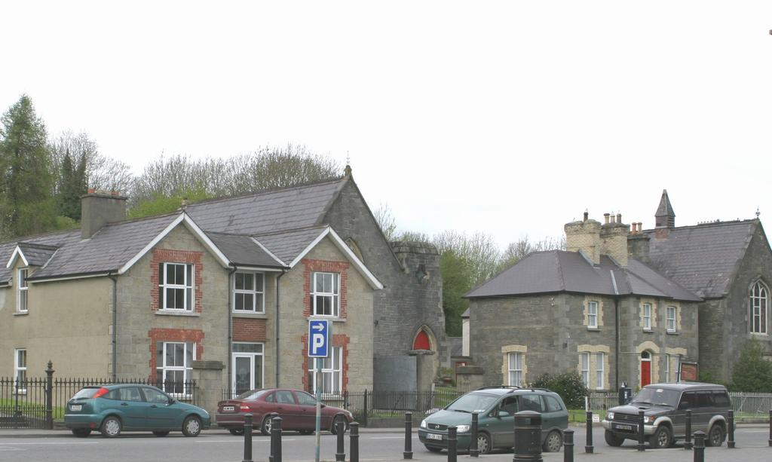

NATURAL HERITAGE
What do we mean by Natural Heritage? Our natural heritage includes the variety of life all around us and includes: flora, fauna, wildlife habitats, landscapes, seascapes, wrecks, geology, inland waterways, heritage gardens and parks.

What is Biodiversity? It is the biological diversity, which is the diversity of plants and animals (including: genetic diversity) and the habitats or landscape where they are found. Biodiversity plays a vital role in human health as we are dependent on the natural environment to provide us with the essentials of life, such as food, medicine, fresh water clean air, recycling of nutrients and places to visit to enhance our spiritual wellbeing.

County Cavan has a landscape filled with a rich and varied flora, fauna, wildlife habitats, heritage gardens, parks, inland waterways and a unique geological makeup. Our natural heritage is valuable for its social, educational and recreational benefit also as a major resource for the development of tourism and economic development, whilst contributing to the quality of life for the people of Cavan and visitors alike.

NATURAL HERITAGE
HAVE YOUR SAY!!
CONSIDER THE FOLLOWING QUESTIONS
How do we increase awareness, understanding and access to heritage in Cavan Town?
What benefits do you/your community experience from Heritage in Cavan Town? Are these measurable economically?
How do we improve the profile of Heritage in the county?
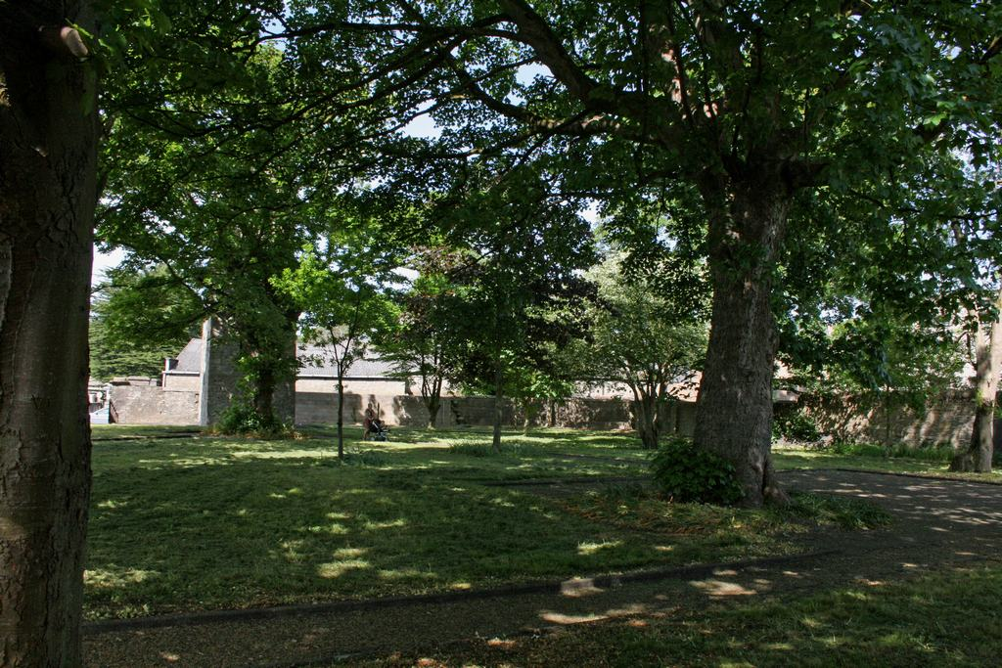
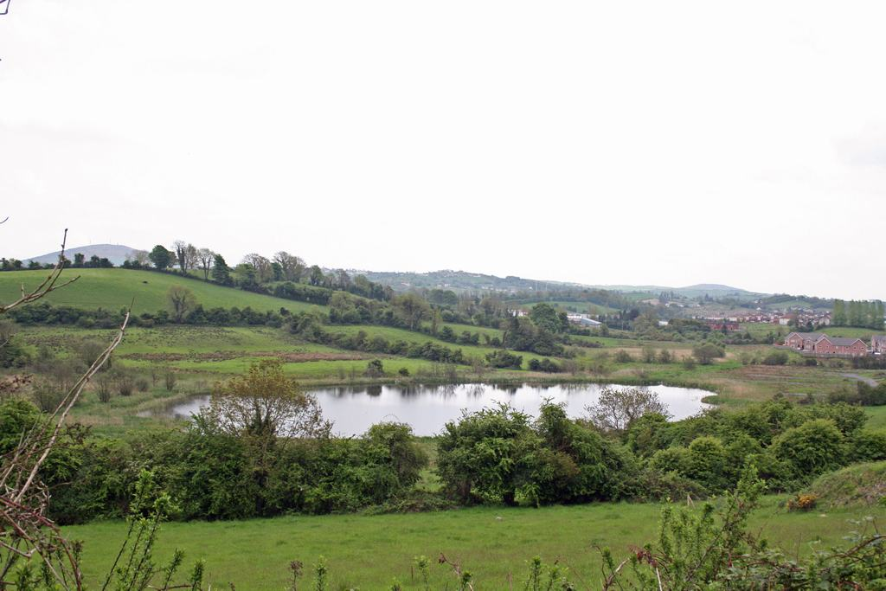
How do we respond to development pressures on our high amenity areas?

ENVIRONMENT

Habiats Directive: An Appropriate Assessment (AA) which is an assessment, based on best scientific knowledge, of the potential impacts of the Development Plan on the conservation objectives of any Natura 2000 site. Natura 2000 sites are Special Areas of Conservation (SAC’s) and Special Protection Areas (SPA’s) which are wildlife sites of European importance. The AA may include mitigation or avoidance measures to prevent negative effects on these Natura 2000 sites. Screening exercises during the preparation of the new plan will be carried out to determine the potential for impacts.

Strategic Environmental Assessment (SEA): The preparation of an SEA is a requirement under European Law, transposed into Irish Law, which measures the effects of proposals in the development plan on the environment. If significant impacts are identified the SEA will indicate what mitigation measures should be applied to the plan and how environmental issues can be monitored. An environmental report relating to the SEA will be made publicly available and comments invited on it at the same time as the Draft Development Plan.

Climate Change: This is an issue of significant local, national and international concern. At a national level, the Government has published ‘The National Climate Change Strategy 2007 – 2012’ which highlights the importance of climate change as an issue which must be addressed. One of the major impacts which the county faces will be potential increases in the frequency and severity of flooding. The EU Floods Directive and the ‘Planning System and Flood Risk Management Guidelines for Planning Authorities’. The development plan will seek to respond to these issues through suitable strategies and policies.

Water Framework Directive: The EU Water Framework Directive came into force in 2003 and apply to all water bodies, requiring us to manage our water systems and protect water quality. The main aim is to ensure that our; rives, lakes, esturaries, coastal waters and groundwater achieve ‘good ecological’ status by 2015. The Water Framework Directive in Ireland will be implemented through River Basin Districts and River Basin Management Plans. The Development Plan will seek to implement these plans.

ENVIRONMENT
HAVE YOUR SAY
PLEASE CONSIDER THE FOLLOWING QUESTIONS

What in your view, are the main environmental issues facing the County?
How can the Development Plan effectively address issues such as Climate Change?
How can the council manage pressure for development in areas at risk of flooding?
What are the issues in relation to drainage and flooding in your area?

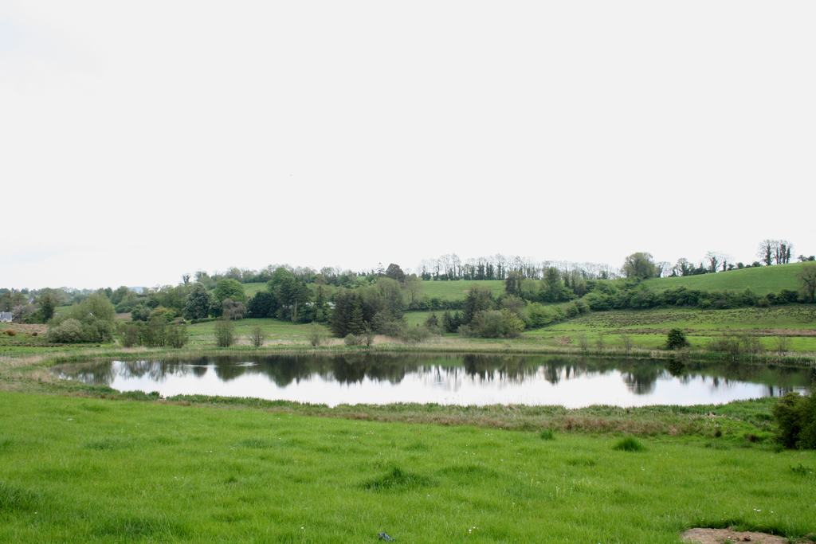

HAVING YOUR SAY
Review of the
CAVAN COUNTY DEVELOPMENT PLAN

HOW TO MAKE A SUBMISSION: Having Your Say - What Planning Issues Would You Like To Raise? It is important to have your input from the beginning so that we can make sure that the final Plan reflects your concerns and ideas, as well as Government strategies and guidelines. Submissions and observations should be made in writing and sent to one of the following by the 5th of December, 2012:

- By Post to: Forward Planning Section, Planning Department, Cavan County Council, Farnham Centre, Farnham Street, Cavan.
- By Email to: plan@cavancoco.ie

The Planning Authority will conduct a series of public consultation exercises in the form of public meetings, workshops, and consultations with individuals and groups. You can find more about the Development Plan and how it is progressing, at the following locations;
- Website at www.cavancoco.ie.
- Our Facebook pages: www.facebook.com/cavancoco & www.facebook.com/CavanCountyDevelopmentPlan
- Twitter: twitter.com/cavancoco

The dates, times and venues for the initial stage of public consultation are detailed in the table below:

Venue | Date | Time | Location
Cavan County Library: Events space | Tuesday, 6th November | 18:00 – 20:00 | Cavan Town
County Museum: Meeting room | Wednesday, 7th November | 18:00 – 20:00 | Ballyjamesduff
Ballyconnell,The Courthouse | Wednesday, 14th November | 18:00 – 20:00 | Ballyconnell
Bailieborough Library | Tuesday, 20th November | 18:00 – 20:00 | Bailieborough

