CAVAN TOWN & ENVIRONS 2020
INTEGRATED FRAMEWORK PLAN
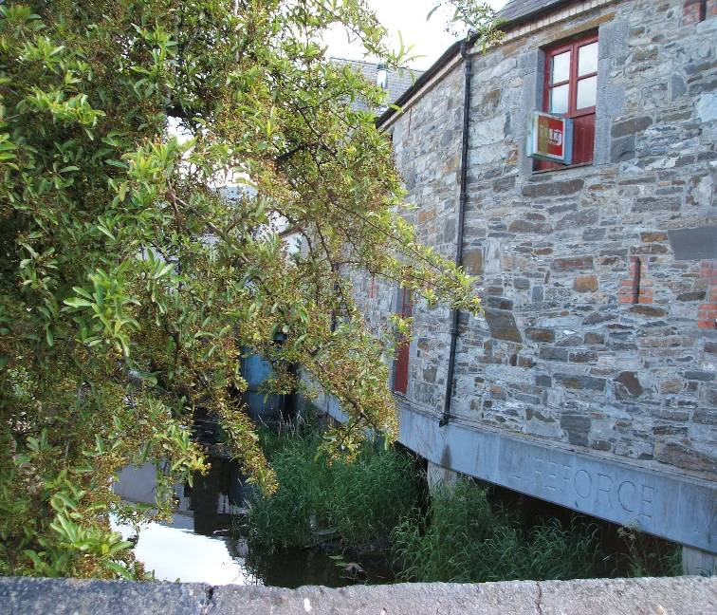

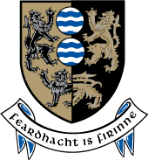

Planning Department
Cavan County Council
July 2007
ACKNOWLEDGEMENTS

This document was prepared under the direction of Seamus Neely, Director of Services, Planning, Roads & Economic Development by the following staff:

Tara Spain Senior Planner,
Marice Galligan-Graham A/Senior Planner,
Angela McEvoy Senior Executive Planner,
Brian Allen Senior Executive Technician,
Ann Marie Ward Heritage Officer,
Paula Comiskey Assistant Planner,
Teresa O’Reilly Assistant Planner.

Additional inputs from:
Members of Cavan Town Council and Cavan County Council, Ger Finn Director Of Services Corporate Services and Infrastructure, Frank Gibbons Director of Services Environment, Joe McLoughlin Director Of Services Community and Enterprise, Kevin Reilly S.E.O, Pauline Mc Kiernan S.S.O., Rhonda Tidy Arts Office, Kevin Smith Executive Engineer, Liam Henry Senior Engineer, Peadar Lafferty Senior Engineer, Aine McKiernan A/Senior Executive Engineer and Peter Gallagher Senior Engineer.

TABLE OF CONTENTS

LIST OF FIGURES 6

LIST OF TABLES 6

EXECUTIVE SUMMARY 7

PART ONE - INTRODUCTION 1
1.1 Purpose of the Report 1
1.2 Background 2
1.4 Report Structure 4
1.5 Consultation 4
1.5.1 Public Consultation 4
1.5.3 Recommendations from Public Consultation 5

PART TWO - POLICY CONTEXT 7
2.1 Policy Framework 7
2.2 National and Regional Level 7
2.2.1 National Spatial Strategy 7
2.2.2 National Development Plan 2007 – 2013 7
2.2.3 Sustainable Development – A Strategy for Ireland 8
2.2.4 National Anti-Poverty Strategy (NAPS) 9
2.2.5 Transport 21 9
2.2.6 Residential Density: Guidelines for Planning Authorities 9
2.2.3 National Climate Change Strategy 2007 – 2013 10
2.2.7 Retail Planning Guidelines (2005) 10
2.2.8 Sustainable Rural Housing Guidelines (2005) 11
2.2.9 Regional Planning Guidelines for the Border Area (2004) 12
2.2.10 Other Relevant Guidelines 13
2.3 Local Level 14
2.3.1 County Strategy 14
2.3.2 Cavan County Development Plan 2003-2009 14
2.3.3 The Cavan Town Development Plan 2003 - 2009 and Cavan Town and Environs Development Plan 2003 – 2009 and Variation No. 1 (2007) to the Cavan Town and Environs Development Plans 15
2.3.4 Retail Strategy for Cavan Town (CAAS 2002) 16
2.4 Key Policy Implications for Cavan 16

PART THREE - PRESENT SITUATION 19
3.1 Overview 19
3.1.1 The Study Area 19
3.1.2 Cavan Town and Environs Basic population & housing statistics 19
3.2 Population 22
3.2.1 Census of Population 22
3.2.2 Long Term Population Projections 22
3.3 Employment & Enterprise 23
3.3.1 Labour Force and Economic Status 23
3.3.2 Basics 23
3.3.3 Socio-Economic Groups 24
3.3.4 Sectoral Employment 25
3.3.5 Qualifications 26
3.3.6 Manufacturing Industry 28
3.3.7 Cavan’s Industrial Output 29
3.3.8 Industrial Output: A Comparison 30
3.3.9 Gross Value Added Per Person 31
3.3.10 Enterprise 32
3.3.11 Summary 33
3.4 Town Centre 34
3.4.1 Architectural Key Sites 35
3.4.2 Civic Spaces 35
3.4.3 Town Renewal Scheme 36
3.4.4 Quality of the Built Environment 39
3.4.5 Retail Activity 39
3.4.6 Spatial Context of Retailing 40
3.5 Transportation 41
3.6 Heritage & Conservation 42
3.6.1 Natural Heritage 42
3.6.2 Archaeological Heritage 43
3.6.3 Built Heritage 43
3.7 Community Facilities & Education 43
3.7.1 Community Issues 43
3.7.2 Education 45
3.8 Culture & Recreation 48
3.8.1 Arts 48
3.9 Infrastructure & Utilities 50
3.9.3 Waste Management 50
3.9.4 Development Contributions Scheme 51
3.10 Current Development Issues 51

PART FOUR - FRAMEWORK VISION, OBJECTIVES AND GUIDING PRINCIPLES 53
4.1 Vision 53
4.2 Objectives 53
4.3 Sustainability Objectives 54
4.4 Common Targets 55

PART FIVE - FUTURE ALTERNATIVE SCENARIOS 57
5.1 Scenarios 57
1. Unrestrained: 57
2. Suburbanise (satellites towns/villages) 57
3. Town centre consolidation 57
4. Town centre expansion and future developments areas: 57
5.2 Assessment 58
5.3 Commentary 59

PART SIX - PREFERRED FRAMEWORK 63
6.1 Introduction 63
6.2 Cavan Town Centre 63
6.3 Employment and Enterprise 66
6.5 Residential Areas 70
6.6 Arts & Culture 73
6.7 Heritage 74
6.8 Open Space & Recreation 76
6.9 Utilities Infrastructure 78
6.10 Education and Community Facilities 80
6.11 Sustainable Travel 82
6.12 Environmental Issues 83
6.12.1 Protection of Natural Resources 83
6.12.2 Natural Ecosystems 83
6.12.3 Water Quality 84
6.12.4 Waste Management 84
6.12.5 Energy Efficiency 84
6.12.6 Integration of Land Use and Transportation 84
6.12.7 Eco-Efficiency 85
6.12.8 Encouraging Indigenous Business 85
6.12.9 Quality of Built Space 85
6.12.10 Open Space Provision 85
6.12.11 Urban Renewal 85

PART SEVEN - IMPLEMENTATION 87
7.1 Monitoring 88

LIST OF FIGURES

Figure 1: National Spatial Strategy – Border Region 12
Figure 2: Study Area (Cavan Town & Environs) 20
Figure 3: Composite Landuse Map 21
Figure 4: Percentage per Employment Sector 24
Figure 5: Sectoral Employment 25
Figure 6: Percentage of Workforce & Education Status Attained 2002 27
Figure 7: Qualifications by Type (2002) 27
Figure 8: Industrial Output 1991 - 2002 30
Figure 9: Architectural Key Sites 37
Figure 10: Civic Spaces 38
Figure 11: Alternative Scenarios for Cavan Town & 57
Figure 12: Cavan Town – Preferred Framework 60
Figure 13: Employment/ Enterprise 66
Figure 14: Residential/ Community Areas 70
Figure 15: Recreation/ Community 76

LIST OF TABLES

Table 1: Existing & Estimated Population Growth in Cavan Town & Hub, 1996-2016 3
Table 2: Census of Population 22
Table 3: Possible Population Estimates based on the amount of undeveloped land in each town 22
Table 4: Housing Units Committed in Environs and Town Core Area 23
Table 5: Classification of Employment Sectors 24
Table 6: Persons aged 15 years and over at work classified by broad industrial group 26
Table 7: Third Level Qualifications 26
Table 8: Occupational Groups of Employees within Local Industrial Units (Cavan) * 28
Table 9: Industrial Local Units – Details of Activity in Cavan 29
Table 10: Statistics for a Range of Counties and the State - 2002 31
Table 11: Gross Value Added (GVA) per person (1996 – 2001) at basic prices indices (state = 100) 31
Table 12: Total Permanent Employment by Sector & Grant Approvals in County Cavan 32
Table 13: Tidy Towns Performance (Cavan Town) 39
Table 14: Bus Service 41
Table 15: Primary Schools with Classification & Pupil Numbers 46
Table 16: Post- Primary Schools with Classification & Pupil Numbers 46
Table 17: Scenarios for Cavan Town & Environs 59

EXECUTIVE SUMMARY

The purpose of the Integrated Framework Plan is to provide a broad vision for the future development of Cavan Town and Environs. The plan establishes a framework that:
- integrates existing and future land uses, including housing, shopping, employment activities and amenities;
- incorporates the principles of sustainability;
- invigorates the town centre;
- provides the basis for the close integration of development with sustainable transportation modes: walking, cycling and public transport; and
- places a strong emphasis on quality of life issues.

A detailed Transportation Study has been developed in tandem with the Integrated Framework Plan (IFP). Despite been separate both documents are symbiotic and interdependent. The IFP takes a medium to longer-term view, up to 2020. The plan is not intended to be a detailed ‘masterplan’ and will be implemented through the Review of the Development Plans for Cavan and its Environs (including Variation No. 1 (2007) to the Cavan Town and Environs Development Plans), and where appropriate through area masterplans, development briefs, and through actions and measures for the improvement of transportation and the further development of infrastructure and amenities. Particular regard has been given to the designation of Cavan as a ‘Hub’ Town by the National Spatial Strategy and Regional Planning Guidelines for the Border Area.

The third component of the Integrated Framework Plan is the Urban Design Framework which examines the built form, open space and urban regeneration and is committed to:
- facilitating an urban design culture that demonstrates civic vision and looks to the future whilst acknowledging the culture, history, arts and sporting traditions of the Town.
- the creation of a well defined urban form with a strong sense of place, flexible and adaptable built forms and strong pedestrian and vehicular connectivity through the town.
- facilitating the enhancement and linkage of open spaces within the town and the re-activation of the 19th century laneway network through imaginative design-led regeneration.

Variation No.1 (2007) to the Cavan Town and Environs Development Plans 2003-2009 is a statutory document under the Planning and Development Act 2000 (as amended). It was adopted on the 9th July, 2007 by Cavan County Council and Cavan Town Council and incorporates:
- Cavan Town and Environs Integrated Framework Plan 2020
- Cavan Town and Environs Integrated Framework Plan 2020: Transportation Study
- Cavan: Urban Design Framework

The Cavan Town and Environs Integrated Framework Plan 2020, Transportation Study and Urban Design Framework are non-statutory documents which provide a guiding principle for the long term development of Cavan Town and Environs over the period 2007-2020. Subsequent statutory Development Plans within this period will also adopt the principles in these documents. It should be noted that specific details in the Transportation Study are subject to further public consultation with relevant stakeholders in order to reach reasonable working agreements. The Urban Design Framework is also adopted by the Planning Authority and the concepts of the document should be incorporated into future development proposals for the Cavan Town area.

Current Development Issues

Issues have been identified during the preparation of the plan inevitably have become increasingly important in the future development and growth of Cavan. The current issues facing Cavan town identify the need to:

- build a sustainable approach to future planning of the Town;
- improve and expand the town centre with high quality urban design culture which complements the town;
- create defined town boundaries;
- provide a co-ordinated and an efficient housing framework which allows for affordability and choice;
- develop a strong and diverse enterprise and employment sector;
- provide access to recreational amenities: natural and man-made;
- protect natural and built heritage;
- develop a legible and efficient transport network with integration with land-uses; and

- co-ordinate and deliver on infrastructure.

The solution to these issues will enhance the integrity and cohesiveness of Cavan Town, allowing it to become an even more attractive town in which to live, work and recreate.

Vision

The vision for the Integrated Framework Plan for Cavan is to provide the framework for a unique and sustainable town, with a balanced range of functions, facilities and amenities, building on its present strengths of its people, enterprise and natural assets while meeting the needs of the whole community who live work and visit the area.

Objectives

The primary objectives of the Integrated Framework Plan are based on the principles of sustainable development and are:

- To promote and encourage the development and growth of Cavan in line with the principles of sustainable development;
- To facilitate the provision of infrastructure to cater for economic development and employment expansion;
- To promote an appropriate balance of employment, residential and service facilities (schools, shopping, community facilities etc) and land uses that will increase the self-sufficiency of the town and support its role as a key part of a designated ‘Hub’ in the ‘National Spatial Strategy’;
- To focus new employment and enterprise to locations that reduces the demand for travel and be appropriate in density and type of activity to its location;
- To encourage and promote diversity and quality in new residential developments at higher densities appropriate to their location within the town and relative to sustainable transport modes;
- To support and facilitating tourism development in the town and county;
- To facilitate the expansion of recreational/leisure facilities;
- To respect our natural and built heritage;
- To improve access to cultural and arts activities;

- To incorporate new civic, commercial, shopping, cultural and community facilities within an expanded town centre;
- To facilitate the sustainable economic and social development of the town, through the promotion of a positive climate for development initiative within the plan area;
- To consider provision of a transportation and landuse structure that will provide the orderly planning and development of the town and accommodate sustainable urban growth;
- To make arts, culture and civic vision a key consideration in the design of urban space and policy development;
- To make arts and cultural activities more accessible through the development of an urban cultural environment by creating an overall vision for the Arts in the design of public spaces;
- To preserve, strengthen and develop vibrant communities;
- To promote well-located local centres, containing sufficient commercial, community and educational facilities, integrated with and supporting new and existing residential development and sustainable transport;
- To support the provision of community infrastructure including an emphasis on socially excluded groups.

Alternative Scenarios

Four alternative development scenarios for the future of Cavan were developed and assessed during the course of the study.

The Scenarios are:
  - Unrestrained;
  - Suburbanise(satellites villages);
  - Town centre consolidation;
  - Town centre expansion and future developments areas.

It is recommended that the preferred framework for future land use and transportation in Cavan in the medium to longer term be based on a combination of Scenarios 3 and 4. That is town centre consolidation, expansion and the co-ordinated development of existing and future residential areas.

Actions to be Undertaken

- Review current Development Plans;
- Review Housing Strategy;
- Review Retail Strategy;
- Review Current Development Contributions Scheme;
- Seek to expand the Town Boundary to reflect Cavan Town’s status, spatial and
socio-economic context;
- Development programme and implement Transport Study;
- Prove framework for future plan and strategies for Cavan Town.

Figure A - Cavan Town – Preferred Framework
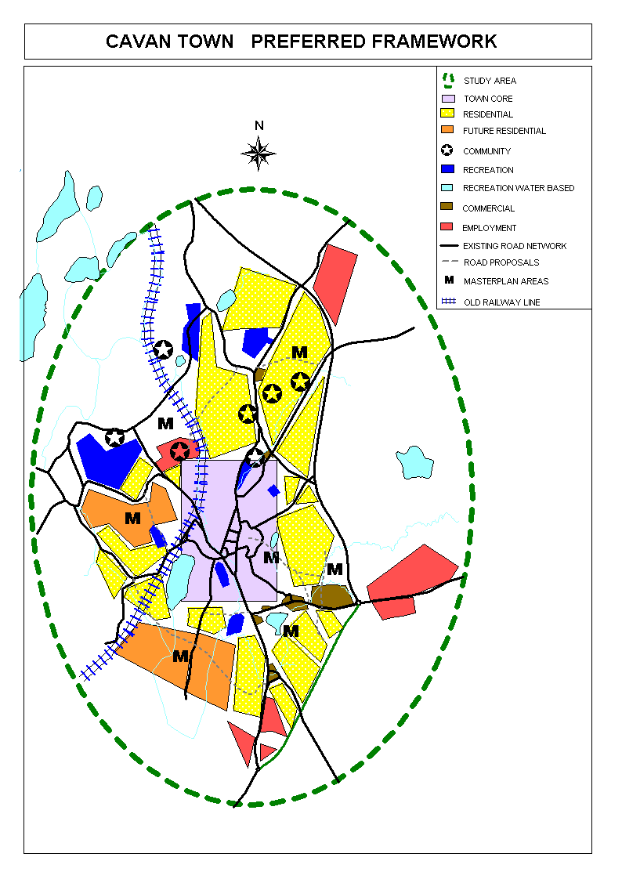

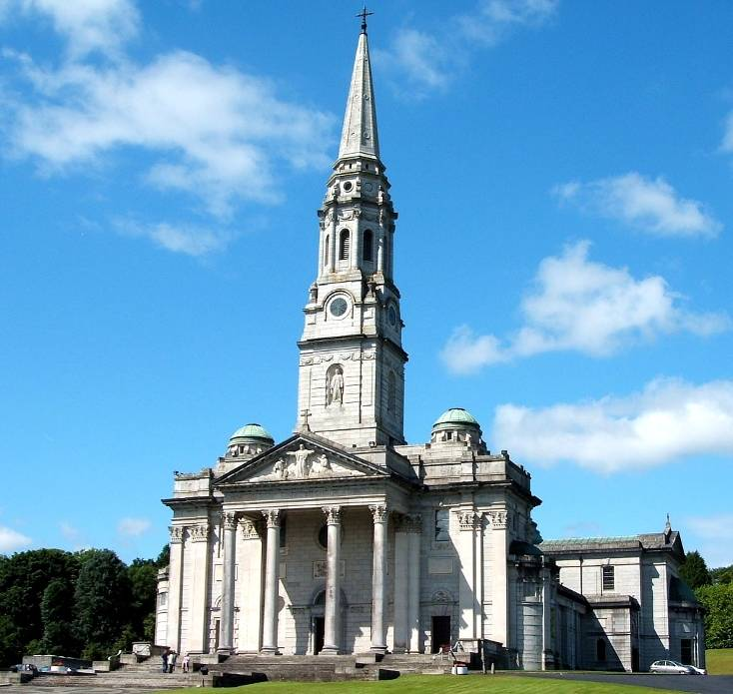
PART ONE
INTRODUCTION

PART ONE - INTRODUCTION

1.1 Purpose of the Report

The purpose of the Cavan Town and Environs Integrated Development Framework is to provide a broad vision for the future development of Cavan. The plan establishes a framework that:

- integrates existing and future land uses, including housing, shopping, employment activities and amenities;
- incorporates the principles of sustainability;
- invigorates the town centre;
- provides the basis for the close integration of development with sustainable transportation modes: walking, cycling and public transport; and
- places a strong emphasis on quality of life issues.

The plan takes a medium to longer-term view, up to 2020. A detailed transportation strategy has been developed in tandem with the Integrated Framework Plan which details the existing transportation framework under separate cover. The plan is not intended to be a detailed ‘masterplan’ and will be implemented through the review of the Development Plans for Cavan and its Environs (including Variation No. 1 (2007) to the Cavan Town and Environs Development Plans), and where appropriate through area masterplans, development briefs, and through actions and measures for the improvement of transportation and the further development of infrastructure and amenities. Particular regard has been given to the designation of Cavan as a Hub town by the NSS and Regional Planning Guidelines for the Border Area.

The third component of the Integrated Framework Plan is the Urban Design Framework which examines the built form, open space and urban regeneration and is committed to:
- Facilitating an urban design culture that demonstrates civic vision and looks to the future whilst acknowledging the culture, history, arts and sporting traditions of the Town;
- The creation of a well defined urban form with a strong sense of place, flexible and adaptable built forms and strong pedestrian and vehicular connectivity through the town;
- Facilitating the enhancement and linkage of open spaces within the town and the re-activation of the 19th century laneway network through imaginative design-led regeneration;

The Development Plans adopt the principle of the Urban Design Framework and the details in the document should be incorporated into future development proposals.

To achieve the target population of 16,000 as set by the Regional Planning Guidelines and the NSS, the needs of this new community require a refined planning strategy for balanced future development of the town. The Town and Environs Development Plans have been refined by Variation No.1 (2007) and have been subject to public consultation along with the Cavan Town and Environs Integrated Framework Plan 2020, Transportation Study and Urban Design Framework.

The vision promoted in the plan is of a framework for a unique sustainable and efficient town, with a balanced range of functions, facilities and amenities, building on its present strengths of its people, enterprise and natural assets while meeting the needs of the whole community, who live in Cavan, work in or visit the area.

The Framework Plan therefore establishes a renewed vision for Cavan, combining the best of the past and present with an exciting way forward and ensuring that future development is sustainable and integrated, leading to a better quality of life for all who live, work in and visit the town.

The Framework establishes integrated land use, transportation and urban design and provides guidance for the Review of the statutory Development Plans of Cavan’s Local Authorities. The Transportation Study makes recommendations for future transportation infrastructure to serve the town and the Urban Design Framework provides a vision for a cohesive vibrant town.

The approach taken will promote sustainability by the minimisation of travel, fewer atmospheric emissions, greater fuel efficiency and a safer living environment for residents. It also accords with the National Spatial Strategy and the Regional Planning Guidelines for the Border Area. An extensive consultation process with elected representatives, stakeholders and the public was undertaken as part of the preparation of the Framework Plan and this provided valuable information and viewpoints that informed the direction of the preferred framework.

1.2 Background

Cavan Town is located centrally within County Cavan, at the junction of the N3 and N55 National Primary Routes. The County is located in the north midlands of the State, bound by the Counties of Fermanagh, Monaghan, Meath, Westmeath, Leitrim and Longford. Cavan is the County Town and the principal administrative centre of Cavan. The development of Cavan Town over recent decades has been primarily concentrated to the east of the town, influenced, at least in part, by proximity to the N3 and the nature of the topography.

The town developed in the valley where the main roads from Dublin to Donegal (N3) and Longford to Dundalk (N55) converged. The town is now being by-passed by the N3 and N55, but will still have significant through traffic. The town centre thus remains heavily congested because of the central spine structure of the town and the absence of an internal relief road system.

The character of the Cavan Town can be defined by its lakes skyline of spires, hills and trees and its greatest asset its people. In enterprise, it is the dominant town in the County and has a large sphere of influence over an extensive rural area. As a result of its dominance within the County, Cavan Town has a wide, predominantly rural hinterland. This is reflected in the IDA estimate that some 175,000 people live within a radius of 25 miles of the town.

The Cavan Hub area has experienced population growth at a rate significantly higher than County-wide growth as demonstrated in table 1. Recent assessment of “live planning permissions” indicates that this population growth will continue with an estimated population of circa 14,000 by 2011.

Housing development in Cavan, in common with many other Irish towns has been at relatively low densities. Over the past 30 years, the town has expanded in a series of layers predominantly to the north-east of the centre. Substantial areas of land close to the town centre remain undeveloped, and these now provide an alternative to development at the periphery of the town.

Table 1: Existing & Estimated Population Growth in Cavan Town & Hub, 1996-2016
 | 2002  Population | 2006 Population | % Change-2002 -2006 | NSS Targets 2020
Cavan Town | 3,538 | 3,934 | 11.2% | 6000
Cavan Town & Environs (Hub) | 6,098 | 7,883 | 29.3% | 16,000
County Cavan | 56,546 | 64,003 | 13.2
Source: CSO (2006)

Major infrastructural improvements are evident such as the ongoing construction of N3/N55 link, pedestrian footpaths improvements, provision of MANS (Metropolitan Area Network) broadband and facilitation of a significant amount of environmental enhancements. Cavan will be one of the best bypassed towns in the country (N3 and N55), and consequently most traffic in the town will be locally generated or arises from activities in the town.

It is apparent that Cavan Town is a thriving town that serves a wide catchment area that extends outside the County of Cavan. Newer industrial and office activities have developed over the past 15 years, mainly in the Killygarry area and the town centre area. The retail sector is strong with the major chains of Dunnes Stores and Tesco located in the town centre. Supervalu and Lidl are located in strategic retail nodes. There is a continuing demand for retail units in the town and, in particular in the central core areas, competition for outlet space is healthy.

In overall terms, Cavan is well served for good accessibility to lakes, hills, mountains and other amenities. Sports and recreational activities are located throughout the town with the major assets of Breffni and Terry Coyle Parks close to the centre. Public sports facilities are provided in the Sports Complex in the north eastern residential area. These assets have enhanced the quality of life of the Town’s citizens through the generation of increased economic and social activity which enhances the prospects of greater self-sustainability and deliver intrinsically the policies and objectives indicated in the plan.

Most new industrial and commercial developments in Cavan are located on the outskirts of the town and rely almost entirely on car usage for accessibility. This is likely to be the case for some time and presents challenges in relation to providing access by walking, cycling and public transport. At present, traffic in Cavan is problematical, especially at some key junctions in peak periods.

Cavan currently lacks intra-county public transport links and recreational parks commensurate with its size and ecological potential, which would serve as an additional major recreational and tourism focus point. In addition, the town lacks a definite boundary to the west to separate the development area from sensitive and important landscapes.

1.3 Brief

The framework plan was prepared using the following steps and the objectives of the report are:

- To collate relevant data on land use and transportation in and about Cavan and, where appropriate, to undertake surveys to obtain additional information;
- To consult with a wide range of stakeholders;
- To consider and assess alternative development scenarios for the future;
- To make recommendations for a preferred land use and transportation scenario;
- To examine the built form, open space and urban regeneration opportunities of Cavan Town and make recommendations in terms of urban design potential;
- To promote the principles and practice of proper planning and sustainable development and to demonstrate how these principles and practices can be applied in Cavan;
- To set out the proposed phasing for implementing the preferred strategy, and provide outline costing of the main elements;
- To provide the basis for the variation of the Cavan Town and Cavan County Development Plans as well the framework for future Development Plans.

1.4 Report Structure

The report follows the following structure:

- Section 1: Parts 1 to 3 develop the principle and background information which guides the Framework;
- Section 2: Parts 4 and 5 establishes the vision and strategic objectives and assesses scenarios;
- Section 3: Parts 6 to 7 presents the preferred framework within which Cavan and its environs should develop.

1.5 Consultation

Within the framework established by the National Spatial Strategy (2002) and Regional Planning Guidelines for the Border Region (2004), an exercise was undertaken to ascertain and develop a vision for Cavan Town & Environs up to 2020. The development of an agreed vision and goal for the Town by the executive, members of the County & Town Councils and the public is an integral theme to future policy development.

1.5.1 Public Consultation

Three periods of public consultation where held, the initial phase was held from the 9th of March – 6th April 2005, the second was held from 5th October – 2nd November 2006 and the third from 24th May – 25th June, 2007.
The consultation process comprised four elements:
- Press advertising: newspaper advertisements inviting written submissions;
- Direct Marketing: letters to and contact with prescribed bodies, service providers and others;
- Website: advertisements inviting written submissions;

- Meetings: public meeting, and special members meeting.

The opinions, views and ideas set out in the five written submissions received during the first phase, the three received during the second phase and the three received during the third phase along with those expressed and recorded at the consultation meetings (22nd March, 2005, 12th June, 2007, 20th June, 2007) related to all aspects of the future of Cavan Town and Environs. The Council wishes to express its appreciation to those that made submissions and/or attended the meetings.

A wide range of topics and concerns were raised at the meetings. Ideas and opinions expressed can be viewed as representing what is perceived as the important planning issues in the Town and what the Integrated Framework Plan should address. The main issues related to: the town centre, recreational and amenity facilities, image and perception of the town, the further nurturing of enterprise, and the provision of infrastructure. Other issues included the use of the Irish language, control of sprawl and the need to have a mix of tenures. All these issues were considered during the drafting of the Integrated Framework Plan.

1.5.3 Recommendations from Public Consultation

The issues raised informed the preparation of the Integrated Framework Plan.

The outcome of the meetings and the written submissions crystallized at a practical level the focus of the Integrated Framework Plan for Cavan Town and Environs should be:

- building a sustainable approach to future planning of the Town;
- on the improving and expanding the town centre with high quality urban design;
- the integration of landuse and transportation proposals;
- nurturing and supporting of enterprise;
- providing access for all to amenities (services and natural);
- protection of natural and built heritage; and
- ensuring affordability and choice in housing.

However the reoccurring themes to drive the vision of the Integrated Framework Plan for Cavan Town and Environs are:

- Being Strategic;
- Being Ambitious;
- Providing outstanding quality of life for citizens;
- Creating a 21st Century Town based on current strengths of people, enterprise and natural amenities.

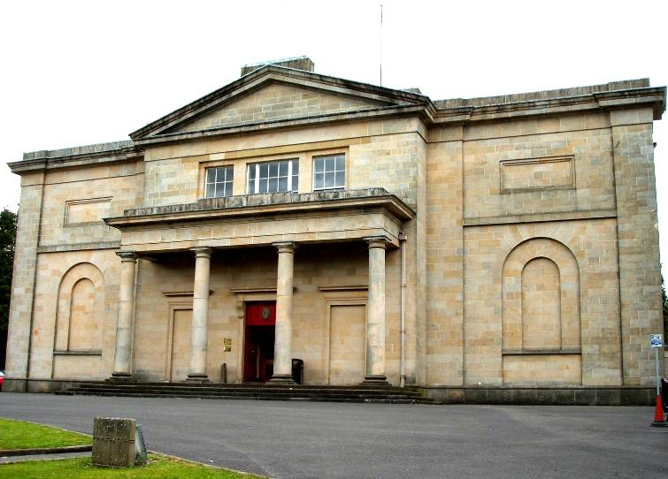
PART TWO
POLICY CONTEXT

PART TWO - POLICY CONTEXT

2.1 Policy Framework

An extensive policy framework, at national, regional, county and local level, informs the formulation of the Integrated Framework Plan for Cavan. The framework, embraces objectives, principles, strategies, policies and actions that have a bearing on the future direction of land use, transportation and urban design in Cavan. The following highlights the relevant documents, plans and strategies which influence the plan.

2.2 National and Regional Level

2.2.1 National Spatial Strategy

The National Spatial Strategy published in November 2002 is an eighteen year planning framework designed to achieve a better balance of social, economic, physical development and population growth between regions. Its focus is on people, on places and on building communities.

The hubs chosen for the National Spatial Strategy need to aim to develop the following characteristics:

- A significant urban population in the range of 20,000 – 40,000 set in an associated rural hinterland;
- Primary and secondary education facilities with the option of third level or outreach facilities;
- A mix of local, medium sized and larger businesses serving local, regional and national/international markets;
- An important local node in transportation and communication terms:
- on the national road and rail or bus networks
- with access to a national or regional airport
- having adequate, reliable, cost effective and efficient access to port facilities
- with effective and competitive broadband access;
- Effective local transport system with facilities for pedestrians and cyclists;
- Local and/or regional hospital;
- Wide range of amenity, sporting and cultural facilities including public spaces and parks;
- Effective water services and waste management arrangements;
- Strategies for physical, social and economic development;
- Phased zoning and servicing of land - banks in anticipation of needs associated with growth;
- Industrial and local business parks.

2.2.2 National Development Plan 2007 – 2013

The National Development Plan (NDP) involves an investment of €184 billion over its intended life, into its priorities of economic infrastructure, enterprise, science and innovation, human capital, social infrastructure and social inclusion. The NDP aims to tackle economic and social infrastructure deficits in areas such as transport, energy, housing, water, education and health.

County Cavan lies in the Border area which is part of the Border-Midland-Western (BMW) region for E.U. Structural Fund purposes. The NDP integrates strategic development frameworks for regional development, for rural communities, for all-island co-operation, and for protection of the environment with common economic and social goals.

The investment framework and strategy of the NDP will promote the development of all regions in Ireland in line with the National Spatial Strategy (NSS). It will assist and enhance physical and spatial planning, with the development of Gateways, Hubs and county towns and provide support for the rural economy.

The NDP identifies recent population trends and projections which suggest that:

The population of Ireland will continue to grow substantially;
- The population levels of all the regions will increase;
- Regions containing large urban centres with a relatively high percentage of the region’s population are performing comparatively better economically;
- Regions with comparatively weaker urban structures will need an enhanced level of critical mass to drive development; and
- The urban-based Gateways are growing at different rates.

The Hubs (identified in the NSS) provide important regional bases for foreign direct investment projects, indigenous industrial and service activity and the provision of essential local facilities and amenities in areas such as public services, education and healthcare. Many of the Hubs (such as Cavan Town) are located on key transport corridors and will benefit from ongoing investments under the NDP and Transport 21. Good local planning added to urban renewal initiatives have transformed the central areas of many Hubs, encouraging significant and subsequent private investment in retailing and commercial activities.

2.2.3 Sustainable Development – A Strategy for Ireland

"Sustainable Development - A Strategy for Ireland" was published in 1997 by the Department of the Environment. The Strategy recognises the need for good spatial planning and the inclusion of sustainability concerns in urban and built environment policies. The Strategy recognises that the pattern and density of urban development has a major influence on travel patterns.

The Strategy promotes a range of sustainable development principles. These state that new development should be located close to settlement centres, public transport nodes and access points so as to achieve greater levels of social integration. The Strategy encourages patterns of economic growth that can be achieved with maximum transport efficiency and the least possible environmental impact, so that economic growth does not generate unlimited growth in demand for transport.

The Strategy encourages high movement activities to locate in areas of maximum accessibility to public transport so as to reduce growth in transport demand. This should be addressed in studies such as the IFP. As a general principle, the minimisation of potential growth in transport demand will be incorporated as a leading consideration in land use planning. The Strategy also aims to ensure a clear demarcation between urban and rural land use, to help prevent urban sprawl and to encourage more sustainable development patterns in settlements.

2.2.4 National Anti-Poverty Strategy (NAPS)

The National Anti-Poverty Strategy (NAPS) is the government strategic initiative to place the needs of the poor and the socially excluded at the top of the national policy agenda. The NAPS recognises the unacceptable scale of poverty and its impact on those directly affected and on the wider society and it particularly notes the distinct spatial aspects of poverty in urban and rural areas. The strategy emphasises the importance of a cross-departmental policy response in dealing with the problem.

The NAPS identifies a number of policy actions that relate to planning and development issues: These are:

- comprehensive (social and physical) regeneration of run-down urban areas;
- provision and effective management of social housing;
- promotion of local development in designated areas of disadvantage;
- involvement of communities in local planning and decision-making;
- provision of youth and recreational facilities in areas of high drug use;
- improved delivery of public services in disadvantaged urban and rural areas.

2.2.5 Transport 21

Transport 21 is a strategy which will see €34.4 billion invested in Irish transport up to 2015. Connecting communities and promoting prosperity is the core aim of this strategy. The programme seeks to meet the transport needs of the country’s citizens and also underpin our competitiveness into the future. A comprehensive and efficient transport network is essential if we are to continue to improve our living standards while remaining competitive in the global market place. Transport 21 recognises that quality, integrated transport is critical for competitiveness, return on investment and regional development.

2.2.6 Residential Density: Guidelines for Planning Authorities

These Guidelines published in 1999 are aimed at addressing the high levels of suburban housing development at low densities on Greenfield sites over the last few decades. This has led to an increase in the demand for travel, greater traffic congestion and high infrastructure costs. The Guidelines address the following:

- Making more economic use of existing infrastructure and serviced land;
- Reducing the need for the development of Greenfield sites, urban sprawl and ribbon development;
- Reducing the need for investment in new infrastructure;
- Creating better access to existing services and facilities; and
- Creating more sustainable commuting patterns.

The Guidelines recognise that higher densities should not be achieved at an unacceptable amenity cost to the surrounding dwellings and the residents of the proposed development. A high quality of design and layout and a good quality living environment, including the availability of adequate shopping, social, transport and leisure infrastructure, are essential if increased residential densities are to be acceptable.

2.2.3 National Climate Change Strategy 2007 – 2013
Under the Kyoto Protocol Ireland agreed to a target of limiting its greenhouse gas emissions to 13% above 1990 levels by the first commitment period 2008-2012 as part of its contribution to the overall EU target. Ireland ratified the Kyoto Protocol on the 31 May 2002, along with the EU and all other Member States, and is internationally legally bound to meet the challenging greenhouse gas emissions reduction target. To ensure Ireland reaches its target under the Kyoto Protocol and, building on measures put in place following the publication of the first National Climate Change Strategy in 2000, the Government has published a new National Climate Change Strategy 2007-2012:

“Local authorities can have a significant influence over emissions in their local areas, both directly in relation to reducing emissions through their own energy use and procurement activities, in raising awareness and stimulating action in local communities, and indirectly through the exercise of their housing, planning and other statutory functions. The Government has made a commitment that all street lighting and traffic lighting, an area that falls under local authority control, should be energy efficient.”

2.2.7 Retail Planning Guidelines (2005)

The Retail Planning Guidelines provide a comprehensive framework to guide local authorities in preparing development plans, assessing applications for planning permission, and guide retailers and developers in formulating development proposals. The revised Retail Planning Guidelines contain policies regarding large retail warehouses. Retail functions reflect four broad tiers of urban development. The classification is indicative and the specific retail functions provided by each tier overlap in many respects. Cavan Town is defined in the third tier of towns. Third tier centres are described as providing urban anchors for a rural economy which is undergoing rapid change.

The Guidelines challenge is how to accommodate the additional retail development required in a way which is efficient, equitable and sustainable with the optimum location which is accessible to all sections of society and is of a scale which allows the continued prosperity of traditional town centres and existing retail centres. This can only be achieved if strategic retail policies and proposals are incorporated in the development plan system.

These Guidelines identify five key objectives which have equal weight:

  - To ensure that in future all development plans incorporate clear policies and proposals for retail development;
  - To facilitate a competitive and healthy environment for the retail industry of the future;
  - To promote forms of development which are easily accessible and encourage multi-purpose shopping, business and leisure trips on the same journey;
  - To support the continuing role of town and district centres. The preferred location for retail development, should be within town centres, consistent with the requirement to achieve good access and sequentially thereafter;
  - The fifth and final objective is a presumption against large retail centres located adjacent or close to existing, new or planned national roads/motorways however, as a limited exception, large retail warehouses may be considered where the proposed development would be situated in an integrated area plan area in designated gateways.

In order for town centres to achieve their full potential and continually improve as retail destinations it will be appropriate and necessary for planning authorities to adopt a pro-active role in enhancing the vitality and viability of town centres. Policies should seek to preserve the present shopping hierarchy and address the following matters:

- The availability of development opportunities and the need to promote land assembly;
- Encouraging a diversity of uses in the town centre throughout the day and evening;
- Ensuring accessibility by a range of transport and reviewing car parking strategy;
- Creating an attractive and safe town centre for pedestrians;
- Undertaking effective management and promotion of the town centre;
- Developing a comprehensive traffic management strategy, and in particular establish clear parking policies;
- Ensuring that parking provision serves the need of the town centre as a whole, rather than exclusive use of a particular development;
- Working with public transport operators to improve services;
- Meeting the access and mobility needs of disabled people;
- Improving access and safety for cyclists and pedestrian visitors through the introduction of cycle routes, pedestrianised streets and park and walk schemes and incorporating a careful appraisal of the safety aspects of new development proposals.

The matters to be included in all future development plans are:

- Confirmation of the retail hierarchy, role of centres and the size of the main town centres;
- Definition of the boundaries of the core shopping area of town centres;
- A broad assessment of the requirement for additional retail floorspace;
- Strategic guidance on the location and scale of retail development;
- Preparation of policies and action initiatives to encourage the improvement of town centres;
- Identification of criteria for the assessment of retail developments.

2.2.8 Sustainable Rural Housing Guidelines (2005)

In supporting housing development patterns in rural areas that are sustainable, policies and practices of planning authorities should seek to:

- Ensure that the needs of rural communities are identified in the development plan process and that policies are put in place to ensure that the type and scale of residential and other development in rural areas, at appropriate locations, necessary to sustain rural communities is accommodated;
- Manage pressure for overspill development from urban areas in the rural areas closest to the main cities and towns such as the gateways, hubs, and other large towns.

A strong theme in the Sustainable Rural Housing Guidelines is the need to strengthen villages and towns. Planning authorities need to ensure that cities, towns and villages offer attractive and affordable housing options to meet the housing needs of urban communities and persons wishing to live in urban areas. A variety of measures including the development plan and local plan processes are available to secure the ongoing development, renewal and improvement of towns and villages. This ensures sufficient high quality, well located and affordable development can take place. This will assist in mitigating excessive levels of pressure for urban generated development in rural areas, especially those closest to the environs of towns.

2.2.9 Regional Planning Guidelines for the Border Area (2004)

The Vision for the Region is
“By 2020 the Border Region will be a competitive area recognised as, and prospering from, its unique interface between two economies, where economic success will benefit all, through the building of distinct sub regional identities, in an outstanding natural environment with innovative people, which in themselves, will be our most valuable asset….”

The key parameters for the Region are:

- Build on National Spatial Strategy
- Gateways of Dundalk, Sligo and Letterkenny
- Hubs Cavan and Monaghan,
- Building on distinct sub regional identities
- Promoting strategic links with Northern Ireland
- Sustaining rural areas and rural communities
- Transport and communication links,
- High quality built and physical environment, with essential infrastructure

Figure 1: National Spatial Strategy – Border Region 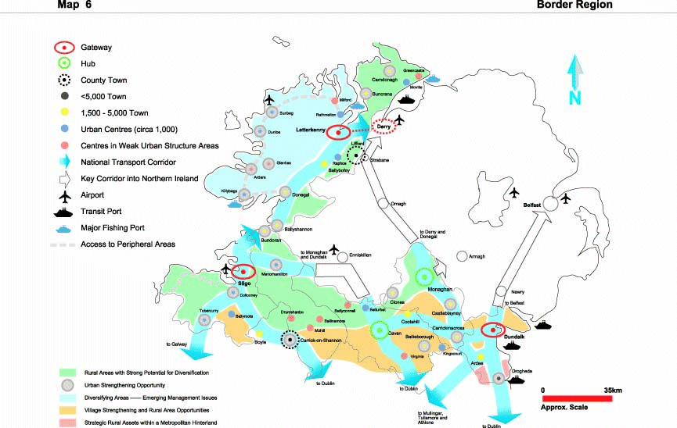
Source: Planning Guidelines for the Border Region

Cavan Town is identified for growth as a Hub within the Regional Planning Guidelines. The RPG states that

“Cavan will capitalise on its strategic position and will act as a catalyst, developing potential future development in the enterprise and community sectors. In the context of renewed cross-border co-operation, Cavan will become more of a crossroads, rather than having a peripheral position. This will enhance the suitability of Cavan for economic development, particularly in terms of cross-border development”.

2.2.10 Other Relevant Guidelines

Strategic Environmental Assessment (SEA)

Strategic Environmental Assessments (SEA) involves assessment of the likely significant environmental effects of plans and programmes prior to their adoption. SEA Directive (2001/42/EC) was adopted on 27 June 2001 and took effect in Member States on 21 July 2004. It provides for strategic environmental consideration at an early stage in the decision making process, and is designed to complement the environmental impact assessment (EIA) process which is project based.

The Directive applies across a wide range of sectors namely, agriculture, forestry, fisheries, energy, industry, transport, waste management, water management, telecommunications, tourism and land use planning. The requirement to carry out SEA of plans/programmes in the sectors mentioned above arises where they "set the framework for future development consent of projects" which are listed in the EIA Directive (85/337/EEC, as amended by Directive 97/11/EC) SEA is also necessary where plans/programmes are likely to have a significant effect on a site governed by the Habitats Directive (92/43/EEC).
Planning and Development (Strategic Environmental Assessment) Regulations 2004, S.I. No. 436 of 2004 give effect to the requirements of the SEA Directive with respect to:

(i) the review/preparation of a development plan;
(ii) the variation of a development plan;
(iii) the preparation or amendment of a local area plan;
(iv) the review/making of regional planning guidelines; and
(v) the making of a planning scheme in respect of part or all of a Strategic
Development Zone (SDZ).

The Strategic Environmental Assessment process is not required for the Integrated Framework Plan as the plan does not permit consent for development but provides concepts for future development frameworks. However future plans and variation arising from this plan will require the process to be undertaken.

Architectural Heritage Protection Guidelines

Section 52 of the Planning and Development Act 2000, the Minister is obliged to issue guidelines to planning authorities concerning development objectives:

a) for protecting structures, or parts of structures, which are of special architectural,
historical, archaeological, artistic, cultural, scientific, social, or technical interest;
and
b) for preserving the character of architectural conservation areas.

The guidelines were issued in February 2005. The Guidelines include the criteria to be applied when selecting proposed Protected Structures for inclusion in the ‘Record of Protected Structures’ (RPS), guidance to Planning Authorities on declarations and determining planning applications in relation to a protected structure, a proposed protected structure or the exterior of a building within an ‘Architectural Conservation Area’ (ACA).

It also contains supplementary detailed guidance to support Planning Authorities in their role to protect architectural heritage when a protected structure, a proposed protected structure or the exterior of a building within an ACA is the subject of development proposals and when a declaration is sought in relation to a protected structure.

2.3 Local Level

2.3.1 County Strategy

In March 2002, the County Development Board (CDB) launched its agreed Strategy, a ‘Shared Vision’, for the Economic, Social and Cultural Development of the County. The strategy document involved rigorous consultation with all sectors to develop achievable objectives and actions which would be implemented over a 10 year period. The agreed vision for County Cavan is as follows

“To retain Cavan’s People in the County through the maintenance, enhancement and promotion of the quality of life therein”
The overall aims for the development of the County’s are:

- to stimulate and sustain the growth of Cavan’s economy through increased innovation and research;
- to ensure that the infrastructure of County Cavan does not impede its economic and social development;
- to broaden the appeal of County Cavan as a “quality tourist destination”;
- to ensure that Cavan is a county that provides “quality of life” for all its people by focusing on social inclusion and tackling poverty and disadvantage;
- to retain the maximum number of people in agriculture through the sustainable production of quality agriculture produce whilst providing viable opportunities for those seeking off farm employment thereby maintaining rural communities;
- to protect and sustain and enhance the clean, green environment of County Cavan;
- to develop, promote and protect the cultural environment of the County whilst celebrating its cultural diversity and artistic strengths.

2.3.2 Cavan County Development Plan 2003-2009

The County Development Plan aims to promote balanced social, physical and economic development in the County. The Plan provides a development strategy that aims to facilitate the sustainable economic and social development of the county, through the promotion of a positive climate for economic initiatives in the towns, villages and rural areas; the conservation of the natural and built environment of the county and the improvement of Cavan's physical infrastructure.

The sustainable development concepts of the plan include the following:

- Promoting established urban areas as development growth area;
- Promoting smaller ‘proto-urban’ centres as development areas particularly those located on transport corridors;
- Preferring development of established energy efficient urban centres with good inter-urban transportation;
- Promoting higher density development where appropriate within established urban areas;
- Promoting development of employment generators within or in proximity to residential areas;
- Providing the infrastructure to ensure adequate serviced land is available to meet these policy objectives in areas that are compatible with the concept of sustainability;

The aim is to improve Cavan's towns, villages and countryside physically while providing for economic development, so that they become more attractive places for living and working and as places in which to invest, to relax and to spend some leisure time in. By these means the Plan seeks to achieve the long term stabilisation of the county's population in the area of 60,000 to 65,000 people within the plan period. It is expected that the long term trend will be for the population to become more urban in that more people will choose to live in the towns and villages. The strategy plans for and positively encourages this trend.

The importance of Cavan Town & Environs as the major industrial, retail and service centre in the County is recognised in the County Plan and its continued growth is accommodated in the context of a separate plan statement.

2.3.3 The Cavan Town Development Plan 2003 - 2009 and Cavan Town and Environs Development Plan 2003 – 2009 and Variation No. 1 (2007) to the Cavan Town and Environs Development Plans

These development plans, translate strategy into strategic planning policies for the main development areas of Housing, Transport, Industry, Sanitary Services, etc., and each aim has linked policies which set out the main six year development framework for the town in terms of physical planning and conservation. Each policy is essentially the method or process by which the strategic planning policies will be achieved. The strategic planning policies are:

- To facilitate the sustainable economic and social development of the town, through the promotion of a positive climate for development initiatives within the plan area;
- To consider provision of a transportation and landuse structure that will provide for the orderly planning and development of the town and accommodate sustainable urban growth;
- To upgrade and expand the towns physical infrastructure to accommodate existing and projected needs;
- To integrate housing and retail strategies, residential densities and childcare facilities as required under Part V of the 2000 Act into the plan as appropriate;
- To conserve the natural and built environment of the town where it is recognised as of special value;
- To strengthen the urban structure in the County through the planned orderly development of the County Town;
- To accommodate urban fringe development where it is considered appropriate in the context of the planned orderly development of the established built-up urban area and to avoid extensive haphazard uncoordinated urban sprawl prejudicial to the towns economic and social vitality;
- To have reference to appropriate Departmental Directives in respect of location of retail development and its impact outside of the central area;
- To have reference to the Town Renewal Plan designation and objectives as stated in the community's Town Renewal Plan as appropriate.

2.3.4 Retail Strategy for Cavan Town (CAAS 2002)

The Retail Strategy for Cavan Town (CAAS 2002) indicated that the town remains a prime destination for people in the border and north midlands region however that to allow for the economic success the following are identified to extend the retail catchments:

- Public transport from local centres needs to be improved to facilitate better access to the town and better movement within it;
- The overall ‘attractiveness’ of the Town needs to be examined and improved through environmental improvement and landscaping schemes;
- The impacts of large retail development proposals need to be considered carefully in relation to their impact on the vitality and viability of the town centre.

The objectives recommended in the Retail Strategy are accommodated in the County and Town’s Development Plans as dictated by the Retail Planning Guidelines.

2.4 Key Policy Implications for Cavan

The key implications for the Town interpreted from the various adopted national, regional and local policy requires that the future planning of Cavan, which is likely to continue to develop at a significant rate in the future, have regard, inter alia, to:

- Developing Cavan as a Hub Town in a self-sustaining manner, with residential growth balanced by employment and service growth, including shopping;
- Increased integration of land use and transportation so as to reduce the demand for growth in transport, especially by the private car by locating high demand activities at locations with good access to sustainable transport modes;
- Placing increased emphasis on the role of sustainable transportation modes, including walking, cycling and public transport;
- Reducing congestion;
- Achieving higher residential densities, to achieve efficient use of land and the provision of efficient public transport with clearer demarcation between urban and rural areas;
- Encouraging the development of mixed use developments;
- Developing and expanding Cavan town centre; and
- Protecting amenity and heritage as well as attracting investment.

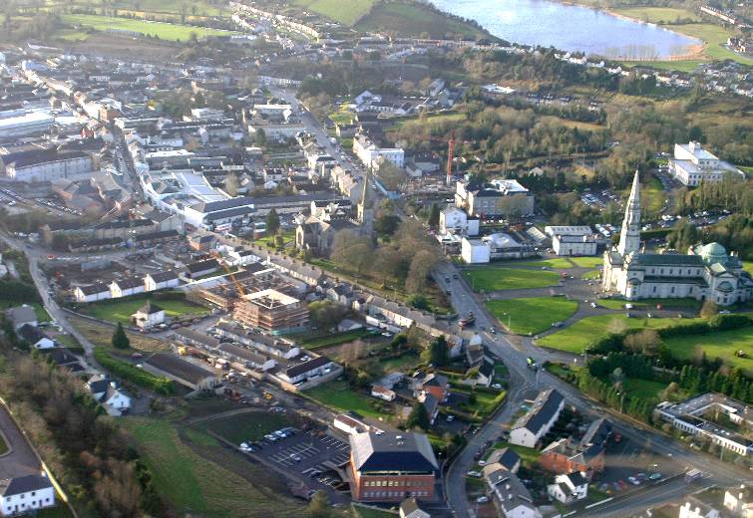
PART THREE
PRESENT SITUATION

PART THREE - PRESENT SITUATION

3.1 Overview

This chapter summarises the existing situation regarding land use and transportation within the study area. It is factual, and is based on the research carried out in the first phase of this study. It first describes the study area, providing an overview of existing land use, the population and employment profile. The remaining sections review economic, social and other community facilities. A detailed Transportation Study has been developed in tandem with the Integrated Framework Plan which details the existing transportation framework separately. The final section indicates future implications these have for the future of Cavan Town and Environs.

3.1.1 The Study Area

The study area for this Integrated Framework Plan (IFP) is Cavan Town and the surrounding area indicated in Figure 2, and its area is at about 3200 hectares. The red line indicates the Cavan Town Council boundary, while the green dashed line indicates the approximate study boundary.

The study area is located in the Border Region. Cavan Town is identified for growth as a Hub within the Regional Planning Guidelines. The RPG states that “Cavan will capitalise on its strategic position and will act as a catalyst, developing potential future development in the enterprise and community sectors. In the context of renewed cross-border co-operation, Cavan will become more of a crossroads, rather than having a peripheral position. This will enhance the suitability of Cavan for economic development, particularly in terms of cross-border development”.

Cavan accommodates the county administrative offices and is also administered by its own Town Council with offices in the Town Hall. Cavan Town Council area is circular in shape extending from the town centre and covering some 200 hectares.

The town has a good range of retailing, as well as commercial, light industry and manufacturing enterprises, but there is evidence of retailing leakage to the edge of Dublin, especially Blanchardstown and Navan. The town serves a wide hinterland in terms of community facilities, healthcare, fire services, law enforcement and education.

The town has developed at moderate densities in large residential developments such as Rocklands and Ardkeen. These areas are relatively close to the town centre and include local shopping areas and primary schools. There are large areas of undeveloped land within the environs area that are currently being used for agricultural purposes. Figure 3 demonstrates the town council area and current land uses. It also shows the current land use zoning being proposed when this study was commenced.

3.1.2 Cavan Town and Environs Basic population & housing statistics

The population of Cavan Town and Environs (Cavan rural) is 7,883 persons based on the 2006 Census of Population. The Census also indicates that there is an average of 2.9 persons per dwelling unit in the county.

Figure 2: Study Area (Cavan Town & Environs)

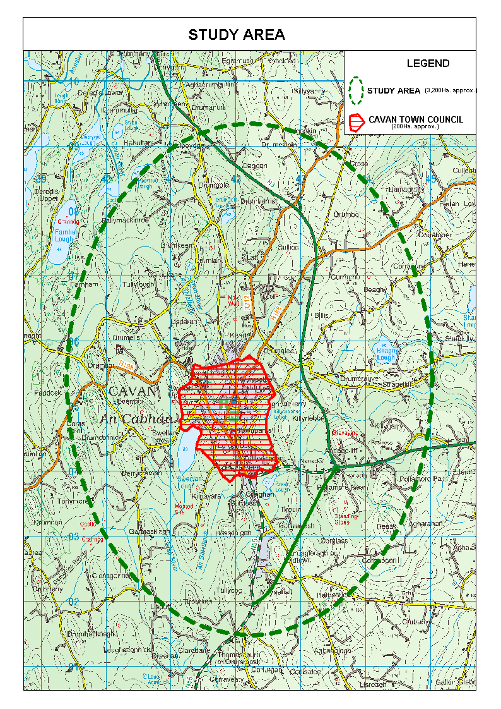

Figure 3: Composite Landuse Map

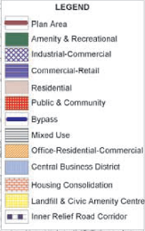
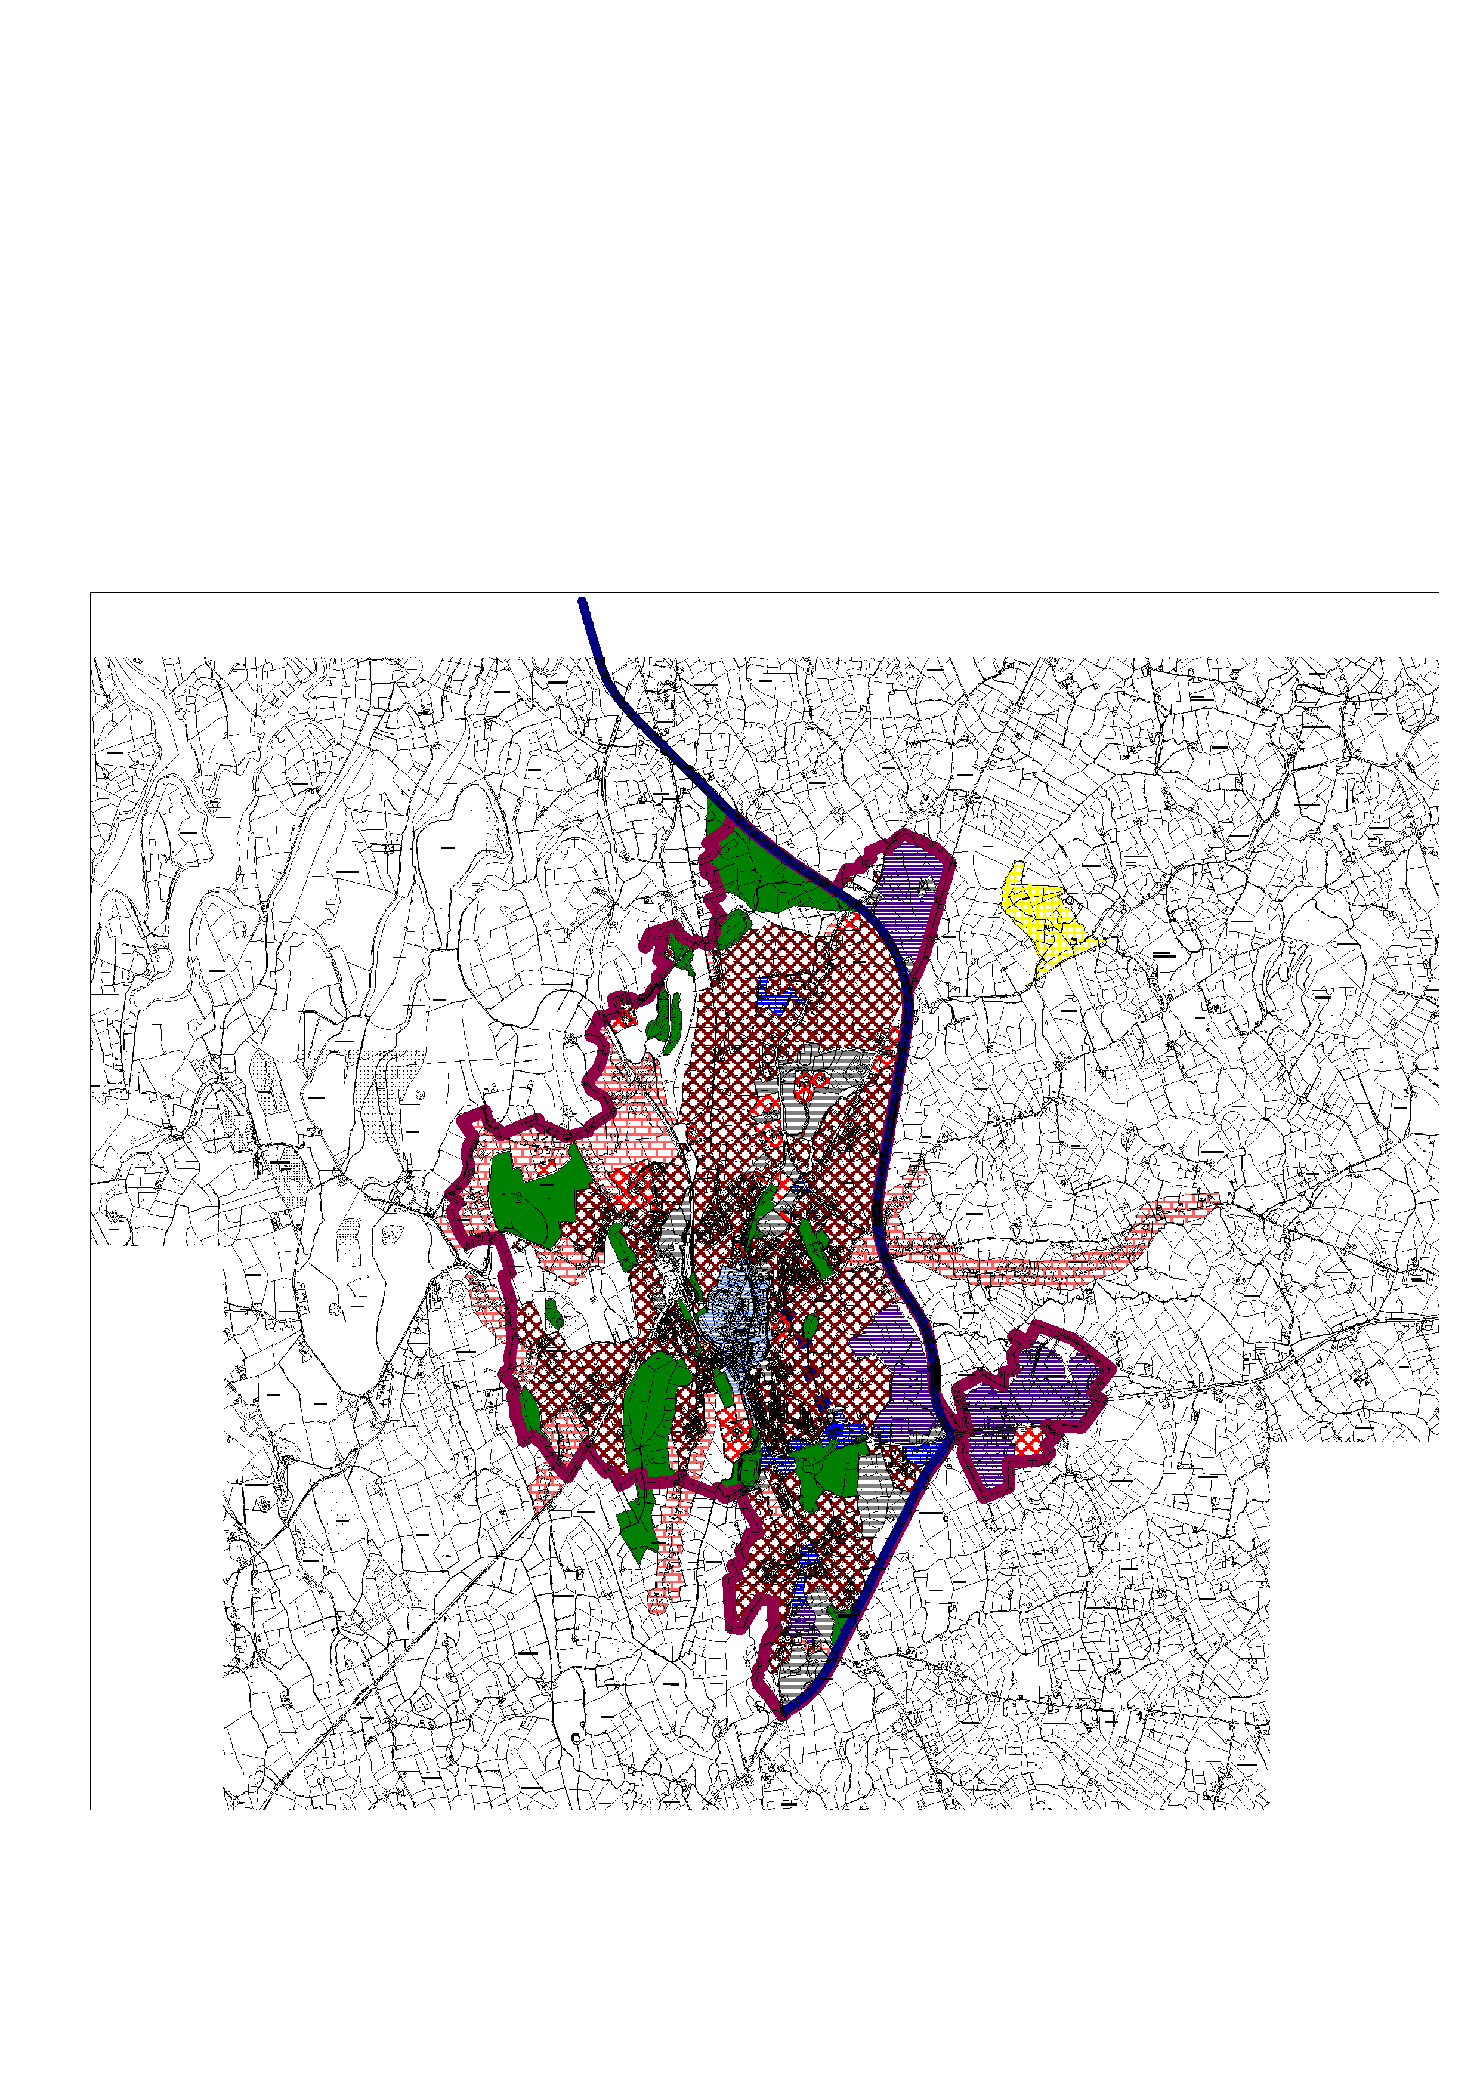
Source: Cavan Town & Environs Development Plan 2003 - 2009

3.2 Population

The Cavan Hub area has experienced population growth at a rate significantly higher than County-wide growth as demonstrated in table 2. Recent assessment of “live planning permissions” indicates that this population growth will continue with an estimate population of circa 14,000 by 2011.

3.2.1 Census of Population

Cavan has experienced unprecedented population growth in the last decade or so. The census data, as shown in table 2 indicated that this growth is increasing and with strong growth in Cavan Town and Environs it is certain that Cavan hub will achieve its NSS target of 16,000 by 2020. An assessment of “live” planning permission, in the context of the Integrated Framework Plan, indicates that there is potential housing to achieve a population of circa 14,000 by 2011.

Table 2: Census of Population
Town | Electoral Division (ED) | 1991 | 1996 | % Change  1991-1996 | 2002 | % Change  1996-2002 | 2006 | % Change  2002-2006 | NSS Targets  2020
Cavan Town | Cavan Urban | 3,332 | 3,509 | +5.3% | 3,538 | +0.8% | 3,934 | 11.2% | 6000
Environs of Cavan | Cavan Rural*  Moynehall* | 1,922 | 2,114 | +10% | 2,560 | +21.1% | 3,949 | 54.3% | 10,000 (Hub)
Total |  | 5,254 | 5,623 | +7% | 6,098 | +8.5% | 7,883 | 29.3% | 16,000 (2020)
County Cavan |  | 52,796 | 52,944 | +0.3% | 56,546 | +6.8 % | 64,003 | +13.2%
*=part of ED

3.2.2 Long Term Population Projections

Table 3 (below) shows long term population projections based on the amount of undeveloped land in each of the towns. The land in question is that land which lies within the development boundary, as defined in the Cavan County and Cavan Town & Environs Development Plans 2003 – 2009. These are estimates to illustrate the maximum theoretical population potential and are taken from the Housing Land Availability Returns 2006. It suggests that over the period 30th June 2006 to 30th June 2011 there may be 419 hectares of undeveloped land available in the Environs of Cavan Town and 39 hectares available within the Town Council Area.

Table 3: Possible Population Estimates based on the amount of undeveloped land in each town
Town/ Village | Hectares | Densities | Household Sizes | Population Estimates
Environs of Cavan Town | 419 | 18 | 2.9 | 21,872
Cavan Town Council Area | 39 | 30 | 2.9 | 3,393
Source: Extraction from Housing Land Availability Returns 2006

Table 4: Housing Units Committed in Environs and Town Core Area
Area | Housing Units Committed | Total
Cavan Town Council | Housing Units Committed (30/6/2005 - 30/6/2006) | 132
Cavan County Council | Housing Units Committed (30/6/2005 - 30/6/2006) | 1870
Cavan & Environs | Housing Units Committed (30/6/2005 - 30/6/2006) | 2002
Source: Extraction from Housing Land Availability Returns 2006

The Housing Land Availability Returns in 2006 (Table 4) indicate that the population of Cavan is likely to continue to grow into the long term. 2,002 residential units have been granted planning permission in the one year period 30th June 2005 and 30th June 2006 indicating strong continued growth in the town and environs. To ascertain population growth estimates based on these figures they were multiplied by 2.9 (the average number of persons per household in County Cavan as indicated in the 2006 census). A field survey conducted as part of the Housing Land Availability Returns indicates that works had yet to commence on the majority (circa 1930) of these residential units. Thus, the population growth estimated from these units is likely to be reached by 2011. This population estimated would see the population of Cavan Town and Environs rise to circa 13,500 by 2011.

Thus allowing for slower population growth, maturing economy, falling household size and mismatching in delivery of housing provision and the need to attract employment and enterprise into the town realistically the projected target population may not be reached as rapidly as current trends suggest. With the maturing economy, reduced land availibility, the need to protect residential, natural and cultural amenities, and the development of more difficult sites, it is expected that the existing trends will not continue.

3.3 Employment & Enterprise

3.3.1 Labour Force and Economic Status

Data on employment is nationally poor the following sections are based on the Census 2002 and the Census of Industrial Production 2002. The Census 2002 provides broad information on the economic background of the residential population. The latter document focuses on the manufacturing sector at County Level which for a town that is service sector dominated provides relatively little information.

3.3.2 Basics

At the time of the 2002 Census, there were 24345 people over fifteen years classified as the County’s labour force, of whom 8784 were females, 15,564 were males and 276 were looking for their first regular job. 1,658 were classed as actively seeking employment, and 4350 were students.
11% of the County’s workforce resides in Cavan Town. The 2002 Census, indicates that in Cavan Town there were 2,584 people over fifteen years classified at work, of whom 1,123 were females (43%), 1461 were males (57%) and 46 were looking for their first regular job, 262 were classed as actively seeking employment, and 436 were students.

3.3.3 Socio-Economic Groups

The Census information on Socio-Economic Group (SEG), of all persons aged-15 years, and over, who are at work is determined by their occupation. Unemployed or retired persons are classified according to their former occupation; all other persons are classified according to the SEG of the person on whom they are deemed to be dependent. The breakdown by SEG for Cavan Town, Cavan County, and the state as a percentage whole, is indicated in Table below.

Figure 4: Percentage per Employment Sector
Source: CSO (2002)

Table 5: Classification of Employment Sectors
CLASSIFICATION | % Town | % County | % IN STATE
A: Employers and Managers  B: Higher Professionals  C: Lower Professionals | 28 | 22 | 31
D: Non-Manual  E: Manual Skilled | 31 | 27 | 27
F: Semi-Skilled  G: Unskilled | 13 | 13 | 13
I: Farmers  J: Agricultural Workers | 6 | 21 | 11
H: Own account workers  Z: All other gainfully employed | 22 | 17 | 18
Source: CSO (2002)

Relative to the country as a whole, Cavan Town has a similar proportion of employees in the higher socio-economic groups i.e. employers, managers and professional people; but a higher proportion of skilled and service employees. The Town has a low incidence of agricultural jobs however this sector within the County supports the range of the town’s services.

3.3.4 Sectoral Employment

All persons aged-15 years and over, at work, were classified in the 2002 Census according to the sector of economic activity of the local unit in which each person was working. The following broad industrial groupings have been analysed for the Town, County and State. The graph indicates the importance of the service sector and especially the public sector to the town’s population and its deviance from the County patterns. Manufacturing and Agricultural industries are important to the County and thus the service role of the Town. In comparison with the state differences arise due to skew of the urban population. Thus Cavan town has a strong public and private service sector which will continue with the designated Hub status.

Figure 5: Sectoral Employment
Source: CSO (2002)

50% of the workforce can be classed as employed in the service sector. This percentage is significantly higher in the town area at 71%. This reflects the changing nature of the national economy and also the role of the town as an administrative, health retail and professional service centre. Manufacturing employment represents 13% of the workforce.

Cavan County has secured higher-than-average growth in ‘manufacturing’ industry and in ‘building and construction’; but it has also seen quite rapid growth in the provision of ‘commercial and business sector’ and in ‘professional services’, albeit that, in both categories, it has lower proportions than the respective national averages.

Table 6: Persons aged 15 years and over at work classified by broad industrial group
 | State | Co. Cavan | Cavan Town
Agriculture, Forestry & Fishing | 97281 | 3367 | 60
Mining, Quarrying & Turf | 6658 | 142 | 1
Manufacturing Industries | 244203 | 4008 | 313
Electricity, Water & Gas | 11363 | 102 | 14
Building & Construction | 149271 | 2569 | 193
wholesale & Retail | 219165 | 2695 | 355
Hotel & Restaurants | 81418 | 1023 | 132
Transport, Communication & Storage | 96855 | 823 | 76
Banking & Financial Services | 70838 | 738 | 143
Real Estate, Renting & Business Activities | 151107 | 956 | 140
Public Administration & Defence | 94746 | 1245 | 215
Education | 109301 | 1174 | 191
Health & Social Work | 143520 | 1831 | 300
Other community, social &  personal services activities | 64333 | 580 | 92
Other Industries or Not Stated | 101528 | 1161 | 97
Total | 1641587 | 22414 | 2322
Source: CSO (2002)

3.3.5 Qualifications

The educational attainments of the County and Town illustrate the extent of qualifications within the resident work force in 2002. 73% of the towns population have attained secondary level education or higher or are currently students.

Table 7: Third Level Qualifications
 | % of Workforce with third level qualifications
Town | 20.5
County | 14.5
State | 20
Source: CSO (2002)

Figure 6: Percentage of Workforce & Education Status Attained 2002
Source: CSO (2002)

The 2002 Census indicated that there were 6622 persons aged-fifteen and over within County Cavan at the time of enumeration holding a third level qualification - a significantly lower proportion of the workforce than that for the State (20%). Cavan Town however reflects the national attainments of qualifications of 20%. 15% of the county’s third level graduates are resident in Cavan Town.

The bar-chart provides a breakdown by classification of qualifications for the County Town and state. ; All figures shown are percentages of the population aged over fifteen. Cavan Town has a significant number of humanities and medical sciences graduates reflecting the key administrative educational and medical role of the town.

Figure 7: Qualifications by Type (2002)
Source: CSO (2002)

The County has relatively high levels of graduates in the agricultural field due to its high dependence on the agricultural sector. There are differentials in the town in particular engineering, architecture and surveying, arts and the “social and natural sciences’. However the County/Town has a higher percentage of communication and information technology graduates than the state.

3.3.6 Manufacturing Industry

Figures for manufacturing employment are available for the County as a whole which represents 18% of the total employed workforce. According to the 2002 Census of Industrial Production, there were 3,828 persons engaged1 in 96 industrial units in County Cavan (an average of 39 persons per unit), ranging from small enterprises with under 10 employees, to large businesses with over 500 employees. Based on research by CEB the average manufacturing unit in Cavan is over 20% smaller than the average for the region, but the region’s average is heavily biased by the significant firms in Louth.

Table 8: Occupational Groups of Employees within Local Industrial Units (Cavan) *
Year | 1995 | 1998 | 2002
Number of Units | 84 | 79 | 96
Industrial Workers  Supervisors & Operatives  - Male  - Female  Apprentices  - Male  - Female  Total | 2,049  455  39  9  2,552 | 1,754  568  16  2  2,340 | 2,239  363  22  6  2,941
Other Employees  Clerical Staff  - Male  - Female  Administration & Technical  - Male  - Female  Total | 105  260  349  72  786 | 91  242  300  69  702 | 157  272  325  99  853
Total Employees | 3,338 | 3,042 | 3,794
Proprietors & Unpaid Family Workers | 43 | 48 | 34
Total Persons Engaged | 3,381 | 3,090 | 3,828
* An Industrial Unit must have at least three employees and be engaged wholly or mainly in industrial production, in order to be included in these figures.
Source: CSO (2002) Census Industrial Production

The previous table provides details of the employment categories of the workers in Cavan and the trends over the years 1995, 1998 and 2002 during which time there has been a cyclical change in the number of workers employed in Industrial Production Units which recovered in 2002.

Cavan’s manufacturing base is dominated by small businesses. The average number of persons engaged in local units is 40. Cavan has experienced a period of economic growth and decline (1995-1998) over the duration of the above statistics, with its situation improved in 2002. This period has been one of tremendous economic growth for the Republic as a whole and it is clear that Cavan still falls behind the rest of the State in terms of its economic standing (based on its industrial employment figures).

3.3.7 Cavan’s Industrial Output

Since 1991, there have been very positive developments in industrial activity within County Cavan. Cavan has experienced increases in industrial input and output. Annual wages and salaries have also been increasing since 1991.

The Table below provides details of industrial activity for the County in the years 1991 – 2002 with more detail provided for the past ten years (no information as yet is available for 2003-2007).

Table 9: Industrial Local Units – Details of Activity in Cavan
 |  | YEAR
INDUSTRIAL OUTPUT | UNIT | 1991 | 1995 | 1996 | 1997 | 1998 | 1999 | 2000 | 2001 | 2002
Gross  Output | No | 617,930* | 739,944 | 660,907 | 734,484 | 725,684 | 788,521 | 936,562 | 840,655 | 920,438
Gross  output  per person engaged | € | 199,075 | 218,854 | 211,085 | 238,469 | 234,850 | 244,276 | 287,642 | 232,450 | 240,475
Total  industrial  Input | €  000 | 469,339 | 504,901 | 461,313 | 500,306 | 536,875 | 492,060 | 562,029 | 589,198 | 635,524
NET  OUTPUT | €  000 | 148,591 | 235,042 | 199,593 | 234,179 | 188,808 | 296,461 | 374,532 | 251,469 | 284,914
Wages &  Salaries  - Total Paid | €  000 | 46,793 | 61,938 | 55,438 | 58,196 | 62,215 | 6,8406 | 74,939 | 86,827 | 99,082
Annual  wages and salaries per employee | € | 13,551 | 16,313 | 17,920 | 19,101 | 20,439 | 21,459 | 23,229 | 24,228 | 26,088
Annual  wages per industrial  worker | € | 15,183 | 18,515 | 15,829 | 17,085 | 17,549 | 18,692 | 20,799 | 21,583 | 23,180
Wages &  salaries as  a % of net output | % | 31.5 | 26.4 | 27.8 | 24.9 | 33 | 23.1 | 20 | 34.5 | 34.8
Source: CSO Industrial Local Units, 1991 -2002 (*Figures for 1991-1998 are converted to euro equivalent)

Cavan’s industrial output has increased from €617,930 in 1991 to €920,438 in 2002. The chart below indicates that there have been some fluctuations in output however, growth has been relatively steady.

Figure 8: Industrial Output 1991 - 2002
Source: CSO (2002) Census Industrial Production

Cavan experienced considerable growth in its gross industrial output between 1991 and 1995 and also its net industrial output over the same period. Between 1995 and 1998, growth was slow and the County experienced a significant fall in both gross and net industrial output in 1996 and a less significant drop in 1998. This reflects the reduction in the number of industrial units in the County over the same period. This was recovered on substantially from 1998 to 2002, except for a slight drop in 2001.

The County’s net industrial output increased by 90% over the eleven-year period (an average of less than 8% per annum), reflecting the costs of material inputs and fuels its gross industrial output rose by 48% (or 4% per annum). Wages and salaries increased over the same period by over 100%, marking either a move towards more highly-skilled labour or a ‘bloating’ of the sector as a result of high wage increases; the net effect is that the proportion of net output paid to workers and employees has risen to 34.8% compared to 31.5% in 1991 (a relative increase of nearly 5%).

3.3.8 Industrial Output: A Comparison

The following table contains a comparison of the output of the industrial sector in Cavan against the corresponding statistics for a number of other neighbouring counties and for the State as a whole.

In terms of aggregate gross output, Cavan lags well behind Louth, but is far ahead of Leitrim; however, due to its lower net/gross profit ratio than County Monaghan, it falls behind that County in terms of Net Output. This reflects a relative lack of profitability within Cavan’s industrial sectors; the County has a Net/Gross profit ratio of 31% in its industrial sector - lower than the figure for any other County in the review area other than Monaghan (i.e. the ‘border area’ within the Republic), including Leitrim.

Table 10: Statistics for a Range of Counties and the State - 2002
Statistic | Cavan | Monaghan | Leitrim | Louth | State
Gross Output | 920,438 | 993,238 | 135,192 | 3,981,860 | 99,966,479
Net Output | 284,914 | 303,702 | 67,287 | 2,824,193 | 60,372,712
Net/Gross Output (%) | 31.0 | 30.6 | 49.8 | 70.9 | 60.4
Net Output Per Unit | 2,968 | 2,266 | 2,039 | 14,121 | 10,907
Annual Wages Per Employee | 26,088 | 22,379 | 23,460 | 27,545 | 29,930
Net Output Per Person Engaged | 74,437 | 64,382 | 70,932 | 326,386 | 233,609
Wages as % of Net Output | 34.8 | 30.6 | 49.8 | 70.9 | 60.4
Source: CSO (2002) Census of Industrial Production

Net output per industrial unit is relatively high in the County at 2,968 million, in comparison with 2,266 million in Monaghan and 2,039 in Leitrim. However, it is much smaller than that of Louth (at 14,121 million) indicating the step-change necessary to bring Cavan’s industrial economy into the leading group within Ireland. The lower output per unit is indicative of a dependence on low value-added products, in comparison with Louth’s thriving IT sector.

The wages per employee in the County are approximately €3,500 lower than the national average. However, wage levels are higher than those for Monaghan or Leitrim and this is reflected in Cavan’s relatively high ratio of wages as a percentage of Net Output.

The County’s industrial sector has some way to go in terms of improving productivity and in developing high value-added value products to safeguard such high wage levels. The County’s dependence on low ‘value-added’ products is confirmed by the analysis of the net output per person engaged, which is, for the County, just under one third of the figure for the state as a whole and just under one quarter of the corresponding figure for Louth. The result is that Cavan has a significantly higher proportion of overall net output expended on wages and salaries than the national average. Whilst the absolute figures may have changed since 2002, the rankings are unlikely to have done so, and action must be taken to ensure a move to higher value-added production, if the existing high wage structure in the County is to be maintained.

3.3.9 Gross Value Added Per Person

The table below provides a regional analysis of Gross Value Added per Person, carried out by CSO between 1996 and 2001.

Whilst these figures are not directly applicable to County Cavan, they give an indication of trends in the Region (encompassing counties Cavan, Donegal, Leitrim, Louth, Monaghan and Sligo).

Table 11: Gross Value Added (GVA) per person (1996 – 2001) at basic prices indices (state = 100)
Region | 1996 | 1997 | 1998 | 2001
Border | 77.6 | 77.1 | 77.9 | 75.1
Dublin | 133.3 | 133.7 | 134.8 | 129.6
National | 100 | 100 | 100
Source: CSO (2003)

The above indices reveal that, since 1996, GVA per Person in the Border region has fluctuated and changed little and remains well below national averages for the Regions.

3.3.10 Enterprise

The role of Enterprise Ireland is to foster the development of the domestic industrial base, with a strong emphasis on science and technology. Enterprise Ireland also works to attract overseas food projects to locate in Ireland. The agency provides assistance to companies in the form of advice management development, research and development as well as a range of financial grants. Enterprise Ireland has a special Small Business Division. It also operates the Enterprise Link, the single contact for all sources of support for start ups and small business in Ireland.

Table 12: Total Permanent Employment by Sector & Grant Approvals in County Cavan
Industry | 1995 | 1996 | 1997 | 1998 | 1999 | 2000 | 2001 | 2002 | 2003 | 2004
Chemicals | 127 | 130 | 127 | 130 | 151 | 149 | 173 | 172 | 181 | 191
Clothing,  Footwear  & Leather | 59 | 60 | 52 | 47 | 45 | 34 | 28 | 29 | 29 | 24
Drink &  Tobacco | 25 | 27 | 29 | 32 | 31 | 36 | 38 | 30 | 22 | 30
Food | 1,222 | 1,150 | 1,170 | 1,211 | 1,280 | 1,140 | 1,138 | 1,127 | 1,214 | 1,354
Furniture | 54 | 55 | 56 | 72 | 115 | 137 | 146 | 142 | 137 | 134
Internationally Traded  Services | 7 | 6 | 7 | 16 | 56 | 56 | 67 | 81 | 105 | 136
Metals & Engineering | 548 | 562 | 547 | 622 | 677 | 685 | 629 | 588 | 583 | 569
Mining,  Quarrying  & Indigenous Services | 0 | 0 | 0 | 0 | 6 | 7 | 153 | 219 | 250 | 269
Miscellaneous Manufacturing | 101 | 74 | 75 | 115 | 136 | 141 | 61 | 53 | 52 | 47
Non-Metallic Minerals | 569 | 658 | 716 | 680 | 724 | 895 | 941 | 999 | 1,047 | 1,086
Paper &  Printing | 87 | 96 | 105 | 105 | 99 | 99 | 107 | 104 | 101 | 98
Plastics &  Rubber | 244 | 254 | 246 | 293 | 260 | 271 | 280 | 280 | 265 | 293
Textiles | 34 | 54 | 58 | 52 | 59 | 60 | 61 | 54 | 59 | 26
Wood &  Wood Products | 25 | 21 | 16 | 27 | 32 | 40 | 24 | 19 | 21 | 30
Total  Permanent  Full Time Jobs | 3,102 | 3,147 | 3,204 | 3,402 | 3,671 | 3,750 | 3,846 | 3,897 | 4,066 | 4,287
Total Grant Approvals (€) | 1,645,853 | 3,224,003 | 3,857,004 | 1,171,438 | 2,206,758 | 1,857,259 | 631,984 | 4,554,254 | 981,681 | 914,414
Source: Enterprise Ireland (2005)

The previous table provides details of the total permanent employment and grant approvals for businesses in the County in respect of Enterprise Ireland assistance over the period 1995-2004.

Over the period 1995 – 2004, Enterprise Ireland has approved over €21 million in grants to companies in County Cavan. In this period the number employed in these assisted companies increased steadily, rising from 3,102 in 1995 to 4,287 in 2004 representing a 38.2% increase.

Since, its inception the Cavan County Enterprise Board (CCEB) has made a significant contribution to the economic well being of County Cavan. The CCEB is situated in the Cavan Innovation and Technology Centre (CITC) on the Dublin Road. This €3 million facility was a joint initiative of the Cavan County Enterprise Board and the Cavan County Enterprise Fund. It has been developed as part of a Cross Border Programme to support local, regional and national agencies in stimulating an environment conducive to innovation, entrepreneurship and inward investment in the Cavan/Fermanagh region.

The CITC also provides distance learning or outreach services for the border area. Their primary role is in promoting enterprise and job creation at local level and to assume responsibility for business areas not already covered by the state industrial development agencies.

The role of the Cavan County Enterprise Board (CCEB) is to stimulate economic activity at local level and to develop the indigenous enterprise potential of the county. This is achieved through the provision of business advice, information and mentoring support to small business. The CCEB is also involved in the delivery of management training and development programmes as required. Grant aid and financial support may also be available for new or existing small companies employing up to 10 people who are engaged in manufacturing or traded services. In its first ten years the CEB had a number of achievements:

- 2,267 pupils participated in various schools programmes and initiatives in which the CCEB has an involvement;
- The CCEB invested over €1.2 million on upskilling and enhancing senior personnel in local companies. It organised 41 training programmes involving 1,821 participants;
- A total of €5.3 million was allocated in grant aid to 368 projects. This investment supported the direct creation of 768 net full-time and 239 part time jobs;
- The negotiation of over €6.3 million for locally based community economic initiatives including development of 60,000 sq. ft. of enterprise space at Bailieborough, Blacklion, Cavan, Cootehill, Kileshandra, and Kingscourt;
- Ongoing management of Cavan County Enterprise Fund -
  - Loans approved €3.3 million
  - Net assets increased by €4.3, from €1.9 m to €6.2m;
- Developed a €3.2m Innovation and Technology Centre;
- Administered funds totalling €1.98m on behalf of Cavan County Council led Task Force;
- Joint initiative with Cavan County Council and IDA Ireland to secure the establishment of a new Business Park at Cavan;
- Grant aid of €1.08m channelled to seven community initiatives under the EU Interreg Programme (Community Economic Development Measure);
- Establishment of a new Tourism Marketing Initiative for the county, in conjunction with Cavan County Tourism Committee;
- Involvement in the establishment and management of various cross border initiatives including the Acumen Interregional Business Development Programme which promotes the development of cross border trade and the Breifne Tourism project;

3.3.11 Summary

Cavan’s as a county has a high dependence on agriculture which militates, to some extent, against its industrial performance. With few exceptions, the County is dominated by small firms. Industrial units in Cavan are generally small in national terms but they are still considerably bigger than those in the rest of the Border Region. In terms of total industrial output, Cavan produces 0.5% of national manufacturing output, against 1.46% of the national population i.e. its output per person is below the national average. While industrial wages and salaries in Cavan are low relative to the national average, they are high relative to output. Correspondingly, net output per person is higher than the Monaghan and Leitrim figures (but much lower than the national average).

However caution needs to be raised in respect to the overall analysis of the manufacturing sector as it represents only 18% of total employment in the County. 50% of the workforce can be classed as employed in the service sector (including public administrative employment). This percentage is significantly higher in the town area at 71%.

The County has a much lower proportion of its workforce with third-level qualifications (especially in technical disciplines), apart from in ‘Agricultural Science’, and surprisingly communication and information technology. The town’s tertiary qualifications portray the significant service sector that it supports.

The development of small businesses has to play an important role in promoting local employment opportunities. In the early stages of business start-up it is sometimes necessary or appropriate for enterprises to be run from home. There are many examples of this phenomenon in both the rural and urban areas of Cavan. In addition in recent years, many large businesses have been encouraging office and mobile staff to use their homes as a base, as a means of reducing overheads. Additionally, the pressure to reduce car usage for environmental and social reasons highlights the benefit of home working. These changes are supported by the rapid development of information communications technology which is encouraging and allowing practices such as teleworking, hot desking and satellite offices to develop in many professions. While flexible office space has many merits experience has shown that it may need to be anchored by a major user. Satellite offices can provide access to employment for those without access to a car, to families with small children, the disabled and the elderly. It is anticipated that home working and practices such as hot desking will increase significantly in the future mainly due to advances in IT that equip people to work from home.

The main conclusion from the analysis of the County’s industrial and economic performance is that Cavan has further potential for industrial and service sector growth, which has yet to be harnessed. This is an issue which must be addressed by decision-makers and those with influence among Cavan’s population including the ability to react to the pace of change and innovation in the employment sector. The overall result is that Cavan is a good place in which to do business, but its full potential has not yet been exploited or reached.

3.4 Town Centre

Cavan Town has a distinctive urban form which can be sub-divided into four main areas distinguished largely by the dominant and distinctive land uses present.

Old Cavan: The oldest parts of the town, dating back to the 16th century, are located at Bridge Street and Abbeylands.

The Core Area: The central business area is centred along Main Street and some of the side streets off it and includes part of old Cavan such as Bridge Street. The existence and retention of traditional carriageways have created attractive ‘arcade’ style retail clusters off the Main Street.

Institutional Area: The Georgian part of the town at Farnham Street, which is now mainly associated with the institutions of the town such as the Courthouse, the Library and various Religious Buildings.

The Periphery: This area consists of the area outside of the town centre and is mainly residential with new industry spreading out on either side of the Dublin road.

3.4.1 Architectural Key Sites

There are a number of key focal points to the town which anchor the historic fabric and character of the town centre. Any approach to redevelopment and expansion of the town centre should focus on the use and protection of these architectural centrepieces (Figure 9).

These include

- St Patrick’s Cathedral
- Court House
- Cana House
- Farnham St
- Town Hall
- Abbeylands
- Mill
- Poor Clare’s Convent
- Royal School
- St Phelim’s Hospital
- St Patrick’s College
- Church of Ireland Parish Church
- VEC Offices
- Loreto College

3.4.2 Civic Spaces

The provision and adequacy of civic space within the urban fabric of a Town Centre is critical when assessing the environmental quality and attractiveness of a town.

Within the central areas of Cavan, there is little civic space, with the only significant space located on Main Street in front of the Post Office. This space has a sculpture with an associated water feature. This space also has some planting, lamps and seating. A smaller attractive civic space is located at the junction of Connolly St and Fair Green. In addition green spaces include the Con Smith Park which provides a valuable but underutilised greenway to the north of the town centre. The Abbeylands Tower provides a quiet oasis within the town centre.

There are a number of opportunities to create new ‘civic spaces’ and streets within or proximate to the town centre. These include (see figure 10):

  - Abbeylands/ Town Hall Street,
  - Courthouse
  - Carpark east of Main Street,
  - Town Hall Street/ Thomas Ashe Street
  - Car park at James Connolly street
  - The Egg Market

Other valuable open space opportunities which provide both ‘recreation and amenity’ challenges approximate to the town centre are (see figure 10):

  - Green Lough
  - Swellan Lough
  - Killymooney Lough
  - Sports facilities of Sports Complex Cavan Gaels, Drumalee, rugby and soccer pitches, Tennis Club and Tullaghmangan
  - Linear river walks through the town including the Royal School, Railway Road
  - Loreto woods
  - Golf Club
  - Con Smith Park

3.4.3 Town Renewal Scheme

The Town Council Plan identifies Farnham Street, Church Street, Bridge Street, Rossa Place (Coleman Road), Wolfe Tone Street and College Street as ‘Streets of Environmental Importance’. The Plan recognises the characteristics of each of these areas and briefly outlines design criteria and improvement schemes, such as tree planting that will be implemented.

Since the introduction of the Town Renewal Scheme many improvements have been effected in the town. Of the designated sites in the Town Renewal Scheme, the following is an outline of progress so far. To date, 13 projects have been completed with an estimated expenditure of €7.1m. Work is in progress on a further 13 projects (estimated investment €18.3m) and an overall infrastructural investment in excess of €40m is projected on sites/projects designated under the scheme.

Work is still progressing on a number of projects in the Town Centre and a large number of projects have gone through the Planning Stage.

It is envisaged that completion of these projects will inject a new vitality and increase commercial activity in the town centre and meet the central planning policies and objectives of the Cavan Town and Environs Development Plan 2003-2009.

Figure 9: Architectural Key Sites
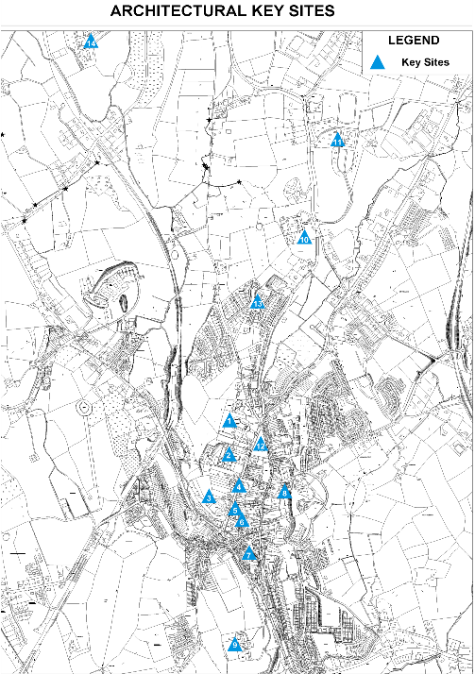

Figure 10: Civic Spaces
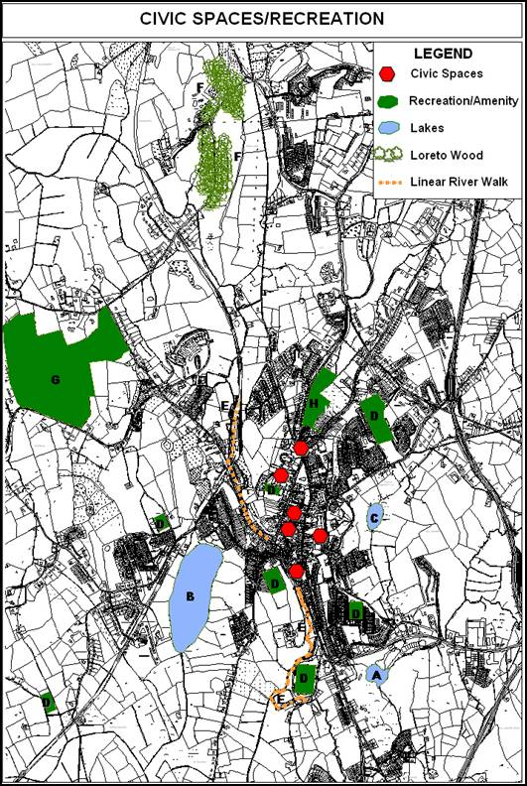

3.4.4 Quality of the Built Environment

Part of the approach to preserve the Town’s quality of life is bringing people, employment and services closer together through appropriate urban design especially in for higher residential densities. In tandem with this is the need to promote a high quality built and natural environment, which is attractive to enterprise. Cavan Town has a rich architectural heritage with buildings, streetscapes and shopfronts of note which establish the character and attractiveness of the area.

With regard to the built environment of the Town research undertaken as part of the Retail Strategy (2002) indicated that, 56.5% of the retailer respondents of Cavan found the town’s built environment untidy, while only some 9% found it attractive.

2006 saw Cavan Town maintain its supreme position in the area of Litter Management by staying at the top of the IBAL Anti-Litter League. Organised by Irish Business Against Litter (IBAL), the League is an assessment of 30 towns across the country according to litter levels. The rankings in the league were based on random surveys carried out throughout the year by An Taisce, on behalf of IBAL.

The performance of Cavan Town in the Tidy Towns competition has been increasing during the period of implementation of the Plan (see table below).

Table 13: Tidy Towns Performance (Cavan Town)
Category D | 2002 | 2003 | 2004 | 2005 | 2006
Cavan | 219/300  (73.0%) | 230/300  (76.7%) | 234/300  (78%) | 236/300  (78%) | 242/300  (81%)
Source: Tidy Towns Competition (2005)

The marking scheme for the competition incorporates issues ranging from the historical and cultural uniqueness of the location to the conservation of natural amenities and wildlife areas.

3.4.5 Retail Activity

Cavan Town is named as a third tier retail centre in the Retail Planning Guidelines. This is the only such centre in the County. The town has a good range of retailing, as well as commercial, light industry and manufacturing enterprises, but there is evidence of retail leakage to Blanchardstown and Navan. The town serves a wide hinterland in terms of community facilities, healthcare, fire services, law enforcement and education. Third tier centres such as Cavan town are characterised by the availability of national supermarket chain stores and with a significant proportion of comparison goods outlets. This classification is supported by the survey results, which indicated the presence of a number of large chain stores – such as Dunnes Stores, Supervalu, Lidl and Tesco. 81% of the retail strategy survey respondents were outlets dealing with comparison goods. Thus, Cavan Town can be considered the primary comparison goods destination within the County and serves a wide catchments area that extends outside the County of Cavan. There is a high demand for retail units in the town and, in particular in the central core areas, competition for outlet space is healthy. Cavan Town further dominates the retail structure of the county accounting for 44% of the total county turnover and 42% of the county’s retail employment. Research by CAAS in 2002 indicated that retailing activity in County Cavan is greatly affected by three key factors:

- The distortional effect of the County’s location close to the Northern Irish border.

- The poorly developed retail structure of the County results in a large number of small rural outlets which have low turnovers and small numbers of employees.
- The unbalanced urban hierarchy within the County

The attractiveness of Cavan Town to the population residing within its sphere of influence is clear given its dominance in the urban hierarchy in the County and also the degree of ‘choice’ available in the Town. The ‘zone of retail influence’ of Cavan Town extends even beyond the County boundary. Due to the distortion created by the Sterling – Euro/ Irish Punt exchange rates, the Town represents an attractive shopping destination for Northern Irish residents. Shoppers also travel from Leitrim and Longford although Sligo and Longford Town exert considerable retail draws over these areas. Survey results indicated that people from smaller towns throughout the County travelled into Cavan Town to avail of retail facilities. It was the general opinion of retailers that the population of settlements, within an approximately 20-mile radius, relied on Cavan Town for comparison and bulky shopping.

On analysis of the four health check indicators in the Retail Strategy (2002), Cavan needs to be improved in certain aspects. These are:

  - Public transport from local centres needs to be improved to facilitate better access to the town and better movement within it.
  - Furthermore, the overall ‘attractiveness’ of the Town needs to be further examined and improved through environmental improvement and landscaping schemes.
  - The impacts of large retail development proposals need to be considered carefully in relation to their impact on the vitality and viability of the town centre.

Upon the improvement of the health of the town centre the retail catchments area can be increased as people realise there is a wide range of shops and good facilities in the town in an attractive environment. This will ensure that Cavan remains a prime destination for people in the border and north midlands region and allow for the economic success of retail outlets in the town.

3.4.6 Spatial Context of Retailing

The core or central area of the Town is the established retail and commercial ‘hub’ of the Town. At present, it has relatively healthy state with a wide variety of shops and a high level of demand for retail units. The core contains a mixture of retail and commercial uses but it is essential to maintain a balance between these.

There has been little retail development outside of the central area to date and this can predominantly be attributed to the Council’s on-going policy of discouraging retail development within out-of-town locations. At present, there are two main retail nodes outside Cavan town:

- On the Dublin Road there are a number of petrol stations with forecourt retailing, and warehouses and a retail park with several wholesalers of home goods. The units in the retail park have been located here due to their large size and the bulky nature of the goods being sold. Cavan Crystal with associated restaurant and showroom is also located on the Dublin Road.
- At the Drumalee Cross there are a number of retail units, office space, and a recently developed restaurant and pubic house.

- The 1,255 sq. m. Lidl supermarket is located at Creighan on the Ballyjamesduff Road.
- There are also several local convenience shops that serve residential areas in the periphery in primarily residential areas.

3.5 Transportation

The main Transportation Study incorporates a much more detailed background to this section and should be read in conjunction with the Integrated Framework Plan.

Situated on the junction of the National Primary Routes N3 and N55, Cavan town is well serviced by the national road network.

The east and southern by-pass for the town was completed in 2006 and has helped to alleviate through-traffic in Cavan town, which was a cause of congestion within the town.

Efficient transport links serve the towns from Cavan heading south east towards Dublin and south towards Longford. Services to the north of Cavan are also quite regular. Services to towns and villages west of Cavan are not as regular and need to be improved.

Cavan Town is serviced by several Bus Éireann routes, namely:

Table 14: Bus Service
Expressway Bus Service | Frequency
Dublin – Cavan  Dublin-Cavan-Donegal  Galway-Longford-Sligo-Belfast  Athlone-Longford-Cavan-Belfast | 17 times daily Monday to Saturday and 14 times on Sunday  6 times daily with an extra service on Fridays  2 times daily Monday to Saturday with an extra service on Friday and one service on Sundays  Once daily Monday to Sunday with an extra service on Fridays.
Source: Bus Éireann

The Dublin-Cavan service provides people travelling into Cavan Town from local centres such as Virginia with the most frequent form of public transport.

While regular, these services largely exclude areas to the west of Cavan Town – due to the predominantly Dublin orientated direction of these services. Furthermore, the Galway-Belfast, and Athlone-Belfast services does not stop for local passenger traffic between Longford and Granard and Granard and Cavan. Thus, the usefulness of these services in catering for local people travelling into Cavan Town is seriously undermined.

There is no bus service within the town of Cavan itself. Private bus operators also provide a wide range of flexible services into Cavan Town. Donnelly’s coaches, based in Longford, operate a service from Cavan to Longford. Streamline coaches, based in Stradone, operate a return service to Dublin. Other private bus operators in the Cavan area predominantly offer coaches for private hire. These providers are critical to the provision of sustainable transport system within the County.

Surveys undertaken during the preparation of the Retail Strategy indicate there is an overall need to consider an integrated pedestrian network in the town, particularly in light of the heavy traffic flows experienced on Main Street. The development of such a network needs to focus on two aspects of accessibility: the provision of footpaths and physical links to separate pedestrian and vehicular traffic and the need to upgrade existing facilities. The ease of movement for cyclists is somewhat restricted in the town due to the narrowness of the roads.

The town has several surface car parks which meets all parking demands except short term parking in areas immediately adjacent to retail and commercial outlets. There is one multi-storey car park in the town, located near Tesco, which has approximately 400 car spaces. There is one underground car park located at Dunnes off Thomas Ashe Street, which accommodates 160 cars. There are some 1,462 spaces available centrally in Cavan Town.

3.6 Heritage & Conservation

Cavan – An Cabhan the hollow place, nestling in a drumlin valley is the bustling shopping and commercial centre for the county of Cavan. The town once the headquarters of the O’Reilly territory is now the administrative centre for the modern county. It contains an array of modern buildings and some very fine examples of 18th and 19th century architecture. Preserving characteristic features of Cavan Town & Environs allows us to maintain and nurture our cultural heritage as part of our identity. The intrinsic value of the drumlin landscape, the natural heritage area and the sites, monuments and structures of historic, architectural, artistic or technical interest is a major resource for the development of tourism and economic development whilst contributing to the quality of life. The sustainable management of this heritage is a key priority Cavan County and Town Councils use powers and available resources to protect its natural, archaeological, architectural, and historic heritage for its cultural value.

3.6.1 Natural Heritage

County Cavan possesses a unique natural scientific heritage. The Council recognises the educational, scientific recreational and tourism value of these areas. Cavan Town and Environs has a rich and diverse landscape which is the basis for the number of designated amenity areas within the Cavan Town and Environs Development Plan 2003-2009. Within Cavan Town and Environs Plan 2003-2009, there is one proposed designated Natural Heritage Area (Drumkeen House Woodland 000980) and six special amenity designations, two public open space areas and amenities and four private open space areas and amenities. Such amenity areas are a potential tourism resource and provide the context for a number of the day to day activities of the community. The town is close to the Special Protection Area of Lough Oughter & Associated Lakes which is a pristine natural environment and refuge for flora and fauna.

Trees are an environmental, economic and landscape resource of great importance within the town. There are currently 13 trees or tree groups listed in Cavan Town and Environs Plan 2003-2009.

3.6.2 Archaeological Heritage

Cavan Town and Environs has a rich archaeological heritage. Cavan County Council continues to seek, identify, protect, manage and interpret this heritage. Within the Town and Environs there are currently 30 sites recorded in the Register of Field Monuments published by O.P.W. (1997). There is also an Urban Archaeological Zone for Cavan Town. These monuments are afforded protection in the Cavan Town & Environs Development Plan 2003-2009.

3.6.3 Built Heritage

Much of Town and Environs heritage lies in its built heritage dating to the 18th and 19th centuries. Within Cavan Town Centre there lies an abundance of very fine examples architecture dating from this period. Though often not individually important, these buildings contribute to the town’s aforementioned distinctive street pattern. Collectively, if properly used and maintained they can make a significant impact on that distinctive character.

The Local Government (Planning & Development) Act, 1999, the Architectural Heritage (National Inventory) and Historic Monuments (Miscellaneous provisions) Act 1999 and the Planning and Development Act 2000 have made the requisite legislative changes necessary to implement many of the recommendations of the 1996 report ‘Strengthening the Protection of the Architectural Heritage’. The Planning Act introduced a range of new measures for the protection of the architectural heritage. In particular it introduced two new mechanisms: Record of Protected Structures (RPS), and the Architectural Conservation Areas (ACAs).

There are currently 71 structures listed in Cavan Town and Environs. It is the objective of the Planning Authority to continue to protect items listed within the Record of Protected Structures for Cavan Town and Environs. Applications for development on buildings listed within the Record of Protected Structures have and continue to require expert architectural assessment and treatment.

3.7 Community Facilities & Education

3.7.1 Community Issues

The Partnership Agreement ‘Towards 2016’ sets an overall goal to achieve the National Economic and Social Council (NESC) vision of a dynamic, internationalised and participatory Irish society and economy, founded on the commitment to social justice and economic development that is both environmentally sustainable and internationally competitive. The shared overall goal for the framework agreement is to achieve the NESC Vision by:
- Nurturing the complementary relationship between social policy and economic prosperity;
- Developing a vibrant, knowledge-based economy and stimulating enterprise and productivity;
- Re-inventing and repositioning Ireland’s social policies;

- Integrating an island-of-Ireland economy and;
- Deepening capabilities, achieving higher social and economic participation rate and more successfully handling diversity, including migration.

Government Policy on Social Inclusion is based on five central planks:
- Articles 136 and 137 of the Amsterdam Treaty,
- Equality legislation, especially the Equal Status Act 2000,
- The National Anti Poverty Strategy 2002,
- Social Partnership 2006 - 2016,
- The National Development Plan 2007 - 2013.

Other Relevant Documents/Policies include:
- National Health Strategy,
- The National Children’s Strategy 2000,
- Childcare Guidelines for Planning Authorities 2001,
- The National Health Promotion Strategy 2000.

The Council is already involved in a range of cross-sectoral initiatives with various public, private and voluntary agencies to help tackle the problems of disadvantaged areas and will continue to play a central role in this regard. The Council has also been involved in the preparation of plans / studies e.g., RAPID (Revitalising Areas through Planning, Investment and Development) and implementation of the County Development Board Strategy 2002 - 2012.

- Cavan RAPID Programme
The Cavan RAPID Programme was launched in February 2002. Cavan RAPID area comprises of the entire town, however, particular focus is given to the areas of local authority housing. The aim of the RAPID Programme is to counteract social exclusion and disadvantage. The programme involves agencies working in co-operation with each other and with the community. An Area Implementation Team (AIT) oversees the implementation of the RAPID Programme at local level. Membership of the AIT includes local community representatives, local State Agencies, and the Local Development Agencies. Government Departments prioritise funding for RAPID areas. The RAPID Programme has been successful in assisting agencies and community groups secure funding for many projects such as social housing and a transition year programme for children at risk of early school leaving. The programme has been directly involved in enhancing facilities and services in the area. The facilities have ranged from the development of a park, enhancement of a play area, environmental improvement programmes and the enhancement of leisure facilities for young people in the area. Funding has been secured for the development of a playing pitch, the employment of youth workers and the establishment of youth clubs. The programme has been instrumental in enhancing inter-agency co-operation most notably in the areas of Childcare, Youth Work, Family Support and Traveller Participation.
The following are the types of initiatives that the RAPID Programme has been involved in:
- Development of a public park at St Phelim’s Place
- Upgrading of footpaths, installation of street lighting and introduction of road safety measures at various locations within Local Authority estates.
- Development of a play ground and playing pitches in Tullaghmangan.

- Enhancement of estates in the town through the planting of trees and flowers and the installation of fences and name plates.
- Estate Management Initiatives
- Development of programmes for women with disabilities and careers
- Development of Youth Services
- Development of Family Support Services such as the employment of Family Outreach Workers, further development of a Speech Therapist Service operating from the Tullaghmangan Resource Centre
- Assisting groups such as the Tullaghmangan Estate Management Committee, Cavan Amateur Boxing Club and the Family Outreach Workers project to secure grant assistance from various agencies.

3.7.2 Education

Cavan has a well developed educational infrastructure which includes pre-schools, primary, secondary schools and a third level institution.

- Pre School

Cavan is well serviced by registered pre-school facilities. There are four types of childcare services obliged to notify the relevant Health Board in accordance with the Child Care (Pre-School Services) Regulations 1996. These are Full Day Care, Sessional Care, Child minders, Drop in Centre, Child Minders, Out of School Care. Cavan County Childcare Committee is one of the 33 County /City Childcare Committees that has been established. It is funded under the Quality Improvement sub measure of the Equal Opportunities Childcare Programme (EOCP). It was established in 2001 and promotes the development of high quality affordable and accessible childcare facilities of all types.

The County Childcare Strategic Plan has the following guiding principals:

- The needs and rights of children
- Equal opportunities and equality of access and participation
- Diversity
- Partnership
- Quality
There are six registered full day-care providers and four sessional service providers within 3-4 miles of Cavan Town Centre.

- Primary & Secondary Education

Cavan Town and its Environs provide a good selection of primary and secondary education facilities. There are ten primary schools and four secondary schools which serve the area. Details of each are indicated in the following tables based on Department of Education and Science information.

Table 15: Primary Schools with Classification & Pupil Numbers
(School year 2005-2006)
NAME | LOCATION | PUPILS
NAME | LOCATION | MALES | FEMALES | TOTAL
St Clare’s | Cock Hill | 80 | 264 | 344
Cavan No. 1 | Farnham | 34 | 26 | 60
Naomh Feidhlim | Farnham | 169 | 0 | 169
Gaelscoil Bhreifne | Railway Road | 57 | 31 | 88
Corlurgan | Corlurgan | 59 | 44 | 103
Butlersbridge | Butlersbridge | 58 | 50 | 108
Killygarry | Killygarry | 69 | 73 | 142
Drom Cnamh | Drumcrave | 15 | 9 | 24
Cruabanai | Crubany | 43 | 50 | 93
Dromaili National School (Farnham St.) | Farnham | 116 | 97 | 213
Source: Department of Education (2007) List of Primary Schools

- Post Primary Schools

Table 16: Post- Primary Schools with Classification & Pupil Numbers
LIST OF POST-PRIMARY SCHOOLS WITH CLASSIFICATION AND PUPIL NUMBERS (School year 2003-2004)
GRADE | NAME OF SCHOOL | CLASSIFICATION* | PUPILS
GRADE | NAME OF SCHOOL | CLASSIFICATION* | MALES | FEMALES | TOTAL
Secondary Schools | St. Patrick’s College, Cavan | 2 | 518 | - | 518
Secondary Schools | Loreto College, Cavan | 2 | - | 667 | 667
Secondary Schools | Royal School, Cavan | 6 | 91 | 102 | 193
Vocational School | Cavan Vocational School, Cavan | 2 | 272 | 218 | 490
Source: Department of Education (2007) List of Post Primary Schools
* School Classification:
2: School caters for boarders and day pupils but provides free education for day pupils only;
6: School caters for boarders and day pupils, all of whom pay fees.

- Third Level

Cavan Institute

The Cavan Institute (formerly Cavan College of Further Studies) is the largest Post Leaving Certificate College in the midlands and is an important asset to Cavan offering over 50 full time and part time courses. From 1985 the college has been providing education and training programmes to an ever increasing number of people especially post leaving certificates wishing to attend specific college courses or undertake certain career paths. In the school year 2005-2006 the College had over 1,000 pupils. There is over 50 teaching staff employed by the college.

A new purpose built campus has been constructed in Keadue, Cavan. It was opened in 2006. The 3000 square metre college is estimated to have cost €6 million and is the first purpose built College of Further Studies in the country. It includes state-of-the-art Computer Laboratories, Lecture Theatres, Science Laboratories, Library, Beauty Therapy Suites and an Art, Craft & Design Suite.

Other Third Level Institutions

Cavan town is within an easy distance of six universities and seven Institutes of Technology. Journey times range from thirty minutes (to Fermanagh) to two hours from Cavan Town (to Belfast). Many of these are well serviced by public transport especially those in Dublin which are served by an hourly Bus Eireann service from Cavan Town.

- Outreach Programme
Cavan Innovation & Technology Centre (CITC) located just outside Cavan Town on the Dublin Road is an approved distance learning and outreach centre for the central border area. It is a cross border programme developed to support local, regional and national agencies in stimulating an environment conducive to innovation, entrepreneurship and inward investment in the Cavan / Fermanagh region. It is a state of the art, accessible facility designed to bring business, education and innovation together in a dynamic way. The CITC has close links to third-level institutions, industry, the state sector and a number of key training providers. It offers part-time certificate, diploma, degree and post-graduate degree courses, and customised training programmes, on an outreach basis to the business community in the central border area. Types of training will fall into three main categories: leadership, technical and professional skills.

3.8 Culture & Recreation

3.8.1 Arts

The Arts have an important catalytic role in democratic participation, cultural entitlement, inclusiveness and diversity. Arts and culture is an established indicator of the quality of life and as work practices change communities become more self-sufficient demanding a range of services, including Arts, culture and entertainment, to be available locally. Research has established that industrial location required three key resources; (i) an educated workforce, (ii) costs of production, (iii) a rich and vibrant cultural environment. The overall vision for delivering communities where people want to live and work recognises that the status of the arts has a direct link to the County’s ability to attract inward investment. Moreover, our sense of civic pride and cultural identity stands to be strengthened through a full range of high quality arts activity rooted in Cavan’s diverse communities. Cavan County Development Board’s Strategy for the Economic Social and Cultural Development of County Cavan aims to establish a partnership approach to this sector that recognises the economic potential of the arts, the benefits of the cross-fertilisation of ideas and experiences, and adopting an integrated and proactive approach to cultural diversity. The development of arts practice itself is a vital component in developing a vibrant cultural life. The creation of platforms for the arts requires a synergy of public vision, the involvement of public and private enterprise, risk taking, and innovation.

The Arts community in the County includes many established and emerging talents across the spectrum of the Arts. The audience for the Arts, and those who actively engage with aspects of the arts includes people of all ages and walks of life.

In the County town there is a strong tradition of Cultural events such as the Cavan Drama Festival, the NYAH Music Festival, and in 2005 the first Literary Festival. There were almost one hundred Local Authority Arts events in Cavan town in 2005. The new library in Cavan town creates an internal space which adds to the culture of our urban environment. However, a greater challenge lies ahead in integrating Arts into the social and cultural fabric of our urban environment.

At present Arts activity is confined to commercial venues and spaces which are unsuitable for the production and showcasing of artwork. The future of creating a sustainable and cohesive cultural environment relies on the development of sustainable spaces for the Arts in the County town for production, performance, and exhibition. Strategic investment in the Arts combined with a developmental approach to the commissioning of artwork reflects our confidence in and commitment to developing a strong, vibrant, and dynamic cultural environment. Innovation, experimentation, and developing public/private partnerships in commissioning Arts in the urban setting stands to enhance our sense of civic pride, the status of our Arts and Culture, and Cavan Town as a unique place in which to live and work. The Arts have the power to challenge and stimulate, to bridge cultural and intergenerational gaps, and to address each member of society individually or collectively. Our first priority is to create an infrastructure which enables this to happen, to create opportunities for the citizens of Cavan to come forward and negotiate the culture in which they live and operate.

Cavan Town and Environs has ready access to natural assets, of lakes, hills, forests and rivers which provide valuable amenity and add to the profile and character of the town as well as providing passive and active enjoyment. There are currently six ‘Special Amenity Designations’, two ‘Public Open Space Areas’ and ‘Amenities’ and five ‘Private Open Space Areas’ and ‘Amenities’ within the Cavan Town and Environs Development Plans 2003-2009. Sports and leisure facilities are abundant with facilities such as:

- Cavan Equestrian Centre
- Terry Coyle Park
- Breffni Park
- Con Smith Park
- Sports Complex at Ardkeen
- Storm Cinema
- Cavan Library
- Ten Pin Bowling Alley

There are also well established walking routes, community centres, public houses, hotels and restaurants which support many varied leisure activities.

Cavan does not possess a town park commensurate with its current or future population. An issue arises with the lack of a formal recognition of the need to manage recreational resources. There are a number of underutilised natural and man-made assets such as the lakes, rivers, urban forests, old railway line and national monuments which could be used for both active and passive leisure pursuits by use of the existing networks.

To achieve the benefits of recreation and leisure opportunities and to avoid the creation of unusable facilities, certain basic principles of open space, sport and recreation provision need to be recognised.

- Accessibility: Open space and recreational facilities must be readily accessible by sustainable means of transport namely walking, and cycling, depending on the catchments of the facility in question.
- Quality and Value: Quality refers to the fulfilment of the needs and expectations of the user of the recreational facility. Value is dictated by the extent to which this fulfilment is achieved coupled with the wider benefits the facility generates for people, wildlife, biodiversity and the wider environment. All recreational and leisure facilities must deliver quality and value to the greatest possible extent.
- Quantity The amount of land required to provide recreation and leisure facilities. Both active and passive pursuits are to be provided for in accordance with open space policy.
- Hierarchy and Design: To achieve accessibility, quality and value effectively, open space and recreational facilities must be located and designed on a hierarchical basis according to the needs of a defined population.
- Multi-functionality: Various types of open/recreation spaces and built facilities perform multiple functions. This multi-functionality will be encouraged as it delivers differing levels of quality for different sectors of the population.

3.9 Infrastructure & Utilities

3.9.1 Broadband

The North East Broadband Project is constructing an extensive broadband network within several towns in the region including Cavan Town. The broadband MANs (Metropolitan Area Network) will allow customers to access communications services, such as internet access, at previously impossible speeds. The MAN scheme will offer services to businesses in the central part of town, to the retail and industrial estate, and to public service buildings. This broadband and ICT improvements ensure that Cavan Town remains competitive in sustaining enterprise and opens opportunities for the community at large to participate in modern technology without barriers. It is envisaged that the project will be completed by September 2005.

3.9.2 Water & Sewerage Schemes

According to the ‘Water Service Investment Programme – Assessment of Needs to 2005 – 2012’, current and planned development around Cavan Town has placed the existing water services infrastructure under considerable pressure and with the designation of the town as a ‘Hub’ in the National Spatial Strategy (2002) this pressure is predicted to increase. The advancement of a number of schemes serving Cavan Town is proposed, together with other strategic schemes around the county to meet the identified need. The preliminary report for the augmentation of the Cavan Regional Water Supply Scheme has been completed and is being considered. An advance contact which consists of the construction of a New Truck Main, Booster station and Reservoir is to commence in June 2007. This will increase the water volume for Cavan Town and Environs.

The Cavan Sewerage scheme is one of several proposed in the county. Consultant Engineers are appointed to carry out a preliminary report. The first step is the completion of an EIS report which will be completed by the end of 2007, followed by the preliminary report. An advance contract has been completed at the treatment plant to cater for the existing demand. Contracts for the upgrading of the Sewerage network in different locations within the town are awaiting consultants’ reports and are to commence in early June.

3.9.3 Waste Management

The North East Regional Waste Management Plan 2005 - 2010 (NERWMP) takes cognisance of the Waste Management Act 1996; the policy statements ‘Changing Our Ways’ and ‘Preventing and Recycling Waste’. The NERWMP sets out a comprehensive series of measures aimed at reducing the regions dependence on landfill.

Corranure, Cavan’s Integrated Waste Management Facility, continues to operate under license from the Environmental Protection Agency. Improvement and expansion of the facility was completed in 2004.

3.9.4 Development Contributions Scheme

Section 48 (Sub-section (1)) of the Planning and Development Act (2000, as amended) gives planning authorities the power to require the payment of development contributions. This was put in place in March 2004. The scheme provides funding for a range of infrastructural projects through out the County and supersedes a number of infrastructural objectives included in the Plan. It allows for greater targeted development of infrastructure by the Council and increases confidence in the delivery of necessary infrastructure. Under this new scheme the value of development contributions collectable and beyond will provide a significant fund for necessary physical and social infrastructure.

3.10 Current Development Issues

Issues have been identified during the preparation of the plan inevitably have become increasingly important in the future development and growth of Cavan. The current issues facing Cavan town identify the need to:

- build a sustainable approach to future planning of the Town;
- improve and expand the town centre with high quality urban design culture which complements the town;
- create defined town boundaries;
- provide a co-ordinated and an efficient housing framework which allows for affordability and choice;
- develop a strong and diverse enterprise and employment sector;
- provide access to recreational amenities: natural and man-made;
- protect natural and built heritage;
- develop a legible and efficient transport network with integration with land-uses; and
- co-ordinate and deliver on infrastructure.

The solution to these issues will enhance the integrity and cohesiveness of Cavan Town, allowing it to become an even more attractive town in which to live, work and recreate.

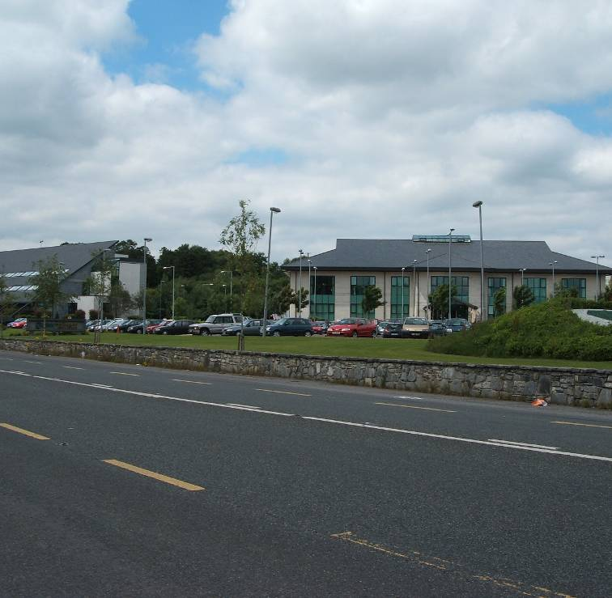

PART FOUR
FRAMEWORK, VISION, OBJECTIVES
& GUIDING PRINCIPLES

PART FOUR - FRAMEWORK VISION, OBJECTIVES AND GUIDING PRINCIPLES

4.1 Vision

The vision for the Integrated Framework Plan for Cavan is to provide the framework for a unique and sustainable town, with a balanced range of functions, facilities and amenities, building on its present strengths of its people, enterprise and natural assets while meeting the needs of the whole community who live work and visit the area.

4.2 Objectives

The primary objectives of the Integrated Framework Plan are based on the principles of sustainable development and are:

- To promote and encourage the development and growth of Cavan in line with the principles of sustainable development;
- To facilitate the provision of infrastructure to cater for economic development and employment expansion;
- To promote an appropriate balance of employment, residential and service facilities (schools, shopping, community facilities etc) and land uses that will increase the self-sufficiency of the town and support its role as a key part of a designated ‘Hub’ in the ‘National Spatial Strategy’;
- To focus new employment and enterprise to locations that reduces the demand for travel and be appropriate in density and type of activity to its location;
- To encourage and promote diversity and quality in new residential developments at higher densities appropriate to their location within the town and relative to sustainable transport modes;
- To support and facilitating tourism development in the town and county;
- To facilitate the expansion of recreational/leisure facilities;
- To respect our natural and built heritage;
- To improve access to cultural and arts activities;
- To incorporate new civic, commercial, shopping, cultural and community facilities within an expanded town centre;

- To facilitate the sustainable economic and social development of the town, through the promotion of a positive climate for development initiative within the plan area;
- To consider provision of a transportation and landuse structure that will provide the orderly planning and development of the town and accommodate sustainable urban growth;
- To make arts, culture and civic vision a key consideration in the design of urban space and policy development;
- To make arts and cultural activities more accessible through the development of an urban cultural environment by creating an overall vision for the Arts in the design of public spaces;
- To preserve, strengthen and develop vibrant communities;
- To promote well-located local centres, containing sufficient commercial, community and educational facilities, integrated with and supporting new and existing residential development and sustainable transport;
- To support the provision of community infrastructure including an emphasis on socially excluded groups.

4.3 Sustainability Objectives

Among the key elements of more sustainable urban policies are a more integrated approach to the physical, economic, social and environmental development of urban areas such as improved accessibility to areas in need of regeneration, environmental up-grading, flexibility in the application of planning policies to encourage a better mix of activities, mechanisms to overcome barriers to regeneration and a partnership approach, involving cross-sectoral consultation and participation.

The following sustainability considerations are of particular importance to Cavan Town and Environs and will form the platform for the attainment of the framework plan:

- Seeking a meaningful reduction in the growth in demand for transport;
- Ensuring that land use and transportation planning are intimately integrated and that future land use proposals incorporate appropriate transport measures;
- Achieving a clearer demarcation between urban and rural land uses than at present;
- Increasing emphasis on sustainable transportation alternatives to the private car;
- Protection of the built and cultural heritage of the area;

- Conservation and enhancement of biodiversity and natural heritage;
- Encourage energy efficiency;
- Protection of the environment by minimising waste and pollution;
- Promote the involvement of the local community in decision making and encourage social inclusion.

4.4 Common Targets

In developing the vision and objectives for the Integrated Framework Plan it is important that the basic common given elements for the Town’s development need to be defined. These are:

- An expanded population of 16,000 by 2020;
- A defined Town boundary;
- Opportunities for sustainable employment and enterprise;
- Development of employment lands;
- Maximum use of the lakes hills and trees as valuable public leisure, educational and recreational resources.

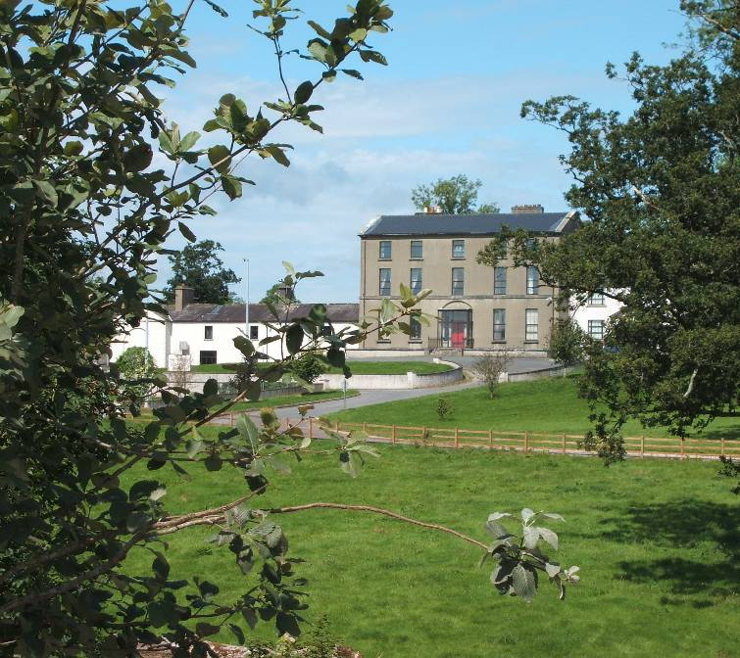

PART FIVE
FUTURE ALTERNATIVE SCENARIOS

PART FIVE - FUTURE ALTERNATIVE SCENARIOS

Four alternative development scenarios for the future of Cavan were developed and assessed during the course of the study. The Scenarios are;

  - Scenarios

Figure 11: Alternative Scenarios for Cavan Town &
Environs
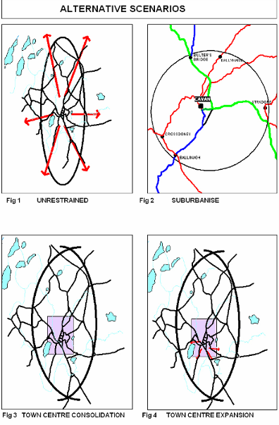
- Unrestrained:
Continue the sprawl of housing estates and one off houses in serviceable lands. This approach is increasingly seen as unsustainable and unacceptable for reasons that include: levels of land take; distance from the town centre; difficulties of integration; and heavy reliance on private car usage; recreates and promotes the use of unsustainable transportation modes.

- Suburbanise (satellites towns/villages)
Develop a necklace of small towns around Cavan Town as distinct and separate suburbs. This approach would focus on future growth of smaller centres such as Butlersbridge, Ballinagh, Ballyhaise, Crossdoney, Lavey, Stradone as expanded settlements.

- Town centre consolidation
This approach would be to focus explicitly on the densification of the town centre with intensification of land uses and focus on employee intensive sectors.

- Town centre expansion and future developments areas:
Promotion of development lands approximate to town centre (East and West), with higher development densities in appropriate existing and future residential areas, improved integration between amenities, development and transportation and better design, so as to create attractive urban living conditions providing a good quality of life.

In developing and testing the scenarios, particular regard was given to the concept of environmental sustainability and the principles adopted by the Government in the National Sustainable Development Strategy (1997).

The following sustainability considerations are of particular importance:

    - seeking a meaningful reduction in the growth in demand for transport;
    - ensuring that land use and transportation planning are intimately integrated and that future land use proposals incorporate appropriate transport measures;
    - achieving a clearer demarcation between urban and rural land uses than at present;
    - increasing emphasis on sustainable transportation alternatives to the private car;
    - protection of the built and cultural heritage of the area;
    - conservation and enhancement of biodiversity and natural heritage;
    - encourage energy efficiency;
    - protection of the environment by minimising waste and pollution;
    - promote the involvement of the local community in decision making and encourage social inclusion.

The scenarios for 2020 include the following common elements:
    - An expanded population of 16,000 (to be achieved by 2020);
    - A defined Town boundary;
    - Opportunities for sustainable employment and enterprise;
    - Development of employment;
    - Maximum use of the lakes hills and trees as a valuable public leisure, educational and recreational resources.

5.2 Assessment

The scenarios were evaluated in the following matrix and compared on performance under the following headings:
    - Transportation;
    - Sustainability;
    - Practicality;
    - Quality of life;
    - Compliance with national and regional policy.

Table 17: Scenarios for Cavan Town & Environs
Scenarios | 1 Unrestrained | 2 Suburbanise | 3 Town centre consolidation | 4 Town centre expansion/ development
transportation |  |  |  | 
sustainability |  |  |  | 
practicality |  |  |  | 
quality of life |  |  |  | 
compliance with national and regional policy |  |  |  | 
Overall |  |  |  | 
Evaluation Matrix
KEY | Promotes | Neutral | Not Compatible
KEY |  |  | 

5.3 Commentary

Scenario 1 does not provide a sustainable transport solution as it reinforces dependency on the private car. Due to the dispersed development, public transport will not be economically viable. Overall quality of life in the long term is lower than the other scenarios and Scenario 1 is therefore not recommended.

The economic viability of practical sustainable transport is less certain for Scenarios 2 than for Scenarios 3 and 4, development is more dispersed and critical thresholds will not be achieved. Scenarios 3 and 4 are the best in this regard. Higher density development, promoted particularly in Scenarios 3 and 4, requires considerably smaller areas of land and consolidates development so walking, cycling and travel by sustainable needs are feasible. The land take requirement associated with higher densities allows for consideration of alternative uses. Scenario 4, envisages an expanded town centre with an additional potential for creation of sustainable jobs and also significant levels of choice for both enterprise and residential development. Whilst Scenario 3 represents a more ideal situation from a sustainability point of view, it is less likely to be achieved than scenario 4.

Increased densities will be the norm in all future urban developments, in response to sustainability issues and government policy. Consequently, the choice is not between high density near the centre and low density on the periphery, but rather between different locations at comparable density levels based on sustainability issues such as energy efficiency, and reduction of reliance on private car. From the above, it is recommended that the preferred framework for future land use and transportation in Cavan in the medium to longer term be based on a combination of Scenarios 3 and 4. That is town centre consolidation, with limited expansion and the co-ordinated development of existing and future residential areas.

Figure 12: Cavan Town – Preferred Framework

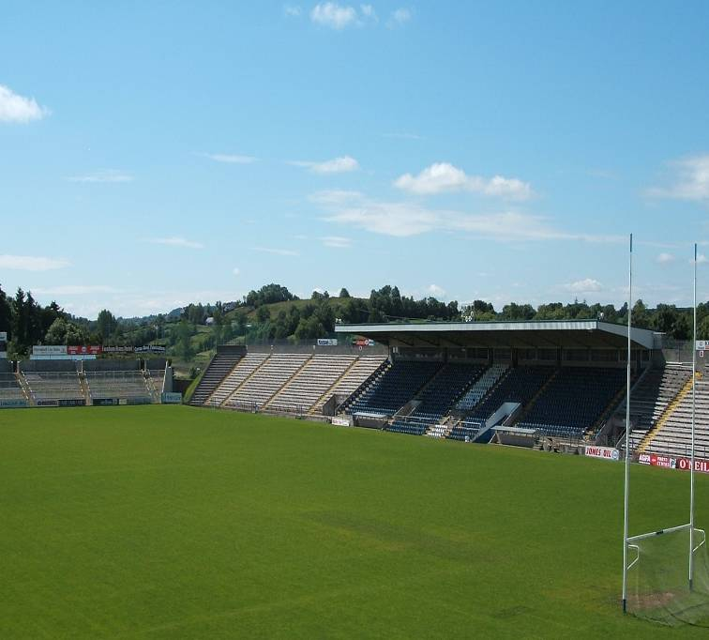

PART SIX
PREFERRED FRAMEWORK

PART SIX - PREFERRED FRAMEWORK

6.1 Introduction

The preferred Framework Plan based on the scenario chosen takes into account the needs of people to travel from their homes to places of work, to schools, to shops and to other services and facilities. It locates housing and other land uses in such a way that, as far as possible, travel is reduced to a minimum. The preferred framework also promotes sustainable modes of travel. The framework combines improvements to the location, scale, form and character of future development with targeted improvements to existing built-up areas. It accommodates higher densities of development, promotes a good demarcation between urban and rural areas, together with high standards of amenity, safety and convenience. The plan is based on developing an expanded town centre, together with a sustainable transport corridor extending from the hospital area through the centre to eastern business parks. Employment will be concentrated in the town centre, retail service and at the identified employment nodes. New walking and cycling routes will connect residential areas, the town centre, recreation/ amenity and employment areas. The framework is described geographically in a Framework Sketch.

6.2 Cavan Town Centre

The town centre will remain as the heart of the community and the principal focus for activity. A vibrant centre will encourage people to live, work, shop and enjoy recreation in Cavan. The existing centre is attractive with a strong identity and sense of place, but its expansion is constrained by limited availability of suitable land, by challenging topography, and by traffic congestion. Part of the approach to preserve quality of life is bringing people, employment and services closer together through designing to higher residential densities. In tandem with this is the need to promote a high quality built and natural environment, which is attractive to industry. Planners and designers involved in the creation of successful new urban centre and residential developments must ensure the following ingredients are incorporated: mixed and inclusive communities; mixture of uses, and a focus on locating housing relative to employment opportunities.

Within the existing urban fabric and through innovative urban design approaches, there are considerable opportunities for co-ordinated backland development with the creation of new streets, civic spaces and squares. The lands east and west of the existing town core provide a unique opportunity to extend the town centre through creative urban design framework which will allow for sustainable transport links whilst controlling the general movement of vehicles. This, together with the implementation of the road proposals as indicated in the transport study, will allow for the creation of a significant pedestrian priority zone in the existing centre.

The maintenance and upkeep of the built environment is critical in ensuring the vitality of the central area. There are a number of areas of high visual quality, though the central area could be better maintained with a resultant upgrading in the quality and attractiveness of the area. Civic Space and the streetscape in the core area are an integral part of the attractiveness and the vitality of the town. The provision of hard and soft landscaping can greatly enhance the visual appearance of the central area.

The result will be a much extended and very attractive town centre with a mix of uses, including residential, and with capacity to accommodate the additional shopping, civic spaces, commercial and other uses arising from the expansion of the town.
The components of the Urban Design Framework for Cavan Town are:
    - Development precincts
    - Public Open Spaces
    - Permeable Streets
    - Historic Fabrics
    - A Landscape Structure
    - A Land Use Framework

The guiding principles are:
- The development precincts should develop as distinct areas, while maintaining a coherent identity between districts.
- The height, massing and scale of the town should respect the existing historic and natural context while establishing a new form for the town.
- An overall identity for the town should be developed.
- The identity and legibility of each precinct should be reinforced by building on the established patterns of urban structure and focusing on key routes, entrances, spaces, and landmarks, as points of expressing local identity.
- The overall town should be permeable with a hierarchy of urban connections linking precincts, and encouraging pedestrian and cyclist movement.
- The urban continuity of the area should be developed by ensuring that buildings fully define urban spaces that streets are created, and that public and private realms are clearly defined.
- A landscape structure should reinforce the urban connections, and facilitate a green network throughout the overall town form, thereby making connections to the countryside, and the main green spaces and corridors within the town and retaining the open character of the area.
- A degree of flexibility in the location of main urban spaces, access points and green areas identified within this plan is required to facilitate inertia and land ownership issues. The plan promotes co-operation and partnership approaches to and between developers.
- A vibrant and living town should be encouraged through sufficient density, a mix of uses and ground floor activities that contribute to all day activities within the context of the character of each precinct.
- The visual appearance of the precincts are suggested through façade articulation, elements, details and a materials palette which are proposed as a starting point for new development.

- The environmental quality of the overall area should occur, through the redevelopment of existing amenity areas, reducing the impact of the car in existing and new development areas, and introducing a simple palette of street furniture, paving, public art and planting, within the development precincts.

To achieve this:

- New town centre development should include a mix of shopping, commercial, community and residential uses in appropriate higher density development around pedestrian friendly streets and squares with high quality urban design;
- New shopping development should be located within the existing or new eastern expanded town centre;
- New expanded town centre will create strong physical and functional links with the existing town centre;
- A diversified town shall be created where people across the spectrum of age, income, ethnicity, and culture can live, work, shop, meet, and play;
- Infill and rehabilitation development will be encouraged within traditionally commercial areas that include proportionately significant residential uses;
- Ensure that pedestrian-oriented building forms and streets will be provided;
- Public safety will be promoted through the provision of pedestrian-oriented street-level uses, sufficient footpath widths, adequate visibility from adjacent buildings and primary pedestrian access from buildings to adjacent footpaths;
- Opportunities for pedestrian amenities, including parks, plazas, greenways and public art installations will be maximised;
- Improve the aesthetics of the built environment;
- Forge a link between planning and design to produce better living environments for people;
- Provide sufficient, safe and accessible parks, plazas and greenways for active and passive enjoyment;
- Prepare urban design codes for development areas especially within the town centre, backlands and infill sites;
- Protect historic fabric through conservation, preservation and redevelopment
- Use the natural topography to deploy new approaches to design;
- Ensure that development is compatible with the remaining traditional fabric and is human in scale;
- Streets will be the focus of design within the town centre and around the public transport corridor;
- New residential layouts should make adequate provision for private open space in the form of gardens, patios, balconies or terraces for all dwellings.

6.3 Employment and Enterprise

Cavan has developed as a key strategic location for industry and employment generating activities. Employment is a high generator of traffic and the location of new employment should therefore reduce the demand for travel and be appropriate in density and type of activity to its location. Mixed use development, including residential, is promoted within the expanded town centre. This will allow more convenient access to facilities, greater opportunities for social interaction, a reduction in both travel demand and town centre congestion and provide a greater urban vitality. In order to support the national, regional and local objectives for sustainable development and to support the local and wider economy, the Framework seeks to ensure that business and industry continue to play an important role, together with a wide range of other commercial and service activities, in providing job opportunities and business activity locally. Policies will therefore aim to conserve appropriately located business activity and provide opportunities for new and expanding employment activities in a flexible and responsive way that takes account of their changing nature and characteristics. Within the town, the Cavan Institute and Cavan Innovation and Technology Centre have some clear strengths which could be more fully utilised.

Figure 13: Employment/ Enterprise
in Cavan Town & Environs

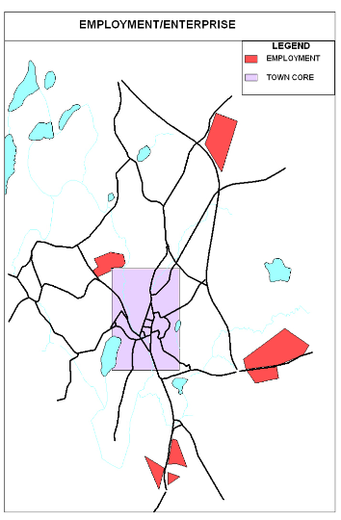
Micro, Small and Medium Sized Enterprises (SMEs) are a crucial component of the economy. Small enterprises can be considered a main driver for innovation, employment, and social and local integration. Aiding the growth of the SME sector in Cavan can be seen as an important development instrument providing valuable employment, social benefits, and sub-contracting functions for larger companies along with many other positive impacts. As a consequence, the Council will seek to identify specific policy initiatives aimed at encouraging existing and potential enterprises and entrepreneurs.

Strategic Employment Locations have been identified to accommodate employment generating uses based on their scale and strategic location and overall accessibility. The proposed employment nodes are generally concentrated in and adjacent to the main development areas and are well located to take advantage of the strategic transport network.

Strategic Employment Locations within the Town can be broken down into six different categories:

  - Science and Technology: Areas for these businesses requiring a high quality environment and are to be provided to the north and east.
  - General Industry: Areas for these enterprises with less demanding requirements located to the south. This will include for Warehousing and Distribution for companies which deal with large volumes of freight transport.
  - Office based industry within town expansion areas and limited areas to the inner eastern bypass area and Killygarry.
  - Hospital Campus: The hospital is recognized as an employment generator and a valuable resource for the Town. Its expansion and development is to be accommodated.
  - Cavan Town Centre: The Town Centre is a place of exchange for goods, services and ideas, providing the focus for a wide range of personal, community, and commercial services. In order for the town centre to achieve their full potential and continually improve as retail and service destination it will be appropriate and necessary to adopt a pro-active role in enhancing its vitality and viability.
  - Home working: The advances in technology is having an increasing impact on employment by bringing home and workplace closer together by supporting home-based working which does not impinge on residential amenity. The benefits of supporting a positive approach to the development of suitable home working are numerous - as organisations become more flexible and responsive, the potential for “smart working”, reduction in commuting, and ultimately quality of life, is attained.

To achieve this:
    - Promote the existence of an enterprise culture in Cavan, encourage start-up business and reduce barriers to success where possible;
    - Provide for economic growth by ensuring that adequate and suitably located serviced employment zoned land is available at appropriate locations;
    - Promote more mixed forms of development in the town centre. Town centre office employment shall be located above shopping developments along main streets;
    - Work in partnership with government agencies and the private sector to promote sustainable economic development and to provide employment opportunities for inhabitants;
    - Encourage development that is likely to generate significant levels of freight traffic to locate at sites close to the existing national roads network;
    - Promote the regeneration of land and premises in a manner which enhances the diversification of the local economy and to encourage business and industry to locate or remain in the County;
    - Support the development of high-end science and technology parks at appropriate locations within the Town and County in order to encourage and support the start up and incubation of innovation led, high growth and knowledge based businesses.
    - Generate stronger working relations between, relevant Institutes of Technology, the Cavan Institute, industry, and the Cavan Innovation and Technology Centre;
    - Seek to facilitate the availability of a range of business accommodation, including that suitable for small business;
    - Encourage developers and other providers to take account of the possibilities of home-working in the design of new houses and the layout of housing areas including provision for broadband facilities;

    - Allow for the development of home based economic activities and small-scale commercial activities carried out by residents of the dwelling which are subordinate to the main use of the property as residential accommodation and are in compliance with the relevant legal requirements including planning;
    - Encourage the development of satellite type office facilities and serviced office premises rented on an "as needed" basis as part of large schemes on lands in urban and industrial areas, where appropriate;
    - Encourage planning and design to achieve better integration of employment areas into the urban fabric of the town, resolving tensions between uses and enhancing the security and permeability of industrial areas for walkers and cyclists as well as business.

6.4 Retail

In tandem with the overall town centre framework, retail development promotes the sustainability and vitality of the town centre. The core or central area of the Town is the established retail and commercial ‘hub’ of the Town. At present, it is a relatively healthy state with a wide variety of shops and a high level of demand for retail units. The core contains a mixture of retail and commercial uses but it is essential to maintain a balance between these. There are an existing number of out-of-centre retail developments in locations at the periphery of the Town’s urban fringe.

Local centres exist throughout the town especially in the eastern and southern areas of the town. It is considered that the provision of a limited neighbourhood facility in the northern western area is essential to facilitate new communities in these areas. The function of these local centres is to provide a range of convenient and easily accessible retail outlets and services within convenient walking distance for the local population. A local centre has traditionally consisted of a small group of shops including such outlets as convenience grocery/newsagent stores, surgeries, and childcare facilities. Due to proximity to the surrounding residential area, certain developments may have an adverse impact on the residential amenity of adjoining occupiers, which must be taken into consideration when evaluating development proposals. The design of new local centres should seek the incorporation of elements such as - quality design, materials and finishes, concentration of appropriate mixed-use activity, accessibility for all and a safe, informally- supervised environment.

To achieve this:

    - A higher proportion of comparison than convenience retail outlets should be permitted in the core to create a lively town centre and healthy competition between retailers;
    - Future retail developments throughout the town will be appropriate to the scale and density of existing development in accordance with the Retail Strategy;
    - Clustering of community and retail facilities will be encouraged to provide a range of activities and to provide for the sustainability of local centres;
    - In the town centre, the amount of service retail uses at ground floor level will be continued to be monitored and, if necessary limited, in order to ensure the retention of the livelier and more animated shopfronts at street level;
    - Residential developments on upper floors in the central area in line with the ‘living above the shop’ policy will be encouraged;
    - Night-time activity should be encouraged in the core e.g. late opening of shops, cafés and restaurants to improve the vitality of the core and improve security by the introduction of ‘passive surveillance” by variety of uses;
    - The evaluation of the impacts of future large-scale developments will be required to prove that they will not have a detrimental impact on the existing retail function of the Town;
    - Retail development in the periphery will be limited to those locations that have already been developed and should be limited to bulky comparison and local convenience only. The size of forecourt retailing will be limited to avoid parking and traffic congestion at these locations. Shops at these locations should remain secondary to the function of petrol station.

6.5 Residential Areas

There is currently enough zoned land to deliver the target population of 16,000. Research undertaken indicates that 43% of residentially zoned land (not committed to planning permissions) remains to be developed. However, additional capacity will be required to allow for headroom, availability of services, choice, challenging topography and provision of a range of housing tenures and size.

Figure 14: Residential/ Community Areas
in Cavan Town & Environs
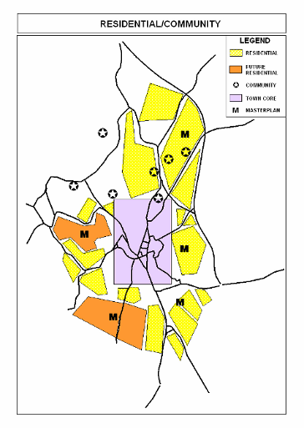
This will be provided by increased densities, preparation of masterplans to facilitate co-ordinated development, changes to zoning approach and phasing of future development land release. Monitoring of relevance of policy and the supply of housing will be undertaken by review of the Housing Strategy and Development Plans as well as by the annual Housing Land Availability Returns for the Department of the Environment, Heritage and Local Government.

Strategic Residential Locations have been identified to accommodate future development based on location, sustainability principles and scale of infrastructural requirements.

Strategic residential locations can be broken down into four different areas.

- Town Core: Mixed use developments will be encouraged within the town core. Significant tracts of zoned lands are available in close proximity to the town centre. Development in these locations will require higher densities subject to high quality architectural treatments and design commensurate with the Hub status of Cavan Town.

- Urban Consolidation Areas: These areas are those which are developed and are continuing to be developed such as established residential areas with infill opportunities. Existing zoned lands not requiring masterplans will be developed sequentially. Development within existing serviced land will ensure the principles of sustainability and efficient use of infrastructure are being attained. Appropriate higher densities will be encouraged in these locations especially in areas close to town core area subject to demonstration of the quality of design and protection of existing residential amenities.

- Masterplan Areas: Large or key sites require significant planning input to ensure development quality for the community. Masterplans provide an opportunity to clearly define the nature, type and development expected. This in turn expedites planning delivery and ensures the delivery of key community objectives. Future and existing zoned land which will require masterplan preparation will be identified. Masterplans establish strategic planning principles for these areas including phasing, infrastructure provision, community facilities, density, layout, open spaces, landscaping and general development design. Masterplans to be approved by the Planning Authority, will be framed within the development plan policy, shall be prepared prior to the submission of planning applications, and be undertaken in conjunction with relevant stakeholders as designated by the Planning Authority. The cost of preparation will be borne by the landowners/developers. The masterplan will require the provision of physical, community and social infrastructure to meet the needs of the growing population. The provision of these infrastructures will be funded by the developers of the proposed development. Open space provision in masterplan areas will be provided in excess of the normal standards and will be required in selected areas to maintain the character of such lands.

- Future Development Areas The Framework Plan indicates lands for future development. These lands will be the subject of future Town and County Development Plans post 2009 and will be phased in tandem with infrastructural provision accordingly. These areas will be subject to masterplans pending the delivery of services.

In general, the quality of life provided for the residents is important in making provision for new residential development. The mix of dwellings, design, layout, density, private and public open space form, materials and colour will influence the quality of the residential environment. The provision of a mix of house types and size will help create a balanced community, provide choice, allow achievement of appropriate densities (at suitable locations) and will create visual variety and interest. It is important that zoning supports the economic drive needed for residential communities to succeed. The relationship to sustainable transport, walking and cycling routes will be important. Certain uses, home-working or home-based offices for example, are acceptable uses within the definition of the residential use and can be distributed directly within housing areas subject to the protection of residential amenities. Private open space provision will be critical. Each household will be provided with private open space: for apartments and high density developments uses of patios, roof gardens, deck, balcony, yard or shared private communal spaces will be promoted. Private open space should not be an afterthought.

To achieve this:
    - Emphasis will be placed on the development of quality residential environments;
    - Appropriate higher residential densities should be promoted close to sustainable transport, employment areas and the town centre;
    - New residential developments should be designed in accordance with masterplans in key locations which will ensure the protection of residential amenity, provision of social and community infrastructure, protection of man-made and natural amenities, useable open space and allow maximum permeability for the pedestrian and cyclist;
    - Facilitate a range of housing types and prices to meet different housing needs;
    - Existing neighbourhoods will be protected from uses and building forms which are incompatible with the scale, character and needs of the adjacent neighbourhoods;
    - Phasing of development, infrastructural provision and development lands will be co-ordinated to avoid piecemeal development;
    - Neighbourhoods will be supported with nodal commercial areas of a size that all uses are within convenient walking distance of one another;
    - New residential developments should include a mixture of different types of houses, apartments and town houses;
    - Encourage developers and other providers to take account of the possibilities of home-working in the design of new houses and the layout of housing areas including provision for broadband facilities;
    - New residential developments should use different building heights, frontages and forms to help create variety and interest in the layout thereby enhancing its visual character;
    - Encourage that both new communities and additional residential units in existing communities are designed to the highest standard. Infill residential units provided in existing communities shall respect the height and massing of existing residential units;
    - Continuous monitoring of the housing market will be undertaken.

6.6 Arts & Culture

A synergy of public vision, risk taking, innovation and creative energies is required to create a Sustainable Town. The challenge involves focusing on the important part which the arts can play in the lives of the people as well as grasping the diversity of the community and the arts sector which can enhance status and civic pride. There is a need to introduce resourcefulness in the integration of the arts into the urban environment and into the urban lifestyle so that the citizens of Cavan can experience art as part of their day to day life.

The aim will be to make the Arts part of every day experience in Cavan town through strategic development of infrastructure, policy, and practice, and by adopting a partnership approach to the integration of the Arts into the urban environment.

To achieve this:

- Identify the public of Cavan town and identify the key concepts and themes related to local identity;
- Enhance the urban environment through the integration of visual artwork and architectural nuances into physical structures. This process will involve collaborations between Artists, Architects, and Engineers in the design and development of urban spaces;
- Look at new approaches to commissioning public art which has value and meaning in the context of Cavan town developing new mechanisms for documenting, evaluating and promoting the arts;
- Demonstrate ways in which collaborations with specialists in the creative industry can enhance urban life and promote Cavan as an innovative and dynamic place to live and work;
- Better understand the ‘public’ of Cavan and generate projects which seek to develop initiatives which reflect the cultural diversity of Cavan and enhance the urban environment in ways which have meaning and value for the people of Cavan;
- The Council will seek to operate as a facilitator and developmental agency for the Arts through the creation of platforms for the arts, both physical and partnership-based, so that the people will be empowered to take greater ownership of arts activity;
- Develop existing spaces in public ownership for arts showcasing, production, and public engagement with the arts. For example, the development of an Arts Centre for Cavan town, a production venue for the Arts through the examination of suitable spaces within the urban environment which may provide useful platforms for the arts;
- Encourage, by example, the investment of private enterprise in the arts. Encourage arts initiatives and arts sponsorship in the business community. For example, through artists in industry and artist in the community residencies;
- Integrate platforms for the arts into the landscaping of natural environments and generate green areas which are stimulating and vibrant and promote local identity to both citizens and visitors alike.

6.7 Heritage

Preserving characteristic features of Cavan Town & Environs allows us to maintain and nurture our cultural heritage as part of our identity. The intrinsic value of the drumlin landscape, the natural heritage areas and the sites, monuments and structures of historic, architectural, artistic or technical interest are major resources for the development of tourism and economic development, whilst contributing to the quality of life. The sustainable management of this heritage is a key priority.

Cavan’s architectural merit is based on the value of the early street pattern of the Old Irish Town (pre 17th century): that is the form and expression of Abbey Street, Bridge Street, Market Square, Main Street and Barrack Hill. Within Cavan Town Centre, there lies an abundance of very fine architecture. Though often not individually important, these buildings contribute to the town’s distinctive street pattern. Collectively, if properly used and maintained they make a significant impact on that distinctive character.

Cavan Town and Environs has a rich and diverse landscape which is the basis for the number of designated amenity areas within the existing Development Plans. Such amenity areas are a potential tourism resource and provide the context for a number of the day to day activities of the community.

The National Spatial Strategy (2002), states that a prime consideration from an environmental standpoint is to maintain the distinction between towns and the countryside and to prevent the further erosion of the respective advantages of both rural and urban areas. The long-term designation and protection of both rural and urban areas encourages the most efficient use and re-use of lands in the urban area while ensuring the viability of the rural hinterland economy. A key policy measure is the consolidation of the urban area and achievement of a greater demarcation between urban and rural land uses Areas of particular sensitivity exist to the west of the town. The vulnerability of this area requires protection by appropriate planning policies.

County Cavan possesses a unique natural scientific heritage. Within Cavan Town and Environs Development Plans 2003-2009, there is one designated Natural Heritage Area (Drumkeen House Woodland 000980) and to the west beyond the town’s built area is the Special Protection Area of Lough Oughter and Associated Lakes. The Council recognises the educational, scientific recreational and tourism value of these areas.

Trees are an environmental, economic and landscape resource of great importance and provide Cavan Town with one of its distinctive natural characteristics. Future development should ensure that trees are retained in groups. Good environmental management is essential and Cavan County and Town Council will continue to co-operate with relevant forestry bodies to seek an increase in appropriate afforestation, particularly of native species and to maintain and improve accessibility to woodlands for recreational purposes

To achieve this:
- Reinforce the distinctive and unique character of Cavan Town, establish the character of the suburbs and ensure that major new developments create their own identity;
- Improve and encourage access to and understanding of the architectural heritage;
- Promote new development that respects the past but allows for necessary change;
- Protect the vulnerability of environmentally sensitive areas;
- Promote the value of knowledge of heritage issues based on educational promotions and ensuring the application of best practice;
- Continue to safeguard the archaeological value of the sites (and their settings) listed in the Record of Monuments and Places and also sites (and their settings) within Urban Archaeological Zone for Cavan Town;
- Continue to protect of Cavan Town's early street pattern of the Old Irish Town (pre-17th century) in particular, seek to conserve and enhance the form and expression of Abbey Street, Bridge Street, Market Square, Main Street and Barrack Hill;
- Continue to conserve and preserve items listed in the Record of Protected Structures, which are of special architectural, historical, archaeological, artistic, cultural, scientific, social or technical interest;
- Facilitate and where feasible, create public rights of way and access to sites of natural, architectural, archaeological and historical interest;
- Ensure that elements of architectural significance are identified, retained and interpreted wherever possible and that the knowledge is placed in the public domain;
- Consider the designation of Architectural Conservation Areas (ACAs) where appropriate and provide a local policy framework for the protection of these areas;
- Ensure the protection/ conservation as appropriate of Drumkeen House Woodland (000980) and to strictly control any development which would be inimical to the preservation or conservation of the essential characteristics of this designated site;
- Continue to conserve important tree groupings within developments and vulnerable trees by means of Tree Preservation Orders as it is deemed necessary. Woodlands to be protected and maintained in accordance with the Woodland Management Strategy;
- Ensure that replanting is required at an appropriate ratio for each tree felled and that new developments should incorporate the planting of native broadleaved species wherever practicable;
- Provide for the creation, maintenance and enhancement of special amenity areas;
- Provide opportunities for access to the open countryside for the urban population, for the retention and enhancement of attractive landscapes and biodiversity near population concentrations;
- Provide opportunities for rural diversification such as urban forestry/woodland, where appropriate;
- Provide opportunities for the enhancement of urban fringe areas in the knowledge that there is a long-term commitment to retain their open character;
- Protect significant tree groups and other vegetation types and encourage landscaping and tree planting as a means of air purification and the filtering of suspended particles.

6.8 Open Space & Recreation

Comprehensive recreational and leisure polices are necessary for the provision of public open space and recreational facilities in new developments. People have condensed leisure time while wishing to improve their quality of life. These factors have led to an increase in the demand for accessible, useable dedicated open space and recreational facilities, including all-weather roofed facilities.

Public open space provides the following functions: routes for movement, leisure, amenity, protection and access to heritage items. Cavan requires access to recreational and amenity facilities which are commensurate with its regional and county town status. Greater use of the lakes (Swellan, Green Lough, Killymoney), rivers, forests (Drumkeen House Woodland 000980), and railway line will be promoted and facilitated subject to addressing sensitive visual and ecological issues due to the presence of important habitats, flora and fauna in these locations. Existing private and public sports facilities will be augmented to promote healthy and enjoyable lifestyles.

The development of a necklace of recreational opportunities with civic and green spaces within the centre would provide access for all citizens to both passive and active leisure opportunities and create a healthy and sustainable urban framework.

Figure 15: Recreation/ Community
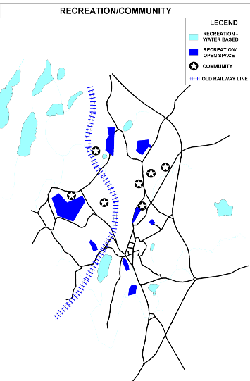
Thus additional recreational open space and amenity in Cavan, will be provided preferably located within easy walking distance of residential areas, which will enhance the quality and sustainability of the residential environment and contribute to people’s health, well-being and quality of life.

In addition open space within developments will focus on quality provision especially with respect to surveillance, maintenance and usefulness to residents. Focus on quantitative provision will no longer be the main control parameter.

In certain circumstances, where the qualitative open space standards cannot be achieved or where more intensive recreational uses are deemed to be desirable, the Council may consider arrangements whereby appropriate intensive facilities may be provided in lieu of open space of lesser utility or contribution to the provision of accessible leisure facilities.

Community facilities are defined as any resource, usually in the form of a building or structure (but may also be a pitch or court), which is used by a variety of ‘not for profit’ voluntary organisations usually to advance their interests in community, culture, sports or other similar group activities. Schools, churches, childcare facilities, health centres and credit unions etc. are not included in this definition.

To deliver this:

- Provide a network of amenity areas, open spaces and places of recreation throughout the town based on natural and manmade assets and a range of activities to reflect the diversity of the population.
- Develop sustainable recreational uses for the lakes of Cavan town.
- Create space for children’s play, nature conservation and sports facilities within walking distance of residential areas.
- Qualitative standards will be applicable especially in respect to usefulness of open space and maintenance issues. Where suitable public open space cannot be delivered provision of alternative intensive recreational facilities or contributions towards the provision of such appropriate amenity facilities will be accepted.
- Design of open spaces should incorporate the need for safety and informal surveillance.
- New residential layouts should make adequate provision for private open space in the form of gardens, patios, balconies or terraces for all dwellings,
- Provide sufficient, safe and accessible parks, plazas and greenways for active and passive enjoyment;
- Promote the development of residential uses in institutional properties, brownfield and new residential areas which will be subject to the preparation of masterplans. Masterplans will include for the retention of its character and recreational or amenity uses. Open space provision in masterplan areas will be provided in excess of the normal standards and will be required in selected areas to maintain the character of such lands.

6.9 Utilities Infrastructure

The future growth and development of Cavan Town is intrinsically and essentially linked to the improvement, expansion and provision of certain essential services. Services such as water supply, sewer and surface water infrastructure, adequate waste re-cycling, disposal facilities and energy supply are all basic necessities. Telecommunications and I.T. facilities are essential to anchor Cavan’s position both as an ideal location for business and a modern urban area.

At present Cavan Town is undergoing a significant degree of growth both in terms of population and development of the town itself. Such growth requires equal improvement and development of water supply, sewer and surface water infrastructure, as well as the provision of adequate waste re-cycling and disposal facilities.

As Cavan Town grows the issue of waste management will become more and more pressing. It is essential that this issue is dealt with in an efficient manner. Up-to-date and efficient Broadband and IT facilities are essential components of life in a modern urban life. As such, it is essential that such facilities are provided in Cavan Town.

Relative to other counties in the region the extent of flooding is low; however there are areas in Cavan which are at risk of flooding. Given the varying predictions about climate changes due to global warming, this issue must now be given serious consideration and will have implications for ground-water levels and storm drainage requirements for the future. The Council recognises the sensitivity of the river catchments both to disruption of the natural flow regime which can cause flooding, and to pollution. These issues must be comprehensively addressed in any application within or draining to these catchments.

To achieve this:
- Ensure an adequate, sustainable and economic supply of good quality water for domestic, commercial and industrial use.
- Promote public awareness and involvement in water conservation measures.
- Ensure that all drinking water complies with the European Union Drinking Water Directive 98/83/EC.
- Implement the Cavan Main Drainage Scheme, construction of the new Wastewater Treatment Plant and improvements to other identified sewerage and drainage schemes so as to ensure a sustainable treatment of effluent waste within the town and environs.
- Ensure that developers provide efficient drainage systems with separate foul and surface water networks.
- Ensure that effluent sludge is treated to the required European Union standards.
- Support the need for a hydrological survey and also an overall assessment of the existing stormwater disposal system in the locality prior to any development.
- Generally prevent the alteration of natural drainage schemes and in the case of development works, require the provision of acceptable mitigation measures in order to minimise the risk of flooding and negative impacts to water quality (including run-off, erosion and sedimentation).
- Ensure Sustainable Urban Design Systems are designed and implemented, such that the permitted flow from a development to a public stormwater or watercourse is restricted to the natural run-off rates from a site before development took place.
- Preserve and protect the water quality of natural surface water storage sites, such as wetlands, where these help to regulate stream flows, recharge groundwater and screen pollutants (such features also provide important habitat functions).
- Protect river channels and streams, which can facilitate surface water drainage, by ensuring that development is kept at an appropriate distance from stream banks and adequate protection measures are put in place.
- Restrict new development that would unacceptably increase the risk of flooding of existing developments and lands. New development should not exacerbate the risk of flooding at other locations.
- Implement the Regional Waste Management Plan.
- Ensure and facilitate the promotion and provision of broadband and ICT facilities
- Ensure that all new developments are served with adequate public lighting and other available public utilities.
- Facilitate the provision of utilities, such as electricity and telecommunications, to serve the projected population growth and consumer demand within the area.
- Co-ordinate with utility providers, particularly in the early stages of major projects, to limit the proliferation of unsightly lines, aerials and/or antennae, and to limit continuous disruption to public roads from the alternate provision of infrastructure by different companies.
- Encourage, where feasible, the joint usage (co-location) of utility facilities and services.
- Support the infrastructural development of ESB networks, including the overhead kV lines required to provide the network needed.
- Require the provision of electricity cables underground, especially in the urban environment and in areas of public open space.
- To implement the Development Contribution Scheme.

6.10 Education and Community Facilities

Sustainable Development requires that due attention be given to social equity and cultural identity. Although, it is beyond the jurisdiction of Council to provide for educational and health facilities, it is committed to involving local people and communities in all issues that affect their area.

There are many organisations in the County and Cavan Town that are working to reduce levels of social exclusion by providing services to communities, building the capacity of local groups, empowering individuals and promoting participation in community activity. The Council seeks to establish the partnership approach, between the Council, local community groups and relevant agencies as the basis for the formulation of plans, which reflect the real needs of the community. The Council is committed to maintaining good working relationships with voluntary groups and organisations and to supporting efforts by communities to provide and improve facilities and amenities in their local areas. It is intended to promote public awareness of the functions and activities of the Council, to provide information in relation to its policies and objectives and to engage in consultation with local communities as appropriate.

Facilities within the community such as childcare, schools and services for the elderly must be properly distributed and located to maximise their efficiency and to facilitate ease of access for their users. The more difficult it is to reach these services, the less likely people are to use them, particularly the more vulnerable members of the community. The facilities also need to be adaptable in order to meet the varying demands placed upon them.

Existing schools, at both primary and post-primary level, will need to be expanded to serve the new population. Education, health and community facilities generate high levels of traffic movements and should, where possible, be developed adjacent to or integrated with the development of future residential centres with their associated good transport links. The integration of the arts into civic spaces will be facilitated and encouraged throughout the town. Facilities serving wider catchments, such as libraries and theatres, are best located in the town centre.

To achieve this:
- Support the provision of a range of social infrastructure facilities to meet the needs of the Town’s population in liaison with other statutory, voluntary, and community groups.
- Support the development of new and improved social infrastructure facilities, including multi-use and clustering of such facilities in areas of maximum accessibility by public transport, walking and cycling routes
- Major community / civic buildings and uses are located within the expanded town centre
- Access to the arts will be facilitated in civic spaces throughout the town and environs.
- Provision for childcare facilities will be undertaken in accordance with the Government’s Guidelines for Childcare.
- The development of healthcare facilities will continue to be facilitated.
- The promotion of providing access to all members of society to facilities will be ensured.
- Build on the spirit of partnership so as to ensure real social development by promoting community participation in the planning process.

- Encourage and assist the formation, development, guidance and co-ordination of community organisations, local interests and self help groups, with an emphasis on areas of Special Need within the County.
- Support the provision of community facilities where necessary and continue to sponsor community projects where appropriate.
- Recognise the need to acknowledge and embrace cultural diversity in planning for the needs of Cavan’s community.
- Recognise the need for people with special needs to enjoy a decent living environment in the County, and to support the local communities, the health authorities and other bodies involved in the provision of facilities for people with special needs.
- To implement the Development Contribution Scheme. This will form a basis for the improvement of existing community facilities and the funding of new community facilities.

6.11 Sustainable Travel

An important objective of sustainable development is to secure a reduction in the need to travel, especially by private car, and to promote a greater use of alternative modes of travel, including walking, cycling and public transport. This can be achieved by locating everyday destinations, such as the workplace, shops, schools and leisure facilities close together, by designing in alternative modes at the earliest stages of development and by concentrating land uses around public transport routes at appropriate higher densities. The travel modes need to be affective, affordable, accessible, and safe and environmentally sound, with adequate carrying capacity.

Cavan is of an appropriate size to be attractive for walking and cycling and existing routes are relatively direct. The network of paths and cycleways need to be extended, improved and made more attractive.

Appropriate car parking control and other traffic management measures can regulate private car usage and encourage trips by non-car modes. Nevertheless, the provision of adequate car parking, including off-street parking in the extended town centre, is essential.

In the longer-term, the completion of the Transportation Study’s priority roads will provide the opportunity to introduce a major pedestrian priority area in the centre of the town. In the interim, traffic management measures should be introduced to improve the environment, enhance provision for walkers and cyclists and to rationalise on-street parking.

Future development should:
- Implement the Transportation Study for Cavan Town & Environs;
- Ensure that sustainable transport is integrated into the development proposals;
- Increase accessibility through development densities;
- Explore with other relevant public, private and community organisations, a range of innovative transport proposals including, rural park and ride schemes, rural carpooling and car-sharing schemes, and rural bus schemes;
- Provide comprehensive walking and cycling routes within the existing urban area and within future developments;
- Develop a cycle link within Cavan Town especially to schools and employment nodes;
- Encourage walking by providing appropriate footways and footpaths;
- Provide appropriately-scaled, continuous pedestrian oriented uses and activities adjacent to sidewalks along streets with identified pedestrian needs;
facilitate safe, pleasant and convenient pedestrian circulation and minimize conflict between pedestrians and vehicles;
- Ensure adequate parking for new developments;
- Introduce traffic management measures throughout the Town Centre;
- Provide off-street parking to serve extended town centre as required;
- Reduce parking requirements by encouraging shared parking and alternative modes of transportation.

6.12 Environmental Issues

As Cavan Town grows, expands and develops there will be an ever increasing pressure on the natural environment within and around the town. All future development will take a sympathetic approach to the natural environment using principles of sustainability as the basis for all decisions.

The policies of this framework were devised at a strategic level, with sustainable values at its core, to locate new development within or adjacent to existing settlements, minimising the distance between homes, jobs and local services, and thus reducing the need to travel and associated energy consumption. The principle of densification therefore has been established in the form of the consolidation of the town centre. The key principles behind the strategy are also key sustainability principles, namely:

- Easy access to transport corridors and nodes,
- Reducing traffic congestion, by transferring trips from private cars to walking, cycling and public transport and diverting traffic away from the town centre to the orbital routes which will reduce total fuel consumption and improve environmental conditions in the town centre.
- Encouraging walking, cycling and bus travel rather than by car
- Increased densities in appropriate locations,
- Accessibility to mixed-use functions and services,
- Protection and enhancement of key landscape features.
- A good distribution and mix of open spaces and recreational facilities
- Promotion of urban renewal and regeneration,
- Promotion of heritage and culture, to enhance the attractiveness of the Town and Environs.

At the local level, the design and layout of new developments can have an important effect on energy consumption and developers will be encouraged to maximise energy efficiency by design.

The principles of sustainability intrinsic to this Framework are as follows:

6.12.1 Protection of Natural Resources

All natural resources need to be carefully used in a sustainable manner so that there is always an equal balance or harmony between the environment and human development. These resources include land take, water consumption, the use of non-renewable resources materials such as fossil fuels contribute to the greenhouse effect. Fossil fuels are used in transport and general energy consumption in heating, lighting, businesses and agriculture. The development of Greenfield land can mean the loss of habitats, flora and fauna and contribute to the depletion of agricultural and recreational land. Over consumption of water can lead to threats to habitats, biodiversity and the natural water table.

6.12.2 Natural Ecosystems

Plants and animals are particularly important to protect as they contribute to the harmony or balance of nature and add to the quality of life. Plants (flora) contribute to the carbon balance; that is the ability of plants to soak up CO2 and many other pollutants caused by burning fossil fuels. The survival of a plant species is often dependent on the existence of a specific animal species and vice versa.
Animals (fauna) are part of the inter-linked eco-system, illustrated by the co-dependency of flora and fauna. Bio-diversity is thus increasingly seen as a key element of sustainability.

6.12.3 Water Quality

All life depends on water. Maintaining water quality is necessary to ensure continued safe consumption, free from harmful bacteria and pollutants. It is also important for the natural environment and natural ecosystems.

6.12.4 Waste Management

The massive amount of waste produced by humans must also be significantly reduced or recycled to increase more sustainable living. Waste covers a wide range of areas including construction, industry, agriculture and household refuse.

6.12.5 Energy Efficiency

Energy production needs to be undertaken through more sustainable means, with less reliance on fossil fuels and greater use of wind, hydro, solar and tidal power; the promotion of energy efficient designs, including passive solar heating, passive cooling, use of shelter-belts, use of site layout to minimize wind exposure, and increased insulation (heat reduction measures), etc.

6.12.6 Integration of Land Use and Transportation

The distribution of land uses and the established densities in Irish towns are not sufficient to sustain an efficient public transport system. By integrating land use and transportation more effectively, this can reduce car travel demand, which in turn reduces energy consumption, congestion and pollution and promotes a more environmentally sustainable transport solution.

Flexibility in the way we live and work such as working from home, working locally and internet shopping are becoming more commonplace due to the advancement of communication technologies and can reduce car trip generation. Cheap communication using the internet and other technologies is now possible. This type of working has benefits for sustainable living as it encourages mixing of uses and reduces unnecessary trips while also helping to ensure local economic buoyancy. Opportunity will be given within the land use planning system to accommodate developments, which might contribute to more sustainable urban systems, such as ‘live-work’ units (where the home or office/workshop merge). The plan promotes good access to local facilities as it reduces the need to travel by car; this is particularly important where facilities are needed for those who don’t or cannot drive such as the elderly, children and the otherwise socially excluded.

6.12.7 Eco-Efficiency

Eco-efficiency aims at breaking the link between economic growth on the one hand, and environmental degradation on the other. To achieve eco-efficiency, the local authority will promote cleaner and more efficient methods of production to reduce pressures on the environment and the use of natural resources.

6.12.8 Encouraging Indigenous Business

Whilst inward investment is a very important element of the local economy, local business growth is important to the long-term economic sustainability and stability of Cavan and its Environs. Locally produced goods also mean that it can contribute towards local self sufficiency reducing the need to import goods nationally and internationally, this includes the reduction of food miles, i.e., the reduction of transportation of food. Local industries and crafts can encourage improved local identity and encourage locally provided jobs. They also add to the vitality of the community and sense of place.

6.12.9 Quality of Built Space

The quality of built space improves the liveability of urban areas and therefore the quality of life, it can also further reduce the need to travel and can have an effect on reducing crime in urban areas.

6.12.10 Open Space Provision

Having access to good quality open space of different types can encourage urban living. Open space gives space for active recreation (sports activities) and also for more passive activities such as bird watching, visual amenity, walking and cycling.

6.12.11 Urban Renewal

Renewal and regeneration are important factors in the physical sustainability of urban areas. Urban regeneration and renewal are also critical principles in the reuse of existing land banks, thus reducing the infringement of urban areas into the countryside. It also provides increased accessibility to existing facilities and services, helping to support and sustain existing developments.

Future development will seek to;
- Improve the quality of air and water through provisions for the planting of trees, green space protection, and bicycle parking.
- All new development will be required to have regard to energy efficiency, materials recovery and environmentally responsible design.
- Encourage both the conservation and the efficient use of energy.
- Reduce environmental impacts through planning.
- Encourage maximum use of walking, cycling and public transport.
- Evoke sustainable planning principles which allows for a mixture of uses and house types, reduced reliance on the car and the provision of higher densities.
- Encourage sustainable design principles which will advocate best practices in environmental design for architectural design, siting and water management.

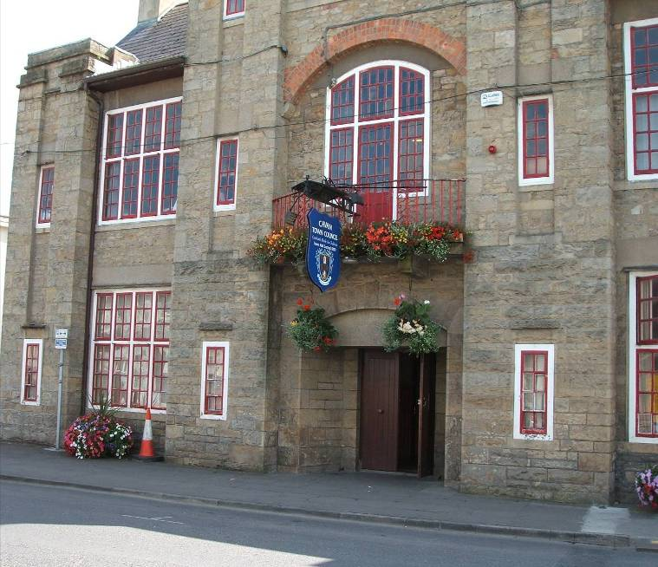
PART SEVEN
IMPLEMENTATION

PART SEVEN - IMPLEMENTATION

The IFP is a single development strategy to avoid uncoordinated fragmented delivery of infrastructure. The Framework Plan is not a statutory plan. The strategy and ethos of the Integrated Framework Plan and Transportation Study will be implemented through the programmes and plans (such as Development Plans) of the Local Authority over the next 13 years. The implementation of a plan may be constrained by a number of elements, namely, the economic climate, political support, allocated local authority funding, and the availability of funding from other sources. Therefore, no funding of projects is guaranteed in advance nor is the implementation of all objectives contained within the plan. However, the local authority intends to exercise all their legal powers to ensure that objectives are implemented.

The responsibility for the implementation of policies and objectives contained within this framework will be dependent on a number of possible sources, including EU programmes and grants, the National Government, the Local Authority and the Private Sector. The local authorities will require developers to incorporate the objectives of future plans into their development proposals. Other objectives, particularly key infrastructural elements will require government funding and support. Where appropriate, the local authority will seek financing from specified sources, both the public and private sector, as well as from EU programmes and grants.

The traditional means of providing infrastructure through the incremental contributions of individual developers will have to meet the scale of growth anticipated in Cavan the framework plan indicates where long term land betterment values should transfer to service public infrastructure using innovative mechanisms which are available or will transpire i.e. Local Delivery Vehicles, Strategic Land and Infrastructure Contracts and Section 49 (special contributions)

Fundamentally the Framework Plan will be implemented through:

- land use measures, as set out in reviews of the Cavan Town Development Plan and the Cavan Environs Development Plan over the next 13 years; and
- short, medium and long term infrastructure and transportation measures.

The following require action to facilitate delivery of the concepts outlined in this document in the short to medium term:

- Review current Development Plans
- Review Housing Strategy
- Review Retail Strategy
- Review Current Development Contributions Scheme.
- Seek to expand the Town Boundary to reflect Cavan Town’s status, spatial and socio-economic context.
- Develop programme and Implement Transport Study
- Develop programme for infrastructure provision.
- Implement the framework through future plans and strategies for Cavan Town

The implementing plans will be based on the framework provided by this plan and should address:

- Meaningful participation and community involvement in the implementation of policies and objectives;
- Engage with government departments, state and semi-state companies, the County Development Board, private developers (through Development Management and public-private partnerships), and community and voluntary groups so as to explore opportunities for the plan’s implementation;
- Pursue funding from all available sources including the private sector and implement a revised comprehensive Development Contribution Scheme. This will be through the mechanisms of a revised Section 48 (Planning and Development Act 2000) Development Contribution Scheme and where necessary Section 49 Supplementary Development Contribution Scheme;
- The phasing and balancing of development throughout the town and environs facilitating flexibility to encourage an enterprise culture and react to ever-changing challenges of new approaches to business and employment;
- Implementation and phasing arrangements which should centre on delivery of key objectives both within the IFP, the Transportation Study and Urban Design Framework.

7.1 Monitoring

The Framework and Transportation Study and Urban Design Framework is to be reviewed in six years or more quickly if there is a significant change in the in National Spatial Planning Policy, Government Policy, funding arrangements or significant economic or environmental effects. To facilitate this review and to assess if the principles are being achieved, monitoring of the strategy will be essential.

Systems will be put in place to monitor the attainment of objectives using the following the following:

- Demographic and housing trends
- Economic Performance
- Social Infrastructure
- Physical Infrastructure
- Environmental Indicators
- Funding
- Implementation Performance

Estimate on current trends and consolidation approach.
Department of the Environment, Heritage and Local Government (2007) Ireland National Climate Change Strategy 2007 -2012. p.36
Border Regional Authority (2004) Regional Planning Guidelines for the Border Region, p.58
Housing Land Availability Research
Estimate on current trends and consolidation approach.
http://www.border.ie/downloads/Population%20Projections.pdf
1 ‘Persons Engaged’ include all employees plus proprietors and unpaid family workers.
Government Publication (June 2006) Towards 2016; Ten-Year Framework Social Partnership Agreement 2006 – 2015. p.6.
Government Publication (June 2006) Towards 2016; Ten-Year Framework Social Partnership Agreement 2006 – 2015. p.10.
The Planning Authority may undertake some masterplans to be agreed with relevant stakeholders.
It should be noted that specific details of the Transportation Study will be subject to the further consultation with relevant stakeholders to reach workable agreements.

