June 2014
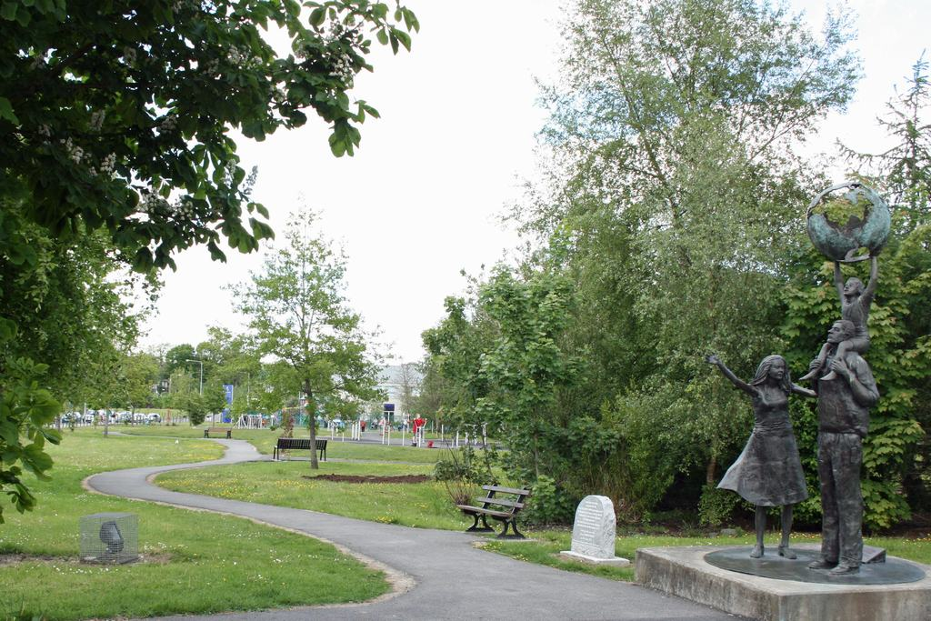
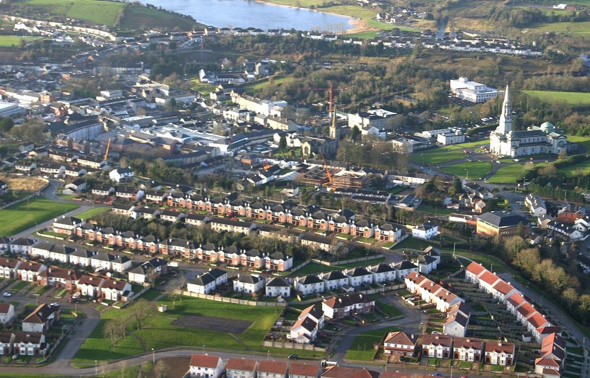

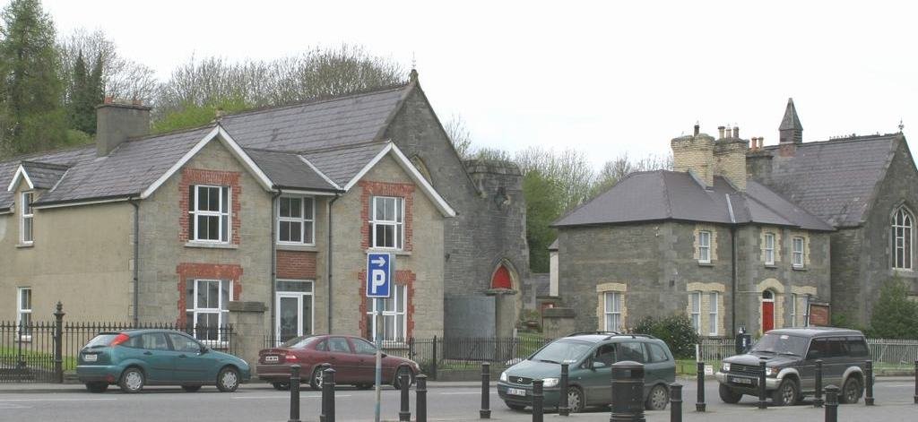

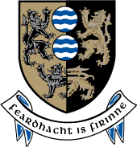
SEA Statement
for the
Cavan Town & Environs Development Plan 2014 - 2020
CAVAN COUNTY COUNCIL

CAVAN TOWN COUNCIL

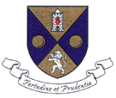

Cavan Town Council
& Cavan County Council
Planning Department
June 2014
Table of Contents

Summary 3
1.1 Introduction 4
1.2 Steps in SEA 4
1.2.1 Scoping of the Environmental Report for the New Draft County Development Plan 4
1.2.2 Consultation with Environmental Authorities 5
1.2.3 Planning Authority Team 7
1.2.4 Environmental Report 7
1.2.5 Draft Cavan County Development Plan & Environmental Report 9
1.2.6 Adopted Development Plan and SEA Statement 10
2.0 Summary of how environmental considerations and the Environmental Report were factored into the plan 11
3.0 Summary of how submissions/consultations were taken into account 12
4.0 Reasons for choosing the plan as adopted, in the light of other reasonable alternatives considered 13
5.0 Monitoring measures and arrangements 14
Conclusion 15
Appendix 1 16

Summary

Cavan County Council has undertaken a Strategic Environmental Assessment of the Draft Cavan Town and Environs Development Plan 2014 – 2020. This process has involved the production of three documents which are Scoping, Environmental Report and the following Strategic Environmental Assessment ‘Statement’.

The Draft Cavan Town and Environs Development Plan 2014– 2020 was adopted on the 21st May, 2014 and will come into effect on the 18th of June 2014.

This SEA Statement has been prepared in accordance with section 13(I)(1) of the Planning and Development (Strategic Environmental Assessment) Regulations 2004 S.I. 346 and contains the following information:
- Summary of how environmental considerations and the Environmental Report were factored into the Cavan County Development Plan
- Summary of how submissions/consultations were taken into account
- Reasons for choosing the plan as adopted, in the light of other reasonable alternatives considered
- Monitoring measures and arrangements

Article 9 of the Strategic Environmental Assessment Directive provides that when a plan is adopted, the environmental authorities, the public, and any relevant transboundary State must be informed and that a SEA Statement must be produced.

1.1 Introduction
The SEA Statement contains a summary of how the following were factored into the Cavan Town and Environs Development Plan as adopted on the 21st of May 2014.
- Summary of how environmental considerations and the Environmental Report were factored into the Cavan Town and Environs Development Plan;
- Summary of how submissions/consultations with the environmental authorities, prescribed bodies, Northern Ireland and the pubic were taken into account;
- Reasons for choosing the Cavan Town and Environs Development Plan as adopted by the Council, in the light of other reasonable alternatives considered; and
- Monitoring measures and arrangements which will identify at an early stage, any unforeseen adverse effects, which will require remedial action making effective use of existing monitoring arrangements to avoid duplication.

The SEA Statement will be made available for public viewing and it will be issued to the Environmental Protection Agency (EPA), Minister for the Environment, Community and Local Government, Minister for Communications, Energy and Natural Resources, SEA Co-ordinator, Environmental & Heritage Service, Department of the Environment Northern Ireland and prescribed bodies.

1.2 Steps in SEA
There are a number of steps in the SEA process (see figure 1). The preparation of the Cavan Town and Environs Development Plan required a full Strategic Environmental Assessment, as the town fulfilled the mandatory requirement in terms of the SEA Regulations (2004) which is: ‘Development Plans by Town Councils, where the population of the is 10,000 persons or more’. This document ‘SEA Statement’ forms part of this statutory requirement.

    - Scoping of the Environmental Report for the New Draft Cavan Town & Environs Development Plan

The Planning Authority, on the 10th of October 2012, gave notice in terms of Sections 9 10 & 11 of the Planning and Development Act2000 (as amended), of the commencement of the review of the current Cavan Town & Environs Development Plan (2008-2014) and the Cavan County Development Plan (2008-2014) and the preparation of new plans for the period (2014 -2020).

The first phase of the public consultation took place from Wednesday, the 10th October to the 5th of December 2012; (8 weeks). In accordance with the provisions of Section 11 of the Planning and Development Act (2000) as amended, and the SEA Directive, a copy of the SEA Scoping Issues Paper and Strategic Issues Papers (attached as Appendix 1), were circulated to the Cavan County and Town Councillors, the Environmental Authorities, Prescribed Bodies. The SEA Scoping Issues Paper and Strategic Issues Papers were also made available on the County and Town websites and all public libraries and Area offices throughout the County. The Paper invited comments from the public on issues relating to the plans and the Environmental Report. A number of public consultation workshops were also held at Cavan Town; Ballyconnell, Bailieborough and Ballyjamesduff, the content of the Scoping Issues Papers were presented and comments were invited from all participants.

The SEA Scoping Issues Paper sets out a description of the County, relevant plans and programmes to be considered during the preparation of the new Draft County and Town Development Plans and Environmental Reports and a baseline of environmental data in the County and Town (grouped under the environmental themes/receptors – biodiversity, flora and fauna, population and human health, soil and landscape, water, air, climate, material assets and cultural heritage including architectural and archaeological).

    - Consultation with Environmental Authorities
The Environmental Authorities (EPA, DoECLG, DoCMNR (now DoCNR) and DoENI) were provided with the Strategic Issues Paper and SEA Scoping Issues Paper and the documents were made available to the public, the Prescribed Bodies and other relevant stakeholders. A number of public consultation workshops on the new Development Plan were held around the County in November 2012.

The Planning Authority formally consulted the designated Environmental Authorities during ‘Scoping’ and during the preparation of the Environmental Report. A submission was received from the Department of the Environment, Heritage and Local Government and from one member of the public in relation to the Scoping Issues Paper. A Scoping meeting was held between the Planning Authority and the Environmental Protection Agency. The submissions received were included in a Scoping Report and the environmental baseline data was updated.

Contact with the Environmental Authorities is as follows: -
The –
    - Environmental Protection Agency (EPA) is to be consulted in all cases.

    - Consultation should take place with the Minister for the Environment, Community and Local Government (DoECLG) where it appears to the Planning Authority that the plan might have significant effects in relation to the architectural or archaeological heritage or to nature conservation; or if consultations are to take place with Northern Ireland.

    - Consultation should take place with the Minister for Communications, Energy and Natural Resources (DoCENR) where it appears to the competent authority that the plan or modification to a plan might have significant effects on the fisheries or marine environment.

    - Consultation should take place with the SEA Co-ordinator, Environmental & Heritage Service, Department of the Environment Northern Ireland (DoENI) where it appears that the plan may have significant environmental transboundary effects.

Figure 1: What Stage are we at?
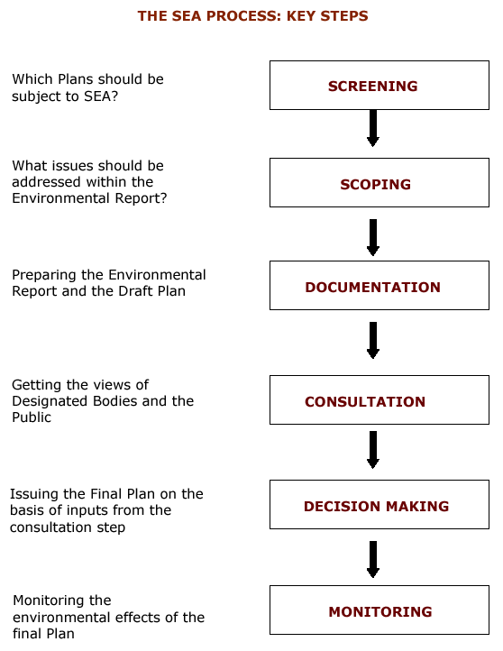
THE SEA & DEVELOPMENT PLAN PROCESS: KEY STEPS
1. Should the Development Plan be subject to a full SEA?
Answer: Yes, proceed to next step as SEA is mandatory in the case of County Development Plans.
DECISION MAKING ON FINAL DOCUMENTS
SCREENING
CONSULTATION
E. REPORT & COUNTY DEV PLAN
MONITORING
SCOPING ISSUES PAPER & SCOPING REPORT

2. What issues, scope and level of detail should be addressed within the Environmental Report?
Answer: Scoping Report contains submissions in relation to level of detail required.

4. Getting the views of Designated Bodies and the Public
5. Adopting the New Development Plan & Environmental Report on the basis of inputs from public consultation. Preparing a Summary Statement detailing how environmental considerations were incorporated into the Development Plan etc.

3. Preparing the Environmental Report and the Draft Development Plan

We are here

We are here

6. Monitoring the environmental effects of the County Development Plan

1.2.3 Planning Authority Team
A Multi-disciplinary team which comprises of members from various sections of the Planning Authority was established in order to prepare a consistent Development Plan and to examine the significant environmental impacts which may result from the implementation of the new County Development Plan. The Environmental Report and Development Plan documents were compiled by the Forward Planning Section of Cavan County Council based on the input of the Multi-disciplinary team.

1.2.4 Environmental Report
The Environmental Report follows the requirements of Schedule 2B (Planning and Development (Strategic Environmental Assessment) Regulations S.I. 436 of 2004). It contains details on relevant plans and programmes which have been taken into consideration during the preparation of the Draft Cavan Town& Environs Development Plan. Existing Environmental Issues in Cavan Town& Environs were identified in the Scoping Report and Environmental Objectives (based on the environmental receptors – biodiversity, water, air etc.) were drafted from national environmental policy while taking existing environmental issues in Cavan Town & Environs into account.

Objectives and policies in the new Draft County Development Plan were drafted and compared to the Environmental Protection Objectives. Subsequently, the likely significant effects of implementation of the County Development Plan were established through the identification of conflicts between the two sets of objectives and policies. This was assessed in a matrix format (see Appendix 1).

Where conflicts arose, opportunities to prevent, reduce or offset any significant adverse effects of implementing the Development Plan were examined and if necessary, some policies were improved with measures to mitigate the effects on the environment.

Alternative development scenarios for Cavan Town & Environ were formulated, based on the environmental receptors (i.e. landscape, biodiversity, human health, etc.) and areas with existing environmental problems. The preferred development scenario was reached for the Draft Cavan Town & Environs Development Plan, based on the Cavan Town and Environs Integrated Framework Plan 2020 (as adopted in July, 2007).

Mitigation measures and methods of offsetting potential impacts have been proposed during the course of the preparation of the two documents. This has resulted in objectives and policies which are more robust and environmentally sustainable. Monitoring will be based around indicators of change in the environment over the lifetime of the Development Plan and set targets which are to be reviewed over the duration of the County Development Plan.

Table 1: Summary of SEA Methodology

Action | Comments
1. Screening | An Environmental Report is mandatory for a Town Development Plan and Local Area Plan where the population is 10,000 persons or more. No Screening was undertaken.
2. Scoping Issues Paper | Scoping Issues Paper prepared containing baseline environmental data.
3. Consultation with the Environmental Authorities | Submissions received from the Environmental Protection Agency.
4. Scoping Report | Submissions received from Environmental Authorities, Prescribed Bodies and members of the public which were incorporated into the Scoping Report and baseline data was amended.
5. Preparation of Environmental Report and Draft County Development Plan  - Environmental Objectives established and Development Objectives established  - Consultation with EPA  - Assessment of Alternative Scenarios  - Mitigation measures detailed  - Monitoring measures detailed | Multi disciplinary team established to create policy consistent documents and to examine the effects on the environment of implementing the objectives and policies.  - Objectives and Polices created in Draft Development Plan assessed in Environmental Report and Development Scenarios for the County examined, based on the previous Environmental Report for the preceding Plan (2008-2014).  - Feedback from on-going Plan preparation process and Environmental Report preparation  - Favoured scenario chosen.  - Mitigation measures discussed and chosen.  - Monitoring incorporated into existing methods.
6. SEA Statement | Information on the adopted Cavan Town & Environs Development Plan 2014 - 2020  - Summary of how environmental considerations and the Environmental Report were factored into the Development Plan  - Summary of how submissions/ consultations were taken into account  - Reasons for choosing the plan as adopted, in the light of other reasonable alternatives considered  - Monitoring measures
7. Monitoring the County Development Plan | Monitoring significant environmental effects over the lifetime of the Cavan Town & Environs Development Plan

1.2.5 Draft Cavan Town & Environs Development Plan & Environmental Report
The Environmental Report and Draft Cavan Town & Environs Development Plan were made available for public viewing and submissions or observations were invited from the Environmental Authorities, the Prescribed Bodies and other relevant stakeholders from the.

Following on from public consultation, the submissions were compiled in a Manager’s Report which identified the main issues in the submissions, a response to the issues raised and a recommendation to the Council as to the Draft Cavan Town & Environs Development Plan and the Environmental Report.

1.2.6 Adopted Development Plan and SEA Statement
The Draft Cavan Town & Environs Development Plan 2014 – 2020 was adopted on the 21st May 2014 and will come into effect on the 18th June 2014. This SEA Statement has been prepared in accordance with section 13(I)(1) of the Planning and Development (Strategic Environmental Assessment) Regulations 2004 S.I. 346. It contains the following information:
- Summary of how environmental considerations and the Environmental Report were factored into the plan
- Summary of how submissions/consultations were taken into account
- Reasons for choosing the plan as adopted, in the light of other reasonable alternatives considered
- Monitoring measures and arrangements

- Summary of how environmental considerations and the Environmental Report were factored into the plan

The SEA process is intended to improve the quality of plans in terms of sustainability and their potential impacts on the environment. Throughout the preparation of the adopted Cavan Town & Environs Development Plans, environmental considerations have been factored into the plans in a number of ways.

Firstly, the SEA process involved consultation and meetings between the Planning Authority, the multi-disciplinary team, the public and the Prescribed Environmental Authorities- EPA, DoE,C&LG, DoCENR and the DoENI.

The consultation and desktop review of documentation, highlighted a number of key Environmental Objectives (EPOs) relevant to the Development Plans.

These include:

Biodiversity, Flora and Fauna
B1 Conserve designated habitats and protected species
B2 Conserve and enhance the biodiversity of interdependent habitats and species in the wider environment.
B3 Protect terrestrial and aquatic habitats form invasive species.

Population and Human Health
P1 Improve people’s quality of life based on high-quality residential working and recreational environments and on sustainable travel patterns
P2 Minimise the amount of waste to landfill.
H1 Minimise noise, vibration and emissions from traffic, industrial processes and extractive industry.
Landscape and Soil including materials
L1 Conserve and enhance natural and historic landscapes and features within them
L2 Conserve and enhance townscape quality
L3 Protection of geological features of Local or National importance.
L4 Provision of Greenways, Walkways, Cycleways to reduce Greenhouse emissions.
S1 Give preference to the re-use of brownfield lands, reducing the need to develop Greenfield lands
S2 Reduce consumption of non-renewable sand, gravel and rock deposits

Water
W1 Protect and enhance the quality of surface, ground and drinking water
W2 Promote water conservation and sustainable water use, based on long term population projections of available water resources
W3 Mitigate the effects of floods
W4 Promote Green Infrastructure and the use of SUDS

Air and Climate
A1 Reduce air pollution and greenhouse gas emission
A2 Promote energy efficiency and maximise use of renewable energy sources

Material Assets
M1 Maximise use of the existing built environment
M2 Maintain infrastructure in the Cavan Town and Environs area and mitigate the effects of further infrastructure provision

Cultural Heritage
C1 Promote the protection and conservation of cultural heritage including architecture and archaeology

The Development Plans have a number of Development Policies and Objectives. The effect of these Development policies and objectives on the environment has been measured and cross-checked against the Environmental Protection Objectives, having regard to mitigating measures proposed where appropriate.

An assessment of proposed development alternatives for Cavan Town and Environs were considered. Scenarios were tested and the most appropriate one was chosen.
Policies and objectives which were chosen were examined in terms of their effects on the environment. Where significant effects arose, measures to prevent, reduce or offset these effects were integrated into the Development Plans. Mitigation measures were identified to prevent, reduce and as fully as possible, offset any significant adverse impacts on the environment of implementing the plans. These include:

Chapter 2: Core Strategy
Development of residential zoned lands in an un-coordinated manner within the development boundary of Cavan Town & Environs, would have a negative impact on the environment particularly: Air & Climate through the increase in contribution of greenhouse gas emissions, through dependence on private motor vehicles to access services in the town; Material Assets – increased pressure on the provision of infrastructure and services; Landscape and Soils – impact of development on the landscape.
The introduction of Core Strategy Policies encourages development that is consistent with the principles of sustainable development and proper planning, through introducing the phasing of zoned lands within the Urban area and by ensuring that development is sustainable in terms of developing in line with existing infrastructure and in a sequential manner, outwards from the core and to make better use of underutilised lands. Cautions against any development being permitted unless the infrastructure deficit has been addressed. The Chapter introduces policies which restrict development in areas which are at risk of flooding.

Chapter 3: Economic Development
- Employment Enterprises
The most significant impact of employment and enterprise objectives and policies is the effect on air quality. All development increases the amount of emissions in the air, through the creation of clusters of industry and enterprise in the urban areas. As a consequence mitigation measures were required in these objectives and policies. A strong landscaping policy, energy efficiency policy and the use of Mobility Management Plans will attempt to offset the emissions which are generated. The Planning Authority will also encourage suitable siting of employment and enterprise areas, including adequate screening and landscaping. The plan also encourages the re-use of industrial buildings for alternative uses, which will have a positive impact on: Material Assests; Air and Climate and Cultural Heritage.

- Energy
In general the policies and objectives for energy have positive impacts on the environmental receptors. Cumulatively, they do have the potential to impact on the character of the townscape and possible impacts on the population in an area due to noise, etc. Supporting Waste to Energy projects or REFIT schemes, limiting emissions of greenhouse gasses through energy efficiency in the development of renewable energy. The plan supports the National Climate Change Strategy. The plan also recommended the strengthening of energy policies- To promote and encourage sustainable energy supplies ‘in appropriate locations subject to normal technical and environmental considerations’.

- Retail
Retail developments significantly contribute to waste generation in the County. They also attract vehicles and generate trips. Out-of-centre retail or commercial development can impact on the town centre. The SEA recommended that retail policies were strengthened in the plan by emphasising a plan led approach to retail development, adopting the principles included in the national Retail Planning Guidelines (2012) and promoting the vitality and viability of the town centres through the Sequential Approach to retail development. This would have a positive impact on Material Assets, Air and Climate and Population and human Health, through facilitating the provision of sustainable patterns of development.

- Major Accidents Directive (Seveso II Sites)
Although there are currently no Seveso II sites located in Cavan Town and Environs or in County Cavan, it is vitally important that sites of this nature are considered for their effects on all the environmental receptors. Problems with the operation of such sites would affect the County and Country as a whole. It is essential to have continuous risk management on any such sites

Chapter 4: Physical Infrastructure
- Accessibility including Cycling and Walking
The provision of adequate parking spaces may both encourage the use of vehicles but it may also reduce the location of cars that would contribute to congestion. The plan supports the use of electrically operated cars and bicycles in-line with National policy, through the requirement for the provision of EV Charging points which supports sustainable transport objectives and zero emissions. Provision of adequate public footpaths, overhead lighting, road pavements, cycling links and bicycle parking will facilitate pedestrian safety and security for movement within the Town. This is especially important in areas linking residential areas and the central area, neighbourhood centres, public facilitates and libraries.
This has a positive implication for
- Transportation
The provision of roads has negative impacts on biodiversity and landscape, human health, water and air quality for the County and the town. Maintaining the road system and extending the road network uses up non-renewable sand, gravel and rock deposits, however, our economic development depends on a safe and efficient road network. The cumulative effect of run-off from roads in the countryside is problematic to local rivers and lakes. The Planning Authority has included policies and objectives in the Development Plans to explore options to increase provision of public transport services and an objective has been included to ensure that the Council considers the recommendations of the Local Biodiversity Action Plan for the County in the construction of new roads.

- Water Services, Wastewater Services, Flood Prevention and
Water Quality
The provision of infrastructure is a requirement to facilitate population growth and to reduce the potential impact on water quality and ultimately human health. Water conservation, protection of Groundwater and measures to reduce flood impacts are encouraged by the Planning Authority. The Water Framework Directive and subsequent River Basin Management Plans are aimed at addressing all impacts to water quality and the Planning Authority will co-operate with other Planning Authorities and agencies in the management of water resources. Waste can have a long term cumulative impact on air and water quality. An adequate waste collection service is necessary to prevent animals using this waste as a source of food, disrupting their normal feeding patterns and this can affect. In order to mitigate this, the Planning Authority will continue to operate within the North East Region Waste Management Plan 2005-2010 and other relevant waste legislation, policy and licensing.

- Energy Supplies and Utilities Infrastructure
Energy supply networks are important for the economic development of Cavan Town and Environs, though they can impact on the landscape and townscape. The Planning Authority has included policies to encourage joint usage or co-location of utility facilities and services in order to minimise visual intrusion.
- Mobile Phone Masts
Mobile Phone Masts have a short term impact on the landscape and this can include cultural heritage. They can have a cumulative impact on scenic areas and tourism resources but are also important for economic development. The Planning Authority will continue to examine the cumulative effects of masts in the landscape.

Chapter 5: Housing
The Housing Chapter is based on recommendations from the Housing Strategy in order to ensure the provision of accommodation for all those who require it and who are unable to obtain it through their own means. All housing developments have an impact as they use non-renewable resources in their construction and contribute to waste and air emissions. However the policies and objectives are positive for the population of County Cavan.

Chapter 6: Social Strategy and Community Facilities
Much of this chapter pertains to the provision of infrastructure which benefits all sectors of the community promoting social inclusion, making provisions for the elderly, persons with disabilities and special needs, the Travelling Community and ethnic minorities. Community facilities can positively impact on the townscapes of County Cavan. Open space and recreational areas enhance living environments. The Cavan Town and Environs Development Plan contains an added objective for ‘public open space’ on ‘biodiversity’- ‘Biodiversity can be enhanced through the creation of green corridors and linking of open spaces to create potential habitats as well as providing a healthy environment for residents’.

Chapter 7: Built Heritage and Archaeology
The objectives and policies for the protection of the Built Heritage are generally positive in terms of population, townscape quality, conservation and protection of the existing built environment and maintaining the built environment. It provides for the retention of Protected Structures, other buildings, non-structural elements, vernacular architecture, shop fronts and industrial heritage. It also provides potential Architectural Conservation Areas within Cavan Town and the necessary protection for archaeological heritage. It encourages a move to positive sensitive design which enhances living environments. The new Development Plans proposes Architectural Conservation Areas. There have been some new additions to the Record of Protected Structures in Cavan Town and Environs. The Urban Design Framework for Cavan Town was adopted in July 2007. Good urban design can enhance the townscape of Cavan Town. The Masterplans which have been identified in the Cavan Town and Environs area have been strengthened through the addition of a biodiversity element where open spaces both public and private, shall consider networking of green areas to create greater space and consider the potential biological benefits and subsequent public health amenity- ‘Issues pertinent to the sustainable management and conservation of Biodiversity shall be considered in all Masterplans’.

Chapter 8: Natural Heritage
The Natural Heritage Chapter contains policies and objectives for the conservation, protection and management of the County’s natural heritage which are generally positive for the protection of designated areas., for specific handling of non-native invasive species, population and human health, landscape, townscape, water quality, flooding and air quality. Development in the Cavan Town and Environs area will be considered subject to site assessment and technical considerations; though the cumulative impact on natural heritage must be assessed and considered. Public open spaces especially green spaces are important for the absorption of water as well as aesthetic benefits, health benefits and as habitats for flora and fauna. A 10-20 metre buffer has been added along rivers as an ‘amenity’ area in the Cavan Town and Environs area in order to protect the river corridor (based on recommendations from the Fisheries Board). The plan also introduces the need to prepare a site specific Flood Risk Assessment as part of the Specific objectives of the plan. The Masterplan areas in Cavan Town and Environs area will provide for adequate provision of amenity including the retention of mature trees where possible, community facilities and employment opportunities in order to reduce unsustainable travel patterns.

- Appropriate Assessment
Along side the SEA process, the Cavan Town and Environs Development Plan was subject to the first stage of the appropriate assessment procedure. This involved the appropriate assessment initial screening stage to determine if the plan would have any likely significant impacts on a designated Natura 2000 site (Special Areas of Conservation or Special Protection Areas). There are no such sites designated within the Plan and the nearest Natura 2000 site is located some distance to the north west of the environs area. The result of the initial screening was that a full appropriate assessment was not required as the plan had no significant impact on any Natura 2000 site.

- Screening of Amendments
The amendments to the Draft Cavan Town & Environs Development Plans were also screened in order to determine if the amendments had any likely significant environmental effects. The results of the screening concluded that the amendments did not have any significant effect on the environment and therefore did not require the full SEA.

Conclusion:

Mitigation measures and methods of offsetting potential impacts have been proposed during the course of the preparation of the documents. This has resulted in objectives and policies which are more robust and environmentally sustainable. Similarly, methods of monitoring and indicators of change in the environment have been proposed with set targets to be reviewed over the duration of the Cavan Town & Environs Development Plans.

The SEA report and methodology applied, has ensured that the Key environmental issues identified, were taken into consideration in the preparation of the Cavan Town & Environs Development Plan for the period 2014 - 2020. As such, the Plan includes a robust set of Policies and Objectives which will ensure the protection and management of key environmental sensitivities and vulnerabilities within the Plan area have been addressed.

- Summary of how submissions/consultations were taken into account
In the case of SEA of a development plan for example, the manager's report under section 12(4) or (8) of the 2000 Planning Act should provide the basis for this part of the SEA statement, which should indicate what action (if any) was taken in response to the submissions/consultations.

3.1 Response from the Environment Authorities:

- EPA: The EPA’s initial submission to assist the planning authority in undertaking an environmental assessment as per the Planning and Development (Strategic Environmental Assessment) Regulations 2004 (S.I.. No. 436 of 2004). This submission consists of an SEA Pack, SEA Scoping Guidance and a checklist to allow you to ensure integration of environmental considerations into the Plans is carried out taking account the Agency’s submission.

Specific Comments to be considered in the Plans
The following in particular, should be reflected in the Draft Plan(s) and associated SEA’s, as relevant and appropriate to the individual plans:
- including a clear commitment for the improvement of water quality (rivers and lakes in particular ranges between ‘Moderate’ to ‘Bad’ status under the Water Framework Directive (WFD) classification.
- Protection of areas listed on the WFD Register of Protected Areas (including River Cavan (Nutrient Sensitive River) Lough Oughter (Nutrient Sensitive Lake).
- Protection of designated (National and EU) and undesignated areas of conservation (Natura 2000 and NHA’s and areas of local undesignated importance), including the Lough Oughter & Associated loughs including the Lough Oughter & associated loughs (SAC/NHA), Lough Sheelin (SPA/NHA) and Cuilcagh – Anierin Uplands (NHA/SCA).
- Areas at risk of flooding, where proposed for development/zoning in the new plans should be appropriate to the risk of flooding identified and avoid vulnerable land uses in areas at significant risk of flooding. A clear commitment to fully integrate, as relevant the requirements of the Flood Risk Management Guidelines (DECLG/OPW, 2009).

- Border Regional Authority:

Key Points
Key issues to note with regard to the development of the new draft Cavan Town and Environs Development Plan include:
- Settlement Strategy should provide a sustainable planning framework for Cavan Town and Environs over the new plan period and beyond. The draft plan should be consistent with all aspects of the County Settlement Strategy and the Regional Planning Guidelines for the Border Region – all population targets, housing and housing land requirements of the RPGs should be incorporated into the new draft plan.
- A full review of the development plan does require an entire review of the plan and this includes a review of all zoning objectives, urban areas and rural settlement types.
- Any land placed in Strategic Residential Reserve in the new plan should be currently serviced or likely to be serviced in the next plan period and have an identified need or else should be considered for alternative objective(new zoning objective) or discontinuing the objective (deletion of zoning objective).
- Excess of land should utilise all options of phasing, alternative objectives and discontinuing of objectives.
- Cavan Town needs to consider consolidation and application of the sequential approach to land use zoning and encouraging the development of the town centre outwards
- Projected growth of Cavan Town needs to be guided by infrastructure capacity of the town in terms of water services.
- All zoning objectives need to be reviewed to ensure there is appropriate amount of land zoned and serviced available to accommodate the sustainable and organic growth of the town in line with the population target.
- Need to have regard to all Section 28 Guidance and Census 2011
- The fall in population in the urban area needs to be addressed by development of pockets of available lands close to town centre.
- All necessary infrastructure including water services, such as water supply and waste water treatment capacity should be put in place in Cavan Town to accommodate the sustainable and organic growth of the town.
- Environment issues emerging through the Environmental Report and Habitats Assessment Report should be incorporated into the new draft plan.
- The issues which rise in relation to land use and transportation need to be addressed at a County and Town and Environs level.

- Leitrim County Council: This Authority welcome the opportunity to make a submission and look forward to continued co-operation with and between both Authorities in the development of the Region; with particular reference to social, cultural and economic development and the protection of the environment. Recommendation that the plan take into account the approach adopted by the Leitrim County Development plan in relation to formulating polices for

Unfinished Housing: Considering the level of vacant, under-construction and unfinished housing developments in both counties, and in the interests of developing a common approach to resolving the issues arising, this Local Authority consider that a similar approach to that taken in the recently adopted Variation No. 1 to the Leitrim County Development Plan, should be adopted. In this regard reference should be made to the ‘Justification Test’ and ‘Sequential Test’ in relation to proposals for new housing developments in both counties, and in the interest of developing a common approach to resolving the issues arising, this Local Authority consider that a similar approach to that taken in the recently adopted Leitrim County Development Plan, should be adopted. In this regard, reference should be made to the ‘Justification Test and Sequential Test in relation to proposals for new housing developments in urban areas where there is a surplus of housing. Likewise, consideration should be given to the inclusion of a specific policy statement in relation to ‘Unfinished Estates’.

In general terms, the following are considered to be amongst the issues of particular importance in the preparation of the plans, (the list is not exhaustive):

- Placing people in particular communities at the centre of Plans;
- Supporting the development of the Border Region with particular regard to securing consistence with the Plans of adjoining counties, RPG’s and National Plans and Policies
- Securing Key Infrastructure
- Promoting and facilitating economic development with particular emphasis on the development of Tourism and indigenous industry
- Ensuring the efficient and effective use of Resources
- Facilitating Renewable Energies
- Protection of the Environment with particular emphasis on securing the aims and objectives of the River Basin Management Plans.
- Ensuring that planning decisions and actions are evidence based
- Ensuring that the Plans are concise, precise and relevant and in general terms more readily accessible.
- Ensuring that the Plans deal appropriately

  - Response from the Prescribed Bodies(as designated in Planning & Development Act 2000, as amended)

The following prescribed bodies responded to the notification, by acknowledging receipt of the letter of notification:

- Inland Fisheries Ireland : The Inland Fisheries Ireland (IFI) is a Statutory Body established on the 1st of July 2010. Under Section 7(1) of the Inland Fisheries Act 2010 (No. 10 of 2010), the principal function of IFI is the protection, management and conservation of the inland fisheries resource.
Under section 7(3) of the IFI Act, it is stated that without prejudice to subsection (1) the IFI shall in the performance of its functions have regard to:
(g) the requirements of the European Communities (Natural Habitats) Regulations 1997 (S.I.No. 94 of 1997) and the need for the sustainable development of the inland fisheries resource (including the conservation of fish and other species of fauna and flora habitats and the biodiversity of inland water ecosystems),
(h) as far as possible, ensure that its activities are carried out so as to protect the national heritage (within the meaning of the Heritage Act 1995).

Having examined the Strategic Issues Paper and the SEA Strategic Issues Paper, we have the following observations to make regarding issues that we believe the Development Plan should address.

County Cavan contains a wide range of fishery habitats with four main river catchments located in the county, namely, Erne, Shannon, Inny, Boyne, Dee and Glyde. These catchments contain a wide variety of fish form Salmonids (Salmon and Brown Trout) to Coarse fish and Pike. Many main river channels and their tributaries are exceptional in the area in supporting Atlantic salmon (Salmo salar, listed under Annex II and V f the EU Habitats Directive ) and Sea trout (Salmo trutta) populations. Recent data also indicates the presence of spawning populations of Sea, River and Brook Lamprey (Lampetra species – Annex II of the EU’s Habitats Directive) in the County. This Highlights the sensitivity of watercourses in the County. Only, clean, uncontaminated surface waters should drain to the river network at all times.

Population, Settlement Strategy and Housing: Development should only take place where the necessary infrastructure is in place to accommodate that development, thus comply with the Water Framework Directive and other legislation to the protection of the aquatic environment.

Community, Recreational and Public Open Spaces: Angling is a popular recreational pastime in the county. With the vast amount of angling waters available we believe the plan should indicate the importance of the development facilities to encourage anglers of all abilities to access this valuable natural resource.

Economic Development and Employment: The Plan should acknowledge the major contribution which angling generally makes to tourism in the county and should provide for close co-operation with IFI in relation to development, promotion and marketing of the angling product in the county.

Physical Infrastructure: The potential impact of roads and watercourse crossings on fish and fish habitats include barriers to fish passage, water pollution, removal of bed material and disturbance of riparian vegetation. The impacts of poorly designed river/stream crossing structures can be serious n terms of habitats loss. Prevention of the free upstream migration of fish species concerned and contravenes the legal obligation under the WDF to protect the ecological status of river catchments and channels. Indeed, it is an offence under the Fisheries Acts to prevent the free passage of fish.
IFI recommends that the new Plan should include a clear policy on the use of clear span structures, where possible, on fisheries waters and that IFI should be consulted on any such proposed developments. Consultation with fisheries bodies should commence early in the planning project and the guidelines “Requirements for the protection of fishery habitat during the construction and development works at river sites” should be referred to in addition to the NRA guidelines.

Water and Wastewater: The Development Plan is an opportunity to promote policies and awareness of water conservation which may ultimately result in a reduction in water use. Water conservation and water use efficiency are central elements of any strategy to enhance water supply reliability, restore ecosystems, and respond to climate change and changing demographics. Significant increases in water conservation and water use efficiency will be required to ensure reliable water supplies in the future. Best practice should be promoted in respect of water conservation in all developments through such methods as rain water harvesting.

Another problem which is particular to summer months (when river/stream flows are often low) is wide scale unregulated water abstraction for crop irrigation. This practice may have significant ecological implications/impacts if large volumes of water are abstracted over a short period of time from nursery or spawning streams, such abstractions during dry weather or drought periods could have severe repercussions for acquatic habitats, fish stocks and accordingly the ecological status of watercourses in terms of the WFD.

Wastewater: Sufficient treatment capacity must be available both within the receiving sewerage systems locally and downstream of waste water treatment plants over the full duration of the plan in order that the ecological integrity of the ultimate receiving waters are protected. IFI would highlight the importance of compiling a comprehensive and robust assessment of both local infrastructural needs and Local Authority capacity to meet those needs into the plan. Should particular WWTP’s fail to provide expected capacities during the life of the plan, IFI would highlight the risk of associated significant environmental impacts which may result from local development.

There are a number of plants in the county, which are at or nearing capacity. Upgrading these plants which discharge into fishery waters should be prioritised. The plants, which are aware of require upgrading include: Kingscourt, Virginia and Bailieborough. The treatment plant at Ballyjamesduff is also approaching capacity.

Renewable Energy: Windfarms: The potential impacts of the proposed development on fisheries relate largely to the construction of the turbines and access roads and the laying of cables, etc. When this work is carried out, in close proximity to a watercourse there is a potential for negative impacts on the aquatic habitat, e.g. water pollution, interference/disturbance with the instream and riparian habitat. Renewable energy projects such as windfarms should be carried out in accordance with any fisheries guidelines issued. Consultation with fisheries bodies should commence early in the planning project.

Rural Areas: Development should comply with the WFD and other legislation to the protection of the aquatic environment.
In relation to agriculture, we would urge the inclusion of a policy to ensure stringent implementation of the Nitrates Regulations/cross-compliance.

Urban Areas: Watercourses are natural corridors for fish and wildlife movement. They may be of significant amenity value or have such potential. They may also be of significance in terms of a towns’ traditional and social history. It is essential that watercourses be maintained in an environmentally and aesthetically sensitive manner for future generations to cherish and protect. IFI requests that the Development Plan provide for the maintenance and preservation of all watercourses and associated riparian habitats.

Natural Heritage: Environment:- The EU Water Framework Directive (2000/60/EC) entered into force in December 2000 requires the protection of the ecological status of river catchments – this encompasses water quality and requires the conservation of habitats for ecological communities. One of the primary objectives of the Directive is to establish a framework which prevents further deterioration and protects and enhances the status of aquatic ecosystems. Protection of aquatic ecosystems requires that river systems be protected on a catchment basis.

The Development Plan should include policies to ensure that developments do not lead to the spread of invasive species. Invasive species may drive local native species to extinction via competitive exclusion, niche displacement or hybridisation with related native species.

- Geological Survey Ireland:

Strategic Environmental Issue Papers – October 2012 – Environmental Scoping Document
Compilation of the Strategic Environmental Assessment (SEA) of the Development Plan, “Soils and Water” chapter:
The “Soils and Water” chapter of the SEA should contain information on soils, geology, geological heritage, surface water and groundwater.
Relevant data are available on GSI website at www.gsi.ie/mapping (either in the form of mapviewers or datasets to download for soils, bedrock, karst, groundwater vulnerability, landslides…)

Geological heritage data are not available as the audit of County Geological Sites has yet to be carried out for Co. Cavan. Please find attached provisional inventory of 20 sites or so for Co. Cavan, which will be confirmed during the audit. Should you have any query in relation to the geological heritage of the County, please contact Sarah Gatley at sarah.gatley@gsi.ie, 01-678 2837.

What key issues will be addressed in the new development plan?
“Protection of our environment and our natural heritage”
The Heritage Act (1995) defines natural heritage as including flora, fauna, wildlife habitats, landscapes, seascapes, wrecks, geology, inland waterways, heritage gardens and parks.
Geological heritage is part of Cavan’s natural heritage and should feature in the “Soils and Geology” chapter of the SEA.
Rigorous evaluation of the County’s geological heritage through an audit of County Geological Sites (CGS) will ensure adequate protection against inappropriate development as per objective of the current County Development Plan (CDP), as described in item 1 of this letter regarding the review of Cavan CDP.
Once documented, the sites should be integrated in the Local Authority’s planning system (in the CDP and in the planning department Geographical Information System). Where applications for development appear to possibly impact on CGS, consultation with GSI should take place to inform on possible mitigation measures, if applicable.
Should you have any query on geological heritage or the above mentioned, please contact Sarah Gatley, Head of the Irish Geological Heritage and Planning Programme at sarah.gatley@gsi.ie, 01-678 2837.
GSI also produced guidelines with the Irish Concrete Federation on how to address geological heritage features when identified in pits and quarries. I’ve enclosed a copy for you information. The guidelines can also be downloaded from GSI website at:http://www.gsi.ie/Programmes/Heritage+and+Planning/Planning/Quarrying+Guidelines.htm

What are the main environmental issues facing Cavan between now and 2020?
- Soils and Water: impact on landscape, geology, soils and water;
Consultation with the Geological Survey of Ireland should take place in relation to planning applications for quarries (either for new applications or applications for retention).
- Air/Noise/Climate: renewable energy;
Consultation with the Geological Survey of Ireland should take place in relation to wind farms applications as per DoEHLG Wind Energy Development Guidelines (chapter 5.3.)
- Material Assets: In order to document the material assets of the county, please note that GSI Minerals Programme has been compiling an “Aggregate Potential Mapping” (APM) project (for crushed rocks and sand and gravel pits) with an online viewer recently launched and accessible either from GSI website: www.gsi.ie/mapping or direct link: http://spatial.dcenr.gov.ie/APM/index.html
Cavan data are not uploaded yet on the viewer but have been compiled. Should you require the dataset, please contact Gerry Stanley, Head of the Minerals Programme at gerry.stanley@gsi.ie, 01-678 2863.
Reference to the GSI/ICF guidelines mentioned above “Geological heritage and the extractive industry” should also be referred to.
I hope that these comments are of assistance for the preparation of Cavan new CDP and SEA, and if the GSI can be of any further help, please contact me.
(A hard copy of this correspondence along with a copy of the GSI/ICF guidelines have also been posted to you).

(3) Health and Safety Authority
In their document ‘Policy and Approach of the Health and Safety Authority to COMAH Risk-based Land-Use Planning’ should be consulted for the preparation of the plan and the plan should include planning policy in relation to major accident hazard sites notified under the regulations.

(4) NRA

- This submission acknowledges the requirement for growth in Cavan and identification of Cavan Town as a Hub Town in the National Spatial Strategy. The M/N3 has been identified as a strategic radial corridor in the National Spatial Strategy and in the Regional Planning Guidelines for the Border Region 2010-2022 as well as the N54 and N55 as strategic links.
- The NRA recommends that the provisions of ‘Spatial Planning and National Roads Guidelines for Planning Authorities’ are included in new policies. The Councils are requested to prepare the draft plan, particularly proposed zoning and development objectives with implications for safe and efficient operation of national roads in the area, to ensure compliance with these Guidelines.
- The NRA supports the concentration of development in established urban centres framed within a coherent integrated land use and transportation strategy.
- The NRA seeks to ensure that the carrying capacity, operational efficiency, safety and significant national investment made in national roads in Cavan are protected.
- The revised Core Strategy should not only consider the extent and location of residential lands but also the extent and location of industrial, employment and other commercial type land uses to prepare a co-ordinated and integrated land use pattern.
- Development plan should contain policy to avoid the creation of additional access points from new development or the generation of increased traffic from existing accesses to national roads to which speed limits greater than 50kph apply and to avoid the proliferation of accesses to national roads subject to 60kph speed limit. There is a requirement to co-ordinate zoning designations and/or access strategies with speed limits on national routes.
- The sustainable integration of land use and transportation needs to be a strategic principle in the draft development plan not only in the transportation section but also as a principle that feeds through social, economic and especially more local area policies and objectives.
- Development objectives should guide developers to design for sustainable transport requirements at the earliest stages of development design.
- Traffic and Transport Assessments are not a substitute for an overall transport assessment of the area prior to preparation of the draft plan. Therefore a Strategic Transport Assessment should be undertaken in the preparation of the Cavan Town and Environs Plan.
- Traffic and Transport Assessments and Road Safety Audits should be carried out on new developments where appropriate.
- The draft plan should contain policy on the control of non road traffic signage on or adjacent to national roads.
- New developments should submit proposals for identification and mitigation of noise.

(5) Department of Arts, Heritage and Gaeltacht - Nature Conservation
The new plan should contain a natural heritage section and the sites, habitats and species listed should be taken into account in the preparation of the new draft plan. Objectives to protect, conserve and protect these sites, habitats and species should be included in the draft plan. The draft plan should ensure nature conservation designation sites are protected through policies and objectives and that the plan takes cognisance of relevant circular letters. This submission makes the following recommendations:
- That new plan fully adheres to Border Regional Authority Regional Planning Guidelines
- Any development arising from the plan complies with proper planning and sustainable development
- Department of Arts, Heritage and Gaeltacht is fully consulted regarding assessments to address possible environmental impacts especially impacts in relation to designated sites e.g. walking trails
- Maps and site synopses of designated and proposed sites are contained in Appendices of the plan
- The plan needs to recognise that protected species can occur outside designated sites and take note of
  - 2020 Biodiversity target agreed at Nagoya Convention on Biological Diversity Intergovernmental Conference in 2010
  - National Biodiversity Plan
  - Need to protect Biodiversity
- Article 10 of Habitats Directive outlines the need to include linear features and stepping stones for Biodiversity in land use plans e.g. hedges, rivers canals and roadside verges, marshes, woodlands
- Proposed plan should emphasise the importance of hedgerows and where require removal should not be done during nesting season and should be replaced.
- Any walkways along rivers or lakes should ensure they are a suitable distance from the water’s edge so as not to interfere with habitats and species.
- A policy needs to be put in place to deal with and protect against the accidental introduction of invasive species. Invasive species needs a policy and plan of action in the new draft plan.
- SEA and Screening for AA or full AA will be required during the process of draft plan preparation. This submission has outlined guidance in relation to baseline information for the Environmental Report, the SEA process and the AA process.

National Monuments Section
The Planning and Development Acts, Local Government Act 2001 and European Convention on the Protection of the Archaeological Heritage (Valetta, 1992) all require that the protection of archaeological heritage is taken into account in the development plan making process. The Department requests that the plan includes a standard objective for the protection of archaeological heritage. The Department also recommends the inclusion of a section/chapter in the draft plan regarding ‘Archaeological Heritage’ which would clearly outline the main planning objectives regarding the archaeological heritage of the Development plan. This submission has included recommended wording of this section of the development plan. The Department has recommended that the development plan includes a record of all areas of importance for the archaeological heritage and all Recorded Monuments should be included on maps.

  - Response from the public
The following comments from the public were made in response to the Strategic Issues papers and the public consultation:

    - GVA Planning:

Key Points
Recent analysis of retail environment in Cavan Town indicates that there are structural problems facing the retail environment of the town. The Retail Excellence Ireland – Town and City Review 2012 indicates that less than 65% of those surveyed use the town as their first choice. A Millward Brown Landsdowne Study confirms that the town is presently lacking a competitive retail offer and requires additional retail representation in both convenience and comparison. Residents are continuing to shop in centres like Enniskillen, Dublin, Navan and Blanchardstown. Shopping expenditure must be retained in the town centre and this can only be achieved by encouraging further retailers to locate within the town centre. It is within the remit of the Planning Authority to integrate economic and spatial planning and to provide for financial incentives for new retailers to invest within the town centre.
Cavan Town and Environs has seen significant population increases over since 2006, however the town has failed to attract significant investment in the retail sector, thereby resulting in very high levels of trade leakage to Northern Ireland and Dublin.
In order for the town to develop, it needs to have an adequate supply of residential zoned land, prioritise a set of economic and spatial development actions that will promote employment creation, develop the attractiveness of the public realm an retain expenditure within the county.
The Planning Authority should take a lead role in the implementation of ‘Putting People First, Action Programme for Effective Local Government’ which seeks to integrate economic and spatial planning. Suggest 3 economic development policies

- Prepare economic strategy in consultation with private sector investors including retailers – this needs to identify the economic challenges facing the retail sector and implement the economic development actions and physical interventions including improved connectivity.
- Re-evaluation of commercial rates and ring fencing a % of commercial rates for improvements to the public realm of the town to improve the quality of shopping experience
- Reduction in development contributions

Cavan Urban Design Framework 2007 will require significant revision to ensure it is reflective of the needs of retail end users.
GVA support the Eastern Access Route and consider that it is important to develop further connections between the town centre, adjacent lands and backland sites.

    - Energy Descent Action Group
Key Points

This group has created an Energy Descent Action Plan which is a guide to reducing our dependence on fossil fuels and reducing our carbon footprint over the next 20 years. This is written for the people of Co. Cavan and community of Cavan Town. Issues include:
- The beginning of the end of cheap oil
- The Earth’s climate is warming
- Our food and water supplies are vulnerable
- World population is booming
- The world economy and financial system is shaking.

The document has provided suggestions in the County for the following topics
- Food
- Health
- Housing
- Community
- Skills/Education/Enterprise/Economics
- Transport
- Energy
- Waste

(3.) Bernard Allan
Key Points
- A town bus network should be considered for Cavan Town linking the town centre, bus station, hospital, retail parks, residential areas and recreational areas. These bus networks are considered viable with populations in excess of 10,000 persons and so, such a service should be viable in Cavan Town.
- The dismantled Cavan-Monaghan- Northern Ireland railway alignment through the urban area of Swellan and Loreto should be protected from development and not used for any purpose that would be incompatible with the potential restoration of the rail service in future decades e.g. a road would be incompatible but a walkway/cycleway would be compatible. The protection of the alignment should be formalised in the Cavan Town and Environs Development Plan.

(4.) Carrickane Residents Association
Key Points
- Request completion of Loreto Road Circuit footpath to create a safe walking circuit and facilitates hospital, school and town traffic.
- They request access to town sewerage system in order to prevent potential pollution of rivers and lakes
- Anxious to see lands at Lisdarn dezoned.
- They regularly clean up rubbish from Loreto Woods and so request more free days for collection of electrical goods and these could be arranged perhaps in Cavan Mart.

Conclusion

The submissions from the Environmental Authorities; the Prescribed Bodies and the Public, were analysed and where relevant, recommendations were made in the Managers’ report to the Council – in January 2014. The proposed amendments to the Draft Cavan Town & Environs Development Plan were proposed and

4.0 Reasons for choosing the plan as adopted, in the light of other reasonable alternatives considered

Consideration of Alternative Scenarios for the Development of Cavan Town and Environs were as follows:
The Planning and Development Act 2000 (as amended) requires the review of a Development Plan, no later than four years after its adoption so as a consequence Cavan County Council does not have an option to ‘doing nothing’. It has a legal responsibility to prepare Development Plans for the sustainable development of the Cavan Town and Environs area.
The Planning Authority has undertaken a Strategic Environmental Assessment in accordance with SEA Regulations 2004 for the Draft Cavan Town and Environs Development Plan. Consequently, Cavan Town Council and Cavan County Council must adopt new Development Plans for their respective areas where identified significant effects can be mitigated through specified actions and where these effects on the environment can be adequately monitored over the lifetime of the Development Plans.

The new Draft Cavan Town and Environs Development Plans 2014 – 2020 will contribute to an environmental improvement for settlement in the Plan area, which will aid sustained economic growth in areas where identified significant environmental effects can be adequately mitigated, thus ensuring a more planned and sustainable approach to the growth of the area. This approach will result in development on lands that have the capacity for it, thus contributing to a more sustainable environment.

A number of Scenarios for the Development of the area were developed based on the Cavan Town and Environs Integrated Framework Plan 2020 which has been formed through analysis of strategic objectives and policies set out at a higher level (see Chapter 4).
A total of four alternative scenarios for the future of Cavan were developed and assessed through consideration of the statutory and operational requirements of the Draft Development Plans.
6.2 Alternative Scenarios for CavanTown & Environs

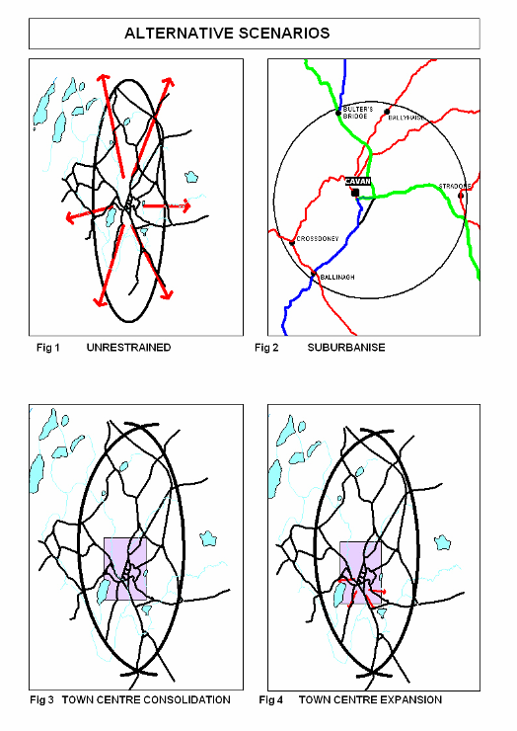
The alternative scenarios for Cavan Town and Environs are considered below:

- Scenario 1 - Unrestrained:
The first Scenario would continue the sprawl of housing estates and one off houses in serviceable lands. This approach is increasingly seen as unsustainable and unacceptable for reasons that include: levels of land take; distance from the town centre; difficulties of social integration; and heavy reliance on private car usage which recreates and promotes the use of unsustainable transportation modes. The economic cost to maintain the infrastructure of the urban area in this scenario would be high. The demarcation between urban and rural area would be unclear resulting in a poor overall townscape and sprawl into the surrounding rural landscape. The cumulative impact of development on the natural environment would result in greater habitat fragmentation or habitat destruction. The targets set out in the National Spatial Strategy to promote balanced sustainable development would not be achieved through the designation of the town as a ‘hub’.
This Scenario could potentially cause significant impacts on all environmental receptors (biodiversity, population, human health, landscape, soil, water, air, climate, material assets and cultural heritage) causing widespread environmental problems, poor water quaility, poor biodiversity, a poor quality built environment and ultimately resulting in poor human health.
- Scenario 2 - Suburbanise (satellites towns/villages)
Develop a necklace of small towns around Cavan Town as distinct and separate suburbs. This approach would focus on future growth of smaller centres such as Butlersbridge, Ballinagh, Ballyhaise, Crossdoney, Lavey, Stradone as expanded settlements.
In this Scenario, the towns surrounding Cavan will grow taking the focus away from developing Cavan Town as a ‘hub’ as identified in the National Spatial Strategy (2002).
Scenario 3 - Town centre consolidation
This approach would be to focus explicitly on the densification of the town centre with intensification of land uses and focus on employee intensive sectors. This would increase the density permitted in the centre of the town with major emphasis of infilling and brownfield development in the existing urban environment. This Scenario may see a rapid growth in population as required by the ‘hub’ town and critical mass could be reached for the provision of a viable public transport system and sustainable waste infrastructure promoting reduction, reuse and recycling of materials. Travel patterns could be sustained with much of the population living and working within close proximity to the town centre reducing the need to travel long distances and encouraging more sustainable means of travel. The cost of maintaining infrastructure is considered viable.

- Scenario 4 - Town centre expansion and future developments areas:
Promotion of development lands approximate to town centre (east and west), with higher development densities in appropriate existing and future residential areas, improved integration between amenities, development and transportation and better design, so as to create attractive urban living conditions providing a good quality of life.
Development in Cavan Town has developed at moderate densities in large residential developments in areas which are relatively close to the town centre and include local shopping areas and primary schools. There are large areas of undeveloped land within the environs area that are currently being used for agricultural purposes. This Scenario would facilitate the development of these lands in a sustainable manner allowing the town to become permeable with linkages from these areas to the town centre and increasing the quality of design of the townscape and creating a clear demarcation between urban and rural areas. The economic cost of infrastructure can be maintained within the area and high levels of service provision and community infrastructure are catered for as well as creating employment opportunities close to residential areas.

6.3 Assessment of the Scenarios
In developing and testing the scenarios, particular regard was given to the concept of environmental sustainability and the principles adopted by the Government in the National Sustainable Development Strategy (1997). The following sustainability considerations are of particular importance:
    - seeking a meaningful reduction in the growth in demand for transport;
    - ensuring that land use and transportation planning are integrated and that future land use proposals incorporate appropriate transport measures;
    - achieving a clearer demarcation between urban and rural land uses than at present;
    - increasing emphasis on sustainable transportation alternatives to the private car;
    - protection of the built and cultural heritage of the area;
    - conservation and enhancement of biodiversity and natural heritage;
    - encourage energy efficiency;
    - protection of the environment by minimising waste and pollution;
    - promote the involvement of the local community in decision making and encourage social inclusion.

The Regional Planning Guidelines (2010 - 2020) have identified a projected growth of 11,600 in 2016 and
12, 800 in 2022 for the ‘Hub’ town of Cavan. All scenarios must work towards reaching the target population. They must also define the boundary of Cavan, provide opportunities for sustainable employment and enterprise and development of employment and maximise the use of the natural environment and educational and recreational resources of the area (Cavan Town and Environs Integrated Framework Plan, 2007). The scenarios were evaluated in the following matrix and compared on performance under the following headings based on the Cavan Town and Environs Integrated Framework Plan (2007) and based on the Environmental Receptors discussed in relation to the Draft Cavan Town and Environs Development Plans.

Integrated Framework Plan
    - Transportation
    - Sustainability
    - Practicality
    - Quality of life
    - Compliance with national and regional policy

Environmental Receptors
- Biodiversity
- Population and Human Health
- Landscape and Soil
- Water
- Air
- Material Assets
- Cultural Heritage

Table 2: Scenarios for Cavan Town & Environs Evaluation Matrix
Scenario | 1 Unrestrained | 2 Suburbanise | 3 Town centre consolidation | 4 Town centre expansion/ development
Biodiversity |  |  |  | 
Population & Human Health |  |  |  | 
Landscape & Soil |  |  |  | 
Water |  |  |  | 
Air |  |  |  | 
Material Assets |  |  |  | 
Cultural Heritage |  |  |  | 
Transportation |  |  |  | 
Sustainability |  |  |  | 
Practicality |  |  |  | 
Quality of Life |  |  |  | 
Compliance with National & Regional Policy |  |  |  | 
Overall |  |  |  | 

Scenario 1 does not provide a sustainable transport solution as it reinforces dependency on the private car. Due to the dispersed development, public transport will not be economically viable. It impacts on many environmental receptors in the long run and overall quality of life in the long term is lower than the other scenarios. It will not achieve the goals set out for ‘hub’ towns under the National Spatial Strategy (2002) and Regional Planning Guidelines (2004) and Scenario 1 is therefore not recommended.

The economic viability of practical sustainable transport is less certain for Scenarios 2 than for Scenarios 3 and 4, development is more dispersed and critical thresholds will not be achieved. There are potential impacts on water quality as not all of these settlements have wastewater treatment plants. It is unlikely that these areas will create a good mix of employment opportunities and services may be dispersed between the settlements. This Scenario does not comply with National and Regional policy guidance.

Scenarios 3 and 4 have the potential to achieve critical thresholds for sustainable growth of the town. Higher density development, promoted particularly in Scenarios 3 and 4, requires considerably smaller areas of land and consolidates development so walking, cycling and travel by sustainable needs are feasible. The land take requirement associated with higher densities allows for consideration of alternative uses. Scenario 4, envisages an expanded town centre with an additional potential for creation of sustainable jobs and also significant levels of choice for both enterprise and residential development. The development of the urban area through town centre expansion will impact on biodiversity with the consequent loss of habitats by developing greenfield sites. Whilst Scenario 3 represents a more ideal situation from a sustainability point of view, it is less likely to be achieved than scenario 4.

Increased densities will be the norm in all future urban developments, in response to sustainability issues and government policy. Consequently, the choice is not between high density near the centre and low density on the periphery, but rather between different locations at comparable density levels based on sustainability issues such as energy efficiency, and reduction of reliance on private car. From the above, it is recommended that the preferred framework for future land use and transportation in Cavan in the medium to longer term be based on a combination of Scenarios 3 and 4. That is town centre consolidation, with limited expansion and the co-ordinated development of existing and future residential areas, through the phasing of residential zoned lands as contained in the Core Strategy and associated maps.
Figure 23: Cavan Town – Preferred Framework
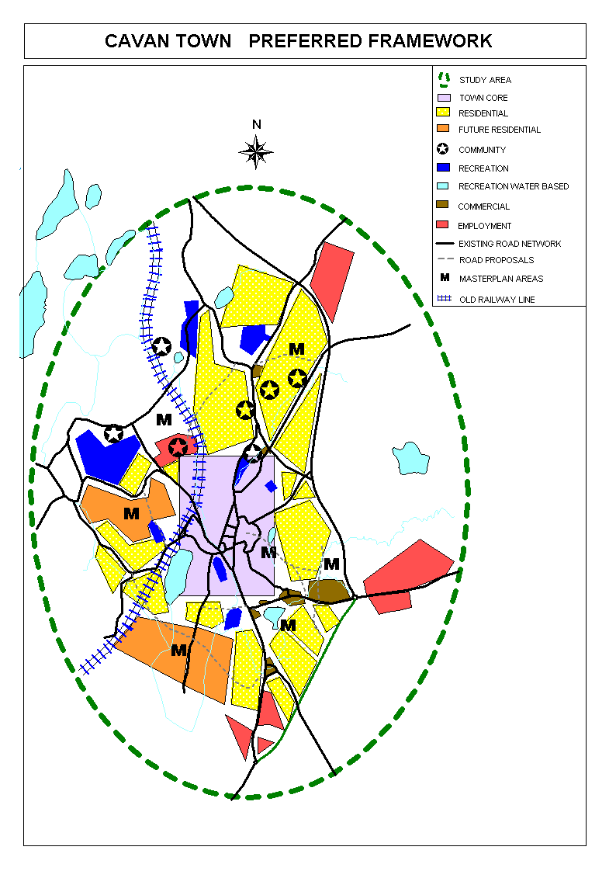

Source: Cavan County Council (2007) Cavan Town and Environs Integrated Framework Plan 2020
- Monitoring measures and arrangements
The Environmental Report which was made available for public consultation included proposals in relation to monitoring of the draft Cavan Town & Environs Development plan. The monitoring of environmental effects of the implementation to the development plan will be prepared in tandems with the monitoring of the adopted Cavan County Development Plan (2014 – 2020) as follows:

Monitoring
The primary purpose of monitoring is to cross-check significant environmental effects which arise during the implementation stage against those predicted during the plan preparation stage. Existing monitoring arrangements may be used if appropriate, to avoid duplication of monitoring. Example: applications for developments which require an Environmental Impact Statement; Appropriate Assessment Screening and/or Natura Impact Statement which will be included in the 2-year progress report on the Implementation of the Plan.

Monitoring Arrangements and Methods
The DoEHLG SEA Guidelines (2004) recommend that the arrangements and methods chosen should be those which are best fitted in each case to checking whether the assumptions made in the Environmental Report correspond with the environmental effects arising from implementation of the plan, and to identifying at an early stage unforeseen adverse effects.

New research activity is not required, existing sources of information can be used. The monitoring of the Development Plan should cover the monitoring of Local Area Plans and Variations etc. Where gaps in environmental information are identified during the preparation of the environmental report, monitoring measures over the period of the plan can be geared towards addressing such gaps, where practicable.

Monitoring will be based around the ‘Environmental Objectives’. A number of Objectives, Indicators and Targets are set below. They will allow measures of trends and progress over time. Many targets will be incorporated with existing targets under European and National legislation (e.g. Phosphorus Regulations). Monitoring proposals must concentrate on likely significant environmental effects, which have been identified in the Environmental Report and the measures identified as necessary to prevent, reduce, or offset any significant adverse effects.

Monitoring at an early stage may identify unforeseen adverse effects and the undertaking of appropriate remedial action.

The Statutory Manager’s Report on Progress in achieving objectives of Development Plan takes place 2-years after the adoption of the Town & Environs Plan and ‘shall include information in relation to the progress on, and the results of monitoring the significant environmental effects of implementation of the development plan’.

If an objective or policy is having a significant adverse impact, a variation may be considered during the lifetime of the Development Plan.

Monitoring Programme for the Cavan County Development Plans (including Local Area Plans)
Cavan County Council will be responsible for monitoring the County Development Plan, Cavan Town & Environs Development Plan and Local Area Plans.
Chapter 11 of the County Development Plan deals with Implementation, Review and Monitoring of the County Development Plan.

Frequency of Reporting
Two years after the Development Plan is adopted, the Manager must prepare a report on ‘Progress in achieving objectives in the Development Plan’. This will include the results of monitoring and a further report will be made available every two years thereafter. It is expected that these reports will be issued to the designated Environmental Authorities and made available on the County Council website.

Gaps in Environmental Information
The preparation of the Environmental Report identified a number of gaps in relation to the follow environmental data.
- Lack of habitats surveys for non-designated sites and insufficient baseline data on habitats and species to allow for on-going monitoring (It should be noted however, that the preparation of a Local Biodiversity Action Plan has begun)
- No wetland inventory (however, it is planned that a Wetland Survey will be undertaken during the lifetime of the Development Plan County Cavan Local Biodiversity Action Plan)
- Information is largely paper based with exceptions of designated areas in digitised format (GIS)
- Deficiency of information on buildings at risk
- No designated Architectural Conservations Areas (ACAs) (The Planning Authority will prepare Draft ACAs during the lifetime of the new County Development Plan)
- Undiscovered sites of cultural heritage

Conclusion
The Strategic Environmental Assessment carried out by Cavan County Council during the preparation of the Cavan County Development Plan and the Cavan Town & Environs Development Plans for 2014 – 2020 has ensured that any potential significant environmental impacts of the plan are identified and that they have been given appropriate consideration. Throughout the preparation of the Plans and the Environmental Reports, consultation has taken place which has contributed to the final adopted plan.

Although the plan has now been adopted, the SEA process will continue through the proposed monitoring of environmental impacts of the implementation of the implementation of the Plan. This will include ongoing monitoring and publication of progress reports.

APPENDIX 5: ENVIRONMENTAL PROTECTION OBJECTIVES:

7.0. Objectives, Indicators and Targets

Biodiversity, Flora and Fauna

Environmental Objectives for Biodiversity, Flora and Fauna:
B1 Conserve designated habitats and protected species
B2 Conserve and enhance the diversity of interdependent habitats and species in the wider environment
B3 Protect terrestrial and aquatic habitats from invasive species

Environmental Receptor  (SEA Directive  Annex I) Biodiversity, Flora and Fauna | Objective  (An objective is a statement of what is intended) | Target  (A target is a more detailed plan specific intended achievement) | Indicator  (An indicator is a measure of variables over time, used to measure achievements of targets and objectives) | Indicator Information Source  or  Authority Responsible for Monitoring | Potential Problems (PP)/  Remedial Action (RA)/  Positive Action (PA)  (If the indicators show potential environmental issues, PPs, RAs or PAs have been identified below) | Format for presentation of results
B1:  Designated Habitats and Protected Species | Conserve designated habitats and protected species | - Retention of designated habitats and protected species (pNHA) in a satisfactory condition. | - Change in condition of pNHA | - National Parks and Wildlife Service  - Information sources in Cavan County Council Audit of Biological Dataset (2007)  - Cavan County Council Environment Department  - EPA | - RA: Examine cumulative effects of planning permissions in these areas in the event of reported change in condition | - Quantitative and qualitative based on information from National Parks and Wildlife Service or any report data available  - Biological quality of water
B1:  Designated Habitats and Protected Species | Conserve designated habitats and protected species | - To site new developments on greenfield sites that are non-sensitive sites | - Rural Housing Annual Report | - Cavan County Council  - Corine Maps | - RA: Investigate source of problem and remedy or mitigate effects if within the remit of Planning Authority Environment Section or Waste Management | - Quantitative and qualitative - % of developments  - Quantitative - trends in Rural Housing and qualitative assessment of effectiveness of policy
B1:  Designated Habitats and Protected Species | Conserve designated habitats and protected species | - Have regard to and undertake actions of the Local Biodiversity Action Plan for County Cavan (when finalised) | - Number of actions undertaken as part of the Local Biodiversity Action Plan and subsequent studies undertaken | - Cavan County Council Heritage Office | - (PA): Examine in the context of the Annual Rural Housing Report

Environmental Receptor  (SEA Directive  Annex I) Biodiversity, Flora and Fauna | Objective  (An objective is a statement of what is intended) | Target  (A target is a more detailed plan specific intended achievement) | Indicator  (An indicator is a measure of variables over time, used to measure achievements of targets and objectives) | Indicator Information Source  or  Authority Responsible for Monitoring | Potential Problems (PP)/  Remedial Action (RA)/  Positive Action (PA)  (If the indicators show potential environmental issues, PPs, RAs or PAs have been identified below) | Format for presentation of results
B2:  Biodiversity in the wider countryside | Conserve and enhance the diversity of interdependent habitats and species in the wider environment | - Establishment of a Hedgerow Committee (consisting of Heritage Officer, Area Engineers, Road Engineers, Planners etc.) | - Implement a policy of use of native seed and native species in County Council projects and planting | - Hedgerow Committee | - (PA): Continuous monitoring of the effectiveness of planning conditions | - Qualitative based on experience of Hedgerow Committee and assessment of success rates
B2:  Biodiversity in the wider countryside |  | - Have regard to and undertake actions of the Local Biodiversity Action Plan for County Cavan (when finalised) | - Number of actions of the Local Biodiversity Action Plan undertaken over lifetime of the County Development Plan | - Cavan County Council Baseline Hedgerow composition based on Hedgerow Survey (2007) and baseline dataset for Local Biodiversity Action Plan (2007) | - (PP): Source of funding  - (RA): Unknown | - Digitised Format of Cavan County Council studies/ publications on Council website
B2:  Biodiversity in the wider countryside |  | - Implement actions of Local Biodiversity Action Plan (when complete) | - Cumulative impact of development based on Rural Housing Annual Report | - Cavan County Council | - (PA): Ensure training of staff in County Council in issues pertaining to biodiversity  - (PA): Engage in education Initiatives for the public and wider community | - Qualitative – based on information from the National Parks and Wildlife Service, Fisheries Boards, other NGOs etc.

Environmental Receptor  (SEA Directive  Annex I) Biodiversity, Flora and Fauna | Objective  (An objective is a statement of what is intended) | Target  (A target is a more detailed plan specific intended achievement) | Indicator  (An indicator is a measure of variables over time, used to measure achievements of targets and objectives) | Indicator Information Source  or  Authority Responsible for Monitoring | Potential Problems (PP)/  Remedial Action (RA)/  Positive Action (PA)  (If the indicators show potential environmental issues, PPs, RAs or PAs have been identified below) | Format for presentation of results
B3:  Invasive Species | Protect terrestrial and aquatic habitats from invasive species | - Cavan County Council and Cavan Town Council will work with other stakeholders in order to control invasive species and continue to raise public awareness of invasive species to prevent the spread of invasive species | - Number of initiatives which Cavan County Council get involved in | - Cavan County Council Planning and Environment Departments  - National Parks and Wildlife Service (DoEHLG) | - (PA): On-going provision of information and awareness campaigns | - List and maps of known areas affected with invasive species (water ways and sites)
B3:  Invasive Species |  | - Cavan County Council and Town Council with support initiatives to manage invasive species | - River Basin Management Plans for Neagh-Bann, North-Western, Shannon and Eastern Region  - Rivers of good and fair biological quality  - Management Plans for the 10 highest risk alien species and contingency plants for 10 highest risk potential invaders (as part of the River Basin Management Plans)  - Local Biodiversity Action Plan (when finalised) | - Fisheries Boards  - Water Framework River Basin Management Plan Monitoring as per www.eden.net  - Cavan County Council  - Bird Watch Ireland (BWI)  - Cavan County Council | - (PA): Continuing involvement and compliance with the River Basin Management Plans  - (PP): Invasive Species  - (RA): Identifying native species at risk at national level due to invasive species | - Qualitative and Quantitative if available  - Number of advertisements in Local Newspapers. Number of information signs at lakes etc.  - Types of information booklets available etc.
Population and Human Health

Environmental Objectives for Population and Human Health:
P1 Improve people's quality of life based on high-quality residential, working and recreational environments and on sustainable travel patterns
P2 Minimise the amount of waste to landfill
H1 Minimise noise, vibration and emissions from traffic, industrial processes and extractive industry

Environmental Receptor  (SEA Directive Annex I) Population and Human Health | Objective  (An objective is a statement of what is intended) | Target  (A target is a more detailed plan specific intended achievement) | Indicator  (An indicator is a measure of variables over time, used to measure achievements of targets and objectives) | Indicator Information Source  or  Authority Responsible for Monitoring | Potential Problems (PP)/  Remedial Action (RA)/  Positive Action (PA)  (If the indicators show potential environmental issues, PPs, RAs or PAs have been identified below) | Format for presentation of results
P1:  Quality of Life | Improve people's quality of life based on high-quality residential, working and recreational environments and on sustainable travel patterns | - Increase distribution of green open spaces for public and private use. | - Land identified as ‘amenity’ spaces on zoned lands in Cavan Towns and quantity of open space provided as part of new developments and status of completion | - Cavan County Council/ Town Council | - (PA): Ensure objectives of Development Plan are implemented with regard to open space provision as part of developments | - Quantitative - % increase of green space in each town both public and private
P1:  Quality of Life |  | - Reduce private car usage, increase and promote walking and cycling and increase access to sustainable means of travel and promote private and public bus services | - Increase in public amenities such as the provision of bus lay-bys (National Routes), cycle parking throughout the area (based on Parking Standards).  - Creation of green linkages and linear walks  - Number of cycle-lanes provided as part of planning permissions.  - Number of Mobility Management Plans in operation as part of planning permission | - Cavan County Council/ Town Council Area Engineers/ Town Engineer | - (PA): Investigate the usefulness of Mobility Management Plans and other opportunities including Transport Studies | - Quantitative analysis of cycle-path provision in towns (Area Engineer/ Town Engineer) and cycle-parking provision  - Mobility Management Plans and Transport Study implementation (Area Engineer/ Planner)
P1:  Quality of Life |  | - Enhance townscape quality | - Number of Masterplans completed | - Cavan County Council/ Cavan Town Council | - (PA): Masterplans to seek the provision of quality open space | - Qualitative and quantitative – number of Master Plans in operation and the subsequent open space provision and community service provision

Environmental Receptor  (SEA Directive  Annex I) Biodiversity, Flora and Fauna |  | Objective  (An objective is a statement of what is intended) | Target  (A target is a more detailed plan specific intended achievement) | Indicator  (An indicator is a measure of variables over time, used to measure achievements of targets and objectives) |  | Indicator Information Source  or  Authority Responsible for Monitoring |  | Potential Problems (PP)/  Remedial Action (RA)/  Positive Action (PA)  (If the indicators show potential environmental issues, PPs, RAs or PAs have been identified below) | Format for presentation of results
P2:  Waste Management | Minimise the amount of waste to landfill through reducing, reusing and recycling |  | - Reduce waste to landfill and increase reuse and recycling of materials  - Increase in volume of waste recycled through use of civic amenity sites/ recycling centre  - Make waste management information available and accessible to the public |  | - Number of new recycling facilities provided as per North East Region Waste Management Strategy.  - Quantity of household waste collected for landfill and quantity of household waste collected for recycling.  - Industrial Waste Generation and Management of Hazardous Waste  - Recovery Rates of Packaging Waste  - Level of success achieved annually in the Tidy Towns Competitions, Irish Business Against Litter (IBAL) League  - National Spring Clean  - National Litter Pollution Monitoring System  - Quantity of street litter, other litter, household and commercial refuse |  | - Cavan County Council  - EPA  - An Taisce | - (RA): Investigate problems and remedy where possible  - (PA): Maintain litter-free status and endeavour to improve areas where problems exist through Cavan Spring Clean Week Initiatives etc.  - (PA): Monitor effectiveness of refuse bins at apartments (policy in Cavan Town & Environs Development Plan) | - Quantitative such as % of Population served by kerbside collection;  - % of population per civic amenity sites and bring sites; green waste composting facilities, biological treatment plants etc in the North East Region;  - Quantitative and qualitative in terms of success in Implementation of North East Region Management Plan
P2:  Waste Management |  |  | - Implement Litter Management Plan |  | - Number of Litter Offences recorded under Waste Management Act 1996-2003  - Number of ‘Adopt a Road’ programmes operational during the lifetime of the Plan  - Number of Fly-Tipping Incidences recorded  - Number of litter fines issued |  | - Cavan County Council | - (PA): Anti-Litter campaigns and education programmes undertaken as part of the Litter Management Plan | - Quantitative and qualitative analysis of implementation of Litter Management Plan  - Number of campaigns initiated.

Environmental Receptor  (SEA Directive  Annex I) Population and Human Health | Objective  (An objective is a statement of what is intended) | Target  (A target is a more detailed plan specific intended achievement) | Indicator  (An indicator is a measure of variables over time, used to measure achievements of targets and objectives) | Indicator Information Source  or  Authority Responsible for Monitoring | Potential Problems (PP)/  Remedial Action (RA)/  Positive Action (PA)  (If the indicators show potential environmental issues, PPs, RAs or PAs have been identified below) | Format for presentation of results
H1:  Emissions | Minimise noise, vibration and emissions from traffic, industrial processes and extractive industry | - Good air quality | - Number of Notices served under Noise Regulations  - Type of Noise Complaints received | - Cavan County Council Environment Department | - (RA): Investigate source of problems and remedy if possible | - Available Traffic Counts  - Number of Noise Notices served and solutions/ mitigation used
H1:  Emissions |  | - Good air quality | - Air Quality Monitoring (EPA)  - Monitoring of Solvents Regulations, Section 4 Licensing  - EIS Monitoring Compliance  - Traffic Counts (Annual Average Daily Traffic)  - Number of home-working applications granted over the lifetime of the Development Plan  - National Allocation Plan 2008-2012 (emissions) | - EPA  - Cavan County Council and Town Council – Planning Department  - Cavan County Council Environment Department  - Cavan County Council Roads Department  - CSO  - Enterprise Ireland | - (RA): Investigate EIAs monitoring if mitigation not effective and any breaches in Solvent Regulations etc. | - Statistics and fines imposed – solutions found etc.
H1:  Emissions |  | - No deterioration in levels of Drinking Water Quality Standards | - Drinking Water Quality Monitoring as per 2007 Regulations or as amended | - EPA  - Cavan County Council | - (RA): Investigate source - remedy based on normal procedures and River Basin Management Plans | - Figures, stats – maps of pressure areas
H1:  Emissions |  | - Implement Transportation Study recommendations for Cavan Town and Environs | - Number of transportation study recommendations in operational | - Cavan County Council Roads Department | - (PA): Successfulness of Transport Studies and Implementation of suggestions/ recommendations  - (PA): Ensure objectives of the Draft Development Plan are implemented | - Quantitative and Qualitative in terms of outstanding areas suffering from traffic congestion

Landscape and Soils

Environmental Objectives for Landscape and Soil including minerals:
L1 Conserve and enhance natural and historic landscapes and features within them
L2 Conserve and enhance townscape quality
S1 Give preference to the re-use of brownfield lands, reducing the need to develop Greenfield lands
S2 Reduce consumption of non-renewable sand, gravel and rock deposits
Environmental Receptor  (SEA Directive  Annex I) Landscape and Soil | Objective  (An objective is a statement of what is intended) | Target  (A target is a more detailed plan specific intended achievement) | Indicator  (An indicator is a measure of variables over time, used to measure achievements of targets and objectives) | Indicator Information Source  or  Authority Responsible for Monitoring | Potential Problems (PP)/  Remedial Action (RA)/  Positive Action (PA)  (If the indicators show potential environmental issues, PPs, RAs or PAs have been identified below) | Format for presentation of results
L1:  Natural and Historic Landscapes | Conserve and enhance natural and historic landscapes and features within them | - Prepare a County Landscape Management Plan and implement recommendations | - Annual Rural Housing Report | - Cavan County Council  - Heritage Council  - Faillte Ireland  - GSI | - (PP): Investigate situations where landscape impact is cumulative  - (RA): Examine if further development policy is required  - (RA): Investigate through Annual Rural Housing Report | - Cumulative effect on landscape, based on Landscape Management Plan  - Conclusions of Rural Housing Annual Report
L1:  Natural and Historic Landscapes |  | - Conduct an audit of designated geological sites of importance in County Cavan and take cognisance of proposed designated sites of geological importance in Cavan Town and Environs area (if any) | - Audit of geological sites of importance in County Cavan (2007) as amended  - Landscape Management Plan | - Cavan County Council Heritage Officer  - GSI  - National Parks and Wildlife Service (DoEHLG) |  | - List of sites

Environmental Receptor  (SEA Directive  Annex I) Landscape and Soil | Objective  (An objective is a statement of what is intended) | Target  (A target is a more detailed plan specific intended achievement) | Indicator  (An indicator is a measure of variables over time, used to measure achievements of targets and objectives) | Indicator Information Source  or  Authority Responsible for Monitoring | Potential Problems (PP)/  Remedial Action (RA)/  Positive Action (PA)  (If the indicators show potential environmental issues, PPs, RAs or PAs have been identified below) | Format for presentation of results
L2:  Townscape | Conserve and enhance townscape quality | - To implement the Cavan Towna and Environs 2020 Integrated Framework Plan including Transportation Study and Urban Design Framework  - To implement policies and objectives to retain the character of the townscape and areas for enhancement, creating a quality urban environment and public realms | - Number masterplans to enhance townscapes operational over the Plan period | - Cavan County Council  - Various agents (architects etc.) | - (PA): Investigate townscape and village-scape design where masterplans are in operation | - Qualitative photograph montage  - Number of Masterplans in operation and qualitative assessment of this.
S1:  Brownfield Development | Give preference to the re-use of brownfield lands, reducing the need to develop Greenfield lands | - Increase in new applications granted on brownfield lands or as suitable infill development | - Number of applications granted on brownfield or infill sites | - Cavan County Council | - (PA): Pre-planning discussions to encourage use of brownfield sites  - (PA): Examine zoning of lands and development of lands over Plan period | - Quantitative and qualitative analysis
S2:  Non-renewables | Reduce consumption of non-renewable sand, gravel and rock deposits | - Increase in reuse or recycling of construction and demolition (C&D) waste | - % increase in C&D waste in County Cavan | - Cavan County Council  - EPA  - North East Region Waste Management Plan | - (PA): Promotion of sustainable waste management and education initiatives | - Quantitative based on monitoring for North East Region Waste Management Plan

Water

Environmental Objectives for Water:
W1 Protect and enhance the quality of surface, ground and drinking water
W2 Promote water conservation and sustainable water use, based on long-term projections of available water resources
W3 Mitigate the effects of floods
Environmental Receptor  (SEA Directive  Annex I) Water | Objective  (An objective is a statement of what is intended) | Target  (A target is a more detailed plan specific intended achievement) | Indicator  (An indicator is a measure of variables over time, used to measure achievements of targets and objectives) | Indicator Information Source  or  Authority Responsible for Monitoring | Potential Problems (PP)/  Remedial Action (RA)/  Positive Action (PA)  (If the indicators show potential environmental issues, PPs, RAs or PAs have been identified below) | Format for presentation of results
W1:  Enhance all Water Quality | Protect and enhance the quality of surface, ground and drinking water | - Achievement of ‘good status’ in all waters as required by the Water Framework Directive and implement River Basin Management Plans (when finalised in 2009) for North-Western Region | - Changes in water quality identified through normal monitoring procedures on biological and chemical rating  - River Basin Management Plans (when complete) | - Cavan County Council  - EPA | - (R.A): Investigate source and remedy - polluter-pays-principle applies | - Quantitative water quality results for lakes and rivers in County as per Annual County Council Water Quality Report  - Map identifying any known polluted areas
W1:  Enhance all Water Quality |  | - Implement Ground Water Protection Scheme for County Cavan | - Number of planning applications granted/ refused based on groundwater and aquifer category and aquifer vulnerability (when Cavan Town and Environs Development Plan is adopted) | - Cavan County Council | - (PA): Refer to River Basin Management Plans for North Western (when finalised)  - (PA): Monitoring of applications in vulnerable areas | - Quantitative and status of Groundwater  - Annual Rural Housing Report and pressures for development
W1:  Enhance all Water Quality |  | - Maintenance of domestic waste water treatment systems in the Cavan Town and Environs area. | - Number of upgraded/ maintained waste water treatment systems for domestic houses as per Waste Water Treatment System Bye-Laws | - Cavan County Council  - Panel of Assessors appointed under Bye-Laws | - (RA): Investigate source of problems | - Quantitative
W1:  Enhance all Water Quality |  | - Reduce discharges of pollutants or contaminants to waters | - Changes in water quality as a result of monitoring under Section 4 Local Authority Licensing or Waste Licensing  - Number of pollution incidences  - River Water Quality | - Cavan County Council  - EPA | - (RA): Investigate source and remedy where possible | - Quantitative and maps of trends in Cavan Town
W1:  Enhance all Water Quality |  | - Upgrade Waste Water Treatment Works and undertake Capital Works projects as necessary | - Number of upgraded Waste Water Treatment works  - Sludge Management Plan | - Cavan County Council/ Cavan Town Council | - (PP): Availability of funding | - Quantitative and effectiveness of treatment works
W1:  Enhance all Water Quality |  | - Adequate nutrient removal at Wastewater Treatment Plant | - Level of nutrient removal at Wastewater Treatment Plant | - Cavan County Council/ Cavan Town Council Water Services Investment Programme | - (PP): Availability of funding | - Quantitative

Environmental Receptor  (SEA Directive  Annex I) Water |  | Objective  (An objective is a statement of what is intended) |  | Target  (A target is a more detailed plan specific intended achievement) | Indicator  (An indicator is a measure of variables over time, used to measure achievements of targets and objectives) | Indicator Information Source  or  Authority Responsible for Monitoring |  | Potential Problems (PP)/  Remedial Action (RA)/  Positive Action (PA)  (If the indicators show potential environmental issues, PPs, RAs or PAs have been identified below) |  | Format for presentation of results
W2:  Sustainable water use | Promote sustainable water use, based on long-term projections of available water resources |  | - Adequate Public Water Supply Scheme  - Implement Water Management System |  | - Sufficient water supplies over lifetime of the Development Plan  - Reduction in estimated loss of water supply through pipeline and network rehabilitation and repair/ replacement of old pipe networks |  | - Cavan County Council/ Cavan Town Council | - (PA): Continuous monitoring  - (RA): Investigate losses through Active Leakage Control and Network Information Management System and remedy accordingly where possible | - Quantitative - % reduction in loss of water based on maintenance of water supply pipe network  - Continuous monitoring
W2:  Sustainable water use |  |  | - Water abstraction to remain within the capacity of the water body |  | - Volume of water abstracted from water body  - Number of notices of water shortages. |  | - Cavan County Council/ Cavan Town Council | - (RA): Investigate problems and remedy where possible | - Quality of water resources and Drinking Water Quality monitoring
W3:  Flooding | Mitigate the effects of floods |  | - Restrict development in flood plains |  | - Flood Impact Assessments (part of Planning Applications)  - OPW Flood Hazard Mapping |  | - Cavan County Council/ Cavan Town Council  - OPW | - (RA): Remedy/ prevent flooding problems where possible | - Spatial – mapping of problem areas as per OPW Flood Hazard Mapping.

Air and Climate

Environmental Objectives for Air and Climate:
A1 Reduce air pollution and greenhouse gas emission
A2 Promote energy efficiency and maximise use of renewable energy sources
Environmental Receptor  (SEA Directive  Annex I) Air and Climate | Objective  (An objective is a statement of what is intended) | Target  (A target is a more detailed plan specific intended achievement) | Indicator  (An indicator is a measure of variables over time, used to measure achievements of targets and objectives) | Indicator Information Source  or  Authority Responsible for Monitoring | Potential Problems (PP)/  Remedial Action (RA)/  Positive Action (PA)  (If the indicators show potential environmental issues, PPs, RAs or PAs have been identified below) | Format for presentation of results
A1:  Air Pollution | Reduce air pollution | - Increase in amount of cycle path provision | - Provision of new cycle paths in towns  - CSO transport information | - Cavan County Council  - CSO |  | - Quantitative and qualitative
 |  | - Reduction in uncontrolled burning/ disposing of waste  - Licensing of facilities under 1987 Air Pollution Act/ Waste Management Act | - Number of incidences of burning or fly-tipping reported  - Number of Air Licenses, Petroleum Vapour Emissions (PVE) Certificates, Volatile Organic Compounds – Certificates of Compliance issued by County Council  - Number of offences/ breaches recorded under the 1987 Air Pollution Act, Waste Management Act and Waste Management (Packaging) Regulations | - Cavan County Council  - EPA  - Cavan County Council  - EPA  - Cavan County Council | - (RA): Investigate sources of waste emissions | - Quantitative
 |  | - Maintain levels of greenhouses gases within National and EU limits | - Air quality monitoring station in Zone D.  - Permits for industrial processes emissions under Ireland’s National Allocation Plan 2008 – 2012 (when finalised) | - EPA |  | - Quantitative
A2:  Energy Efficiency | Promote energy efficiency and maximise use of renewable energy sources | - Application of EU Energy Performance of Buildings Directive | - % of houses with each Building Energy Rating | - Cavan County Council Contractors (e.g. Energy Agency Manager etc.) where funding permits |  | - Quantitative

Material Assets

Environmental Objectives for Material Assets:
M1 Maximise use of the existing built environment
M2 Maintain infrastructure in the County and mitigate the effects of further infrastructure provision
Environmental Receptor  (SEA Directive  Annex I) Material Assets | Objective  (An objective is a statement of what is intended) | Target  (A target is a more detailed plan specific intended achievement) | Indicator  (An indicator is a measure of variables over time, used to measure achievements of targets and objectives) | Indicator Information Source  or  Authority Responsible for Monitoring | Potential Problems (PP)/  Remedial Action (RA)/  Positive Action (PA)  (If the indicators show potential environmental issues, PPs, RAs or PAs have been identified below) | Format for presentation of results
M1:  Built Environment | Maximise use of the existing built environment | - Increase % of applications granted on brownfield sites | - Number of applications on brownfield or infill sites | - Cavan County Council/ Cavan Town Council | - (PA): Promotion through pre-planning | - Quantitative
M1:  Built Environment | Maximise use of the existing built environment | - Increased re-use and appropriate maintenance of protected structures including use of upper floors of Protected Structures in towns and villages | - Number of applications for use of Protected Structures  - Number of applications for re-use of older buildings (in towns/ countryside) | - Cavan County Council/ Cavan Town Council | - (PA): Ensure proposed development works are referred are sent to DoEHLG Built Heritage Section | - Quantitative
M2:  Infrastructure | Maintain infrastructure in the County and mitigate the effects of further infrastructure provision | - Implement recommendations of Transportation Studies for towns in the County | - Number of Transportation Studies and recommendations adopted | - Cavan County Council/ Cavan Town Council |  | - Qualitative

Cultural Heritage

Environmental Objectives for Cultural Heritage:
C1 Promote the protection and conservation of the cultural heritage including architecture and archaeology
Environmental Receptor  (SEA Directive  Annex I) Cultural Heritage | Objective  (An objective is a statement of what is intended) | Target  (A target is a more detailed plan specific intended achievement) | Indicator  (An indicator is a measure of variables over time, used to measure achievements of targets and objectives) | Indicator Information Source  or  Authority Responsible for Monitoring | Potential Problems (PP)/  Remedial Action (RA)/  Positive Action (PA)  (If the indicators show potential environmental issues, PPs, RAs or PAs have been identified below) | Format for presentation of results
C1:  Protection and Conservation | Promote the protection and conservation of cultural heritage including architecture and archaeology | - Prevent damage to or loss of protected structures or national monuments | - Structures included in RPS or areas designated as ACAs  - Architectural Surveys (such as Industrial Architecture) undertaken by Cavan County Council/Town Council and DoEHLG during the lifetime of the Plan.  - National Inventory of Architectural Heritage (County Survey) when complete | - Cavan County Council/ Cavan Town Council  - Heritage Council  - DoEHLG (NIAH) | - (RA): Investigate disruption of sites with enforcement and refer to the National Monuments Section/ Built Heritage Section  - (PA): Raise public awareness through the County Heritage Plan 2006 - 2011 | - List and any damage reports  - Digitised Format of Cavan County Council studies/ publications on DoEHLG (Buildings of Ireland) website etc.
C1:  Protection and Conservation |  | - To establish Architectural Conservation Areas in the town | - Number of ACAs in Cavan Town and Environs and ACA Surveys completed | - Various Consultants’ Reports undertaken on behalf of Cavan County Council |  | - Number of ACA’s adopted
C1:  Protection and Conservation |  | - Refer all applications that impact on heritage to DoEHLG for recommendations  - Education and Training through the Heritage Plan 2006 - 2011 | - Numbers of structures on the RPS or within an ACA or archaeological zone damaged or demolished as a result of development | - DoEHLG  - Cavan County Council/ Cavan Town Council and various consultants reports | - (RA): Investigate situations with enforcement and refer to the DoEHLG | - List and any damage reports
C1:  Protection and Conservation |  | - Have regard to County Heritage Plan in order to conserve, protect and promote sustainable management of archaeological sites. | - Number of new archaeological sites discovered or added to RMP  - Number of archaeological actions of the Heritage Plan undertaken | - DoEHLG (NMS)  - Cavan County Council  - Heritage Council  - OPW  - Other Statutory Bodies | - (RA): Consult with National Monuments Service if damage occurs | - List of monuments and maps  - Location of archaeological monument if disturbed

Planning and Development Regulations, 2001 as amended.
Planning and Development Regulations, 2001 as amended.
This is based on the recommendations of the ‘Invasive species in Ireland Project’ which began in May, 2006 for the Environment and Heritage Service (Northern Ireland) and the National Parks and Wildlife Service of the Department of the Environment, Heritage and Local Government and other initiatives undertaken.
Part of the Government’s Litter Action Plan.
Part 4 of 2003 Act Protection of the Environment Act 2003
Disposal of Waste in a manner that causes or is likely to cause environmental pollution. Waste Management (Packaging) Regulations 2004 places obligation on all businesses to arrange for their packaging waste to be recycling – it s an offence not to do so and therefore such waste should not be disposed of in any other manner.
Noise Regulations (1994) S.I. 179 Other Environmental Noise Regulations – S.I. No. 140 of 2006.
The Air Quality Standards Regulations 2002, (DoEHLG, 2002) transposed the Framework Directive (CEC, 1996) and the first two daughter Directives (CEC, 1999 and EP and CEU, 2000) into Irish law. They established new air quality standards for SO2, NO2 and NOx, lead, PM10, CO and benzene. The Ozone in Ambient Air Regulations 2004 (DEHLG, 2004) transposed the third daughter Directive (EP and CEU, 2002) dealing with ozone into Irish Law. The Irish Regulations specify the dates by which the limit values or target values for each of the pollutants must be achieved and also the reference methods for sampling, analysis and measurement. Specific requirements are set out in relation to providing the public with information on ambient air quality. Up-to-date information on ambient air quality must be made available on a widespread basis through appropriate media including newspapers and the Internet, with the more sensitive population groups provided with more specific information. Ireland’s small population and generally good air quality means that a relatively small number of monitoring stations are sufficient across the country for the purposes of implementing the EU Air Directives.
Sulphur Dioxide, Nitrogen Dioxide, Particulate Matter, Black Smoke, Lead, Benzene, Carbon Monoxide and Ground-Level Ozone are monitored at stations in Zone D. The Ozone Regulations (DoEHLG) 2004 specify target values to be achieved by 2010 and more stringent long-term objectives to be achieved by 2020.
Monitoring of Solvent Regulations (2006) Emissions of Volatile Organic Compounds from Organic Solvents Regulations 2002, S.I. No. 543 of 2002 (the Solvents Regulations) - V.O.C monitoring of dry-cleaners emissions etc.
Based on funding made available under the main Water Services Investment Programme, the Rural Water Programme and the Serviced Land Initiative.
Air Quality Standard Regulations (2002) and Air Framework Directive 96/62/EC (CEC, 1996).
Zone D is all the rural areas of the country outside of major towns and cities. There are no monitoring stations in Cavan but the nearest monitoring stations of Navan, Co. Meath, Kilkitt, Co. Monaghan, Drogheda, North County Louth.
Kingscourt Bricks Limited, Gypsum Industries Limited, Bailieboro Foods Limited and Bailie Foods Ireland, Meath Proteins, Quinn Cement Ltd, Abbott Ireland, Glanbia PLC.

