STRATEGIC ENVIRONMENTAL ASSESSMENT
INITIAL SCREENING
FOR THE PROPOSED
VARIATION TO
Cavan Town and Environs Development Plan
2008-2014
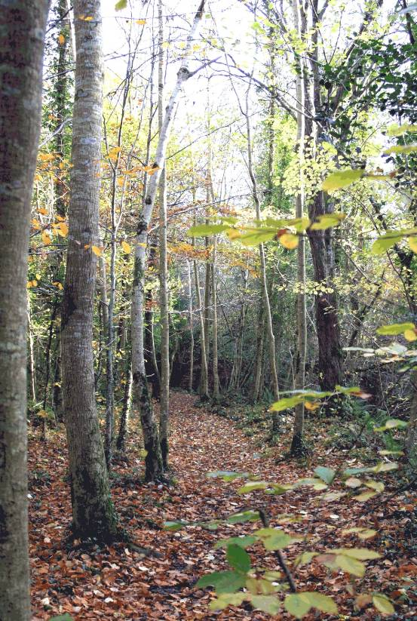

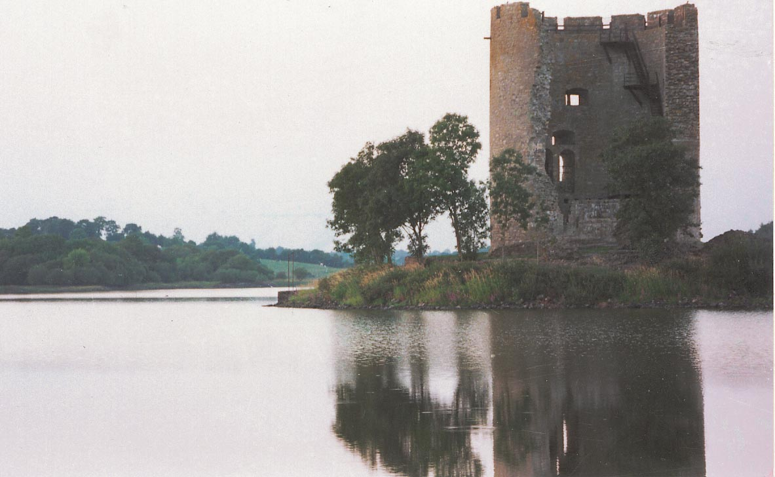
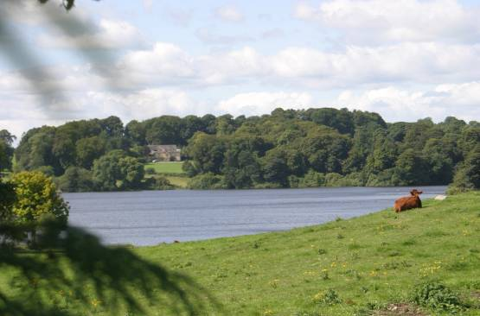
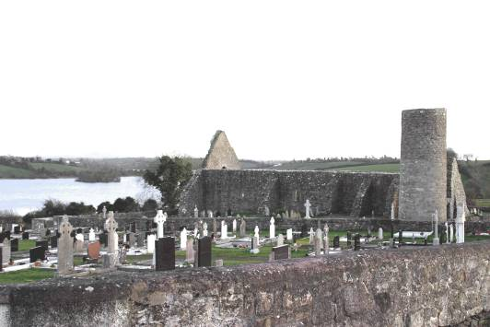

Table of Contents

- Introduction
  - Aim and Purpose of Report
  - Context of Variation
  - Reason for proposed Variation
  - Mandatory Requirement under SEA Directive

- Screening
  - Characteristics of the plan
    - Degree which Plan sets framework for other projects
    - Degree which plan influences other plans
    - Relevance of Plan
    - Environmental Problems relevant to the plan
    - Relevance of plan for implementation of EU legislation on the environment

  - Characteristics of the effects an of the area likely to be affected
    - Probability, duration, frequency and reversibility of effects
    - Cumulative Nature of effects
    - Transboundary nature of effects
    - Risks to Human Health or the environment
    - Magnitude and spatial extent of the effects
    - The value and vulnerability of the area
    - Effects on areas or landscapes which have recognised National, European Union or International Protection Status

- Initial Determination of Cavan County Council

- Statutory Consultation

- Determination for an Appropriate Assessment

- Decision of the Planning Authority
6.1 SEA – Legal Requirements
6.2 Response to Notification
6.3 Considerations
.4 Final Determination of Cavan County Council

1.0 INTRODUCTION

  - Aim & Purpose Of The Report
The Planning and Development (Strategic Environmental Assessment) Regulations (S.I. 436 of 2004) came into force on 21st July, 2004 following the EU Directive on Strategic Environmental Assessment (SEA). Section 13K of the 2004 Regulations set out when a Planning Authority is making a variation that it shall consider whether or not the proposed variation would be likely to have significant effects on the environment
Accordingly a planning authority shall, prior to giving notice under section 13 of the Planning and Development Act (2000-2010), prepare a report of the likely significant effects on the environment of implementing the variation. If it is determined that significant effects would be likely, then the variation will be subject to a full Strategic Environmental Assessment and an Environmental Report must be prepared.

The aim of this report is to consider whether a variation for the insertion of the Core Strategy and associated amendments to the Cavan Town and Environs Development Plan 2008-2014 would require a Strategic Environmental Assessment (as set out in the SEA Guidelines and Annex II of the Directive). This report shall investigate the likely significance of environmental effects.

Context of Variation

The type of plan in question which requires a Variation is the existing Cavan Town and Environs Development Plan 2008-2014. This plan sets out the overall strategy for the proper planning and sustainable development for its functional area with an intent to offer the public a well thought out, consistent and purposeful framework for a future successful County Town and its environs. The making of the Cavan Town and Environs Development Plan has been informed by the Housing Strategy, Retail Strategy, Strategic Environmental Assessment and Appropriate Assessment Screening. The Plan came into effect in October 2008 and has a 6 year lifespan.

The reason for the proposed Variation is as follows:
The Reason for the proposed variation is to incorporate a Core Strategy as set out in Section 10 (1b) of the Planning and Development (Amendment) Act 2010. It is now a requirement in the preparation of a development plan to prepare a core strategy which shows that the development objectives in the development plan are consistent, as far as practicable, with the national and regional development objectives set out in the National Spatial Strategy and Regional Planning Guidelines. It is a requirement that a Core Strategy shall be prepared not later than a period of one year after the making of the Regional Planning Guidelines which in the case of the Cavan Town and Environs Development Plan is not later than 1 year after the making of the Border Regional Guidelines which was on 29th September 2010.

The Core Strategy will
- Recognise Cavan Towns Hub status as indicted in the Border Regional Guidelines 2010-2022.
- Will set out population growth framework, housing targets and Housing Land Requirement for Cavan Town and Environs

  - Mandatory Requirement under SEA Directive

The Strategic Environmental Assessment Regulations require that ‘Screening’ be carried out in the case of ‘Variations to Development Plans’. The Screening Report can be used for appropriate consultation with the designated authorities. If it demonstrates that a SEA is necessary, the Screening Report will inform the Scoping and Environmental Report.

If the Planning Authority is uncertain as to the need for a SEA, the designated environmental authorities will be formally consulted during this exercise. The designated authorities are:

    - The Environmental Protection Agency (EPA)

    - Minister for the Environment, Community and Local Government;

    - Where it appears to the planning authority that the plan or programme, or modification to a plan or programme, might have significant effects on the fisheries or the marine environment, the Minister for Agriculture, Marine and Food and the Minister for Communications, Marine and Natural Resources.

    - Where it appears to the competent authority that the plan or programme, or amendment to a plan or programme, might have significant effects in relation to the architectural or archaeological heritage or to nature conservation, the Minister for Arts, Heritage and Gaeltacht.

    - Any adjoining planning authority whose area is contiguous to the area of a planning authority which prepared a draft plan, proposed variation, or local area plan.

In the case of a ‘Variation’ the Environmental Authority/ Authorities will have 3 weeks to make a response to the completed Screening Report.

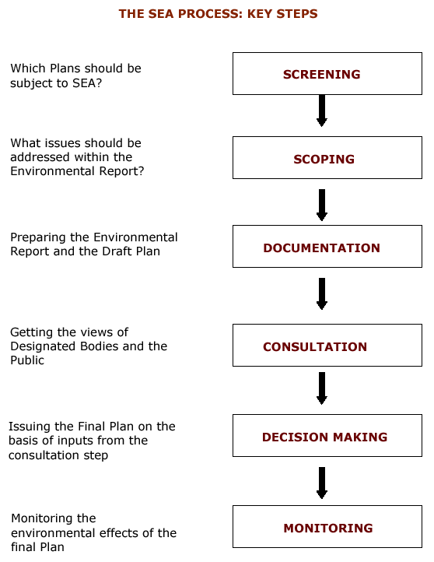
Should the Variation to Cavan Town and Environs Development Plan be subject to SEA?

What issues should be addressed within the Environmental Report?
Preparing the Environmental Report and the Variation

Getting the views of Designated Bodies and the Public

Issuing the Final Variation on the basis of inputs
from the consultation step

Monitoring the environmental effects of the
Variation
MONITORING
DECISION MAKING
SCOPING
SCREENING
DOCUMENTATION
(ENVIRONMENTAL REPORT)
CONSULTATION
THE SEA PROCESS: KEY STEPS

Figure 1: Key Steps within the SEA Process

Figure 1

2.0 Screening
Schedule 2A of the Planning and Development (Strategic Environmental Assessment) sets out the criteria for determining whether a plan is likely to have significant effects on the environment. This proposed variation so is assessed against these criteria

2.1 The characteristics of the plan having regard, in particular, to

2.1.1 The degree to which the plan sets a framework for projects and other activities, either with regard to the location, nature, size and operating conditions or by allocating resources,
The existing Cavan Town and Environs development plan sets out the blueprint for the proper planning and sustainable development of the Town and Environs and includes a land use planning map for the area, indicating types of suitable development for the lands. The existing plan was subject to a full SEA and AA screening process to examine the environmental impacts of the plan.
The introduction of Core Strategy’s will ensure closer alignment of the Town and Environs Development Plan to the Border Regional Guidelines 2012-2022 and further strengthen the Hub Status role of Cavan Town.
The population targets set in the BRG’s will be adhered to in the draft variation and thus result in this closer alignment in terms of population growth. The BRG’s population targets are well below what is catered for in the existing Cavan Town and Environs land use plan. The Population Targets of 1,600 person increase between 2010 and 2016 is considered over optimistic. There is currently 623ha of undeveloped Residential zoned land in the Cavan Town and Environs Development Plan 2008-2014. This plan was produced for a longer timeframe than the development plan period and also in a time of stronger housing growth in the principal town. As a result of this, the alignment of available zoned residential land to the populations targets set out (in the Border Regional Guidelines) will result in a reduction of the residential zoned land required. This reduction will result in 36 ha of Residential Zoned Land being available to the end of the plan period 2014.

2.1.2 The degree to which the plan influences other plans, including those in a hierarchy,

Figure 2: Levels of Plan Making
EU
POLICY DIR
EUROPEAN SPATIAL
DEVELOPMENT PERSPECTIVE

NATIONAL SPATIAL STRATEGY

OTHER NATIONAL STRATEGIES (e.g. NDP)

REGIONAL PLANNING GUIDELINES (BORDER REGIONAL AUTHORITY)

TOWN AND ENVIRONSDEVELOPMENT PLAN - TOWN DEVELOPMENT PLAN

LOCAL AREA PLAN - VILLAGE PLAN – VARIATION TO PLAN

As indicated in figure 2 the variation to the plan is at the lower level of the hierarchy of plans within the state. The varied plan will influence the locations and types of new development on zoned land and thus will influence the location of roads, infrastructure and social services in the town and environs. The Cavan Town and Environs Development Plan will undergo a full review which will begin in October 2012, in accordance with Section 11 of the Planning and Development Act.

2.1.3 The relevance of the plan for the integration of environmental considerations in particular with a view to promoting sustainable development,
The development plan as varied will act in the interests of promoting the proper planning and sustainable development of the area. The Town and Environs development plan has a SEA and AA screening completed during its preparation and the proposed variation aims to align the amount of zoned residential land in the Town and Environs so that it is in accordance with the population targets as set out in the Border Regional Guidelines. This essentially will reduce the area of residential land that is immediately available for development. There are currently 623 ha of zoned residential land in the Cavan Towns and Environs Area and the proposed variation has proposed 36 ha as the requirement for the period 2010-2014. Existing areas of amenity/recreation located within and outside of development boundaries remain unchanged and all environmental standards previously set out in the Town and Environs Plan remain. Any environmentally sensitive lands currently zoned for Residential in the development plan has been rezoned to Recreation/Amenity in the proposed Variation e.g. incidents of flooding. This ensures protection of the environment.

2.1.4 Environmental problems relevant to the plan
The proposed variation will alter the zoning of existing residential land to a Phasing Plan which means that there will be a reduction in the lands available for development for residential purposes for the remaining duration of the plan period i.e. to October 2014. The Phasing Plan seeks to ensure that development of the Hub Town will occur in the town centre ‘Town Core’ zone as well as Phase 1 lands. Phase 1 lands have been identified as lands located within 500 metres of the Town Core and thus are sequentially suitable. This will also ensure that transport is more sustainable. Phase 1 lands are also subject to Site Justification. The proposed variation will essentially result in a reduction of available zoned land and thus decrease the development potential of the lands in question.

Areas that require environmental protection have been identified in the current Town and Environs Development Plan and these are
- Protected Structures
- Archaeological Heritage /Recorded Monuments
- Older Buildings and Shopfronts
- Natural Hertiage Areas
- Public Amenity Areas
- High Landscape Areas
- Special Amenity Areas
- Public Open Space Areas and Amenities
- Tree or Tree Groups

All of the relevant policies and objectives contained within the existing Town and Environs Development Plan seek to ensure the safekeep and protection of the environmental qualities in the area. These Policies and Objectives will be retained and strengthened through this variation process.

Flooding
Data collected since the previous development plan adoption regarding flooding incidents in the Town and Environs area have been considered. Remedial works have taken place or will take place in these areas as the flooding in this plan area was not on green field sites but existing developed areas. Adherence to the Planning System and Flood Risk Management Guidelines, November 2009 will continue to be applied to all planning applications. Assessment of planning applications will be based on three pillars of avoidance, reduction and mitigation of flood risk.

2.1.5 The relevance of the plan for the implementation of European Union legislation on the environment (e.g. plans linked to waste-management or water protection).
Monitoring measures in terms of water protection are currently in place. Issues relating to European Union Legislation on the environment are considered to be enhanced because of the proposed variation. The available residential land for development within the lifetime of the plan has been reduced and thus the infrastructural requirements required for such developments has been reduced. The variation will also ensure that the Town and Environs Development Plan is more consistent with the hierarchy of plans including European legislation on the environment due to written compliance with regional and local plans.

2.2 Characteristics of the effects and of the area likely to be affected, having regard, in particular, to
Any development within a development envelope will have an effect on the area through
- Increase in human population
- Expansion of the built up area
- Protection of the wildlife e.g. protection along rivers and streams of the town
- Protection of built heritage and archaeology
- Protection of existing natural assets such as mature trees, hedgerows, forestry and river banks
- Protection of rural landscape

These effects however will be carefully assessed in the Development Management Role of planning applications and existing polices and objectives in the County Development Plan will have to be adhered to.

    - The probability, duration, frequency and reversibility of the effects,
The development of land is not a reversible change. Development on zoned residential land is sustainable when properly located close to services like schools, parks, shops, libraries etc. This results in the creation of communities who live and work ion an area and have an excellent quality of life. The preparation of the County Development Plan was subject to an SEA. The proposed variation by its nature will have a positive effect on the environment. The Core Strategy through its implementation will ensure that the population targets set for Cavan Town will be closely aligned with the land available for residential purposes in the Town and Environs. This will result in a reduction of residential zoned land available for development in this development plan period.
The Core Strategy addresses the significant overprovision of zoned residential lands in the existing plan. The Core Strategy proposes to regulate the development of residential lands so that they are developed on a sequential basis in line with proposed infrastructure improvements. This will result in the proper planning and sustainable use of land in town and village cores.

2.2.2 The cumulative nature of the effects,
It is considered that the cumulative nature of effects on the environment from the proposed variation will have positive impact on the Town and Environs as it will ensure town core concentration of development and ensure that development occurs sequentially from the town core. The sequential development from the town core will ensure that the town grows in accordance with the proper planning and sustainable development. The cumulative nature of effects will be positive as it will ensure planned growth.

2.2.3 The transboundary nature of the effects,
It is considered that there will be no transboundary effects of the proposed variation.

2.2.4 The risks to human health or the environment (e.g. due to accidents),
There are no SEVESCO sites in or near the Town and Environs area and as such the risk of accidents to the environment or human health is low. Having regard to the nature of the proposed variation, which will seek to ensure that the development of the town occurs in a planned and controlled manner, it is envisaged that the variation will reduce the risk to human health or the environment due to accidents.

2.2.5 The magnitude and spatial extent of the effects (geographical area and size of the population likely to be affected),
The proposed variation affects the entire Cavan Town and Environs area. The Cavan Town and Environs area occupies 16.7 km2 (1676 ha2) with a population of 7,883 persons as per the 2006 census. The Border Regional Guidelines has projected a population in Town and Environs Cavan of
- 10,000 persons by 2010,
- 11,600 persons by 2016
- 12,800 persons by 2022.
The Cavan Town and Environs Development Plan 2008-2014 projected a population in the area of 15,402 persons by 2016. The insertion of the core strategy document which aligns the Town and Environs Development Plan 2008-2014 with the Border Regional Guidelines and outlines clearly this alignment will have an effect on the development of housing in the plan area. An additional Phasing Plan will be produced for Cavan Town and Environs area, indicating the direction of development in the plan.

2.2.6 The value and vulnerability of the area likely to be affected due to:

- special natural characteristics or cultural heritage,

It is considered that the Town and Environs Development Plan 2008-2014 has a positive impact on special natural characteristics of the area and cultural heritage. These have been identified in the Town and Environs plan and protected by means of buffer and/or policies and objectives which ensure their protection. It is considered that the existing polices and objectives in the County Development Plan are adequate to ensure the protection of the natural and cultural heritage of the County.

- exceeded environmental quality standards or limit values,
It is considered that the proposed variation to the Town and Environs development plan will not exceed environmental quality standards or limit values as same seeks to consolidate the town core area and thus will reduce the area of zoned residential land from the area proposed in the existing plan which has already been subject to a full SEA and screening for AA. Work is currently ongoing at the Cavan Town Wastewater Treatment Plant to increase the capacity to meet the needs of the town.

- intensive land-use,
It is considered that the proposed variation will not result in a more intensive landuse than that already proposed in the existing Cavan Town and Environs Development Plan 2008-2014. The process of zoning lands and identifying them suitable in principle for various uses does result in a more intensive use of land, however individual planning applications must consider polices, objectives and guidelines in relation to the form and nature of proposed development thus ensuring that same are suitable and sustainable. For example
Sustainable Urban Housing: Design Standards for Apartments –Guidelines for Planning Authorities 2007
Sustainable Residential Development in Urban Areas 2008
Urban Design Manual –A Best Practice Guide 2008

The variation through zonings, policies and specific objectives will create a distinction between the urban form and the rural landscape. The proposed draft variation, due to alignment of the RPG’s for Border Region will reduce the amount of land that is immediately available for residential purposes in the plan period.

2.2.7 The effects on areas or landscapes which have a recognised national, European Union or international protection status.
The proposed variation will have no effects on recognised National, European Union or International protection status. The Cavan Town and Environs Development Plan 2008-2014 has already ensured that environmentally sensitive areas are afforded protection to the area so that they are protected and enhanced.
3. Initial Determination of Cavan County Council and Cavan Town Council

On the basis of the above assessment and consideration of the criteria as set out in Schedule 2A of the Regulations, it is the opinion of the Planning Authority that the proposed Cavan County Development Plan Core Strategy (Variation Number 2) will not have any likely significant effects on the environment and therefore does not require a full SEA. The Planning Authority is satisfied that the Cavan County Development Plan 2008-2014 was carried out in accordance with the principles of sustainable development and the commitment to the enhancement and protection of the natural and built environment of the county. The Core Strategy does not propose to introduce any policies or objectives that would have a negative impact on the environment nor does it propose to include additional zonings in the plan area.

- Statutory Consultation

The specified environmental authorities which are requires to be consulted in accordance with Article 13A (4) of the Planning and Development (Strategic Environmental Assessment) Regulations are as follows
a) The Environmental Protection Agency (EPA)

b) Minister for the Environment, Community and Local Government;

c)Where it appears to the planning authority that the plan or programme, or modification to a plan or programme, might have significant effects on the fisheries or the marine environment, the Minister for Agriculture, Marine and Food and the Minister for Communications, Marine and Natural Resources.

d) Where it appears to the competent authority that the plan or programme, or amendment to a plan or programme, might have significant effects in relation to the architectural or archaeological heritage or to nature conservation, the Minister for Arts, Heritage and Gaeltacht.

e) Any adjoining planning authority whose area is contiguous to the area of a planning authority which prepared a draft plan, proposed variation, or local area plan.

- Determination for an Appropriate Assessment

The DoEHLG Circular Letter SEA 1/08 and NPWS 1/08 relates to the requirement to screen Land Use Plans for any potential impacts on areas designated as Natura 2000 sites (Special Areas of Conservation and Special Protection Areas). Where appropriate an assessment of the plan must be carried out.

There are 6 no. Natura 2000 sites located in County Cavan and as such a separate and complete Appropriate Assessment Screening Report has been prepared with regard to the conservation objectives of these sites against the proposed draft Variation to the Cavan County Development Plan. There are no Natura 2000 sites located within the town and environs development boundary.

6. DECISION OF THE PLANNING AUTHORITY - REGARDING THE NEED FOR STRATEGIC ENVIRONMENTAL ASSESSMENT OF THE PREPARATION OF THE FORTHCOMING VARIATION TO CAVAN COUNTY DEVELOPMENT PLAN 2008-2014.

6.1 SEA – Legal Requirements
It was necessary to determine whether or not an environmental assessment of the proposed variation to the Cavan Town and Environs Development Plan 2008-2014 needed to be carried out. Therefore, the principles of the proposed variation underwent a screening process to establish whether it was likely to have significant effects on the environment. In doing so, the Planning Authority took account of relevant criteria set out in Schedule 2A of the Planning and Development (Strategic Environmental Assessment) Regulations 2004.

6.2 Response to Notification
There was no response from the Minister for the Environment, Community and Local Government;

A submission has been received from the EPA. This has noted the SEA determination made by Cavan County Council and Cavan Town Council. It has reminded the Councils of the following
- Future variations/amendments may require SEA
- AA Screening required and advice consult NPWS
- Adherence should be had to national plans and policies and EU Environmental Legislation
- Updated SEA Regulations and Circular

A submission was received from Department of Communications, Energy and Natural Resources stating they have no comments/observations to make at this time.

6.3 Considerations
The above points will be taken on board in the Core Strategy document and in future plans or variations.

6.4 Final Determination of Cavan County Council
On the basis of the above assessment and consideration of the criteria as set out in Schedule 2A of the Regulations, it is opinion of the planning authority that the proposed variation will have an overall positive environmental impact on the environment and will not be likely to have any significant adverse effects. Accordingly it does not require an SEA.

August 2011

- The Environmental Protection Agency
- The Department of the Environment, Community and Local Government
- The Department of Communication, Energy and Natural Resources
- National Parks and Wildlife Service

Re/ Planning and Development (Strategic Environmental Assessment) Regulations S.I. No. 436 of 2004
Strategic Environmental Assessment (Screening Report)
Proposed Variation to Cavan Town and Environs Development Plan 2008-2014

A Chara,

Notice is hereby given, in accordance with Section 13K of the Planning & Development (Strategic Environmental Assessment) Regulations 2004 that Cavan Town Council and Cavan County Council intends to prepare Variation to the Cavan Town and Environs Development Plan 2008-2014 and a SEA Screening Report has been undertaken in order to assess whether or not implementation of the variation would be likely to have significant effects on the environment.

Submissions or observations in relation to the proposed draft variation may be made in writing to the Marice Galligan, A/Senior Planner, Planning Department, Cavan County Council, Farnham Centre, Farnham Street, Cavan, within the period Week 18th July to 12th August 2011 (both dates inclusive, but excluding public holidays).

I enclose copy of the SEA Screening Report in accordance with Section 13K of Planning & Development (SEA) Regulations 2004.

Mise Le Meas

___________________
Marice Galligan,
A/Senior Planner.

Send to
Environmental Protection Agency
Department of Environment, Community and Local Government
Department of Communications Energy and Natural Resources

