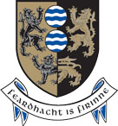
Joint Statement from ISPCA & Cavan County Council.

Following a recent BBC report, Cavan County Council has undertaken a thorough investigation of all issues involving dog breeding establishments within the county.
This investigation has included joint inspections of dog breeding establishments conducted in conjunction with the ISPCA. No offences under the Animal Health and Welfare Act were detected in the course of the inspections.
However, Cavan County Council served improvement notices in relation to a number of issues to ensure complete compliance with the Dog Breeding Establishments Act and associated Guidelines.
In the event that these notices are not complied with within the specified time period, Cavan County Council will work with the ISPCA to take appropriate enforcement action.

