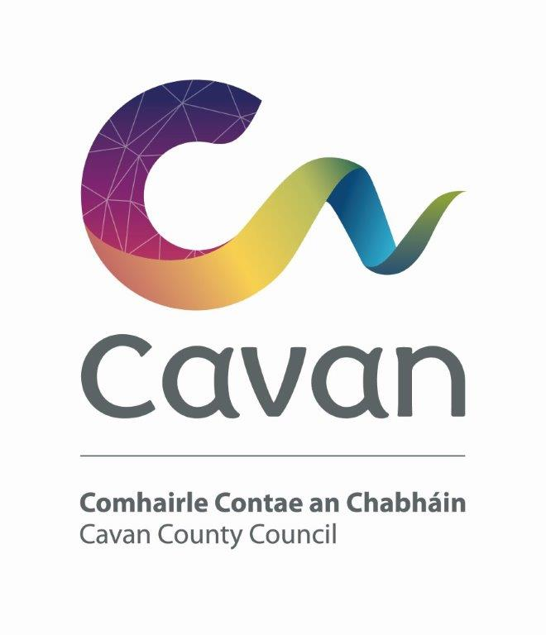

Cavan County Council
Comhairle Chontae An Chabhain

Briefing Document and Selection Process

Sports Development Officer

1 Year Fixed Term Contract Post

Competition:

The purpose of this recruitment campaign is to fill the position of Sports Development Officer for Cavan County Council on a one year fixed term contract basis.

Background:

Sport Ireland (previously the Irish Sports Council) supported the establishment of Local Sports Partnerships around the country to co-ordinate and to promote the development of sport. The key aims of the Local Sports Partnerships are to increase participation in sport and to ensure that local resources are used to best effect. Sport Ireland sees these partnerships as the best mechanism for delivering recreational sport to the greatest number of people.

Funding has been awarded to Cavan Sports Partnership by Sport Ireland under the Dormant Accounts Fund to employ a Sports Development Officer on a temporary basis to co-ordinate the delivery of physical activity programmes within the county.

Main responsibilities:

The duties of the office will be such as may be assigned by the Sports Co-ordinator of Cavan Sports Partnership, Sport Ireland and Cavan Sports Partnership Board. The Sports Development Officer will report directly to the Sports Co-ordinator of Cavan Sports Partnership.

The Sports Development Officer will work towards increasing participation by people throughout County Cavan in sport and active recreation through working in partnership with all stakeholders. The Sports Development Officer will be responsible to the Sports Co-ordinator of Cavan Sports Partnership for the development, delivery and monitoring of sports and recreational programmes for priority target groups. The Sports Development Officer will support externally funded projects delivered by Cavan Sports Partnership.

The Sports Development Officer’s work will focus on two main pieces of work
- To coordinate phase 2 delivery of the Kilnaleck activity hub.
- To coordinate the development of the Belturbet activity hub.

A number of key objectives that must be achieved within both activity hubs:
- Conduct a needs analysis of each hub area.
- Developing partnerships and coordination between relevant local sports clubs, schools and community based and statutory organisations serving the area.
- Resourcing the local community through sports training and education programmes
- Increasing overall physical activity participation in both hub areas
- Making physical activity more accessible to local people
- Developing partnership and co-ordination between the relevant local statutory and voluntary bodies and maximising their involvement in the development of sports in the county
- Deliver participation programmes to key target communities of schools, youth groups, clubs and organisations
- Increase participation and the opportunities for participation in both hub areas.
- Help to maximise the sports and recreation potential of each hub area by promoting existing events and developing new sport events.
- Be responsible for the monitoring and evaluation of these initiatives.
- Contribute to and assist with the implementation of the Cavan Sports Partnership Strategy.
- Support the roll out of Cavan Sports Partnership’s activities including Sport Ireland’s national programmes as required.
- Any other duties assigned to them by the sports co-ordinator.

The Person:
Candidates will demonstrate through their application form and at the interview that he/she has/is:

- Excellent communication and organisation skills.
- Have satisfactory experience working within the area of sports/recreation/leisure.
- Track record of working with various groups i.e. schools, communities etc.
- Motivated individual with the ability to undertake and see through tasks with the abitilty to integrate as part of an expanding team
- Show an ability to manage a budget and complete tasks within a set timeframe.

Candidates will be expected to be flexible in terms of working hours as the duties can involve working outside of normal office hours. Notwithstanding the requirements of the post successful applicants may be assigned to any service area/role within the Local Authority at an analogous level by the Chief Executive at any time.

Salary:
Renumeration will be €34,050 per annum
Pension:
The Local Government Superannuation Scheme applies.
Annual Leave:
30 days per annum
Hours of Work:
37 hours per week. The successful candidate must be flexible and willing to work evenings and weekends.

Qualifications:
The qualifications for the position of Sports Development Officer shall be as set out hereunder:-

Character:
Each candidate must be of good character. Employment of the successful candidate shall be subject to satisfactory references.

Health:
Each candidate must be in a state of health such as would indicate a reasonable prospect of ability to render regular and efficient service for the post.

Education/ experience, etc.:
Each candidate must, on the latest date for receipt of completed application forms:

- Hold at least a National Diploma / Degree in Sport, Health Fitness & Leisure Studies, Community Development, Health Promotion or other relevant disciplines or equivalent qualification desirable.
And

Hold a current class B Drivers Licence and have access to own car.
Selection process:
Candidates will initially be assessed to ensure that they meet the minimum qualifications set down above. Assessment will be based on information provided by the candidate on the application form. Qualifications of successful candidates will be subject to further checks post interview to confirm that they meet the criteria.

Candidates will then be assessed on the basis of other information contained in their application form to determine, having regard to the requirements of the position and the number who have applied, if they should be called for interview. Candidates may be short listed on the basis of information provided in the application form.

Interview:
Candidates at the interview will be assessed on the following areas:
KNOWLEDGE  /EXPEREINCE | SKILLS | GENERAL ATTRIBUTES
- Role of post  - Sports/recreation/leisureexperience/knowledge base  - Previous & current working environment | - Communication and  interpersonal skills  - Judgement/decision making  - Analytical  - Ability to work as part of a team and maintain effective working relationships  - Planning/organising/ budgeting  - Problem solving  - Leadership | - Initiative  - Commitment  - Positive attitude with self motivation.

All applications must be made on the official Application Form. Application Forms are available from the Human Resources Department, Cavan County Council, Farnham Centre, Johnston Central Library, Farnham Street, Cavan Tel. 049-4378653/8654 or email jobs@cavancoco.ie or on web www.cavancoco.ie

Completed Application Forms together with supporting documentation will be accepted in hard copy format only. Four copies are required to be submitted.

Completed Application Forms must be submitted by 5.00pm on Friday 8th February, 2019 to

HUMAN RESOURCES DEPARTMENT
CAVAN COUNTY COUNCIL
FARNHAM CENTRE
JOHNSTON CENTRAL LIBRARY
FARNHAM STREET
CAVAN

Any claim in relation to the late receipt of Application Forms will not be entertained unless such claim is supported by a certificate of evidence of postage from the appropriate postal authority.

Note:
Applicants are reminded that any attempt by themselves or by any persons acting on their behalf directly or indirectly by means of written communication or otherwise to canvass or otherwise influence in the applicants favour any employee of the County Council or persons nominated by the Chief Executive to interview or examine applicants, will automatically disqualify the applicant for the position they are seeking.

Data Protection:

All of the information you provide during the process will only be used for the purpose of progressing your application, or to fulfil legal or regulatory requirements if necessary.
We will not share any of the information you provide during the recruitment process with any third parties for marketing purposes or store any of your information outside of the European Economic Area. The information you provide will be held securely by us and/or our data processors whether the information is in electronic or physical format.
We will use the contact details you provide to us to contact you to progress your application. We will use the other information you provide to assess your suitability for the role you have applied for.
Cavan County Council is an equal opportunities employer


