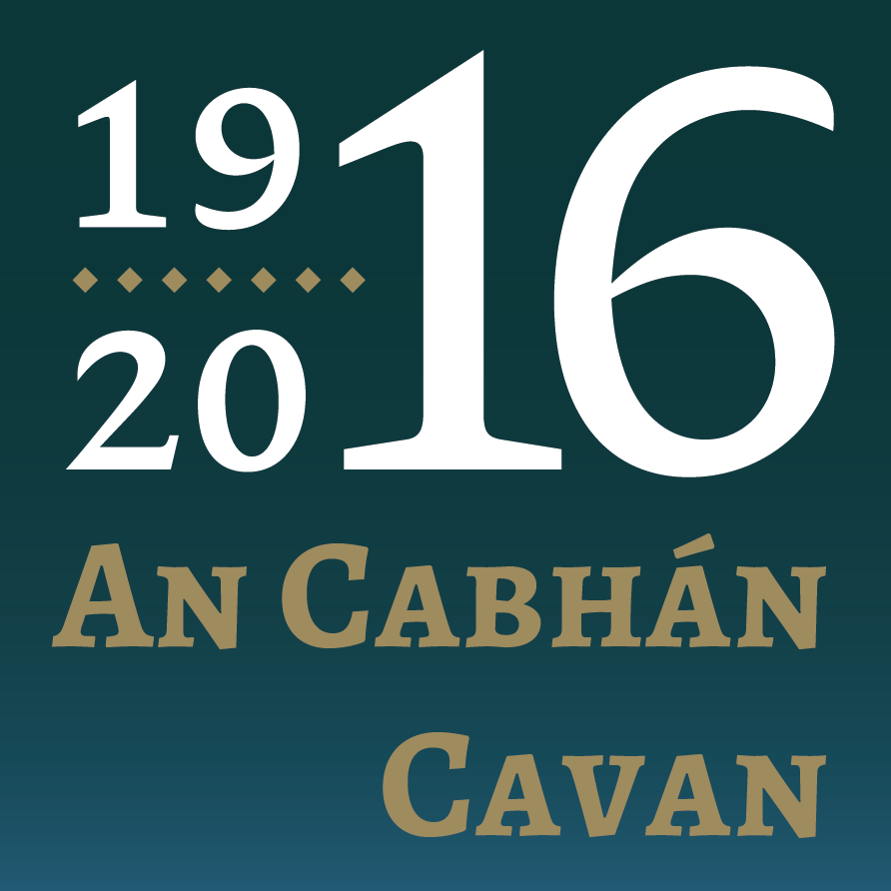
1916 Commemoration Grants
Application Form:
Applicant Details

Name of Community Group / Organisation
Address of Community Group / Organisation

Name and contact details of the person dealing with the application

Name:
Telephone:
Email:
Details of proposed community event

Name Of Event:

Dates:

Location(S):

Was the event held in previous year(s)
Who are you inviting to your event?

Please list groups, clubs, and associations as appropriate. (if you have a listing please attach and include in your application).

How have you identified the target group?

How will you promote the event?

State which (one or more) of the five themes the project relates to and explain this relevance
Capacity to deliver
Do you have contacts, connections that will facilitate this event occurring? (If so, please detail). What structures are in place, who will oversee it etc.?

Briefly describe your event. Explain the rationale for its existence and how it will support Cavan County Council’s Ireland 2016 county plan. (keep to a maximum of 100 words max)
Please give a breakdown of the events expenditure | Description | Expenditure
Have you received or applied for other sources of public funding? Please circle as appropriate ) | Yes | No
If yes, please state the source and amount of funding.

Please Note:
That applicants who have received funding from Fáilte Ireland’s regional festival fund 2016 will not be eligible to apply for funding.
Incomplete Forms Will Not Be Considered
Disclaimer – Please Read Carefully
It will be a condition of any application for funding under the terms and conditions of the Cavan County Council – Ireland 2016 project that the applicant has read, understood and accepted the following:
- Cavan county council shall not be liable to the applicant or any other party, in respect of any loss, damage or costs of any nature arising directly or indirectly from:

  - The Application Or The Subject Matter Of The Application.
  - The Rejection For Any Reason Of Any Application.

- Cavan county council shall not be held responsible or liable, at any time in any circumstances, in relation to any matter whatsoever arising in connection with the administration of activities.

- By submitting an application, applicants agree to the processing and disclosure of the applicant’s information by cavan county council, and to other third parties.

Declaration of Applicant(S)
We Have Read And Understood The Information And Criteria Applicable To The Fund And Agree To Comply In Full Therewith. I/We Certify That All Information Provided In This Application, And All Information Given In Any Documentation Submitted In Support Of The Application Is Truthful And Accurate And That I Have Not Applied To Any Other City / County Council For Funding For This Event.

Signed: ____________________________________ Date: _________________

Name: (In Block Capitals): ___________________________________________

On Behalf Of: (Organisation's Name): __________________________________

Completed Application Forms
Should be returned on or before Friday, 19th February 2016 to
Tom Sullivan, A/County Librarian
Johnston Central Library
Farnham Street
Cavan H12 A3T1

Grant Scheme Conditions:-

Cavan County Council, In Association With Ireland 2016 And The Department Of Arts, Heritage And The Gaeltacht Wishes To Develop A Programme Of Events To Mark The 1916 Centenary. Community Funding Is Now Available For Local Groups To Play Their Part By Developing A Project To Mark The Event.

Ireland 2016 Is A National Initiative To Develop, Coordinate And Deliver A Programme For The 2016 Centenary Year With Local, National, And International Events, Based On Five Intersecting Themes, Drawing Inspiration From The Ideals Of 1916, The Proclamation, And The Events Of That Time.
It Is A Call To Action To Remember The Events Of 1916, Reflect On The Last 100 Years, And Re-Imagine Ireland’s Future.

What Is The Purpose Of Cavan County Council’s Ireland 2016 Grant Fund ?
The Key Objective Of The Fund Is To Provide Support To Local And Community Event Organisers And Activities / Projects That Will Harness Diaspora Links For The Benefit Of Local And Community Tourism. The Fund Is Being Administered By Cavan County Council.

The Five Themes
In Order To Be Successful, Projects Must Correspond With One Or More Of The Following Themes:
- Remember – Commemorating The Historic Events Of 1916 In The Full Context Of Our History
- Reconcile – Confronting The Divisions Of The Past And Reflect On How The Ideals Of The Proclamation Were Rekindled And Contributed To Reconciliation
- Imagine – Engaging With All Of Our People To Challenge Our Assumptions To Re-Imagine Our Legacy For Future Generations
- Present – Showing How As A Republic We Took Our Place ‘Among The Nations’ Expressing Our Individuality Through Our Own Distinctive Culture
- Celebrate – The Idealism Of The Proclamation, Exemplified By Our Legacy Of Un Peacekeeping, And The Developmental And Humanitarian Work Of Irish Aid And Our Ngos
Criteria
The Following Must Be Demonstrated:
- The Extent To Which The Proposed Initiative Is Aligned To The Five Themes Of “Ireland 2016”
- The Extent To Which The Proposed Initiatives Maximize Community And Citizen Engagement And Mobilization Around The Key “Ireland 2016” Themes
- The Extent To Which The Proposed Initiative Connects With The Events Of The 1916 Easter Rising And Those Who Fought Or Died During That Time
- The Extent To Which The Project Proposed Is Unique, Innovative, Creative, Interesting And Likely To Make An Impact
- The Potential Scope Of The Project Within The Local Authority Area And Anticipated Target Audience
- The Cost Of Executing The Proposed Project
- Any Additional Supports And Funding That May Be Required And Have Been Secured From Relevant Stakeholders
- The Feasibility Of Project Completion Within The Timeframe Allocated

What Fund Amounts Are Available?
Fund Amounts Will Be For A Minimum Of €200 And A Maximum Of €400 And Will Be Directly Related To The Project’s Relevance To The Above Themes. Cavan County Council “Ireland 2016 Steering Group” Will Evaluate Each Application

Who Is Eligible To Apply?
It Is Open To Groups Or Organisations That Are Organising Community Events / Activities In 2016. To Be Eligible For Funding, The Event / Project Must Be Based In County Cavan And Take Place Before October 31 2016. Projects Should Emphasise The Following:
- Be Focused On Developing Strong Links With The Community
- Demonstrate A Capacity To Deliver I.E. The Community Event Organiser(S) Must Provide Evidence Of And Have A Clear Plan For Delivering The Project
- Have The Capability To Promote The Event And Provide A Potential For Media Coverage
- Be Either A New Event Which Will Take Place In 2016 Or An Addition To An Existing Event Which Is Being Expanded Celebrate The 1916 Centenary
- Celebrate / Commemorate The Event In A Sensitive Manner

There Is No Guarantee Of Funding For Events Which Achieve The Minimum Eligibility Criteria. The Fund Is Limited And Eligible Applications Will Be Evaluated On A Competitive Basis.
What Items And Expenses Are Excluded From The Fund?
- Spend On Ongoing Running Costs, Alcoholic Beverages, Fines, Penalty Payments, Legal Cost, Audit Fees, Financial Consultancy Fees And Wages And Salaries Of Consultants
How Do I Apply?
You Should Apply Directly To Cavan County Council. Only Completed Submissions Received Via The Approved Application Form Will Be Considered. The Completed Form Must Be Sent To:
Tom Sullivan, A/County Librarian, Johnston Central Library, Farnham Street, Cavan.
You May Also Submit Accompanying Additional Documentation With Your Completed Application Form As Appropriate.

Applications Must Be Received In Cavan County Council Offices By Friday, 19th February, 2016.
If I Am Successful How Do I Draw Down The Fund?
Payment Will Only Be Made After The Event Has Taken Place. In Order To Receive The Payment, The Successful Applicant Must Complete A Short Post Event Report Form (To Be Supplied By The Cavan County Council) And Provide The Following:

- Evidence That The Event Has Taken Place (E.G. Photographic Evidence)
- Receipts For The Full Costs
- Note: Payment Will Be Made To Community Group And Not To Individual(S)

Funding Not Claimed By The Agreed Deadline Will Be Cancelled.

How Will I Know If My Group Has Been Successful?
Successful Applicants Will Receive Notification.
A List Of Successful Events Will Be Published On Cavan County Council’s Website Stating The Name And Date Of The Event Taking Place.

Acknowledgement
Once You Have Been Notified That You Have Been Successful In Receiving Funding, You Must Ensure That Your Event Is Promoted As Part Of This Initiative And Acknowledge Funding By Cavan County Council.

