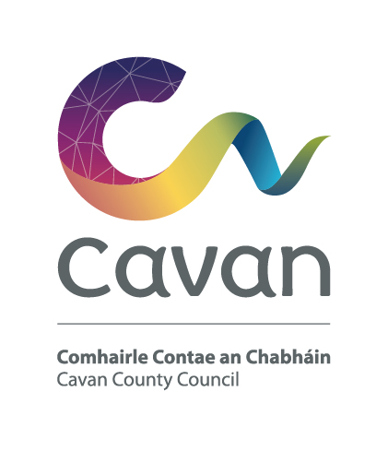

Cavan County Council
Comhairle Contae an Chabháin

Briefing Document and Selection Process

Environmental Technician – Grade II
Competition:
The purpose of this recruitment campaign is to form a panel for Cavan County Council from which full-time, permanent and fixed-term contract posts may be filled at Environmental Technician Grade II Level.

Post:
The Environmental Technician Grade II will work under the control and supervision of the Senior Engineer or other designated officer.

Responsibilities /Duties:
The following list is not meant to be an exhaustive list and is provided only as a guidance note on the types of activities which the successful candidate will be required to undertake.

- To investigate, report on and make recommendations in relation to complaints and incidences of environment pollution (air, water, noise) and waste management

- Undertake sampling, laboratory analysis and reporting for a variety of different sample types.

- Implement various environmental and waste national legislative requirements, EU Directives and EPA standards.

- Evaluate planning applications and waste facility Permits, CORs and AERs which have consequences for the environment and produce conditions to manage and monitor same

- Monitoring/surveying of waste management facilities including recycling, composting, transfer stations and landfill;

- Monitoring, inspection and enforcement activities as per Environmental, Waste and Water Services legislation;

- Preparation of litter and waste plans;

- Any other duties that may be required from time to time.

Notwithstanding the requirements of the post successful applicants may be assigned to any service area/role within the Local Authority at an analogous level by the Chief Executive at any time.

The Person:
Candidates will demonstrate through their application form and at the interview that he/she has/is:

- Good communication and interpersonal skills
- self motivated with a record of demonstrating initiative and judgment in a work place environment
- the capacity to contribute to and work well in a team
- ability to prepare and present technical reports
- an ability to interpret and critically analyse scientific data
- good planning and organisational skills
- knowledge in the area of Health & Safety
- strong ICT skills

Candidates will be expected to be flexible in terms of working hours as the duties can involve working outside of normal office hours.

Salary:
Remuneration will be at the Environmental Technician Grade II Scale of the national wage scales. The present minimum scale is €26,246 increasing to €41,543 per annum (including LSIs) with annual increments subject to satisfactory performance via PMDS. The rate of remuneration may be adjusted from time to time in line with Government pay policy.
Pension:
The Local Government Superannuation Scheme applies.

Annual Leave:
27 days per annum

Hours of Work:
37 hours per week

Qualification:

- Character
Each candidate shall be of good character.

- Health
Candidates shall be in a state of health such as would indicate a reasonable prospect of ability to render regular and efficient service

- Education, experience, etc;

3.1 Each candidate must on the latest date for receipt of completed application forms:

- have passed the N.C.E.A. / H.E.T.A.C National Certificate Final Examination in
Science in Applied Biology, or in Science in Applied Chemistry,
or
hold an equivalent qualification
or
- have satisfactory service, immediately preceding the latest date for receipt of completed application forms, in a technician post at Grade II level, or in an analogous post under a local authority or health board in the State.

3.2 Hold a current full clean driving licence.

Selection process:

Candidates will initially be assessed to ensure they meet the minimum qualifications set down above. Candidates will then be assessed on the basis of other information contained in their application form to determine, having regard to the requirements of the position and the number who have applied, if they should be called for interview. Qualifications of successful candidates may be subject to further checks post interview to confirm they meet the criteria.

Interview
At interview candidates will be assessed in the following areas:
Knowledge/Experience | Skills | General Attributes
- Range & depth of Environmental & Waste experience relevant to post  - Role of post  - Understanding of health & safety  - Previous & current working environment  - Broad Understanding of local government | - Prepare and present technical reports  - Judgement/ decision making  - Problem Solving  - Analytical  - Ability to work as part of a team & maintain effective working relationships  - Planning/organising  - IT | - Communication and interpersonal  - Initiative  - Commitment  - Positive attitude with self motivation

Data Protection:

All of the information you provide during the process will only be used for the purpose of progressing your application, or to fulfil legal or regulatory requirements if necessary.
We will not share any of the information you provide during the recruitment process with any third parties for marketing purposes or store any of your information outside of the European Economic Area. The information you provide will be held securely by us and/or our data processors whether the information is in electronic or physical format.
We will use the contact details you provide to us to contact you to progress your application. We will use the other information you provide to assess your suitability for the role you have applied for.
Cavan County Council is an equal opportunities employer

