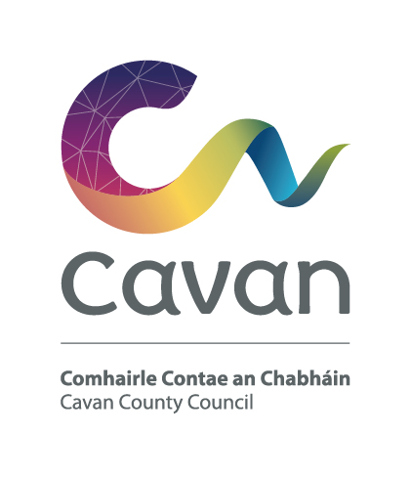

Cavan County Council
Comhairle Contae an Chabháin

Briefing Document and Selection Process

Environmental Senior Executive Technician
Competition:
The purpose of this recruitment campaign is to form a panel for Cavan County Council from which full-time, permanent and fixed-term contract posts may be filled at Environmental Senior Executive Technician Grade.

Post:
The Environmental Senior Executive Technician will work under the control and supervision of the Senior Engineer or other designated officer.
The Environmental Senior Executive Technician will be expected to:
- Provide technical services relevant to the area of responsibility to which he/she has been assigned, e.g. Waste Management, Environmental Management, Water Quality, Air, Noise, etc.
- Operate the appropriate technology as required to carry out the work to which he/she has been assigned e.g. Waste Management, Environmental Management, Water Quality, Air, Noise, etc.
- Work as part of a team
- Liaise with other departments, members of the public and external agencies in relation to operational aspects of assigned work;
- Function as a Team Leader, this includes: prioritising work as determined by the Head of Department/Service/Line Manager, functioning as a facilitator and co-ordinator between team members and other departments and external agencies and being responsible for the allocation of work and ensuring task completion;
- Prepare estimates;
- Preparation of public consultation display material and assistance at public consultation;
- Manage work flows and producing regular progress reports on all aspects of area of responsibility;
- Supervise staff assigned to him/her
- Coach and mentor Technicians Grade 1, Grade 2 and Executive Technicians;
- Contribute to individual staff development, personal development and team development initiatives;
- Be accountable for efficient and effective operation of his/her area of responsibility;
- Undertake any course of training organised by the Council which he/she is designated to attend;
- Such other duties as may be assigned from time to time.

The holder of the post will be required to have a good knowledge and awareness of Health & Safety Legislation Regulations, their implications for the organisation and the employee and their application in the workplace.

Notwithstanding the requirements of the post successful applicants may be assigned to any service area/role within the Local Authority at an analogous level by the Chief Executive at any time.

The Person:

Candidates will demonstrate through their application form and at the interview that he/she has/is:
- good communication and interpersonal skills
- people management skills
- self motivated with a record of demonstrating initiative and judgment in a work place environment
- leadership skills and experience
- sufficient knowledge and understanding of technical skills in Waste Management, Environmental Management, Water Quality, Air, Noise, etc.
- problem solving skills
- knowledge in area of Health & Safety
- competent in the area of information technology
- good planning and organisational skills

Candidates will be expected to be flexible in terms of working hours as the duties can involve working outside of normal office hours.

Salary:
Remuneration will be at the Environmental Senior Executive Technician Scale of the national wage scales. The present minimum scale is €44,461 increasing to €53,601 per annum (including LSIs) with annual increments subject to satisfactory performance via PMDS. The rate of remuneration may be adjusted from time to time in line with Government pay policy.
Pension:
The Local Government Superannuation Scheme applies.

Annual Leave:
30 days per annum

Hours of Work:
37 hours per week

Qualification:

- Character
Each candidate shall be of good character.

- Health
Candidates shall be in a state of health such as would indicate a reasonable prospect of ability to render regular and efficient service.

- Education, experience, etc;

Each candidate must on the latest date for receipt of completed application forms:

- have satisfactory experience, in a Technician post at Grade 1 or higher level or in an analogous post under a local authority in the State;
- have at least seven years satisfactory relevant experience in a Technician post at Grade II or higher level or an analogous post;
- have a thorough knowledge of all the technical aspects of local authority work and also a deeper knowledge of at least one relevant section of the work and possess such training or experience as would enable them to take charge of such a section of the work;
- have adequate experience in dealing with other departments within their own organisations and with other bodies;
- have adequate experience in the direction, supervision and control of staff and
- Possess technical training and experience of a high standard and adequate administrative ability.

- Hold a current full clean driving licence.

Selection process:
Candidates will initially be assessed to ensure they meet the minimum qualifications set down above. Assessment will be based on information provided by the candidate on the application form. Candidates will then be assessed on the basis of other information contained in their application form to determine, having regard to the requirements of the position and the number who have applied, if they should be called for interview. Qualifications of successful candidates may be subject to further checks post interview to confirm they meet the criteria.

Interview
At interview candidates will be assessed in the following areas:
Knowledge/  Experience | Skills | General Attributes
- Range & depth of Waste Management, Environmental Management, Water Quality, Air, Noise, etc. experience relevant to post  - Role of post  - Understanding of health & safety  - Previous & current working environment  - Understanding of local government legislation, local government policy. | - Change & people management  - Problem solving/ decision making  - Ability to work as part of a team & maintain effective working relationships  - Planning/organising/ budgeting  - IT | - Communication and interpersonal  - Initiative  - Commitment  - Positive attitude with self motivation  - Leadership

Data Protection:

All of the information you provide during the process will only be used for the purpose of progressing your application, or to fulfil legal or regulatory requirements if necessary.
We will not share any of the information you provide during the recruitment process with any third parties for marketing purposes or store any of your information outside of the European Economic Area. The information you provide will be held securely by us and/or our data processors whether the information is in electronic or physical format.
We will use the contact details you provide to us to contact you to progress your application. We will use the other information you provide to assess your suitability for the role you have applied for.
Cavan County Council is an equal opportunities employer

