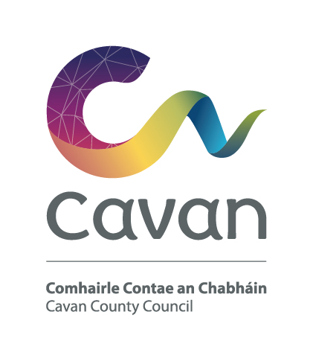

Cavan County Council
Comhairle Contae an Chabháin

Briefing Document and Selection Process

Civil Technician – Grade II
Competition:
The purpose of this recruitment campaign is to form a panel for Cavan County Council from which full-time, permanent and fixed-term contract posts may be filled at Civil Technician Grade II.

Post:
The Civil Technician Grade II will work under the control and supervision of the Senior Engineer or other designated officer.

Responsibilities/Duties:

The actual duties will depend on the actual placement of the post, but in general they will include but are not limited to the following:-

- Have a satisfactory knowledge of the technical aspects of local authority work and in particular the design of transportation projects;
- Have knowledge in AutoCAD, site surveying using GPS, total stations, automatic levels and in the preparation of preliminary design plans, detail design drawings;

- Prepare reports, survey and record data and process information using computer systems, as required;

- Possess satisfactory knowledge of health and safety and carry out all responsibilities in relation to Health and Safety;

- Read and review maps, technical drawings and structural specifications;

- Have good communication and organisational skills;

- Demonstrate ability to work as part of project team;

- Supervise contractors when required to ensure that all works are carried out as per specification and in compliance with the design requirements;

- Participation in such training programmes as will enable him/her to discharge their responsibilities in various areas of the local authority;

- Perform day-to-day administrative tasks i.e. maintaining files, preparation of reports and related documentation;

- Understand and be knowledgeable of regulations – including traffic signs manual, Design manual for urban roads and streets, and construction regulations;

- Any other activities as assigned by Line Manager/Supervisor

Notwithstanding the requirements of the post successful applicants may be assigned to any service area/role within the Local Authority at an analogous level by the Chief Executive at any time.

The Person:

Candidates will demonstrate through their application form and at the interview that he/she has/is:

- good communication and interpersonal skills
- self motivated with a record of demonstrating initiative and judgment in a work place environment
- the capacity to contribute to and work well in a team
- good planning and organisational skills
- technical knowledge and experience in computer aided drafting
- knowledge in the area of Health & Safety
- strong ICT skills

Candidates will be expected to be flexible in terms of working hours as the duties can involve working outside of normal office hours.

Salary:
Remuneration will be at the Civil Technician Grade II Scale of the national wage scales. The present minimum scale is €26,246 increasing to €41,543 per annum (including LSIs) with annual increments subject to satisfactory performance via PMDS. The rate of remuneration may be adjusted from time to time in line with Government pay policy.
Pension:
The Local Government Superannuation Scheme applies.

Annual Leave:
27 days per annum

Hours of Work:
37 hours per week

Qualification:
- Character
Each candidate shall be of good character.
- Health
Candidates shall be in a state of health such as would indicate a reasonable prospect of ability to render regular and efficient service.

- Education, experience, etc;

Each candidate must on the latest date for receipt of completed application forms:

(a) have passed the N.C.E.A. / H.E.T.A.C National Certificate Final Examination in Civil Engineering, or Geo-surveying, or Construction Studies, or
Construction Studies in Building Maintenance, or Construction Studies in Architectural Graphics
Or
hold an equivalent qualification,

Or
- have satisfactory service, immediately preceding the latest date for receipt of completed application forms, in a technician post at Grade II level, or in an analogous post under a local authority or health board in the State.

- Hold a current full clean driving licence.

We will use the contact details you provide to us to contact you to progress your application. We will use the other information you provide to assess your suitability for the role you have applied for.
Selection process:
Candidates will initially be assessed to ensure they meet the minimum qualifications set down above. Assessment will be based on information provided by the candidate on the application form. Qualifications of successful candidates may be subject to further checks post interview to confirm they meet the criteria.

Candidates will then be assessed on the basis of other information contained in their application form to determine, having regard to the requirements of the position and the number who have applied, if they should be called for interview. Candidates may be short listed on the basis of information provided in the application form.

Interview
At interview candidates will be assessed in the following areas:
Knowledge/Experience | Skills | General Attributes
- Range & depth of experience relevant to post  - Role of post  - Understanding of health & safety  - Previous & current working environment  - Understanding of local government legislation, local government policy. | - Problem solving  - Ability to work as part of a team & maintain effective working relationships  - Planning/organising  - IT | - Communication and interpersonal  - Initiative  - Commitment  - Positive attitude with self motivation

Data Protection:

All of the information you provide during the process will only be used for the purpose of progressing your application, or to fulfil legal or regulatory requirements if necessary.
We will not share any of the information you provide during the recruitment process with any third parties for marketing purposes or store any of your information outside of the European Economic Area. The information you provide will be held securely by us and/or our data processors whether the information is in electronic or physical format.

Cavan County Council is an equal opportunities employer

