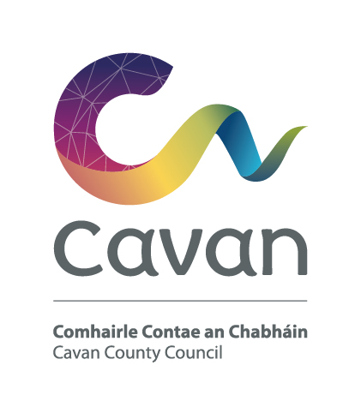

Cavan County Council
Comhairle Contae An Chabháin

Briefing Document and Selection Process

Civil Technician – Grade I
Competition:
The purpose of this recruitment campaign is to form a panel for Cavan County Council from which full-time, permanent and fixed-term contract posts may be filled at Civil Technician Grade I.

Post:
The Civil Technician Grade I will work under the control and supervision of the Senior Engineer or other designated officer.

Responsibilities/Duties:
- Preparation of detailed design drawings for contract documents using AutoCad, for various complex construction projects
- Preparation of pavement condition surveys
- Preparation of traffic management plans and traffic surveys
- Road accident mapping and investigation
- Surveying for various water services and roads projects
- Planning for, and supervision of, various construction/ investigative projects
- Preparation of Health & Safety documentation for works projects.
- Producing presentation work for Council and Public display
- Duties in relation to Public Lighting
- Mapping of water-mains & sewer networks including mapping of burst plots records for water-mains
- Mapping of sewer defects
- Carrying out of surveys to capture, record and map data on water-mains & sewers realigned as part of a road or other capital scheme
- Liaison with IT section and provide updates for water services infrastructure on Location Publisher
- Liaison with all relevant sections in order to gather and compile all existing hard copies of water-mains and sewer networks and digitise same
- Liaison with Planning Section in terms of estates taken in charge for purposes of digitising same
- Creation of mapping through MapInfo/AutoCAD Map and use of GIS editors e.g. Mapinfo, Mapdrain, Sus25, Mapnet, Autocad, An Post Geodirectory, Leaks Database
- Provide and distribute maps and reports for LA Water Services Section and Irish Water
- Implementation of GIS applications for sourcing and collation of geographical information from third party and internal LA sections
- Coordinate GIS activities between CCC and Irish Water
- Use of Irish Water Web Mapping Applications
- GIS map production including GIS data collection, conversion/editing, integration, updating, quality assurance and management and GIS System deployment and maintenance
- Create and present GIS data reports and mapping
- Maintenance of asset databases in GIS system
- Management of GIS systems implementation
- Produce Water Audits at DMA and WSS levels
- DMA mapping and Use or ArcGIS
- Control and supervision of staff
- Support other staff in the implementation and use of AutoCad & GIS systems and applications
- Report writing in relation to all of the above including ensuring that reporting is complete, timely and accurate, and that content is appropriate to users’ needs
- Keeping up to date with best practices in relation to duties above
- Any other activities as assigned by Line Manager/Supervisor

Notwithstanding the requirements of the post successful applicants may be assigned to any service area/role within the Local Authority at an analogous level by the Chief Executive at any time.

The Person:

Candidates will demonstrate through their application form and at the interview that he/she has/is:

- good communication and interpersonal skills
- self motivated with a record of demonstrating initiative and judgment in a work place environment
- the capacity to contribute to and work well in a team
- ability to prepare and present technical reports
- excellent planning and organisational skills
- technical knowledge and experience in computer aided drafting
- knowledge in the area of Health & Safety
- strong I.T. skills

Candidates will be expected to be flexible in terms of working hours as the duties can involve working outside of normal office hours.

Salary:
Remuneration will be at the Civil Technician Grade I Scale of the national wage scales. The present minimum scale is €39,018 increasing to €46,689 per annum (including LSIs) with annual increments subject to satisfactory performance via PMDS. The rate of remuneration may be adjusted from time to time in line with Government pay policy.

Pension:
The Local Government Superannuation Scheme applies.

Annual Leave:
30 days per annum

Hours of Work:
37 hours per week

Qualification:

- Character
Each candidate shall be of good character.
- Health
Candidates shall be in a state of health such as would indicate a reasonable prospect of ability to render regular and efficient service.

- Education, experience, etc;

Each candidate must on the latest date for receipt of completed application forms:

(a) (i) Have passed the NCEA/HETAC National Certificate Final Examination in
Civil Engineering, or
Geo-surveying, or
Construction Studies, or
Construction Studies in Building Maintenance, or
Construction Studies in Architectural Graphics
or
Hold an equivalent qualification
and
(ii) Have at least three years satisfactory experience after attaining the qualification concerned

(b) Possess adequate training and/or experience relating to the control and supervision of staff.
Or
(iii) Fulfill the following requirements

- have, satisfactory relevant experience in a technician post at Grade II level or in an analogous post under a local authority or health board in the State,
and
have at least three years satisfactory relevant experience in a technician post at Grade II level or in an analogous post, or
- have satisfactory service, in a technician post at Grade I or higher level in an analogous post under a local authority or health board in the State.
- possess adequate training or experience relating to the control and supervision of staff

- Hold a current full clean driving licence.

Please note a working knowledge of GIS and/or AutoCAD is desirable

Selection process:

Candidates will initially be assessed to ensure they meet the minimum qualifications set down above. Assessment will be based on information provided by the candidate on the application form. Qualifications of successful candidates may be subject to further checks post interview to confirm they meet the criteria.

Candidates will then be assessed on the basis of other information contained in their application form to determine, having regard to the requirements of the position and the number who have applied, if they should be called for interview. Candidates may be short listed on the basis of information provided in the application form.

Interview

At interview candidates will be assessed in the following areas:
Knowledge/Experience | Skills | General Attributes
- Range & depth of experience relevant to post  - Role of post  - Understanding of health & safety  - Previous & current working environment  - Understanding of local government legislation, local government policy. | - Change & people management  - Problem solving/ decision making  - Ability to work as part of a team & maintain effective working relationships  - Planning/organising/ budgeting  - IT | - Communication and interpersonal  - Initiative  - Commitment  - Positive attitude with self motivation

Data Protection:

All of the information you provide during the process will only be used for the purpose of progressing your application, or to fulfil legal or regulatory requirements if necessary.
We will not share any of the information you provide during the recruitment process with any third parties for marketing purposes or store any of your information outside of the European Economic Area. The information you provide will be held securely by us and/or our data processors whether the information is in electronic or physical format.
We will use the contact details you provide to us to contact you to progress your application. We will use the other information you provide to assess your suitability for the role you have applied for.

Cavan County Council is an equal opportunities employer

