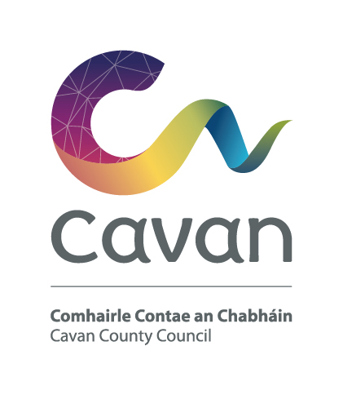

Cavan County Council
Comhairle Contae an Chabháin

Briefing Document and Selection Process

Assistant Staff Officer (Grade IV)
Competition:
The purpose of this recruitment campaign is to form a panel for Cavan County Council from which full-time, permanent and fixed-term contract posts may be filled at Assistant Staff Officer Grade.

Post:
The Assistant Staff Officer is a support or supervisory position within the Council and is assigned responsibility for the day to day operation of a work area, section or team.
The Assistant Staff Officer works as part of team, supporting managers and colleagues to meet work goals and objectives and to deliver quality services to internal and external customers. The post holder will be responsible for the implementation of work programmes to achieve goals and targets set out in Departmental and Team Plans.
The Assistant Staff Officer is expected to carry out their duties in a manner that enhances public trust and confidence.

The key duties and responsibilities of the post of Assistant Staff Officer include:

- To support the line manager to ensure the section or department work programmes are implemented to deliver on the Council’s Corporate Plan and operational plans.

- To communicate and liaise effectively with employees, supervisors and line managers in other sections and customers in relation to operational matters for their section or area of work

- To prepare reports, correspondence and other documents as necessary.

- To organise and facilitate internal and external meetings and participate and engage in discussions as appropriate.

- To provide assistance and support in the delivery of projects as required.

- To ensure high levels of customer service, responding to queries and requests for information in a professional and courteous and timely manner.

- To support the line manager to communicate, implement and manage all change management initiatives within the relevant area of responsibility.

- To supervise employees within their team or programmes of work within their area of responsibility, providing support to team members or colleagues as required.

- To participate in corporate activities and responsibilities appropriate to the grade.

- To be in compliance with Health and Safety legislative requirements, policies and procedures and safe systems of work

- To deputise for the line manage or equivalent as required.

- To undertake any other duties of a similar level and responsibility, as may be required, or assigned, from time to time

Notwithstanding the requirements of the post successful applicants may be assigned to any service area/role within the Local Authority at an analogous level by the Chief Executive at any time.

Requirements
In the context of the key duties and responsibilities for the post of Assistant Staff Officer listed above, the ideal candidate will demonstrate the following knowledge, experience, skills and competencies:

Knowledge, Experience and Skills:

The ideal candidate will demonstrate:

- Knowledge and understanding of the structure and functions of local government.

- Knowledge of current local government issues.

- Understanding of the role of an Assistant Staff Officer.

- Relevant administrative experience.

- Experience of working as part of a team.

- Experience of preparing reports and correspondence.

- Knowledge and experience of operating ICT systems.

Competencies:

The ideal candidate will demonstrate the ability to:

- Understand and implement change and demonstrate flexibility and openness to change.

- Develop and maintain positive, productive and beneficial working relationships

Delivering Results

- Plan work and allocation of staff and other resources effectively.

- Implement high quality service and customer care standards.

Performance Management and Team Work

- Supervise the team or work area to achieve corporate objectives.

- Work as part of a team to ensure delivery of plans and schedules.

- Have a strong team ethic of co-operation and mutual support.

Communicating Effectively

- Have effective written and verbal skills.

Personal Effectiveness

- Take initiative and be proactive when he or she sees the opportunity to make a contribution.

- Manage time and workload effectively.

- Maintain a positive and constructive and enthusiastic attitude to their role

Candidates will be expected to be flexible in terms of working hours as the duties can involve working outside of normal office hours.

Salary:
Remuneration will be at the Assistant Staff Officer Scale of the national wage scales. The present minimum scale is €27,024 increasing to €44,328 per annum (including LSIs) with annual increments subject to satisfactory performance via PMDS. The rate of remuneration may be adjusted from time to time in line with Government pay policy.
Pension:
The Local Government Superannuation Scheme applies.

Annual Leave:
30 days per annum

Hours of Work:
37 hours per week

Qualification:

- Character
Each candidate shall be of good character.

- Health
Candidates shall be in a state of health such as would indicate a reasonable prospect of ability to render regular and efficient service.

- Education, Training, Experience, Etc:
Candidates shall, on the latest date for receipt of completed application forms:-

(i) (a) have obtained at least Grade D (or a Pass) in Higher or Ordinary Level, in
five subjects (or four subjects if Irish is included) from the approved list of subjects in the Department of Education Established Leaving Certificate
Examination or Leaving Certificate Vocational Programme including Irish
and/or English and one of the following: Mathematics, Accounting,
Business Organisation or Economics, and

(b) have obtained at least Grade C (or Honours) in higher level (or Honours)
papers in three subjects in that examination (or two subjects if Irish and/or
one of the following is included: Mathematics, Accounting, Business
Organisation or Economics), or

(ii) have obtained a comparable standard in an equivalent examination, or

(iii) hold a third level qualification of at least degree standard, or

(iv) be a serving employee of a local authority, health service executive, vocational education committee in the State, institute of technology, the General
Medical Services (Payments) Board, St. James's Hospital Board, Beaumont
Hospital Board, An Bord Altranais, the Local Government Computer
Services Board, the Border, Midland and Western Regional Assembly or the
Southern and Eastern Regional Assembly and have satisfactory experience
in a post of Clerical Officer or an analogous post.

Selection process:
Candidates will initially be assessed to ensure they meet the minimum qualifications set down above. Assessment will be based on information provided by the candidate on the application form. Qualifications of successful candidates may be subject to further checks post interview to confirm they meet the criteria.

Candidates will then be assessed on the basis of other information contained in their application form to determine, having regard to the requirements of the position and the number who have applied, if they should be called for interview. Candidates may be short listed on the basis of information provided in the application form.

Data Protection:

All of the information you provide during the process will only be used for the purpose of progressing your application, or to fulfil legal or regulatory requirements if necessary.
We will not share any of the information you provide during the recruitment process with any third parties for marketing purposes or store any of your information outside of the European Economic Area. The information you provide will be held securely by us and/or our data processors whether the information is in electronic or physical format.
We will use the contact details you provide to us to contact you to progress your application. We will use the other information you provide to assess your suitability for the role you have applied for.

Cavan County Council is an equal opportunities employer

