All applicants must show the approximate location of their current residence on the map using an asterisk with a capital R beside it (i.e. *R). The location of your current place of work must be identified on the map using an asterisk with a capital W beside it (i.e. *W). This map is not to scale and will be used by the Cavan County Council as an aid to help readily identify and record the place where you currently reside and the place where you currently work.

Signature of Applicant __________________________________ Date ____________________
Complete in BLOCK CAPITALS:

Applicant Name:

__________________________

Home / Residence - Address
________________________________________________________________________________________________________
EIRCODE:

Place of work – Address
________________________________________________________________________________________________________
EIRCODE:

Type of work undertaken
____________________________________________________

All Recruit firefighters are required to reside and work within a distance of 1.5 miles from the fire station. In order to process your application you must indicate the location of your place of residence and your place of employment on this map as per the instructions above the map. Any change of residence or place of employment during the application process or after recruitment must be immediately notified to the County Council.

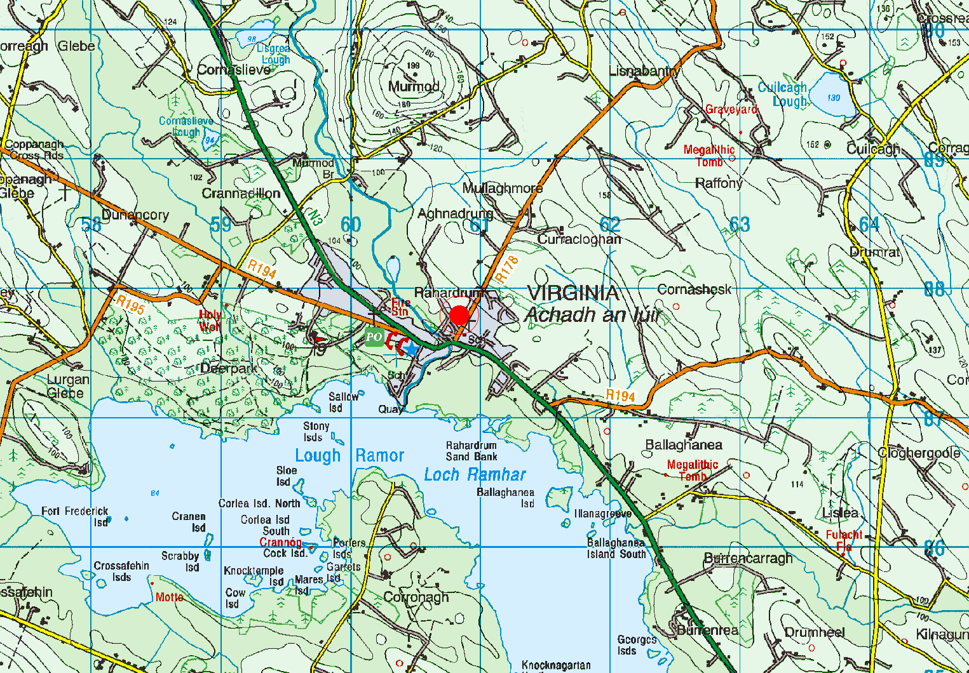

Fire Station

