How to Make Compost from Garden Clippings & Vegetative Food Scraps from the Kitchen

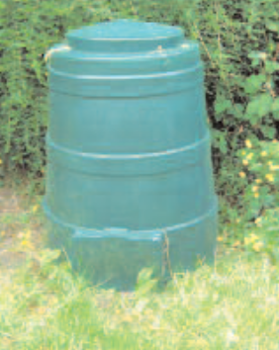
The very first step in creating a garden is healthy soil. Composting is the process where we store garden clippings and kitchen vegetative food scraps in a heap, a bin or even a homemade unit. Over 1-2 years the natural soil bacteria, creepy crawlies and fungi break down what we once classed as garden and kitchen waste into a fertile nutrient rich compost that will maintain a healthy soil and help encourage the growth of vegetables and flowers in your garden or around your community.

Step 1 - Choosing your compost system
The most popular compost systems for garden clippings and some vegetative kitchen scraps is the compost bin designed for small to medium sized gardens or building your own compost system using pallets of wood or concrete blocks for larger gardens. The principles of composting for both are the same you will just be working with smaller or larger quantities of material depending on the size of your garden

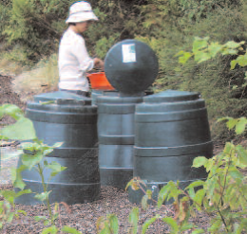
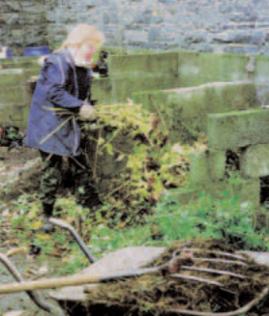

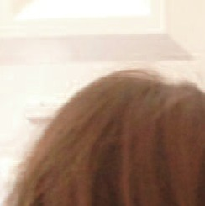

Step 2 - Where to put your compost system
Your choosen compost unit should generally be placed along a boundary of the garden,in a shady spot and on soil. Compost units are designed for the garden so keep away from the house and put a path in place if you want to avoid trampling as you may be visiting your compost unit on a daily basis especially in the summer.

Step 3 - Compost essentials
There are five essetial elements to remember when making compost:
- Add a blend of wet (nitrogen rich) green material and dry (carbon rich) brown material

- The smaller the particle size the quicker the material will break down so shred, cut or slice larger items into smaller pieces before adding into the compost system
- Moisture is keep to the compost process your mixture should be damp to the touch - to wet or dry and your compost unit will smell - use your senses to judge the blend of green (wet) and brown (dry) materials needed
- Oxygen is essential turn your compost on a regular basis to activate the decomposers breaking down your waste into compost
- Larger heaps can generate more heat and in turn break down quicker than smaller heaps




Step 4 - Harvesting your compost
You will know your compost is ready by using your senses - look at it, feel it and smell it. It should be brown in colour, crumbly texture and you should no longer recognise the waste materials you added. Use this compost on your vegetable patch or in your flower beds to add nutrients to the soil, use it as a mulch under hedges and around trees to encourage growth, add 50:50 ratio of compost and sand and use for germinating seedlings or alternatively use 1/3 compost and 2/3 garden soil as a potting mix.

Step 5 - Trouble shooting
Here are some of the common problems people experience while composting & how to solve them:

Fruit Flies - These are harmless but annoying and are attracted to the vegetative fruit scraps added into the compost system to prevent always bury your vegetative food scraps in the compost unit or alternatively to remove from the compost unit leave the lid of the compost unit off and all the flies will leave the compost unit then cover your composting material with whole wet sheets of newspaper to create a barrier

Rodents - Unfortunately some people have experienced rodents in their compost units to avoid at- tracting them to it do not put any animal products into the compost unit. If they are in the area and you are concerned about them line the bottom of the compost unit with a fine mesh wire to prevent them
entering the compost unit or plant lavender around the compost unit as the smell of this deters them.

Offensive Smells - Your compost material should never smell - smells are a sign that there is not enough oxygen in the compost system - eliminate the offensive smell by turning the material to add oxygen and you may also have to add a brown drier material if the compost material is very wet

pH - by adding a balance of materials your compost pH will be neutral to alkaline however if you add a high quantity of citrus fruit peels from juicing and include pine needles you may create an acidic compost if this is produce choose acid loving plants for the compost or add lime to bring the pH back to nuetral/alkaline

Items to Avoid - paint, oil and grease as these will eliminate oxygen and create a smell in your
|compost heap, animal products as they may attract rodents, coal and barbeque ash as the toxins in these will kill the natural bacteria, fungi and creepy crawlies in the heap and diseased plants as there is no gaurantee the disease will die during the compost process

For further information on composting why not visit www.stopfoodwaste.ie

This leaflet was prepared with funding support from Cavan County Council as part of the Local Agenda 21 Environmental Partnership Fund 2013 by Nuala Madigan, Environmental Education Officer of the Irish Peatland Conservation Council and Stop Food Waste Team member

