



How to make Leaf Mould with Autumn Leaves

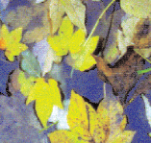
Every year we gather up leaves around our gardens or indeed our communities and generally we throw them into the bin for landfill and that is the last we think about them until the following year. Throwing leaves away is a waste. Leaf mould is free and easy to make. It is ideal for germinating seedlings, for suppressing weeds and for locking moisture into our flower beds or around our vegetable patches.

How to make leaf mould

- Make a wire mesh cage by stretching wire mesh around four posts which have been secured into the ground.
- Fill the cage with soggy leaves.

- Cover the wet leaves in the mesh cage with carpet or cardboard.

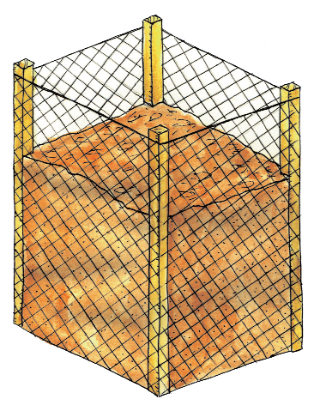
- After 1 - 2 years the leaf mould will be ready to use.

Wooden post


Wire mesh

Soggy leaves covered with cardboard or old carpet

For further information on composting why not visit www.stopfoodwaste.ie

This leaflet was prepared with funding support from Cavan County Council as part of the Local Agenda 21 Environmental Partnership Fund 2013 by Nuala Madigan, Environmental Education Officer of the Irish Peatland Conservation Council and Stop Food Waste Team member

