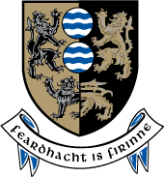
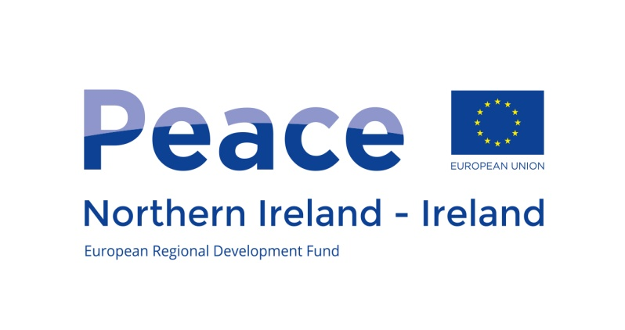
GUIDELINES

PEACE IV
EU Programme for Peace and Reconciliation 2014-2020,
Cavan County Council

Cavan County Council is seeking applications for funding from the Peace IV Programme under the following measure:

Building Positive Relations - Objective 4.1 ''Local Authority Action Plans - Shared Spaces and Services Measure

This project/initiative is supported by the EU’s PEACE IV Programme, managed by the Special EU Programmes Body.

INTRODUCTION

The Special EU Programmes Body (SEUPB) is a North/South Implementation Body sponsored by the Department of Finance in Northern Ireland and the Department of Public Expenditure and Reform in Ireland. It is responsible for managing two EU Structural and Investment Funds Programmes – PEACE IV and INTERREG VA - which are designed to enhance cross-border co-operation, promote reconciliation and create a more peaceful, social and economic prosperous society.

PEACE IV
Through the PEACE IV Programme Cavan County Council wish to support projects that promote social inclusion, combat poverty and discrimination and make a lasting difference in building greater cohesion between communities. In particular, projects should be able to demonstrate how they will foster enhanced peace and reconciliation in Co Cavan and in some instances in our bordering northern counties.

PEACE IV will place a strong emphasis on promoting cross-community relations and understanding. All projects will be required to identify how they will contribute towards the achievement of the result indicators of the Programme in order to promote a greater level of reconciliation and understanding in Co Cavan and in some instances in our Bordering Northern Counties

Summary of Call
Cavan County Council is seeking applications from Community Groups, Community and Voluntary Sector Organisations or Statutory bodies.

Organisations are invited to submit project proposals with the following specific objective:

The creation of a more cohesive society through an increased provision of shared space and services; Successful projects will develop Cross Community shared spaces of a transformative nature that deal with the legacy of conflict.

A total of €963,385 (subject to funding being approved) may be allocated to this measure. The minimum level of funding available per project will be €200,000

This document offers guidelines on how to apply for funding to Cavan County Council PEACE IV Programme – Shared Spaces and Services Measure
It is addressed to those organisations, institutions or Community & Voluntary Groups which propose to lead in the implementation of a project supported by Cavan County Council.

The Programmes are open to any organisation(s)/group(s) that can contribute to the results and outputs of the Programmes with the capacity to implement an EU funded project. The assessment process will assess both of these aspects.

The timetable for the submission of applications is as follows:
- Opening Date: 14 December 2016
- Closing Date: 27 January 2017
- Application forms and guidelines are available on www.cavancoco.ie or by e-mailing jcrudden@cavancoco.ie or request for posting by calling Jane Crudden on 049 437 8585

Result indicators: The creation of a more cohesive society through an increased provision of shared spaces and services that will contribute to the result indicators listed below:

- The percentage of people who would define the neighbourhood where they live as neutral; from 64%: always or most of the time to 68% and from 22%: sometimes to 26%;
- The percentage of people who would prefer to live in a neighbourhood with people of only their own religion; from 20% to 16%; and
- The percentage of people who prefer to live in a mixed religion environment; from 71% to 75%.

Shared Spaces and Services: it is anticipated that the programme will fund the following types of actions:

- Successful projects will develop Cross Community shared spaces of a transformative nature that deal with the legacy of conflict;
- Dialogue, reconciliation and capacity building between different communities, leading to the creation of shared vision and conditions;
- Developing the shared aspects of existing neighbourhoods, public spaces and buildings;
- Public/Community partnerships and facilitation for programme activities for shared space;
- Protocol development programmes to facilitate greater collaboration between people and places.
Successful projects will also demonstrate that they:
- Will not duplicate or compete with existing infrastructure and services locally; and
- Will be sustainable in the longer term
- Can be delivered within the programme timeframe, and have the necessary permission in place in order to progress

Financial Information
Applications should include a detailed breakdown of all costs involved in delivering the project. The budget proposed will be robustly tested as part of the assessment of your project.
Application assessment Criteria
Applications must demonstrate relevance to the seven criteria, each with a weighting listed below, against which applications will be appraised and scored (0 to 5). These are:

 | Criterion | Weighting
1. | Contribution of the project to the defined results and outputs of the programme | 20%
2. | Quality of project proposal | 20%
3. | Quality of cross community/border co-operation with demonstrable added value | 20%
4. | Quality of the project team and implementation arrangements | 10%
5. | Is the budget realistic and offer Value for money | 20%
6. | Contribution towards sustainable development | 5%
7. | Contribution towards equality | 5%

In order to be successful, a minimum score of 3 for each criterion is required.

All projects which meet the required threshold will be ranked in order of score. Cavan LCDC will make the final decision on which applications are successful.

Unsuccessful applications will be formally rejected with clear reasons for rejection. Applicants rejected at this Stage will have the right to a review.

Completed applications should be submitted to jcrudden@cavancoco.ie or Jane Crudden, Peace IV Programme Manager, Community and Enterprise, Cavan County Council, Library Building, Farnham Street, Cavan H12C9K1.

Contact Us
For enquiries about this funding call please contact Cavan County Council

Contact Name: Jane Crudden
Peace IV Programme Manager
Cavan County Council, Community & Enterprise
Farnham Street, Cavan H12C9K1
jcrudden@cavancoco.ie 
049 437 8585

