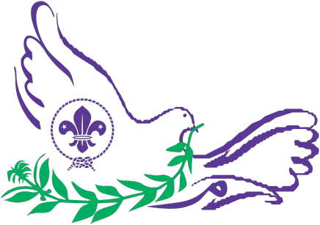

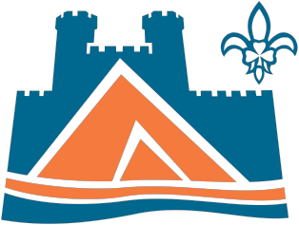
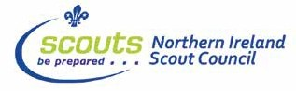
Brochure compiled and produced by Scouting Ireland

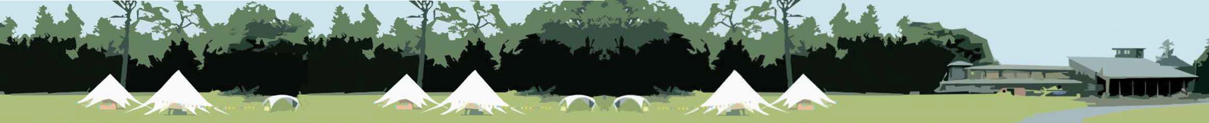



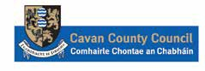

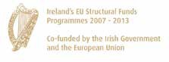
This project has been supported by the EU’s Peace III Programme, managed for the
Special EU Programmes Body by Cavan County Council
Scouting Ireland

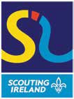
Official Opening - August 18th 2012

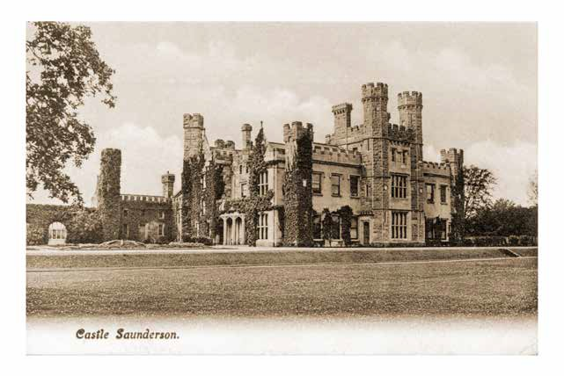
Castle Saunderson was the family seat of the Saunderson family who acquired the original castle in 1573 during the Plantation of Ulster. The original castle was inhabited by the O Raghallaighs of Breffni and was formally known as Breffni Castle.

The present castle dates from the 1840’s. A notable member of the family born here was Col. Edward Saunderson, Leader of the Irish Unionist Party from 1895 –
1906. A statue of him stands to this day in Portadown.

Captain Alexander Saunderson sold the castle in 1977 and it changed hands a number of times until it was acquired by Scouting Ireland (C.S.I.) in 1997. The dream was to create an International Scout Centre. Despite huge efforts by many people that dream never materialised.

In 2004 Scouting Ireland was formed and in 2008 new life was breathed into the project. A Partnership was formed between Scouting Ireland, Northern Ireland Scout Council, Cavan County Council and the Special EU Programmes Body. Plans were soon agreed on the development of
what we see today. Castle Saunderson International Scout Centre is the most modern facility of its kind anywhere in Europe.

At last the day has arrived and we finally get to open Castle Saunderson International Scout Centre. The project as a whole has seen many setbacks and it has been pushed, tested and faltered on many occasions. However the project also motivated many people along the way and some great people had seen the vision,
potential and dreamed about what was possible. It has taken many years of patience to finally see the scouting light at the end of this very long and at times arduous tunnel.

As the quote from our founder Baden Powell who wrote in the Letters from the varsity of life. “Softly, softly, catchee monkey”, is the West African rendering of a very valuable precept. An awful lot
of people fail through lack of patient persistence. So it was through the patience and dedication of many members of the Scouting Family that helped us get to where we are today.

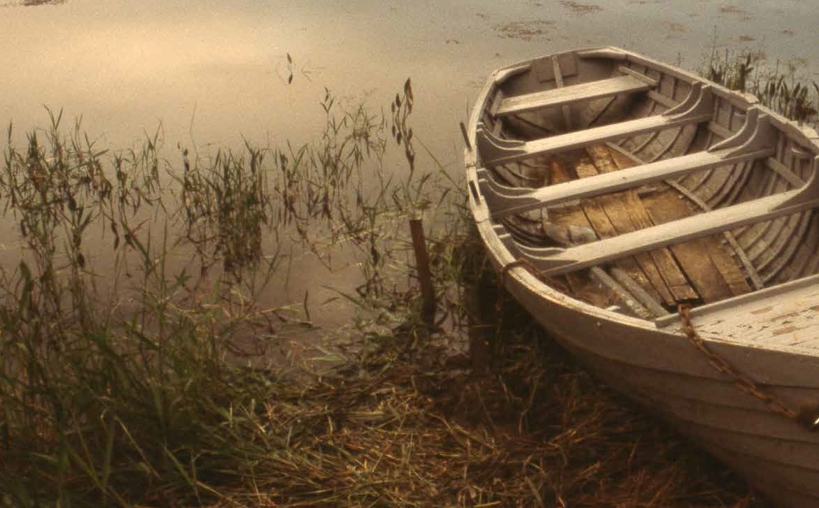
The responsibility for the day to day management and operation of
Castle Saunderson International Scout Centre lies in the hands of its Management Team.

The Management Team is led by myself Camp Chief Tony Smith and I am supported by the Centre Manger Finbar Gethins.
The Management Team is made up of Volunteers from Scouting. These people have a vision for the future of Castle Saunderson,
and a passion to deliver the best possible programme to the young and not so young that will use the Centre. The management team itself will be backed up by a team of committed volunteers that
will operate the Centre on an ongoing basis. These volunteers from Ireland & abroad will ensure Castle Saunderson International Scout Centre will be the envy of Scout Centres throughout the world.

Camp Chief Tony Smith Manager/ Administration Finbar Gethins Treasurer Ruairi Molloy Head of Programme Gerry Finnegan Head of Projects Declan Heeney Campsite Staff Lead Shane Maguire International Co-ordinator Anne Foley Team Member Robin Ferguson

Tony Smith
Camp Chief
Castle Saunderson International Scout Centre

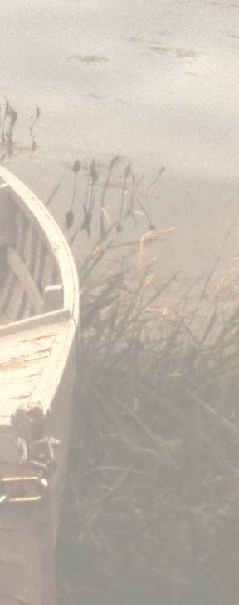
The Steering Committee of the Castle Saunderson Project has overseen the construction of the project over the last number of years and has members representing all the partners. The
Steering Committee has given great guidance and leadership to the project. The current & former members of the Steering Committee are:

Jack Keyes, County Manager, Co-Chair Michael John Shinnick, Chief Scout, Co-Chair John Lawlor
Francis Minogue Damien O’Sullivan, Finbar Gethins Colin Lammey
Ken Gillespe John Brannigan Ger Finn
Kevin Smith Majella Tierney Paddy Connaughton Martin Burbridge Cllr. Andrew Boylan Cllr. Patricia Walsh Cllr. Charlie Boylan David Clarke
Emma Bredin Wilfred Mulryne Brendan Jennings Orla Brady
Eamonn Lynch
Niall Walsh
Scouting in Ireland has never been as strong. Currently
there are over 44,000 members involved in Scouting Ireland throughout the country. It is made up of 35,000 Youth Members and 9,000 Adult Leaders. Since the start of Scouting Ireland in 2004 Scouting has increased its membership by
nearly 30% and is the fastest growing youth organisation in the
Country.
Scouting Ireland now has 462 Scout Groups based in every county on the Island of Ireland Including the Republic of Ireland and Northern Ireland and is opening on average about
20 New Groups each year. Scouting Ireland is open to both male and female members and operate Youth Programme Sections from age 6 to 25 year old youth members. The Youth Programme Sections are for Beaver Scouts 6 to 8 years, Cub Scouts 9 to 11 years, Scouts 12 to 15 years, Venture Scouts 15 to
17 years and Rover Scouts 18 to 25 years.
Scouting offers fun, challenge and everyday adventure to all its youth members. We provide over 200 different activities such as abseiling, archery, drama, sailing and canoeing, hill walking, campcraft etc. Scouting helps 6 to 25 year olds grow in confidence, achieve their full potential and become
active members of their communities. This is possible through the efforts of 9,000 volunteers who also enjoy the fun and friendship of Scouting. Trusted by nearly 100,000 parents
each week, the movement welcomes members from all backgrounds, faiths and cultures. Special emphasis is placed
on bringing the Scouting Programme to young people in inner cities, rural areas and other disadvantaged communities. Scouting seeks to equip young people with life skills, independence and leadership ability appropriate to their
age. While Scouting moves with the times and uses the latest technology across its 462 local Scout Groups nationwide,
camping and hiking remain firm favourites with young people, even after 100 years. Scouts are the original innovators of youth empowerment which has been a central tenet from the very beginning, when many countries in Europe were still without democracy. Today, one of the most attractive aspects of Scouting for young people is the very real freedom to attain their potential in an environment where teamwork and leadership development flourish. Scouting has placed a focus on care for the environment and minimising the human footprint on it, long before it was fashionable or newsworthy to do so.
Scouting Ireland has recognised the power of branding
in today’s society and has developed a modern, colourful brand identity that enjoys increasingly strong recognition with young and old alike across Ireland. This represents a movement that is going from strength to strength with a new, vibrant and more accurate image, in contrast with the
‘traditional’ image of the past. Well known former Scouts include Roy Keane, Michael O’Leary, Bob Geldof, Entertainer Graham Norton, Brian Hayes, Charlie O Connor, Trevor Sargeant and several other politicians, heads of industry and educationalists. Famous former scouts from further afield include Former British PM Tony Blair, Former US President
Bill Clinton, Footballer David Beckham, Entrepreneur Richard Branson, Naturalist Sir David Attenborough and Astronaut Neil Armstrong.
For more information on Scouting and about the Youth Programme Sections you may be interested in check out www.scouts.ie

Sean Farrell.
National Secretary, Scouting Ireland

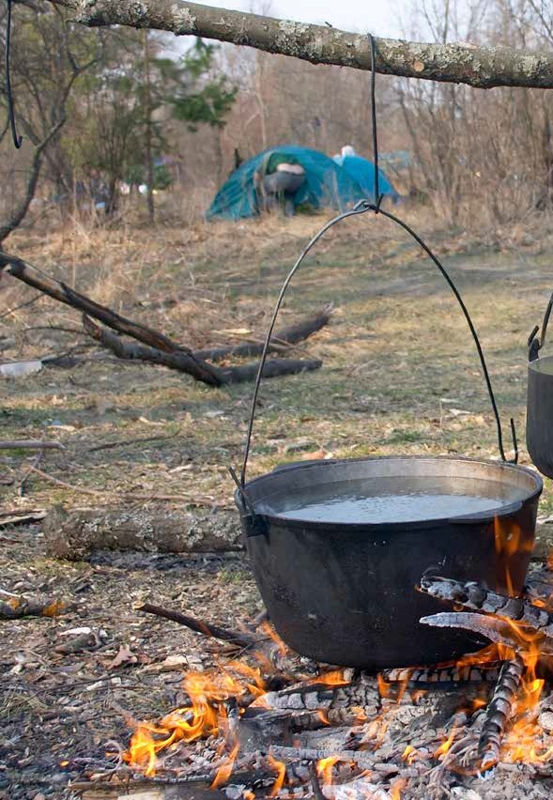
Scouting Ireland is built on a shared respect for the uniqueness of young people. We believe in the abilities of young people
and their wish to discover and harness their own potential. We help them achieve this
by providing them with the support and encouragement they need through our ONE Programme.

At the heart of Scouting’s philosophy is a belief in young people and their ability to learn from each other and speak for themselves in an atmosphere of trust
and responsibility. Scouting Ireland’s
ONE Programme assists the 44,200
Youth Members (6 years – 25 years) across the island of Ireland to develop in an environment of fun, adventure
and challenge through use of The Scout Method; a methodology which has at its heart, the giving of responsibility to the young person to lead and plan their own learning and to find their voice in education and society.

In this exciting time for Scouting in Ireland with the continued development of ONE Programme where Adults in Scouting
are now assuming the role of ‘mentor & facilitator’ while Youth Members are become the Leaders in their own Programme
and life choices we continue to forge partnerships with external accreditation bodies such as ‘Gaisce’ and ‘The Duke of Edinburgh’ Award Schemes via the Chief Scout Award to give wider recognition to the development of our Youth Members.

With Nature and the Out of Doors and Young People & Adults Working Together being two key elements of The Scout Method, the camping and activity grounds in Castle Saunderson provide a new and exciting offering to our Youth Membership on the island of Ireland (and indeed young people within the greater World Scout Movement), that is a venue
that provides the context and adventures to grow the kind of key skills needed not just to create the adults of tomorrow but to develop our Youth as the Citizens of Today.

Ian Davy
Chief Commissioner (Youth Programme) Scouting Ireland

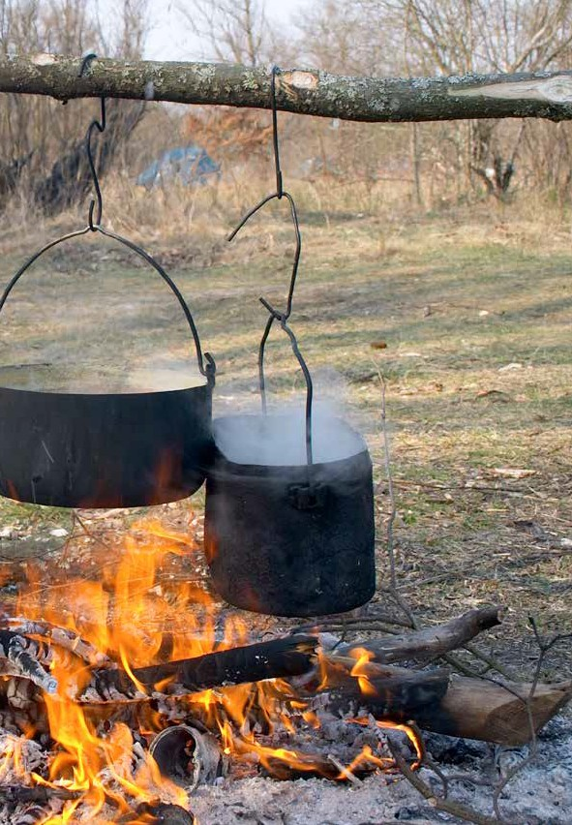
Recently the concept of ‘community’ has gained new momentum as policy makers struggle with public sector cutbacks and ever-increasing demands to improve services through greater engagement with the commu- nities they serve.

Volunteering in the community is a key component of the Scout programme. In a recent UK wide survey some
47 per cent of the adult leaders surveyed said that they volunteer outside of Scouting, sharing their skills and knowledge freely with others. In addition, Scouting has a strong ethos of helping young people to take an active role in their local community through volunteering activities and 82 per cent of youth members take part in volunteering activities at least once a year.

Research undertaken shows that a substantially higher proportion of Scouts engage in voluntary activities than children and young people not engaged within Scout- ing. This effect is also long-lasting:

• 36 per cent of former young members volunteer
regularly (at least two hours per week)
• This is set against only 26 per cent of the general
population volunteering regularly.

Of the former youth members that do volunteer, 66 per cent said that Scouting positively influenced their decision to get involved.

Scouting provides opportunities for young people to engage with their communities in a productive manner through routes that might otherwise be difficult to identify and/or access.
This community integration and support was welcomed by the external society-wide organisations surveyed with
80 per cent stating that Scouting benefited their organ- isation and 69 per cent stating that it benefited their clients or service users. When Scouting was present in a community it provided a broad range of mutual benefits including:

• shared facilities/property
• help from volunteers
• training opportunities
• shared expertise and knowledge
• youth diversion activities
• support at community or civic engagements

Where communities can support Scouting to grow – by encouraging new adult volunteers or working in partner- ship on shared objectives (eg Cavan County Council on the Castle Saunderson Project) those same communities will benefit from the skills, knowledge and volunteering support that Scouting can and willingly offers.

Scouting in Northern Ireland is happy to support the work of Scouting Ireland and have been part of the develop- ment of this tremendous facility that is Castle Saunder- son, we wish you well for the future.

Colin Lammey
Chief Commissioner
The Scout Association
Northern Ireland Scout Council
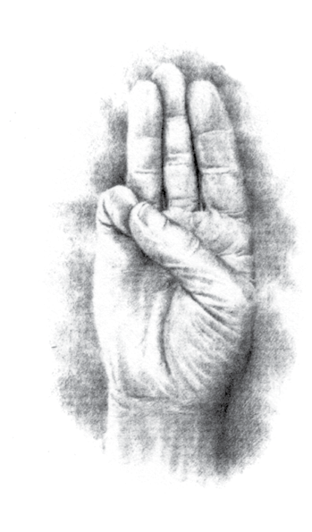

We are honoured to have President of Ireland, Michael D. Higgins with us today to inaugurate Castle Saunderson International Scout Centre. President Higgins is also the Patron of Scouting Ireland. As a mark of our appreciation we wanted to present the President with a gift. What better gift to give than a Scout Stave. We hope that Presi- dent Higgins will use and enjoy his Scout Stave for many years.

The top of the Stave is whittled to show the Scout sign and along the body of the stave is the poem ‘An Ghleann inar Togadh mé’ (The Glen were I was reared) written by Douglas Hyde, poet and first President of Ireland. Below is the poem as Gaeilge and an English translation. The Stave was carved by Scouter Martin Thompson.

Ó háit go háit ba bhreá mo shiúl
‘S dob ard mo léim ar bharr an tsléibhe
San uisce fíor ba mhór mo dhúil
‘S ba bheo mo chroí i lár mo chléibhe Mar chos an ghiorria do bhí mo chos, Mar iarann gach alt is féith,
Bhí an sonas romham, thall ‘s abhus, Sa ghleann inar tógadh mé.

Ba chuma liomsa fear ar bith,
Ba chuma liom an domhan iomlán, Mar rith an fhia do bhí mo rith,
Mar shruth an tsléibh’ ag dul le fán; Is ní raibh rud ar bith sa domhan,
Nach ndéanfainn (dá mba mhaith liom é) Do léim mo bhád ar bharr na habhann.
Sa ghleann inar tógadh mé.

Gach ní dá bhfacas le mo shúil, Bhí sé, dar liom, ar dhath an óir,
Is annamh a dhearcainn ar mo chúl,
Ach ag dul ar aghaidh le misneach mór, Do leanainnse gan stad gan scíth
Mo rún, nuair chuirinn romham é;
Do bhéarfainn, dar liom, ar an ngaoth, Sa ghleann inar tógadh mé.

Ní hamhlaidh tá sé liom anois,
Do bhí mé luath, ‘nois tá mé mall; Is é mo léan, an aois do bhris
Sean-neart mo chroí is lúth mo bhall;
Do chaill mé mórán ‘s fuair mé fios,
Ar mhórán - och ní sású é-
Mó léan mo léan gan mé arís óg
Sa ghleann inar tógadh mé.
Walking for fun without a rest, I could leap the highest leap, My joy was in cold water deep
As my heart leapt within my chest. My foot was swift just like the hare Each sinew, nerve and vein was strong
With joy all round, there was no wrong
In the glen that raised me there.

I feared not any man around
I cared not the whole world wide
The deer’s stride that was my stride
Like the mountain stream that rushes down. There was nothing in this great world wide That I couldn’t do, if so I chose
My boat across the waters rose
In the glen where once I did reside.

All things that first I did observe Seemed to me like burnished gold Not looking back for I was bold
And driving on without reserve. I would go and take no rest
My heart’s desire that was my call Catching the wind would be my all In the glen that I loved best.

Now old age has left me weak I was swift but now I’m slow It’s my regret that I’m laid low
Old age has left me rather meek. I lost much and I learned more And yet I am not satisfied
Oh to be young and still reside
In that lovely glen in days of yore.

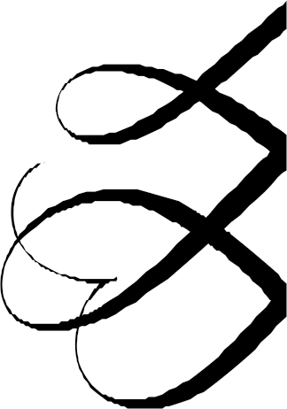
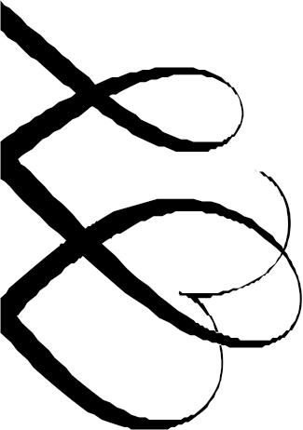
Order of Ceremonies
John Lawlor, Chief Executive Officer, Scouting Ireland - Master of Ceremonies
Paddy O’Reilly, Chairman Cavan County Council
Michael John Shinnick, Chief Scout, Scouting Ireland
Colin Lammey, Chief Commissioner, Northern Ireland Scout Council
Pat Colgan, Chief Executive, Special EU Programmes Body
Jack Keyes, Cavan County Manager.
Minister Jennifer McCann, Junior Minister, Office of First Minister and Deputy First Minister Minister Jonathon Bell, Junior Minister, Office of First Minister and Deputy First Minister Minister Fergus O’Dowd, Minister of State with Responsibility for the NewEra Project Minister Nelson McCausland, Minister for Department of Social Development

Musical Entertainment by St. Michael’s Scout Band

Arrival of President Michael D. Higgins & Presidential Salute

Tour of Castle Saunderson International Centre

Official welcome by Michael John Shinnick, Chief Scout, Scouting Ireland

Unveiling of Plaque by President Michael D. Higgins

Address by President Higgins

Reply by Jack Keyes, Cavan County Manager Presentation of gifts to President Michael D. Higgins President departs

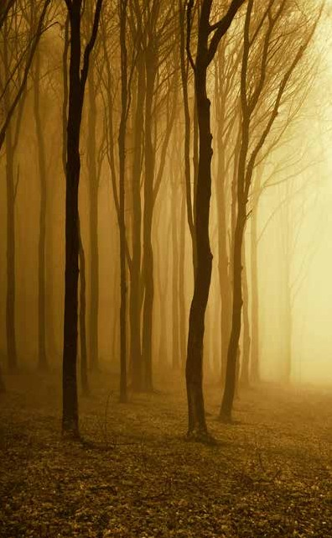
Castle Saunderson International Scout Centre is a unique and exciting development which will be synonymous with the word Cavan in the years to come.

As it is a corporate aim of Cavan County Council to support young people in the region, the Council is delighted to see the Scouting Jamboree project coming to fruition.
The County Council were in consultation with Scouting Ireland over a number of years regarding development of their lands at Castle Saunderson but the financing of such a project was problematic.

In 2008, Cavan County Council submitted an application to the Special European Union Programmes Body
(SEUPB) for funding for an All Ireland Scouting Jamboree Project on a 34 acre site at Castle Saunderson. The application was successful in securing funding in excess of €3.4m.

The County Council entered into a legal agreement with Scouting Ireland to enable Cavan County Council to develop the facilities on Scouting Ireland’s land. The County Council also purchased the remainder of the lands owned by Scouting Ireland with the intention
of developing the lands with complimentary tourism related facilities at a future date.

The project was undertaken by the Partnership of Scouting Ireland and Cavan County Council, supported by the Scout Association Northern Ireland Scout Council.
The project was tendered through a design and build competition, the main criteria being excellence in design and accessibility. Cavan County Council managed the design and construction of the complex.

When the Contractor originally appointed for the complex got into difficulties, the Council took on the role of Project Managers with the approval of SEUPB availing of the services of the original design team and sub-contractors.
The project was managed by Kevin Smith with support from
John Brannigan.

The Special E.U. Programmes Body has recently approved funding for the renovation of the Church at Castesaunderson and this development will provide additional complimentary facilities adjoining the Scouting site.
Through Peace III Funding, Cavan County Council has provided diversity training to over 300 scouting leaders from the six Northern Counties and the six southern border counties. This training consolidates the Peace III theme of the complex with the potential of promoting diversity and peace building.

The All Ireland Scouting Jamboree is a flagship project which will not only serve Scouting Organisations from all over the world but has enormous tourism potential for the locality, the County and the region.

Jack Keyes County Manager Cavan County Council

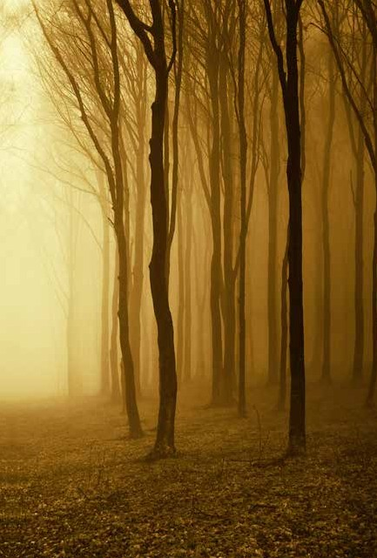
I would like to congratulate all of those who worked on the development of the Castle Saunderson International Scout Centre, and thank them for their incredible dedication and commitment in ensuring the completion of this magnificent new Centre and site. Delivering a project of this magnitude is a significant undertaking and no one can underestimate the work involved along the way.

This initiative has been supported under the creating shared public spaces priority of the EU’s PEACE III Programme. This priority provides support to projects that create shared neutral spaces which allow people from different communities to come together and learn from each other. Castle Saunderson is an excellent example of this as it will help foster new and positive relationships, particularly amongst the young people who use it. The European Commission is particularly committed to helping the people of this region as they work towards the goal of lasting peace and prosperity.

The PEACE III Programme has delivered job creation, urban and rural regeneration, social inclusion and
cross-border co-operation, but at its heart lies the human element of encouraging meaningful contact between
the two main communities and the commitment to tackling sectarianism, racism, polarisation and stereotyping by building relationships and fostering dialogue. Castle Saunderson is an excellent example
of this, as it will help foster new and positive relationships, particularly amongst the young people who use it.

The most fundamental goal of the European Union is to bring people together to live in peace, with
a common respect both for shared values and for diversity, bridging the social and economic gaps that exist across Europe and the investment of almost
€3.5 million of PEACE III funding demonstrates the commitment of the European Union, the Government of Ireland, and of the Northern Ireland Executive to the creation of shared spaces and the promotion of peace and good relations between the communities who live along the border region.

Pat Colgan, Chief Executive
Special EU Programmes Body


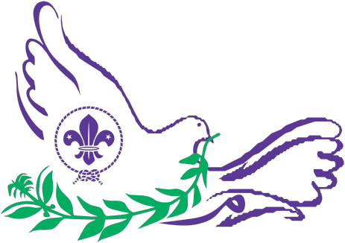

Let me introduce you to the most ambitious project ever undertaken by Scouts. It is called ‘Messengers of Peace’.

Scouts are changing the world today; at this very minute they are doing what scouts do! They solve conflicts in schools by
preventing bullying using the simple concept of friendship. They lead educational programmes using the idea of learning by doing. They help the poor and the hungry using their unique scouting skills. The countryside is their playground and of course they would like to protect it for everyone to enjoy.

So, Messengers of Peace is a simple idea with a really big impact – changing the world.

Imagine, if every Scout in the world, all 30 million of them, were to undertake a simple project or act of kindness to make the world a better place to live in - this truly would change the world! The Messengers of Peace programme therefore, is a challenge to every Scout to make a simple commitment to do something for others. One action multiplied by 30 million acts worldwide…a massive movement for Peace.

The idea of this project is to mobilize 30,000,000 scouts worldwide to action within their community.

From disaster-ravaged Haiti to war-torn Burundi, poverty stricken Salvador to post apartheid South Africa – Scouts are engaged in cutting edge services which are changing their communities

How are we going to do it – by asking Scouts world wide to undertake a project within their community. The result of their actions will make the world a better place to live in and enrich the lives of all involved.

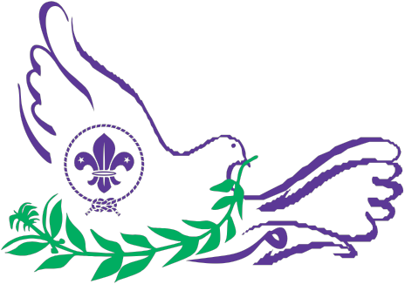

To conceive of an action that will involve 30,000,000 scouts is scary but we believe in the premise – ‘that if you dream it you can make it a reality’.

To me, the magic of this programme is that it allows us to connect the dots between what our Scouts already do…to the reality that they are part of a much larger picture. Their efforts, along with those of their fellow Scouts around the globe, can be a powerful force for good.

Castle Saunderson will be a key component in the realisation of this dream. The centre will be a World Centre for Education in
Peace and Dialogue under the Messenger of Peace banner.

Earlier this year a team, lead by Michael John Shinnick, Chief Scout, attended an extensive course in dialogue run by the King Abdullah International Centre for Dialogue in Saudi Arabia. These pioneers will provide future generations of Scouts with vital skills in dialogue and leadership that will inspire them to acion within their local communities.

As a World Scout international Centre for Peace Education and Youth Leadership it will become a beacon for Scouts worldwide who seek to understand the processes of peace and leadership.

I really am excited about the future interactions that will happen at Castle Saunderson….creating a better world …it all begins
with the first steps and Castle Saunderson is leading the way.

John Geoghegan
World Scout Foundation
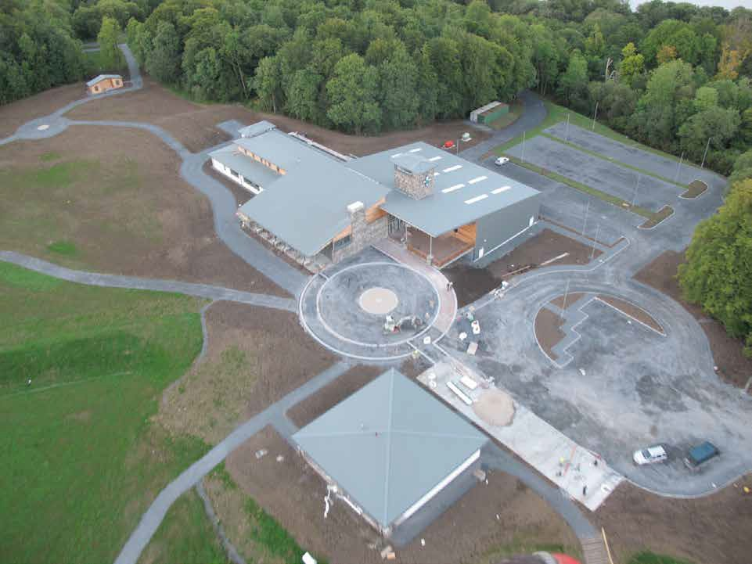

A Word of Thanks

It can be said that this project was a team effort; various team members had different roles with one common goal, to develop a Scout Centre of world class standard. From the purchase of the land right to completion each and every person involved had a part in the project and a part of them in the project. On occasions like this thanks go to ALL involved, without naming any one individual from the land owner to the American donors who, through the Ireland Funds, gave generously to Scouting
for the initial purchase. To those with the vision, those who rescued the project, and those who worked on the Centre and who took Scouting under their wing to achieve a dream of dreams for so many on this Island.

To Special EU Programmes Body for their foresight and belief in the concept of such a project , a proactive Cavan County Council both Staff and elected councillors for their vision and energy and those who over the years served on the Steering Committee for this Centre, on behalf of Scouting on this Island a sincere thanks to one and all.

Céad míle fáilte romhaibh go léir go dtí Caisleán Shandarson inniu.

Chief Scout
Michael John Shinnick

