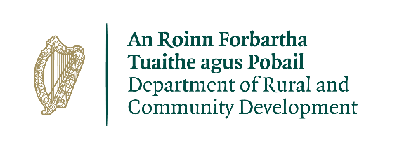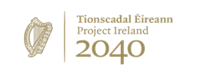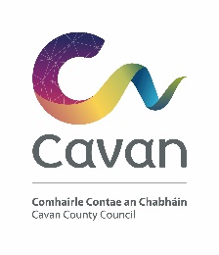
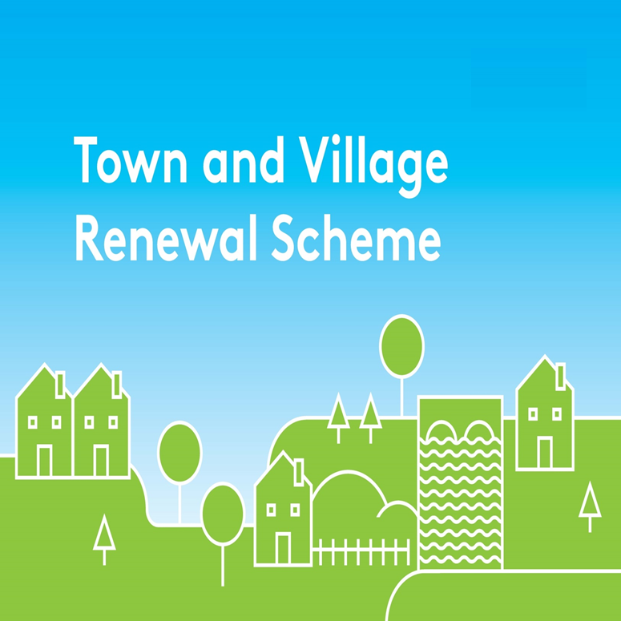
Town and Village Renewal Scheme 2020
Accelerated Measure in Response to COVID-19
CLOSING DATE 17TH JUNE 2020

Town/Village covered:

Amount of Funding Requested:

Applicant Group:

Applicant Contact Name:

Applicant Contact Address:

Applicant Telephone Number:

Applicant Mobile Number:

Applicant Email Address:

- Brief description of project (max 30 words):

- Project Proposal (Max 300 words):

- Who will be implementing the project?

- How will this project assist businesses/communities of the town/village to adapt to the specific challenges posed by COVID-19 (e.g. social distancing) and increase footfall/economic activity in the short-term:

- When will work on the project commence and how long will the proposed work take to complete?

Proposed commencement date:
Proposed completion date:
The number of weeks it will take to complete this project:

DECLARATION
I hereby confirm that I have read and understand this document. I request that consideration be given in support of the project as outlined above.

Signature: __________________________________________

Position: ____________________________________________

Date: _______________________________________________

