SIU
Report 2
February 2013
SIU
Cavan County Council
Extracts from:
This is Ireland: Part 2

Census 2011 - Highlights for Cavan
Report 1
Extracts from
This is Ireland: Part 1
Population by Area and
Town and Country Profile

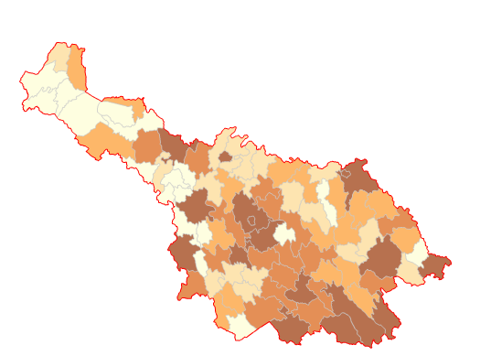

Census 2011 - Highlights for Cavan
Contents

Introduction…………………………………………………………………5

The labour force…………………………………………………………6-9
A look at changes in the labour force and participation rates

Unemployment………………………………………………………..10-12
A look at unemployment across the county

Industry…………………………………………………………………….13
Persons at work by industrial sectors, and changes since 2006

Socio-economic group and social class…………………………14-18
A look at the socio-economic group and social class

Education………………………………………………………………19-24
The change in the numbers in education

Travel patterns and car ownership……………………………......25-28
Examining modes of transport, average journey time to work, and the rate of car ownership

Internet & Broadband………………………………………………..29-30
Changes in broadband and internet access

General Health, disability and carers……………………………..31-36
Disability, carers and a new question on the general health of the population

Deprivation Index……………………………………………………..37-38

References…………………………………………………………………39

Appendices……………………………………………………………40-44

List of Tables
Table 1: Persons 15 years & over by Principle Economic Status. County Cavan. 2011…...7
Table 2: The number of unemployed by gender. County Cavan, 2006 & 2011…….……..10
Table 3: Number of unemployment blackspots by administrative county. 2011…………...12
Table 4: Population by socio-economic group. County Cavan & the State, 2011…………14
Table 5: Population by Social Class. County & the State, 2011……………………………..15
Table 6: Number and percentages of students by gender. County Cavan, 2006 & 2011...19
Table 7: Population aged 15 years & over by gender and whose full time education has ceased by highest level of education completed. County Cavan, 2011…………………….20
Table 8: Population aged 15 Years & over with a third level qualification.
County Cavan, 2011………………………………….…………………………………………..22
Table 9: Journey time to work, school or college. County Cavan & State, 2011…………..27
Table 10: Population by departure time from work, school or college. County Cavan & State, 2011………………………………………………………………………………..………28
Table 11: Private households classified by personal computer ownership and
access to the internet. County Cavan, 2011…………………………………………...………29
Table 12: Population by general health. County Cavan & State, 2011……………………..31
Table 13: Persons with a disability by gender. County Cavan, 2011……………………….33
Table 14: Total population by type of disability. 2011………………………………………..34
Table 15: Carers by gender and number of unpaid hours per week.
County Cavan, 2011……………………………………………………………………………...36

List of Figures
Figure 1: Labour Force Participation Rate by County. 2011……………………………….….8
Figure 2: Labour Force Participation Rate. County Cavan, 2011……………………………..9
Figure 3: Change in Unemployment Rate by County. 2006-2011…………………………..11
Figure 4: Population Aged 15 Years and Over at Work (Number) by Broad Industrial Group. County Cavan, 2006 & 2011…………………………………………………………....13
Figure 5: Socio-economic groups. County Cavan, 2006 & 2011…………………...............15
Figure 6: Population by Social Class. County Cavan, 2011………………………...............17
Figure 7: Persons by social class in each county. 2011……………………………………...18
Figure 8: Percentage of persons aged 15 years and over by highest education completed. Primary level only. County Cavan, 2011…………………………………………………….....21
Figure 9: Number of households with cars. County Cavan, 2011………………………..….25
Figure 10: Percentage of car ownership among households by county. 2011…………….26
Figure 11: Means of travel to work, school or college. County Cavan, 2011……...............27
Figure 12: Households by internet connection type & county. 2011…………………….….30
Figures 13: Percentage of people who rated their general health as
“very good” by county. 2011……………………………………………………………………..32
Figure 14: Persons with a disability. County Cavan, 2011……………………………….…..33
Figure 15: Percentage of people with a disability by age group. County Cavan, 2011………………………………………………………………………………………………..34
Figure 15: Percentage of people with a disability by age group. County Cavan, 2006 & 2011………………………………………………………………………………………………..35
Figure 16: Pobal HP Deprivation Index (Haase & Pratschke, 2012). Relative Deprivation Score 2011 & 2006……………………………………………………………………………….38

Introduction
Principal Socio-Economic Results from Census 2011 were published in June 2012 by the Central Statistics Office. The ‘This is Ireland’ Part 2 report is the second of two summary publications presenting the results of the 2011 census and it covers the social and economic topics such as employment, occupations, education and skills and the health-related questions.
Some of the key statistics for County Cavan are provided within this report, highlighting in particular changing trends in our community. It presents findings on topics such as the changing rate of participation in both the labour force and education and how unemployment has changed over the past five years. It also includes results to provide a profile of the health of the population across a range of factors.

Labour Force

Growth in labour force slows

A question on present principal status on the census form enables an analysis of the economic status of all people aged 15 and over into those in the labour force, and outside it. The results displayed in Table 1 show that the total in the labour force (including those at work, looking for first regular job, or unemployed having lost or given up previous job) for County Cavan in April 2011 stood at 34,640 an increase in 3,800 (12.3%) since 2006.

Nationally those in the labour force stood at 2,232,203 in 2011, an increase of 5.8 per cent since 2006. This translates into an annual average increase of 1.1 per cent. However when this is looked at historically this would represent a considerably less growth then the previous inter-censal period when growth averaged 4 per cent per annum.

(Note: The official labour force and unemployment estimates are based on the Quarterly National Household Survey (QNHS). The results in this report differ for methodological reasons from these official estimates. See Appendix 1 for a full
explanation)

Table 1: Persons 15 years & over by Principle Economic Status. County Cavan, 2011.
Principal Economic Status | 2006 | 2011 | Change | % Change
At work | 28,319 | 27,309 | -1,010 | -3.5
Looking for first regular job | 448 | 559 | 111 | 24.7
Unemployed having lost or given up previous job | 2,073 | 6,772 | 4,699 | 226.6
Labour Force (A) | 30,840 | 34,640 | 3,800 | 12.3
Student | 4,325 | 5,477 | 1,152 | 26.6
Looking after home/family | 6,460 | 5,989 | -471 | -7.2
Retired | 6,009 | 7,241 | 1,232 | 20.5
Unable to work due to permanent sickness or disability | 1,965 | 2,385 | 420 | 21.3
Other | 152 | 219 | 67 | 44.0
Not in Labour Force (B) | 18,911 | 21,311 | 2,400 | 12.6
Pop. Aged 15 & Over (=A+B) | 49,751 | 55,951 | 6,200 | 12.4

Labour participation

The percentage of people aged 15 and over who participate in the labour force - as opposed to having another status such as student, retired or homemaker - is known as the labour force participation rate. It is measured as the number in the labour force (at work or unemployed) expressed as a percentage of the total aged 15 and over. For the State as a whole this rate was 61.9 per cent in 2011, down from 62.5 per cent recorded in 2006, the first fall in the rate since 1986. The labour force participation rate for County Cavan in 2011 was equal to the State's at 61.9 per cent and this was the same for 2006 also. Figure 1 demonstrates how County Cavan compares to other counties in terms of its labour force participation rates.

Figure 1: Labour Force Participation Rate by County. 2011.

Figure 2 indicates County Cavan’s labour participation rates for each of the electoral areas of County Cavan. The electoral divisions of Diamond (67.89), Mullagh (68.41), Cavan Rural (65.62) and Drumcarban (64.35) have the highest labour force participation rates. Many of the electoral divisions in the west of Cavan have a lower labour force participation rate.

Figure 2: Labour Force Participation Rate. County Cavan, 2011.
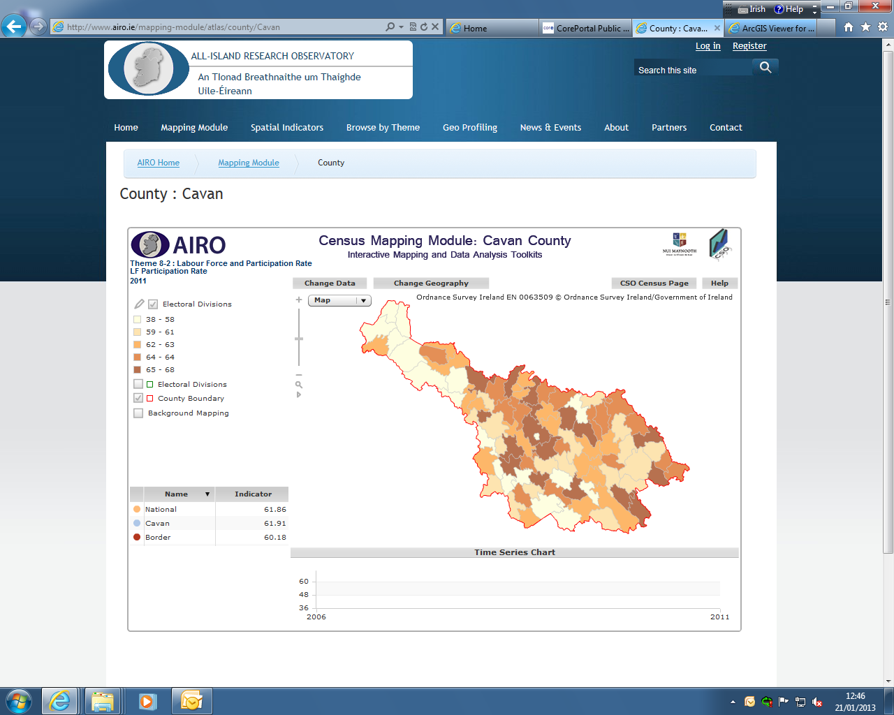
Source: All Island Research Observatory (AIRO) Maynooth

In terms of gender, 35.4 percent of the labour force participation rate is male and 26.5 per cent is female.

Outside the labour force

The number of people outside of the labour force, namely students, those looking after the home or family, retired persons and those unable to work due to disability, increased by 12.6 per cent or by 2,400 between 2006 and 2011 for County Cavan, see Table 1.

The largest contributor to this increase was the growing numbers of retired people which increased by 20.5 per cent or 1,232 people from 2006 to 2011.

Unemployment

Unemployment has trebled within the county

The number of people unemployed (that is unemployed having lost or given up a previous job or looking for their first regular job) based on their declared Principal Economic Status in April 2011 for County Cavan was 7,331 or 21.2 per cent of the total labour force, an increase of 4,810 compared to 2006.

Table 2: The number of unemployed by gender. County Cavan & State, 2006 & 2011.
Unemployed | Cavan 2006 |  | Cavan 2011 |  | State 2006 |  |  | State 2011
Unemployed | No. | % | No. | % | No. | % |  | No. |  | %
Males | 1,475 | 58.5 | 4,765 | 65.0 | 106,633 | 59.4 |  | 274,327 |  | 64.6
Females | 1,046 | 41.5 | 2,566 | 35.0 | 72,823 | 40.6 |  | 150,516 |  | 35.4
Total | 2,521 |  | 7,331 |  | 179,456 |  |  | 424,843

As can be seen from Table 2 there has been a very large increase in the number of unemployed males within the county growing by 3,290 between 2006 and 2011. Females on the other hand have not experienced such a high rise in unemployment, only increasing by 1,520 in comparison.
Male unemployment accounted for 65 per cent of all those unemployed in the county in 2011.
Within County Cavan unemployment rates in certain individual EDs reach levels well above others within the county. The highest are Belturbet Urban (42.6% male, 28.5% female), followed by Cavan Urban (40.2% male, 29.8% female), Cootehill Urban (35.0% male, 27.0% female), Drumakeever/Derrynananta (28.3% male, 29.2% female) and Bailieborough (30.9% male, 22.6% female). (Trutz Haase & Feline Engling. The 2011 Pobal HP Deprivation Index. February 2013)

Unemployment nationally
The overall rise in unemployment nationally over the five years (from 8.5% in 2006 to 19% in 2011) can be presented as a simple point change of 10.5 per cent as illustrated in the graph in Figure 3. As can be seen on the graph, County Cavan comes in as the 9th highest on the graph with an unemployment rate of 21.2 per cent in 2011.
Figure 3: Change in Unemployment Rate by County. 2006-2011

Unemployment blackspots at Electoral Division level

One of the major advantages of a Census of Population is its ability to provide data for small areas such as Electoral Divisions (EDs). Table 3 provides a summary analysis of EDs where the unemployment rate in April 2011 was considered high relative to the level of the State overall. For this report an unemployment blackspot was defined as an ED whose labour force exceeded 200 persons and where the unemployment rate on a principal economic status basis exceeded 35 per cent. There were 81 such EDs in 2011 with an average unemployment rate of 39.2 per cent compared with 19 per cent nationally. As can be seen from the table Cavan has two of these blackspots.

Table 3: Number of unemployment blackspots by administrative county. 2011

Industrial Group
There are 1,010 fewer people at work within County Cavan by Broad Industrial Group in 2011 from 2006. As figure 4 illustrates construction has gone way down from 4,082 in 2006 to 1,765 in 2011 while education has gone up from 1,472 in 2006 to 2,172 in 2011. There was an increase in the Agriculture, Forestry and Fishing sector which has traditionally been seeing a decrease over the years.
Figure 4: Population Aged 15 Years and Over at Work (Number) by Broad Industrial Group. County Cavan, 2006 & 2011
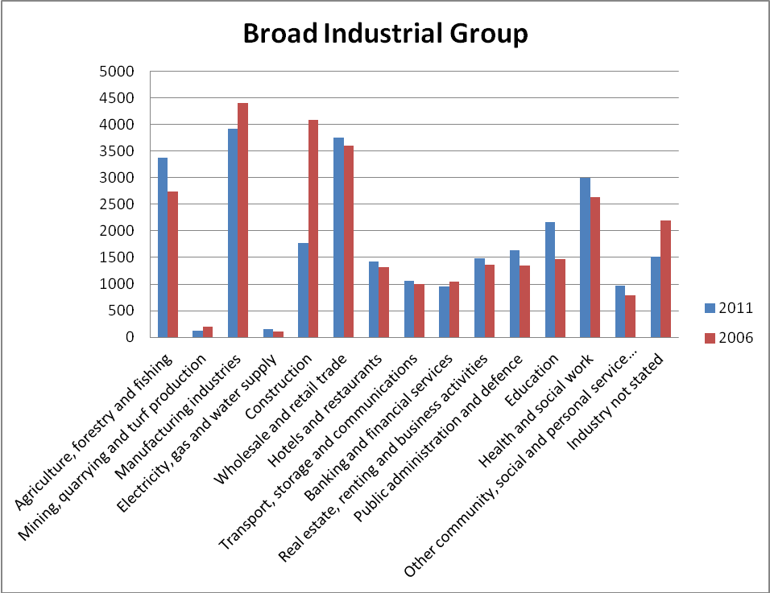

Socio-Economic Group & Social Class
Socio-economic grouping classifies the entire population into one of ten categories based on the level of skill and educational attainment of their occupation (those at work, unemployed or retired) while all other people are classified to the socio-economic group of the person in the family on whom they are deemed to be dependent.

Within County Cavan the majority of people, 19.15 per cent fall into the socio-economic grouping of ‘Non-manual’, which is also the case for the State (20.29%). There is a lower proportion of workers in the A and B socio-economic groups (employers, managers and higher professionals) 16.4 per cent in Cavan compared to 21.81 per cent for the State.

Table 4: Population by socio-economic group. County Cavan and the State, 2011
2011 | Cavan Number | Cavan % | State Number | State %
All socio-economic groups | 73,183 |  | 4,588,252
A. Employers and managers | 9,124 | 12.47 | 705,132 | 15.37
B. Higher professional | 2,873 | 3.93 | 295,586 | 6.44
C. Lower professional | 7,801 | 10.66 | 556,587 | 12.13
D. Non-manual | 14,016 | 19.15 | 931,068 | 20.29
E. Manual skilled | 7,394 | 10.10 | 386,742 | 8.43
F. Semi-skilled | 6,712 | 9.17 | 359,725 | 7.84
G. Unskilled | 2,255 | 3.08 | 151,949 | 3.31
H. Own account workers | 3,756 | 5.13 | 196,774 | 4.29
I. Farmers | 6,028 | 8.24 | 166,231 | 3.62
J. Agricultural workers | 753 | 1.03 | 23,504 | 0.51
Z. All others gainfully occupied and unknown | 12,471 | 17.04 | 814,954 | 17.76

Figure 5 compares the socio economic groupings within County Cavan in 2011 and 2006. In 2006 ‘Non-manual’ was the most common socio-economic grouping (19.1%), however in 2011 ‘All Others Gainfully Occupied and Unknown’ was the most common at 18.6 per cent. ‘Agricultural Workers’ recorded the lowest percentages for both years.

Figure 5: Socio-economic groups. County Cavan, 2006 & 2011.
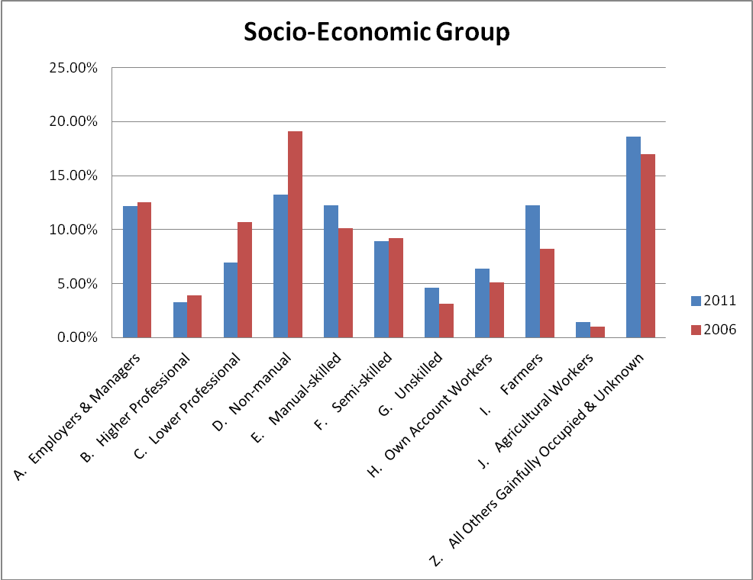

Social class

The entire population aged 15 years and over is classified into one of seven social class groups which are ranked on the basis of occupation, thereby bringing together people with similar levels of occupational skill. In determining social class no account is taken of the differences between individuals on the basis of other characteristics such as education. See Appendix 2 for a complete definition.

Table 5: Population by Social Class. County Cavan & State, 2011.
Social Class | Cavan Number | Cavan % | State Number | State %
Professional Workers | 3,488 | 4.8 | 336,620 | 7.3
Managerial & Technical | 17,146 | 23.4 | 1,251,671 | 27.3
Non-manual | 13,420 | 18.3 | 801,304 | 17.5
Skilled Manual | 13,680 | 18.7 | 707,369 | 15.4
Semi-skilled | 9,286 | 12.7 | 487,449 | 10.6
Unskilled | 2,866 | 3.9 | 170,014 | 3.7
All Others Gainfully occupied & Unknown | 13,297 | 18.2 | 833,825 | 18.2
Total | 73,183 |  | 4,588,252

As Table 5 represents almost a quarter of the county’s population would fall into the social class ‘Managerial & Technical’ in 2011. The lowest category was ‘Unskilled’ with only 3.9 per cent of the population coming in under this category. These results are also reflective of the State’s percentage.

Figure 6 compares the social classes in County Cavan for 2006 and 2011. The social class of ‘Managerial & Technical’ was also the most common social class for the county in 2006, being slightly higher that year with 24.2 per cent of the population over 15 years of age falling within it. The biggest drop would have been within the category of ‘Skilled Workers’ and the biggest gain would have been under the category of ‘All Others Gainfully Occupied and Unknown’.

Figure 6: Population by Social Class. County Cavan, 2011.
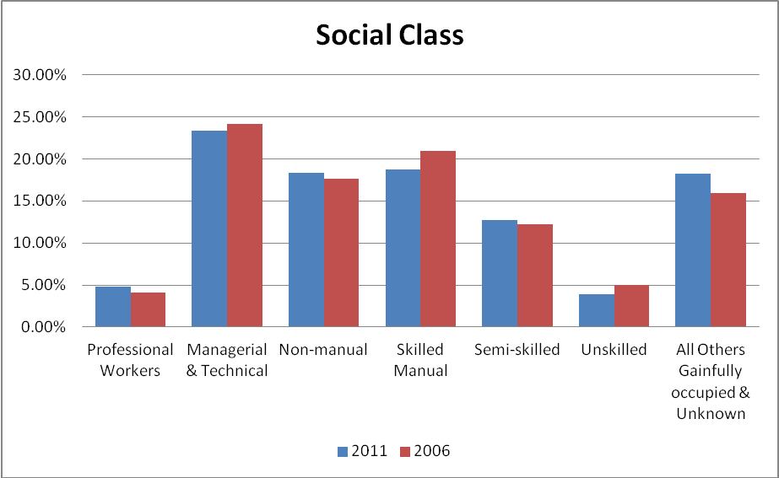

National differences

On a national level, the social class ‘Managerial & Technical’ accounted for the largest proportion of the population at 27.3 per cent, up from 26.4 per cent in 2006. It also showed the largest overall increase of 133,685 persons. As illustrated in Figure 7, there are significant differences between the distribution of social classes across the county, with Dún Laoghaire-Rathdown containing the highest proportion of people classified to the combined classes of 1 and 2.

Figure 7: Persons by social class in each county. 2011

Education

Students & highest level of education completed

Table 6 below shows the detail on the makeup of students in the county (as stated in their Principal Economic Status). There has been an increase in the number of students, from 4,325 in 2006 to 5,477 in 2011, a percentage change of 26.6 per cent. Females make up the higher proportion of students in both 2006 and 2011, however males do seem to be catching up in 2011 with the gap narrowing.

Table 6: Number and percentages of students by gender. County Cavan, 2006 & 2011.
Students | 2006  Number | 2006  % | 2011  Number | 2011  %
Males | 1,933 | 44.7 | 2,638 | 48.2
Females | 2,392 | 55.3 | 2,839 | 51.8
Total | 4,325 |  | 5,477

Table 7 shows there has been a large increase in 2011 under the number of people with ‘No Formal Education’, 1,040 compared with only 273 in 2006. However the 2011 figure is expected to be incorrect due to a change in the layout and format of the questions asked within the census questionnaire. Please see Appendix 3 for further information on this explanation.

Females tend to dominate those in the higher or further education fields apart from the Apprenticeship and Doctorate (Ph.D) levels.

Table 7: Population aged 15 years & over by gender and whose full time education has ceased by highest level of education completed. County Cavan, 2011.
Highest Education Level | Males | Females | Total County Cavan
No formal education | 621 | 419 | 1,040
Primary | 4,761 | 3,409 | 8,170
Lower Secondary | 5,167 | 3,695 | 8,862
Upper secondary | 3,893 | 4,779 | 8,672
Technical/vocational | 2,244 | 2,560 | 4,804
Advanced certificate/completed apprenticeship | 2,149 | 1,123 | 3,272
Higher certificate | 778 | 1,211 | 1,989
Ordinary bachelor degree/ professional qualification or both | 1,144 | 1,633 | 2,777
Honours bachelor degree/professional qualification or both | 1,134 | 1,897 | 3,031
Postgraduate diploma or degree | 712 | 1,294 | 2,006
Doctorate (Ph.D) | 56 | 50 | 106
Not Stated | 1,356 | 1,388 | 2,747
Total | 24,018 | 23,458 | 47,476

At a national level there has been a continuous improvement in the level of education amongst those aged 15 years and over throughout the years. In County Cavan, the percentage of people whose formal education has ceased with primary education only, has fallen from 23.07 per cent in 2006 to 17.2 per cent in 2011, however this is still higher than the state which is 13.8 per cent.

Despite the considerable improvement at county level, there still remains several EDs were a significant proportion of the population have primary education only. These are mainly found in the west Cavan area and include Diamond (32.67%), Templeport/Benbrack (31.73%), Dunmakeever/Derrynananta (30.63%) and Derrylahan (30.87%).

Figure 8: Percentage of persons aged 15 years and over by highest education completed. Primary Level only. County Cavan, 2011.
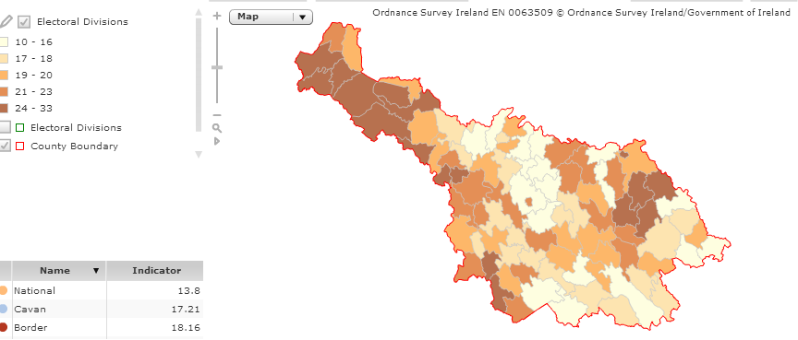
Source: All Island Research Observatory (AIRO) Maynooth

Third level qualification

The proportion of County Cavan’s population with a third level qualification has grown from 8.3 per cent in 1991, to 23.3 per cent in 2006 and marginally decreased to 22.2 per cent in 2011. However, this 20 year growth is well below that which occurred nationally, 13.9 percentage points compared to 17.6 percentage points nationally. (Trutz Haase & Feline Engling. The 2011 Pobal HP Deprivation Index. February 2013)

‘Social sciences, business and law’ is the most common area of study for people within the county to go on to complete their third level qualification in as Table 8 indicates.

Table 8: Population aged 15 Years & over with a third level qualification. County Cavan, 2011.
Third Level Qualification | Number
Education & teacher training | 1,538
Arts | 351
Music & performing arts | 77
Audio-visual techniques & media production | 107
Design | 92
Other arts | 75
Humanities | 506
Foreign languages | 58
Mother tongue | 89
History & archaeology | 89
Other humanities | 270
Social sciences, business and law | 2,810
Psychology | 100
Economics | 85
Business & administration (broad programmes) | 719
Marketing & advertising | 132
Accounting & taxation | 563
Management & administration | 350
Secretarial & office work | 109
Law | 237
Other social sciences, business and law subjects | 515
Science , mathematics & computing | 918
Biology & biochemestry | 116
Physical sciences (physics, chemistry, earth science) | 269
Computer science | 145
Computer use | 271
Other science, mathematics & computing | 117
Engineering, manufacturing & construction | 1,345
Engineering and engineering trades (broad programmes) | 304
Mechanics and metalwork | 92
Electricity & energy | 119
Motor vehicles, ships & aircraft | 52
Architecture & town planning | 237
Building & civil engineering | 309
Other engineering, manufacture & construction | 232
Agriculture & veterinary | 380
Crop & livestock production | 234
Other agriculture & veterinary | 146
Health & welfare | 1,951
Medicine | 200
Nursing & caring | 952
Child care & youth services | 82
Social work & counselling | 278
Other health & welfare | 439
Personal services | 500
Hotel, restaurant & catering | 189
Hair & beauty services | 154
Other personal services | 157
Transport services | 34
Security services (includes police & fire services) | 139
Other subjects | 32
Not Stated (including unknown) | 631

Travel patterns – Work, School or College

Car ownership

86 per cent of households have at least one car and only 14 per cent have no motor car at all within County Cavan.

Figure 9: Number of households with cars. County Cavan, 2011.
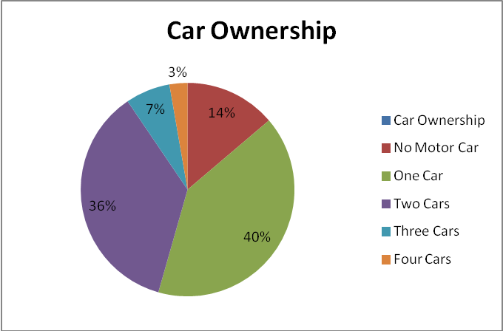

Figure 10 presents car ownership nationally across all the counties. As can be seen County Cavan would be quite average in terms of car ownership. Dublin City has the highest population with no car owners.

Figure 10: Percentage of car ownership among households by county. 2011

Households in County Meath had the greatest likelihood of having at least one motor car (90.1% of households) while households in Dublin City were least likely to have a car (61.8%). Cavan households were more likely to have a car (86.2%) than the average for the State (82.4%)

Means of travel

As Graph 11 shows the majority of people (aged 5 years and over) within the county make their way to either school, college or work by car (41%), or being a car passenger (20%).

Figure 11: Means of travel to work, school or college. County Cavan, 2011.
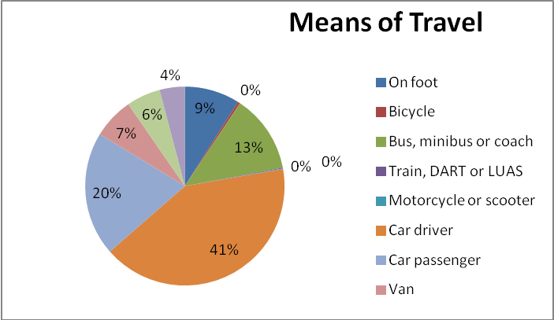

Travel time

The majority of people within the County make their journey to either work, college or school in under 30 minutes (66.3%). The average journey time for the State is 26.6 minutes so the majority of people within County Cavan would fall much short of this.

Table 9: Journey time to work, school or college. County Cavan and State, 2011.
Journey Time | County Cavan (No.) | County Cavan (%) | State (No.) | State (%)
Under 15 minutes | 16,638 | 40.1 | 427,993 | 25.2
1/4 hour - under 1/2 hour | 10,853 | 26.2 | 520,128 | 30.7
1/2 hour - under 3/4 hour | 5,878 | 14.1 | 352,362 | 21.0
3/4 hour - under 1 hour | 1,629 | 3.9 | 123,298 | 7.2
1 hour - under 1 1/2 hours | 1,980 | 4.7 | 112,701 | 6.6
1 1/2 hours and over | 1,367 | 3.3 | 39,764 | 2.3
Not stated | 3,074 | 7.4 | 118,828 | 7.0
Total | 41,419 |  | 1,695,074
Departure time

As can be seen in the table below a quarter of the population within the county leave for work, school or college between 08:31and 09:00am, the most common time of departure.

Table 10: Population by departure time from work, school or college. County Cavan & State 2011
Time of Departure | County Cavan (No.) | County Cavan (%) | State (No.) | State (%)
Before 06:30 | 2,419 | 5.8 | 119,601 | 7.1
06:30-07:00 | 2,188 | 5.2 | 153,263 | 9.0
07:01-07:30 | 2,838 | 6.8 | 201,029 | 11.6
07:31-08:00 | 5,780 | 13.9 | 288,658 | 17.0
08:01-08:30 | 7,112 | 17.1 | 297,931 | 17.6
08:31-09:00 | 10,389 | 25.0 | 261,027 | 15.3
09:01-09:30 | 6,095 | 14.7 | 109,671 | 6.4
After 09:30 | 2,575 | 6.2 | 184,701 | 10.9
Not stated | 2,023 | 4.8 | 79,193 | 4.7
Total | 41,419 |  | 1,695,074

Internet & Broadband

As Table 11 represents 17,270 households in County Cavan have a personal computer. This is quite a significant jump from 2006 when only 10,796 of the population owned one. There has also been a huge improvement in the availability of access to broadband across the county with 55.4 percent of households having access to broadband in 2011 compared with only 9 per cent of households having access in 2006.

The proportion of homes using slower types of internet connection decreased accordingly from 29.9 per cent in 2006 to 9.5 per cent in 2011 while those with no internet connection fell from 48.1 per cent to 32.7 per cent.

Table 11: Private households classified by personal computer ownership and access to the internet. Number & Percentages. County Cavan, 2011.
County | Total | Personal Computer Ownership |  |  | Access to the Internet
County | Total | Yes | No | Not Stated | Broadband  Connection | Other connection | No connection | Not Stated
County Cavan (No.) | 25,720 | 17,270 | 7,905 | 545 | 14,250 | 2,445 | 8,426 | 599
County Cavan (%) |  | 67.1 | 30.7 | 2.1 | 55.4 | 9.5 | 32.7 | 2.3

Nationally broadband usage has increased from 21.1 per cent in 2006 to 65.3 per cent in 2011. Figure 12 demonstrates how we compare nationally with other counties in terms of our type of internet connection and type. We fall into the lower ranking counties in terms of broadband coverage.

Figure 12: Households by internet connection type & county. 2011.

General Health, Disability & Carers

Self-assessed health

A new question on general health was introduced for the first time in census 2011 and asked respondents to select one of five categories ranging from very good to very bad. Self-perceived health provides a well validated and widely used measure of actual health, despite its subjective nature.
Table 12 shows that overall the vast majority of County Cavan’s population (96.76 %) believe their general health was either very good, good or fair on census night. Only 0.20 per cent of people in Cavan said their health was very bad, and 1.09 per cent said it was bad.
Nationally 5.4% of people in unskilled social classes said their health was very bad. It is known that health risks are higher for people in poverty.

Table 12: Population by general health. County Cavan and State, 2011.
General Health | State |  | Cavan
 | Number | % | Number | %
General health - All | 458,8252 |  | 73,183
General health - Very good | 276,7681 | 60.32 | 45,084 | 61.60
General health - Good | 128,2956 | 27.96 | 19,681 | 26.89
General health - Fair | 368,131 | 8.02 | 6,029 | 8.24
General health - Bad | 57,243 | 1.25 | 798 | 1.09
General health - Very Bad | 12,418 | 0.27 | 145 | 0.20
Not stated | 99,823 | 2.18 | 1,446 | 1.98

Health by county

Figures 13 shows the percentage of people per county who indicated that their health was ‘very good’. The greater Dublin area (excluding the city) and the surrounding counties all made up the top seven healthiest counties. The only county outside of Leinster in the top seven was Cork County.

Figures 13: Percentage of people who rated their general health as “very good” by county. 2011.

Disability

11.9 per cent of County Cavan’s population have been classified as having a disability according to the 2011 census, up from 8.5 per cent in 2006. In terms of numbers with a disability this is a percentage change of 60.3 per cent. We fall just below the State which stands at 13 per cent of the population in 2011. The electoral divisions with the highest population of people with a disability would include Cavan Rural (867), Cavan Urban (710), Bailieborough (494) and Virginia (462).

Figure 14: Persons with a disability. County Cavan, 2011.
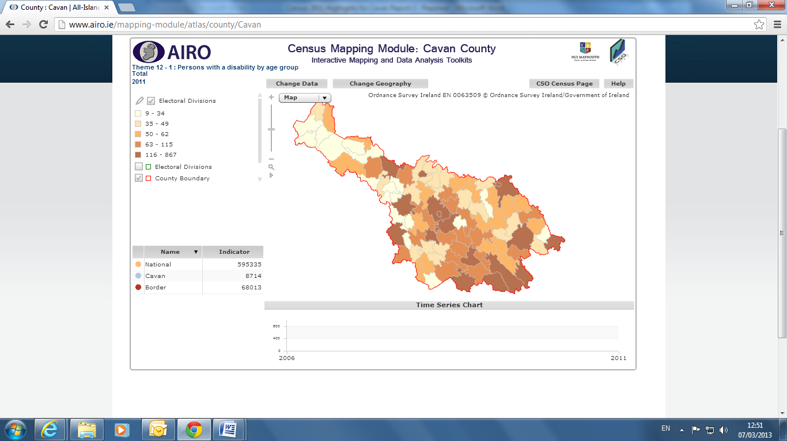
Source: All Island Research Observatory (AIRO) Maynooth

Table 13 shows that the majority of those with a disability within the County are Males at 51.4 per cent.

Table 13: Persons with a disability by gender. County Cavan, 2011.
Disability by Gender | Number | Percentage
Males | 4,480 | 51.4%
Females | 4,234 | 48.6%
Total | 8,714

In the 2011 census some of categories on disabilities were broadened to get more information on the range of different types of disabilities. Specifically the 2006 category for visual and hearing disabilities were separated along with the category on learning and intellectual disabilities. Finally the wording of the category for ‘other’ disabilities was broadened to specifically reference pain and breathing. The total population by type of disability is shown in Table 14 for both the County and State. As can be seen ‘Other disability, including chronic illness’ is the highest proportion for both County Cavan (16%) and the State (17%), followed closely by the category of ‘A condition that substantially limits one or more basic physical activities’.

Table 14: Total population by type of disability. 2011.
Disability Type | Cavan | % | State | %
Blindness or a serious vision impairment | 729 | 3 | 51,718 | 3
Deafness or a serious hearing impairment | 1,396 | 6 | 92,060 | 6
A condition that substantially limits one or more basic physical activities | 3,840 | 15 | 244,739 | 15
An intellectual disability | 828 | 3 | 57,709 | 4
Difficulty in learning, remembering or concentrating | 2,012 | 8 | 137,070 | 7
Psychological or emotional condition | 1,168 | 5 | 96,004 | 6
Other disability, including chronic illness | 3,921 | 16 | 274,762 | 17
Difficulty in dressing, bathing or getting around inside the home | 2,146 | 9 | 125,450 | 8
Difficulty in going outside home alone | 2,677 | 11 | 165,681 | 10
Difficulty in working or attending school/college | 2,961 | 12 | 194,398 | 12
Difficulty in participating in other activities | 3,228 | 13 | 207,455 | 13

Disability & age

As can be seen from Figure 15 the largest proportion of people with a disability within the county would fall into the age category of 65+ years (37.43%) Overall it can be seen that the rates of disability increased with age group, the exception being those within the age category of 15-24, which has the lowest disability rate. This was the same pattern for both 2006 and 2011.

The biggest change between 2011 and 2006 was within the age category of 65+ which saw a drop in percentage of -4.15 between 2006 and 2011.

Figure 15: Percentage of people with a disability by age group. County Cavan, 2006 & 2011.
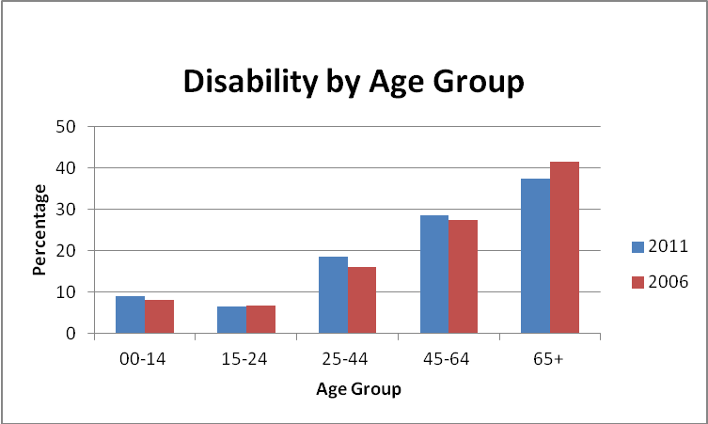

Carers
In the census carers are defined as people who provide regular unpaid personal help for a friend or family member with a long term illness health problem or disability

There were 2,553 carers recorded in County Cavan in the 2006 census. For 2011 this number has increased by 440, bringing the total number of carers to 2,933 standing at 4 per cent of the county’s population. Females lead as being the majority of carers once again (57%). As Table 15 shows the largest proportion of carers dedicated 1 to14 hours caring per week (1,166), followed by the second largest amount of carers dedicating 43 or more hours a week (630).

2.3 per cent of people aged 85 and over in Cavan are acting as carers.

Table 15: Carers by gender and number of unpaid hours per week. County Cavan, 2011.
Number of hours | Males | Females | Total
1-14 | 511 | 655 | 1,166
15-28 | 198 | 300 | 498
29-42 | 107 | 119 | 226
43+ | 230 | 400 | 630
Not stated | 190 | 223 | 413
Total | 1,236 | 1,697 | 2,933

Deprivation Index

The 2011 Pobal HP Deprivation Index is the latest in a series of deprivation indices developed by Trutz Hasse and Jonathan Pratschke and funded by Pobal. Based on the just recently released data from the 2011 Census of Population. The index shows the level of overall affluence and deprivation at the level of 18,488 Small Areas in 2006 and 2011 using identical measurement scales.

Like any other part of the country, Cavan has massively been affected by the economic downturn after 2007, reflected in the drop in the absolute deprivation score from -2.8 in 2006 to -11.0 in 2011. This represents a drop of 8.2, compared to a nationwide drop of 6.5. This also implies that the relative position of Cavan has significantly worsened from the thirteenth most disadvantaged to the eighth most disadvantaged local authority area in Ireland. To see where this change has occurred Figure 16 contrasts the two deprivation index maps for County Cavan for 2011 and 2006, highlighting the change in deprivation levels experienced by the county over the inter-censal period. It clearly shows that many of the rural parts of the county are more disadvantaged with even more ED’s falling into the ‘marginally below average’ category. In particular the North West of Cavan and Cavan Urban area has significantly worsened over this period falling into the ‘disadvantaged’ category. The most affluent areas still tend to be in the surroundings of Cavan town, but excluding the town centre itself.

In 2011 the deprivation index shows that of the 89 EDs in County Cavan in 2011, 72 (80% of EDs) are marginally below average while 12 are marginally above average and 5 EDs are in the disadvantaged range.

At a local level, the most disadvantaged EDs are Drumakeever/Derrynananta (-16.8), Derrylahan (-12.8), Cavan Urban (-11.8), Killinagh/Teebane (-11.7) and Doogary (-10.2). These five EDs fall into the ‘disadvantaged’ category. All other EDs are, at the most, marginally below the national average.
The most affluent EDs are Butler’s Bridge (7.7), Tullyvin West (7.0) Cavan Rural (3.5), Lissanover (2.) and Carrafin (1.3). All of these are marginally above average, but no ED in County Cavan falls into the affluent category.

Figure 16: Pobal HP Deprivation Index (Haase & Pratschke, 2012). Relative Deprivation Score 2011 & 2006.
Map A - Relative Deprivation Score 2011
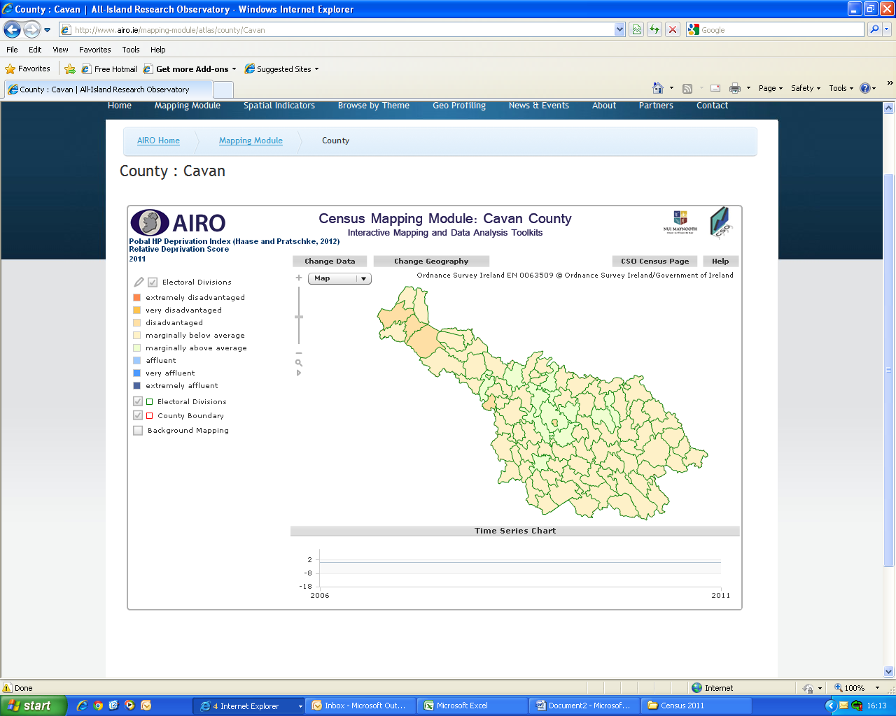
Map B - Relative Deprivation Score 2006
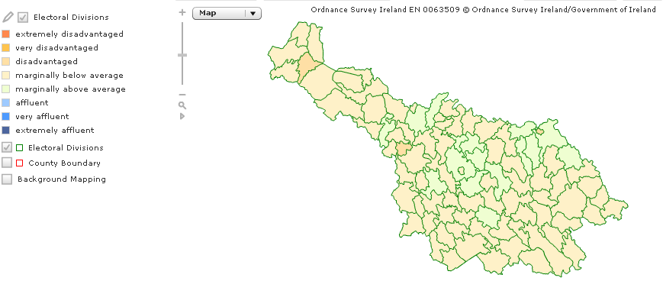
Source: All Island Research Observatory (AIRO) Maynooth

References

Central Statistics Office, This is Ireland – Highlights from Census 2011, Part 2

The 2011 Pobal HP Deprivation Index – Area Profile for County Cavan. Feline Engling & Trutz Hasse. February 2012.

Appendices

Appendix 1

Labour Force and Unemployment - differences between census and official figures

The results of the Quarterly National Household Survey (QNHS) provide the basis for the official series of quarterly labour force estimates. The labour force and its constituent figures shown in this report are directly based on the census. Users should be aware that information derived from identical questions in the census and QNHS for the same year may show appreciable differences. The main categories affected are the constituents of the question on principal economic status and the employment estimates classified by industry and occupation. The main reasons for the differences are:
- the QNHS uses the International Labour Office (ILO) classification, which has a much wider range of questions on the labour force and which may have a bearing on the responses received to individual questions. Under the ILO criteria, employment, unemployment and inactive population are defined as follows:

In Employment: Persons who worked in the week before the survey for one hour or more for payment or profit, including work on the family farm or business and all persons who had a job but were not at work because of illness, holidays etc. in the week

Unemployed: Persons who, in the week before the survey, were without work and available for work within the next two weeks, and had taken specific steps, in the preceding four weeks, to find work.

Inactive Population (not in labour force): All other persons

- the census form is completed by a responsible adult in each household throughout the State in respect of everyone present in the household on Census Night while the QNHS is by face to face interview.
- the census relates to all persons present in the State (including visitors from abroad) at the time of the census while the QNHS covers persons usually resident in Ireland.

- the census is a complete enumeration while the QNHS is a sample survey.

The chief difference resulting from this is that the Census records an unemployment rate (based on Principal Economic Status) of 19.0 per cent, compared with the official rate (based on ILO criteria) of 14.3 per cent.

Appendix 2

Social Class

The entire population is also classified into one of the following social class groups (introduced in 1996) which are defined on the basis of occupation (coded using Soc90):

1 Professional workers
2 Managerial and technical
3 Non-manual
4 Skilled manual
5 Semi-skilled
6 Unskilled
7 All others gainfully occupied and unknown

The occupations included in each of these groups have been selected in such a way as to bring together, as far as possible, people with similar levels of occupational skill. In determining social class no account is taken of the differences between individuals on the basis of other characteristics such as education. Accordingly social class ranks occupations by the level of skill required on a social class scale ranging from 1 (highest) to 7 (lowest). This scale combines occupations into six groups by occupation and employment status following procedures similar to those outlined above for the allocation of socio-economic group. A residual category “All others gainfully occupied and unknown” is used where no precise allocation is possible.

Appendix 3

The large increase in ‘No Formal Education’ was also replicated within other counties. Statisticians in the CSO examined the data and have concluded that the most likely explanation for the large increase in the number of persons with no formal education is due to a questionnaire effect.

The layout and appearance of the education question changed significantly
between the two censuses. The version used in 2011 contained more text in the
question body including information on NFQ levels for all categories, including 'Primary education'. This may have caused respondents to answer the question in a different manner to how they would have answered the 2006 version of the question.

