SIU
May 2012
Cavan County Council
SIU
Census 2011 - Highlights for Cavan
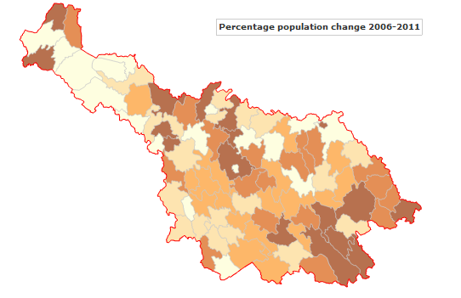
Report 1
Extracts from
This is Ireland: Part 1
Population by Area and
Town and Country Profile
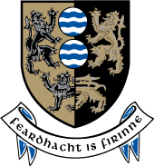

Census 2011 Highlights for Cavan
Contents

Introduction 7
Rapid population growth in County Cavan 8
Cavan Town becomes a ‘large town’ 12
Population density high in Ballyjamesduff and Kingscourt 14
Growth in constituency population 17
Population of Electoral Divisions in County Cavan 18
Migration of 5,800 into Cavan over 5 year period 22
Rural tradition continues in Cavan 25
Children make up almost a quarter of our population 25
10% of households in Cavan are lone parent households 30
County Cavan has one of the lowest rates of marital breakdown 33
County Cavan has the highest rate of growth in the Traveller Population 34
Greater religious diversity in Cavan 37
Number of Cavan households exceeds 25,000 40
High rate of vacant housing 41
Detached housing more common in Cavan 45
Ninety per cent of Cavan households are heated with fossil fuel sources 46
Less than half of Cavan households connected to public water mains 48
Almost half of all Cavan households have a septic tank 49
10,000 Cavan residents born in other EU countries 50
Over 5,500 Dubliners live in Cavan 51
1,785 people moved into the county between 2010 and 2011 52
Over 600 Cavan residents lived in other countries one year previously 52
Conclusion 54
References 56
Appendix I Population change in all counties 57
Appendix II Place of birth of Cavan residents 59
Appendix III Summary Table 61

Table of figures
Table 1 Population of County Cavan and the State, 2006 and 2011 8
Table 2 Population of Cavan Town, 2006 and 2011 12
Table 3 Population density and area size of county towns, 2011 14
Table 4 Population, density and area size of Cavan Town, 2011 15
Table 5 Population of county towns ordered by size, 2006 and 2011 15
Table 6 Population of Cavan-Monaghan Constituency 17
Table 7 Population of County Cavan's Electoral Divisions, 2006 and 2011 18
Table 8 Components of population change, County Cavan and the State, 2011 22
Table 9 Population born in County Cavan, usually resident and present in the State (number) by county of usual residence 24
Table 10 Persons in urban and rural areas, Cavan and the State, 2011 25
Table 11 Population (number and %) by age group, Cavan and the State, 2011 27
Table 12 Age breakdown of Cavan's population, 2002 to 2011 28
Table 13 Persons in private households and persons living alone in County Cavan 29
Table 14 Number of private households in Cavan and the State, 2011 30
Table 15 Number of people in private households in Cavan and the State, 2011 32
Table 16 Population by detailed marital status, 2011 33
Table 17 Irish Travellers as a proportion of the total population, 2011 34
Table 18 Irish Travellers in private households, classified by household type, 2011 34
Table 19 Religious breakdown for County Cavan, 2011 37
Table 20 Number of private households and number of persons in private households, 2011 40
Table 21 Private Households in Cavan by Type of Household (Permanent or Temporary) 40
Table 22 Occupied and vacant permanent housing units by occupancy on census night. 41
Table 23 Private households in permanent housing units in County Cavan and the State by type of accommodation, 2011 45
Table 24 Private Households in Permanent Housing Units (Number) in County Cavan by Type of Central Heating 46
Table 25 Private households in permanent housing units (number) in County Cavan by type of water supply, 2011 48
Table 26 Private households in permanent housing units (number) in County Cavan by type of sewerage, 2011 49
Table 27 Population usually resident and present in the State, resident in County Cavan by Birthplace 50
Table 28 Population usually resident and present in County Cavan by county of birth 51
Table 29 Population aged one year and over usually resident and present in County Cavan by usual residence one year previously 52
Table 30 Population usually resident in County Cavan and present in the State on Census night by former country of usual residence one year previously 53
Table 31 Population by County or City, actual and percentage change 2011 57
Table 32 Population Usually Resident and Present in County Cavan by Birthplace, 2011 59

Table of Figures
Figure 1 Total Population in Cavan Electoral Divisions 2011 9
Figure 2 Percentage population change 2006-2011 10
Figure 3 Population of County Cavan at each Census from 1984 to 2011 11
Figure 4 Map of Cavan Town and environs derived from Census 2011 results 13
Figure 5 Average annual estimated net migration (rate per 1,000 population), 2006-2011 23
Figure 6 Irish Travellers per 1,000 population by county 36
Figure 7 Religious breakdown of Co Cavan's population, 2011 38
Figure 8 Percentage religious breakdown of Cavan and the State, 2011 38
Figure 9 Percentage of Roman Catholics in County Cavan at each Census 39
Figure 10 Percentage of Church of Ireland, Presbyterian and Methodist/Wesleyan communities in Cavan at each Census 39
Figure 11 Vacant housing rate, 2011 42
Figure 12 Maps of vacant housing rate (left) and electoral divisions eligible for the Upper Shannon Renewal tax incentive scheme (right). 43
Figure 13 Map of unfinished estates, National Housing Development Survey 2011 44
Figure 14 Home heating sources in Cavan 2011 47

Introduction

Principal demographic results from Census 2011 were published on 29 March 2012 by the Central Statistics Office. The ‘This is Ireland’ Part 1 report looks at the overall change in the population since the last census in 2006. It also provides first results on age and marriage, households and families, as well as including results on nationality, foreign languages, the Irish language, religion and housing.
The ‘Population Classified by Area’ report (formerly Volume 1) and Profile 1: Town and Country, were both published on 26 April 2011.
The following document presents some of the key statistics for Cavan from these reports, highlighting in particular changing trends in our community.

Rapid population growth in County Cavan

The 2011 population of County Cavan was recorded at 73,183 (37,013 males and 36,170 females).
The population of the county grew by 14.3 per cent between 2006 and 2011, nearly twice the growth rate for the State (8.2%). Cavan’s had one of the highest percentage increases since 2006 of all counties. (See Appendix I for population data on other counties)
The actual growth in the county’s population was 9,180 people.

Table 1 Population of County Cavan and the State, 2006 and 2011
 | State |  | Cavan
 | 2006 | 2011 | 2006 | 2011
Population (Number) | 4,239,848 | 4,588,252 | 64,003 | 73,183
Actual change Since Previous Census (Number) | 322,645 | 348,404 | 7,457 | 9,180
Percentage Change Since Previous Census (%) | 8.2 | 8.2 | 13.2 | 14.3

Figure 1 on the following page illustrates the population centres in the county, with greater concentrations around the main towns, and fewer residents in the West Cavan area.

Figure 1 Total Population in Cavan Electoral Divisions 2011

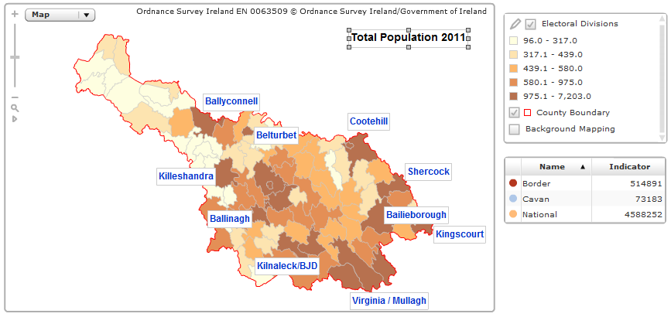
Source: All Island Research Observatory [AIRO] Maynooth

Figure 2 Percentage population change 2006-2011
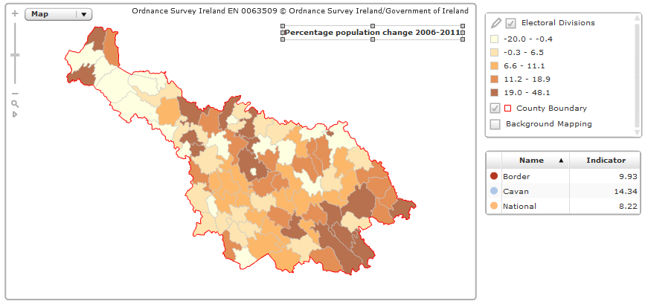
Source: AIRO Maynooth
Figure 2 above shows the percentage population change in Cavan Electoral Divisions between 2006 and 2011. Dark red areas experienced the greatest percentage increase in population. Apparent here is the population expansion in the Cavan Rural ED area (that is, the area surrounding Cavan town), and greater increases to the south of the county (which is within the Dublin commuter belt). Yellow shaded areas show a decline in population.
Figure 3 Population of County Cavan at each Census from 1841 to 2011
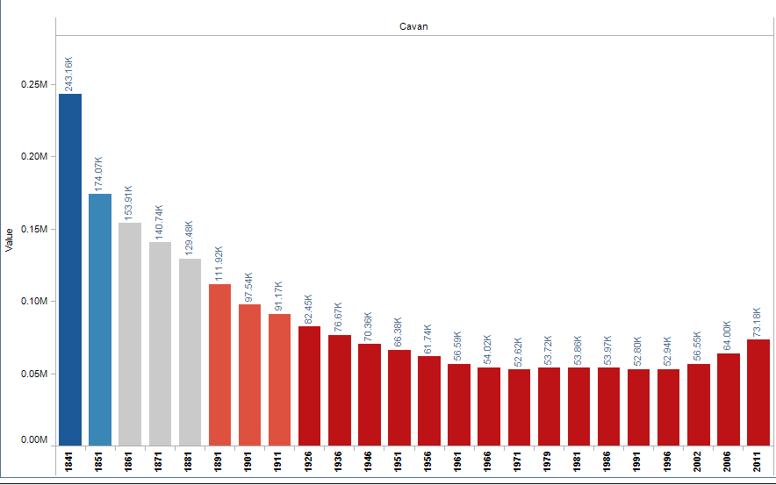
Source: AIRO Maynooth

Cavan Town becomes a ‘large town’

Cavan was one of five towns to join the ‘large town’ category in the 2011 Census (i.e. those with a population of 10,000 or more). The population of Cavan town grew by 2,322 people (or 29.45%) between the two census periods. The population of Cavan town in 2011 was 10,205, having grown from 7,883 in 2006.
Cavan Town is ranked number 39 out of 192 towns in Ireland in terms of population size.

Table 2 Population of Cavan Town, 2006 and 2011
 | Population 2006 | Population 2011
Cavan Urban | 3,934 | 3,649
Cavan Rural* | 3,693 | 6,170
Moynehall* | 256 | 386
Total Cavan Town | 7,883 | 10,205
* part of Cavan Rural and Moynehall are counted by the CSO in the definition of Cavan town and environs.

Figure 4 Map of Cavan Town and environs derived from Census 2011 results
Source: CSO

Population density high in Ballyjamesduff and Kingscourt
The density of the State’s population in 2011 was 67 persons per square kilometre, having risen from 62 in 2006. The population density of County Cavan in 2011 was 39.43 persons per square kilometre (having increased from 34.48 in 2006).
Population density of our county’s towns is particularly high in Ballyjamesduff (1,519 persons per sq km) and in Kingscourt (1,393 persons per sq km), both of which have a land area of 2 square kilometres.
Ballyjamesduff Town has had an excellent population growth of 52 per cent between 2006 and 2011, making it the fastest growing town in Ulster (part). The population of Kingscourt expanded by a third in the same period, and in Virginia by just under a third.

Table 3 Population, density and area size of county towns, 2011
2011 | Cavan | Ballyjamesduff | Bailieborough | Kingscourt | Virginia | Cootehill
Area (Sq km) | 18 | 2 | 4 | 2 | 2 | 6
Population (including Suburbs or Environs) (Number) | 10205 | 2568 | 2530 | 2326 | 2282 | 2123
Population Density (persons per sq km) (Number) | 554.6 | 1519.2 | 621.9 | 1393.5 | 1144.8 | 370.8
Population within Legally Defined Boundary (Number) | 3649 | .. | .. | .. | .. | 1592
Population of Suburbs or Environs (Number) | 6556 | .. | .. | .. | .. | 531
Population Change Since Previous Census (%) | 29.5 | 52 | 28.7 | 33.1 | 31.6 | 12.2

The density of Cavan Town and environs is 554.6 persons per square kilometre, and the geographic of the town covers 18 square kilometres, giving it the largest land area of all the county’s towns.

Table 4 Population, density and area size of Cavan Town, 2011
2011 | Cavan Town and Environs
Area (Sq km) | 18
Population (including Suburbs or Environs) (Number) | 10,205
Population Density (persons per sq km) (Number) | 554.6
Population within Legally Defined Boundary (Number) | 3,649
Population of Suburbs or Environs (Number) | 6,556
Population Change Since Previous Census (%) | 29.5

Among electoral divisions (or part of) that make up the county’s towns, Kilconny (in the environs of Belturbet) had the largest percentage increase at 81.2. This was followed by Mullagh with a 67.5 per cent increase in population, while the population of Cavan Rural ED increased by 67 per cent.

Table 5 Population of county towns ordered by size, 2006 and 2011
Town | Electoral Division, etc.  ( * = part of ED) | Re. No. of ED in Table 6 | Pop 2006 | Pop 2011 | 2011 Males | 2011 Females | Percentage change 2006-2011
Cavan | Cavan Urban | 1 | 3,934 | 3,649 | 1,762 | 1,887 | -7.2
Environs o f Cavan | Total | - | 3,949 | 6,556 | 3,201 | 3,355 | 66.0
 | Cavan Rural* | 48 | 3,693 | 6,170 | 3,007 | 3,163 | 67.1
 | Moynehall* | 73 | 256 | 386 | 194 | 192 | 50.8
Bailieborough | Bailieborough* | 2 | 1,966 | 2,530 | 1,244 | 1,286 | 28.7
Cootehill | Cootehill Urban | 51 | 1,436 | 1,592 | 806 | 786 | 10.9
Environs of Cootehill | Total | - | 456 | 531 | 267 | 264 | 16.4
 | Cootehill Rural* | 50 | 273 | 358 | 192 | 166 | 31.1
 | Ashfield* | 37 | 102 | 93 | 38 | 55 | -8.8
 | Tullyvin East* | 78 | 81 | 80 | 37 | 43 | -1.2
Kingscourt | Kingscourt* | 8 | 1,748 | 2,326 | 1,156 | 1,170 | 33.1
Virginia | Virginia* | 34 | 1,734 | 2,282 | 1,112 | 1,170 | 31.6
Ballyjamesduff | Total | - | 1,690 | 2,568 | 1,292 | 1,276 | 52.0
 | Ballyjamesduff* | 29 | 1,690 | 2,550 | 1,285 | 1,265 | 50.9
 | Lurgan* | 32 | - | 18 | 7 | 11 | -
Belturbet | Belturbet Urban | 42 | 1,395 | 1,378 | 674 | 704 | -1.2
Environs of Belturbet | Kilconny* | 64 | 16 | 29 | 17 | 12 | 81.2
Ballyconnell | Ballyconnell* | 15 | 747 | 1,061 | 538 | 523 | 42.0
Mullagh | Mullagh* | 10 | 679 | 1,137 | 554 | 583 | 67.5
Ballinagh | Bellananagh* | 41 | 675 | 766 | 363 | 403 | 13.5
Ballyhaise | Ballyhaise* | 39 | 597 | 620 | 301 | 319 | 3.9
Shercock | Shercock* | 11 | 461 | 531 | 250 | 281 | 15.2
Killeshandra | Killashandra* | 66 | 411 | 364 | 190 | 174 | -11.4
Arva | Arvagh* | 36 | 364 | 380 | 205 | 175 | 4.4
Kilnaleck | Kilnaleck* | 68 | 334 | 384 | 176 | 208 | 15.0
Swanlinbar | Swanlinbar* | 26 | 266 | 211 | 104 | 107 | -20.7
Butlersbridge | Total | - | 182 | 282 | 131 | 151 | 54.9
 | Butler’s Bridge* | 44 | 182 | 278 | 129 | 149 | 52.7
 | Carrafin* | 46 | - | 4 | 2 | 2 | -
Blacklion | Tuam* | 88 | 174 | 229 | 107 | 122 | 31.6
Lough Gowna | Scrabby* | 93 | 123 | 161 | 74 | 87 | 30.9

Growth in constituency population

The population of the Cavan-Monaghan Constituency increased by 11.4 per cent between 2006 and 2011. This followed on from a 10 per cent increase in the constituency population between 2002 and 2006.

Table 6 Population of Cavan-Monaghan Constituency
Cavan-Monaghan | 2006 | 2011
Population (Number) | 120,000 | 133,666
Percentage Change in Pop Since Previous Census (%) | 10.0 | 11.4
Dail Members in each Constituency (Number) | 5 | 5
Population per Dail Member in each Constituency (Number) | 24,000 | 26,733

Population of Electoral Divisions in County Cavan

Table 8 below illustrates the population figures for all 93 Electoral Divisions in County Cavan.
Electoral divisions with the greatest percentage growth were:
- Cavan Rural ED (48.1%)
- Mullagh (40.6%)
- Ballyjamesduff (39.9%)
- Tircahan (34.4%)
Electoral divisions with the greatest population decline were:
- Derrylahan (-20%)
- Teebane (-17.1%)
- Derrynananta (-12.5%)
- Swanlinbar (-9.5%)

Table 7 Population of County Cavan's Electoral Divisions, 2006 and 2011
District | Pop 2006 | Pop 2011 | Actual change 2006-2011 | Percentage change 2006-2011 | Area (km²)
Ulster (part of) | 267,264 | 294,803 | 27,539 | 10.3 | 7,893.77
Cavan County | 64,003 | 73,183 | 9,180 | 14.3 | 1,855.93
Cavan Town | 3,934 | 3,649 | -285 | -7.2 | 2.01
001 Cavan Urban | 3,934 | 3,649 | -285 | -7.2 | 2.01
Bailieborough rural area | 12,201 | 14,825 | 2,624 | 21.5 | 287.09
002 Bailieborough | 3,190 | 3,862 | 672 | 21.1 | 45.75
003 Carnagarve | 585 | 623 | 38 | 6.5 | 21.58
004 Crossbane | 489 | 594 | 105 | 21.5 | 20.94
005 Drumanespick | 421 | 462 | 41 | 9.7 | 14.93
006 Enniskeen | 391 | 461 | 70 | 17.9 | 19.02
007 Killinkere | 368 | 480 | 112 | 30.4 | 22.13
008 Kingscourt | 2,580 | 3,224 | 644 | 25.0 | 19.58
009 Lisagoan | 327 | 388 | 61 | 18.7 | 14.33
010 Mullagh | 1,395 | 1,962 | 567 | 40.6 | 24.05
011 Shercock | 1,029 | 1,169 | 140 | 13.6 | 22.43
012 Skeagh | 394 | 428 | 34 | 8.6 | 21.52
013 Taghart | 560 | 626 | 66 | 11.8 | 21.54
014 Termon | 472 | 546 | 74 | 15.7 | 19.29
Bawnboy rural area | 4,068 | 4,404 | 336 | 8.3 | 244.71
015 Ballyconnell | 1,229 | 1,512 | 283 | 23.0 | 27.64
016 Ballymagauran | 252 | 251 | -1 | -0.4 | 15.09
017 Bawnboy | 544 | 580 | 36 | 6.6 | 28.39
018 Benbrack | 73 | 82 | 9 | 12.3 | 28.36
019 Bilberry | 146 | 179 | 33 | 22.6 | 11.88
020 Carn | 226 | 229 | 3 | 1.3 | 11.53
021 Diamond | 115 | 138 | 23 | 20.0 | 8.45
022 Doogary | 150 | 147 | -3 | -2.0 | 9.37
023 Kinawley | 121 | 112 | -9 | -7.4 | 23.97
024 Lissanover | 271 | 288 | 17 | 6.3 | 16.61
025 Pedara Vohers | 160 | 160 | – | – | 12.65
026 Swanlinbar | 441 | 399 | -42 | -9.5 | 15.17
027 Templeport | 308 | 284 | -24 | -7.8 | 18.80
028 Tircahan | 32 | 43 | 11 | 34.4 | 16.80
Castlerahan rural area | 8,683 | 10,625 | 1,942 | 22.4 | 169.05
029 Ballyjamesduff | 2,240 | 3,134 | 894 | 39.9 | 21.36
030 Castlerahan | 869 | 911 | 42 | 4.8 | 28.17
031 Kilbride | 884 | 956 | 72 | 8.1 | 29.02
032 Lurgan | 524 | 565 | 41 | 7.8 | 14.46
033 Munterconnaught | 969 | 1,116 | 147 | 15.2 | 26.27
034 Virginia | 3,197 | 3,943 | 746 | 23.3 | 49.77
Cavan rural area | 31,813 | 36,158 | 4,345 | 13.7 | 909.06
035 Ardue | 633 | 734 | 101 | 16.0 | 23.91
036 Arvagh | 900 | 925 | 25 | 2.8 | 28.28
037 Ashfield | 346 | 343 | -3 | -0.9 | 17.32
038 Ballintemple | 459 | 460 | 1 | 0.2 | 16.79
039 Ballyhaise | 982 | 975 | -7 | -0.7 | 17.66
040 Ballymachugh | 713 | 762 | 49 | 6.9 | 29.03
041 Bellananagh | 1,242 | 1,358 | 116 | 9.3 | 15.00
042 Belturbet Urban | 1,395 | 1,378 | -17 | -1.2 | 4.38
043 Bruce Hall | 219 | 208 | -11 | -5.0 | 9.46
044 Butler’s Bridge | 371 | 478 | 107 | 28.8 | 7.65
045 Canningstown | 558 | 571 | 13 | 2.3 | 23.86
046 Carrafin | 363 | 417 | 54 | 14.9 | 19.08
047 Castlesaunderson | 223 | 282 | 59 | 26.5 | 17.86
048 Cavan Rural | 4,865 | 7,203 | 2,338 | 48.1 | 34.95
049 Clonervy | 790 | 896 | 106 | 13.4 | 17.92
050 Cootehill Rural | 988 | 1,068 | 80 | 8.1 | 34.38
051 Cootehill Urban | 1,436 | 1,592 | 156 | 10.9 | 1.82
052 Corr | 255 | 280 | 25 | 9.8 | 11.02
053 Corraneary | 406 | 438 | 32 | 7.9 | 23.52
054 Crossdoney | 542 | 584 | 42 | 7.7 | 21.45
055 Crosskeys | 643 | 708 | 65 | 10.1 | 19.38
056 Cuttragh | 342 | 389 | 47 | 13.7 | 11.89
057 Denn | 690 | 709 | 19 | 2.8 | 20.60
058 Derrin | 384 | 416 | 32 | 8.3 | 14.85
059 Drumcarban | 556 | 615 | 59 | 10.6 | 18.79
060 Drumcarn | 522 | 535 | 13 | 2.5 | 25.11
061 Drung | 546 | 539 | -7 | -1.3 | 22.60
062 Graddum | 475 | 538 | 63 | 13.3 | 20.93
063 Grilly | 402 | 403 | 1 | 0.2 | 18.38
064 Kilconny | 379 | 479 | 100 | 26.4 | 16.30
065 Kill | 352 | 369 | 17 | 4.8 | 14.45
066 Killashandra | 1,130 | 1,141 | 11 | 1.0 | 28.22
067 Killykeen | 538 | 584 | 46 | 8.6 | 22.87
068 Kilnaleck | 956 | 1,057 | 101 | 10.6 | 20.92
069 Knappagh | 421 | 440 | 19 | 4.5 | 22.45
070 Larah North | 444 | 501 | 57 | 12.8 | 23.00
071 Larah South | 477 | 465 | -12 | -2.5 | 21.31
072 Milltown | 338 | 335 | -3 | -0.9 | 18.24
073 Moynehall | 1,503 | 1,675 | 172 | 11.4 | 23.53
074 Rakenny | 413 | 442 | 29 | 7.0 | 21.49
075 Redhill | 420 | 439 | 19 | 4.5 | 17.16
076 Springfield | 175 | 198 | 23 | 13.1 | 18.41
077 Stradone | 723 | 777 | 54 | 7.5 | 25.82
078 Tullyvin East | 386 | 430 | 44 | 11.4 | 21.65
079 Tullyvin West | 230 | 264 | 34 | 14.8 | 17.11
080 Waterloo | 682 | 758 | 76 | 11.1 | 28.26
Enniskillen No.2 rural area | 1,209 | 1,293 | 84 | 6.9 | 163.14
081 Derrylahan | 120 | 96 | -24 | -20.0 | 19.17
082 Derrynananta | 40 | 35 | -5 | -12.5 | 25.12
083 Dowra | 129 | 161 | 32 | 24.8 | 22.65
084 Dunmakeever | 128 | 117 | -11 | -8.6 | 23.02
085 Eskey | 283 | 342 | 59 | 20.8 | 15.82
086 Killinagh | 125 | 125 | – | – | 16.79
087 Teebane | 35 | 29 | -6 | -17.1 | 16.66
088 Tuam | 349 | 388 | 39 | 11.2 | 23.91
Mullaghoran rural area | 2,095 | 2,229 | 134 | 6.4 | 80.87
089 Drumlumman | 516 | 535 | 19 | 3.7 | 17.55
090 Kilcogy | 365 | 434 | 69 | 18.9 | 17.79
091 Kilgolagh | 319 | 317 | -2 | -0.6 | 15.89
092 Loughdawan | 326 | 338 | 12 | 3.7 | 13.40
093 Scrabby | 569 | 605 | 36 | 6.3 | 16.24

Migration of 5,800 into Cavan over 5 year period

Cavan’s population increased by 9,180 people between 2006 and 2011. This increase comprised 5,921 births, and net migration of 5,809, less 2,550 deaths. Cavan has a higher average annual number of births (17.3 per 1,000 pop) than the State (16.6) and a higher average annual number of deaths (7.4 per 1,000 population compared to 6.4).
Our net migration rate of 16.9 per 1,000 population was over three times higher than the rate for the State as a whole (5.5).
Table 8 Components of population change, County Cavan and the State, 2011
 | State | County Cavan
Change in Population since Previous Census (Number) | 348,404 | 9,180
Births (Number) | 367,191 | 5,921
Deaths (Number) | 141,079 | 2,550
Natural Increase (Number) | 226,112 | 3,371
Estimated Net Migration (Number) | 122,292 | 5,809
Average Annual Births (Rate per 1,000 Pop.) | 16.6 | 17.3
Average Annual Deaths (Rate per 1,000 Pop.) | 6.4 | 7.4
Average Annual Natural Increase (Rate per 1,000 Pop.) | 10.2 | 9.8
Average Annual Estimated Net Migration (Rate per 1,000 Pop.) | 5.5 | 16.9

Cavan had the second highest rate of net migration (16.9 per 1,000 pop) after Laois (23.8). This indicates that Cavan has a stronger ability to attract new residents to live here than other counties.

Figure 5 Average annual estimated net migration (rate per 1,000 population), 2006-2011

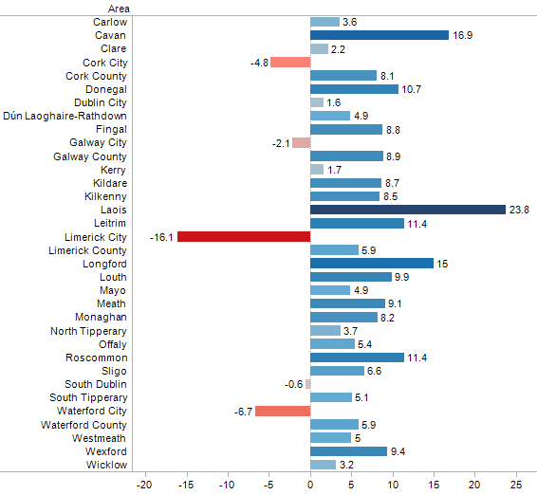
Source: AIRO Maynooth

Table 10 below illustrates that of all people born in County Cavan (who are usually resident in the State and present on Census night), 43,901 were living in their county of birth (that is, Cavan). Of those living in other Irish counties, the largest numbers were living in Dublin (6,796), Meath (1,920), Louth (1,732) and Monaghan (1,465).

Table 9 Population born in County Cavan, usually resident and present in the State (number) by county of usual residence
Pop Born in Cavan | 2011
State | 60,553
Leinster | 12,117
Carlow | 45
Dublin | 6,796
Kildare | 178
Kilkenny | 76
Laois | 75
Longford | 531
Louth | 1,732
Meath | 1,920
Offaly | 105
Westmeath | 418
Wexford | 116
Wicklow | 125
Munster | 947
Clare | 98
Cork | 297
Kerry | 112
Limerick | 181
Tipperary | 187
Waterford | 72
Connacht | 1,806
Galway | 384
Leitrim | 626
Mayo | 295
Roscommon | 196
Sligo | 305
Ulster (part of) | 45,683
Cavan | 43,901
Donegal | 317
Monaghan | 1,465

Rural tradition continues in Cavan

Cavan has traditionally been a rural county, with only 26.4 per cent of the population living in urban areas in 2006. Although there has been some change, it is still the case that a minority of people in Cavan live in urban areas (30%). This is hugely different from the State average where 62 per cent of the population live in urban areas. Leitrim is the most rural of all Irish counties, with almost 90 per cent living in a rural setting.
Table 10 Persons in urban and rural areas, Cavan and the State, 2011
2011 | Aggregate Town Area |  | Aggregate Rural Area |  | Percentage of population in the aggregate town area
Cavan | 22,034 | 51,149 |  | 30.1
State | 2,846,882 | 1,741,370 |  | 62.0

Children make up almost a quarter of our population

Almost a quarter (23.55%) of County Cavan’s population are children (aged 0-14 years), and 12.11 per cent of people are aged 65 and over.
The dependency ratio is defined as the number of young people and the number of older people as a percentage of the number of people of working age. In 2011, Cavan had a ‘dependency rate’ of 55.42, which veered towards the higher side when compared with other counties.
In 2011, Leitrim had the highest dependency of any county at 57.3 per cent, closely followed by counties Donegal (56.9%), Mayo (55.9%) and Roscommon (55.9%).
The lowest dependency ratios were in urban areas with Galway City at 34.9 per cent, followed by Dublin City (38.4%), Cork City (42.3%) and Limerick City (45.1%).
The total dependency ratio for the State in 2011 was 49.3, having increased from 45.8 in 2006.
Cavan’s population of young people = 17,232
Cavan’s population of older people = 8,866
Population of young and old = 26,098
Cavan’s population aged 15-64 = 47,085

Old dependency ratio: The population aged 65 years and over expressed as a percentage of the population aged 15-64 years.
Young dependency ratio: The population aged 0-14 years expressed as a percentage of the population aged 15-64 years.
Total dependency ratio: The sum of the young and old dependency ratios.

Cavan has a slightly higher proportion of young people in its population (23.55%) compared to the State as a whole (21.35%). Cavan also has a slightly higher proportion of older people than the State average – 12.12 per cent in Cavan compared to 11.66 per cent nationally.
Table 11 Population (number and %) by age group, Cavan and the State, 2011
2011 | State |  |  | State  (%) |  | Cavan |  | Cavan (%)
All ages |  | 4,588,252 |  |  | 73,183
0 - 4 years |  | 356,329 | 7.77 |  | 6,177 |  | 8.44
5 - 9 years |  | 320,770 | 6.99 |  | 5,529 |  | 7.56
10 - 14 years |  | 302,491 | 6.59 |  | 5,526 |  | 7.55
15 - 19 years |  | 283,019 | 6.17 |  | 4,583 |  | 6.26
20 - 24 years |  | 297,231 | 6.48 |  | 4,106 |  | 5.61
25 - 29 years |  | 361,122 | 7.87 |  | 5,133 |  | 7.01
30 - 34 years |  | 393,945 | 8.59 |  | 5,727 |  | 7.83
35 - 39 years |  | 364,261 | 7.94 |  | 5,484 |  | 7.49
40 - 44 years |  | 330,812 | 7.21 |  | 5,286 |  | 7.22
45 - 49 years |  | 305,185 | 6.65 |  | 4,864 |  | 6.65
50 - 54 years |  | 274,386 | 5.98 |  | 4,428 |  | 6.05
55 - 59 years |  | 244,522 | 5.33 |  | 3,950 |  | 5.40
60 - 64 years |  | 218,786 | 4.77 |  | 3,524 |  | 4.82
65 - 69 years |  | 173,638 | 3.78 |  | 2,714 |  | 3.71
70 - 74 years |  | 131,190 | 2.86 |  | 1,990 |  | 2.72
75 - 79 years |  | 102,036 | 2.22 |  | 1,775 |  | 2.43
80 - 84 years |  | 70,113 | 1.53 |  | 1,243 |  | 1.70
85 years and over |  | 58,416 | 1.27 |  | 1,144 |  | 1.56

As Table 12 below illustrates, County Cavan has experienced a large percentage increase in its population of young people. The number of children age 0-4 increased by 30 per cent between 2006 and 2011, and there was a 20 per cent increase in those aged 10-14. These data are highly relevant for services such as schools, the Childcare Committee and VEC and other groups providing services for young people.

Table 12 Age breakdown of Cavan's population, 2002 to 2011
County Cavan | 2002 | 2006 | 2011 | Actual change 2006-2011 | % change 2006-2011
Total | 56546 | 64003 | 73,183 | 9,180 | 14.34
0 - 4 years | 4189 | 4743 | 6,177 | 1,434 | 30.23
5 - 9 years | 4143 | 4914 | 5,529 | 615 | 12.52
10 - 14 years | 4559 | 4595 | 5,526 | 931 | 20.26
15 - 19 years | 4651 | 4417 | 4,583 | 166 | 3.76
20 - 24 years | 3719 | 4326 | 4,106 | -220 | -5.09
25 - 29 years | 3575 | 4686 | 5,133 | 447 | 9.54
30 - 34 years | 3796 | 4665 | 5,727 | 1062 | 22.77
35 - 39 years | 3985 | 4760 | 5,484 | 724 | 15.21
40 - 44 years | 3936 | 4567 | 5,286 | 719 | 15.74
45 - 49 years | 3730 | 4226 | 4,864 | 638 | 15.10
50 - 54 years | 3360 | 3826 | 4,428 | 602 | 15.73
55 - 59 years | 2911 | 3497 | 3,950 | 453 | 12.95
60 - 64 years | 2177 | 2774 | 3,524 | 750 | 27.04
65 - 69 years | 2215 | 2131 | 2,714 | 583 | 27.36
70 - 74 years | 1907 | 2018 | 1,990 | -28 | -1.39
75 - 79 years | 1686 | 1663 | 1,775 | 112 | 6.73
80 - 84 years | 1208 | 1214 | 1,243 | 29 | 2.39
85 years and over | 799 | 981 | 1,144 | 163 | 16.62

Table 13 below shows a breakdown of older people in private households and those living alone. Of the 8,206 people aged 65 and over living in private households, 29.8 per cent were living alone.
These data show that increasing age is linked to a greater likelihood of living alone, with 40 per cent of those aged 85 and over living on their own.
Among people of all ages in private households in County Cavan, only 8.7 per cent live alone.

Table 13 Persons in private households and persons living alone in County Cavan
 | All ages | 65 years and over | 70 years and over | 75 years and over | 80 years and over | 85 years and over
Persons in Private Households (Number) | 72625 | 8206 | 5553 | 3638 | 1978 | 892
Persons Living Alone (Number) | 6334 | 2443 | 1897 | 1396 | 810 | 358
Persons Living Alone as a Percentage of Persons in the Age Group in Private Households (%) | 8.7 | 29.8 | 34.2 | 38.4 | 41 | 40.1

There are 8,866 people aged 65 and over. Of these 8,206 are living in private households, which means that the remaining 660 people are living in non-private accommodation (possibly hospital or nursing home settings).

11% of households in Cavan are lone parent households

Of the total number of private households in Cavan (25,818), there are 2,753 lone parent households (with 6,728 persons). These are made up of 2,142 lone mother and children households, 392 lone fathers with children, 176 lone mother with children and other persons, and 43 lone father with children and other persons. Lone parent households comprise 10.66 per cent of all private households in Cavan.

A quarter of the county’s households are one person households, while households consisting of husband and wife with children make up 35 per cent. Cohabiting couples with children form 3.55 per cent of all Cavan households (about the same proportion as are in the household composition of the State as a whole).
Table 14 Number of private households in Cavan and the State, 2011
2011 Household Composition | State (number) | State (%) | Cavan (Number) | Cavan (%)
Private Households (Number) | 1,654,208 |  | 25,818
One person | 392,000 | 23.70 | 6,334 | 24.53
Husband and wife | 240,146 | 14.52 | 3,826 | 14.82
Cohabiting couple | 73,111 | 4.42 | 899 | 3.48
Husband and wife with children | 522,959 | 31.61 | 9,054 | 35.07
Cohabiting couple with children | 54,911 | 3.32 | 917 | 3.55
Lone mother with children | 155,264 | 9.39 | 2,142 | 8.30
Lone father with children | 24,497 | 1.48 | 392 | 1.52
Husband and wife with other persons | 13,095 | 0.79 | 200 | 0.77
Husband and wife with children and other persons | 26,226 | 1.59 | 467 | 1.81
Cohabiting couple with other persons | 8,602 | 0.52 | 73 | 0.28
Cohabiting couple with children and other persons | 4,233 | 0.26 | 71 | 0.28
Lone mother with children and other persons | 15,190 | 0.92 | 176 | 0.68
Lone father with children and other persons | 2,986 | 0.18 | 43 | 0.17
Two family units with/without other persons | 18,317 | 1.11 | 222 | 0.86
Three or more family units with/without other persons | 452 | 0.03 | 3 | 0.01
Non-family households containing related persons | 39,611 | 2.39 | 548 | 2.12
Households comprised of unrelated persons only | 62,608 | 3.78 | 451 | 1.75

The total number of people living in private households in Cavan in 2011 was 72,625. Of these, 52.89% were in the ‘husband and wife with children’ category.
Table 15 Number of people in private households in Cavan and the State, 2011
 | State (number) | State  (%) | Cavan (Number) | Cavan (%)
Private Households (Number) | 4510409 |  | 72625
One person | 392000 | 8.69 | 6334 | 8.72
Husband and wife | 480292 | 10.65 | 7652 | 10.54
Cohabiting couple | 146222 | 3.24 | 1798 | 2.48
Husband and wife with children | 2147067 | 47.60 | 38408 | 52.89
Cohabiting couple with children | 206327 | 4.57 | 3498 | 4.82
Lone mother with children | 420011 | 9.31 | 5695 | 7.84
Lone father with children | 62014 | 1.37 | 1033 | 1.42
Husband and wife with other persons | 43209 | 0.96 | 652 | 0.90
Husband and wife with children and other persons | 136077 | 3.02 | 2533 | 3.49
Cohabiting couple with other persons | 29551 | 0.66 | 255 | 0.35
Cohabiting couple with children and other persons | 20437 | 0.45 | 349 | 0.48
Lone mother with children and other persons | 56134 | 1.24 | 653 | 0.90
Lone father with children and other persons | 10885 | 0.24 | 173 | 0.24
Two family units with/without other persons | 97384 | 2.16 | 1191 | 1.64
Three or more family units with/without other persons | 3554 | 0.08 | 23 | 0.03
Non-family households containing related persons | 92664 | 2.05 | 1230 | 1.69
Households comprised of unrelated persons only | 166581 | 3.69 | 1148 | 1.58

County Cavan has one of the lowest rates of marital breakdown

Nationally the increase in the number of divorced people has driven the marital breakdown rate up from 8.7 per cent in 2006 to 9.7 per cent in 2011. This rate is calculated as the number of separated and divorced persons as a proportion of those who were ever married. When examined on a county basis, the highest rates of marital breakdown were in the cities, while Galway County had the lowest rate (7.5%). County Cavan’s rate of 8.2% was the third lowest in the State (after Limerick County and Galway County).

Table 16 Population by detailed marital status, 2011
 | State (number) | State  (%) | Cavan (number) | Cavan  (%)
All marital status | 4,588,252 |  | 73,183
Single | 2,484,625 | 54.15 | 38,419 | 52.50
All married | 1,708,604 | 37.24 | 28,699 | 39.22
Married (first marriage) | 1,655,906 | 36.09 | 27,895 | 38.12
Re-married (following widowhood) | 9,738 | 0.21 | 156 | 0.21
Re-married (following dissolution of previous marriage) | 42,960 | 0.94 | 648 | 0.89
Separated (including deserted) | 116,194 | 2.53 | 1,569 | 2.14
Divorced | 87,770 | 1.91 | 1,279 | 1.75
Widowed | 191,059 | 4.16 | 3,217 | 4.40

County Cavan has the highest rate of growth in the Traveller Population

The biggest percentage increases in the Traveller population were recorded in Cavan (where Traveller numbers rose by 114 per cent) and Donegal (where numbers climbed by 99 per cent). Irish Traveller numbers increased in every county with the exception of Waterford where the numbers declined by over 7 per cent.

Table 17 Irish Travellers as a proportion of the total population, 2011
2011 | State | Cavan
Irish Travellers (Number) | 29,573 | 453
Irish Travellers (No. per 1,000 Pop.) | 6.4 | 6.2

Very few Travellers now live in caravans and mobile homes (12% nationally). This has dropped from 25% in 2006.
Cavan had the highest proportion of Travellers living in permanent housing (97% of Travellers).
Table 18 Irish Travellers in private households, classified by household type, 2011
2011 | Total | In permanent housing units | In temporary housing units | Not stated
State | 28932 | 24270 | 3600 | 1062
Cavan | 421 | 407 | 10 | 4

Nationally the number of people enumerated as Irish Travellers in Census 2011 increased by 32 per cent from 22,435 to 29,573, with all counties apart from Limerick and Waterford showing increases larger than the increase in the general population (although this may also be related to higher rates of self-reporting).
Cavan has a low number of Travellers in its population (less than 500) compared with other counties. Galway County has the highest number of Travellers in its population (2,476), followed by South Dublin (2,216) and Dublin City (1,958). The county with the fewest is Waterford County with only 152 Travellers in its population.
As well as lower numbers, County Cavan has proportionally fewer Irish Travellers than many other counties. Counties with a higher proportion of Travellers (calculated per 1,000 population) are Galway City and County, Longford, Offaly and Mayo.
See Figure 6 on the next page for a representation of the proportion of Travellers in each county.

Figure 6 Irish Travellers per 1,000 population by county
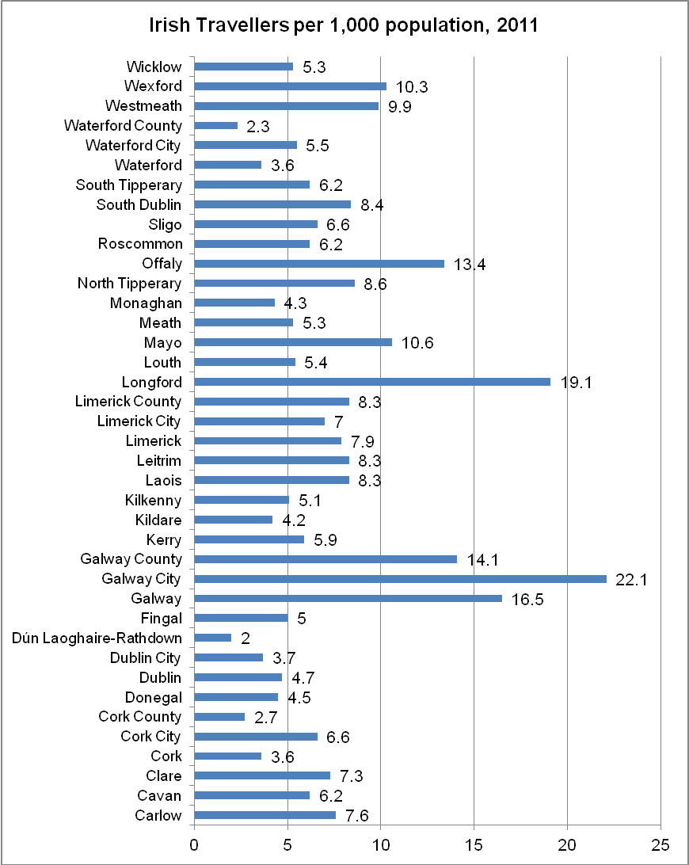

Greater religious diversity in Cavan

The majority of people who live in County Cavan describe themselves as Roman Catholic (85%), while the 5,260 people from Protestant communities make up 7.19 per cent of the county’s population.
In 2011, there were 2,487 people with ‘other stated religions’ in the county, an increase of 82.9% since the previous census and an indication of our increasing diversity. There was also a large increase (56.1%) in the number of people stating they had no religion, which now stands at 2,276.
Table 19 Religious breakdown for County Cavan, 2011
Cavan | Population (number) | Population (%) | Actual Change Since Previous Census (Number) | Percentage Change Since Previous Census (%)
Roman Catholic | 62,195 | 84.99 | 6,942 | 12.6
Church of Ireland (incl. Protestant) | 4,230 | 5.78 | 252 | 6.3
Presbyterian | 910 | 1.24 | 82 | 9.9
Methodist, Wesleyan | 120 | 0.16 | -65 | -35.1
Jewish | 17 | 0.02 | 11 | 183.3
Other stated religions (2) | 2,487 | 3.40 | 1,127 | 82.9
No religion | 2,276 | 3.11 | 818 | 56.1
Not stated | 948 | 1.30 | 13 | 1.4
All religions | 73,183 |  | 9,180 | 14.3

Figure 7 Religious breakdown of Co Cavan's population, 2011
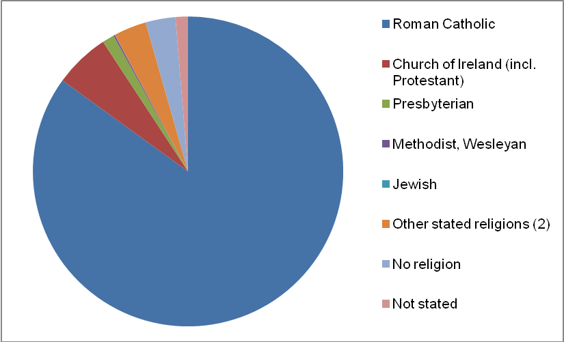
A comparison between religious diversity in Cavan and in the national population is illustrated in Figure 8 below. We have approximately the same proportion of Roman Catholics in our population as the State, but a higher proportion of Church of Ireland and Presbyterian communities.
Figure 8 Percentage religious breakdown of Cavan and the State, 2011
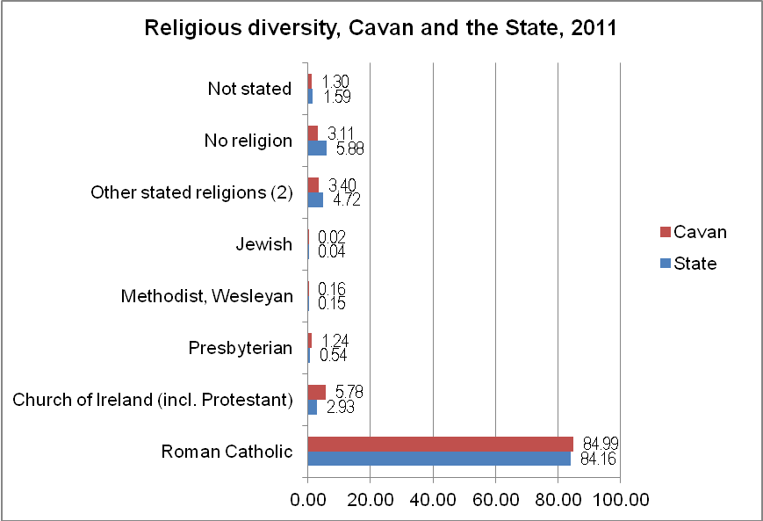
Figure 9 Percentage of Roman Catholics in County Cavan at each Census

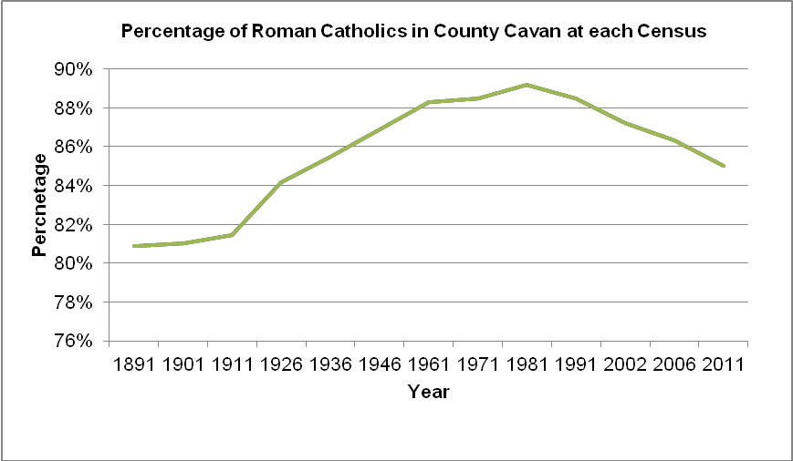

Figure 10 Percentage of Church of Ireland, Presbyterian and Methodist/Wesleyan communities in Cavan at each Census
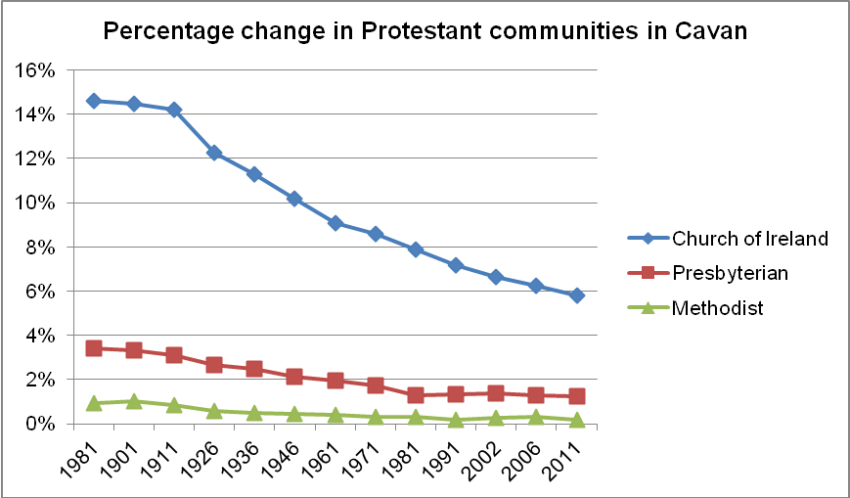

Number of Cavan households exceeds 25,000

There was an increase of 3,889 (17.73%) households in Cavan between 2006 and 2011. The number of households in Cavan now exceeds 25,000.
In 2006, there were 21,929 private households in Cavan. This had grown to 25,818 by 2011.
The average number of persons per household in County Cavan is currently 2.8.

Table 20 Number of private households and number of persons in private households, 2011
2011 | State | Cavan
Private Households (Number) | 1,654,208 | 25,818
Persons in Private Households (Number) | 4,510,409 | 72,625
Average Number of Persons in Private Households (Number) | 2.7 | 2.8

Of the 25,818 private households in County Cavan, only 98 were temporary households. (Data also show that of the 147 people living in temporary private households, only 10 people were from the Traveller community.)
Table 21 Private Households in Cavan by Type of Household (Permanent or Temporary)
County Cavan | 2011
Number of private households | 25,818
Number of persons in private households | 72,625
Number of permanent private households | 25,720
Number of persons in permanent private households | 72,478
Number of temporary private households | 98
Number of persons in temporary private households | 147

High rate of vacant housing

Cavan has a much higher rate of vacant property than the State, at 21.6 per cent compared to 14.5 per cent nationally. The figures show a total of 7,277 vacant dwellings in Cavan in 2011. This figure includes holiday homes but does not include homes where the residents are temporarily absent or homes under construction. Almost 290,000 homes were vacant in the State on Census night.

Table 22 Occupied and vacant permanent housing units by occupancy on census night.
 | Occupied by |  | Unoccupied |  |  |  | Total housing stock | Vacancy rate
 | Usual resident(s) of the household | Visitors only | Residents temporarily absent | Vacant house | Vacant flat | Holiday home | G=A+B+C+D+D+F | (D+E+F)/G%
 | A | B | C | D | E | F | G=A+B+C+D+D+F | (D+E+F)/G%
Cavan | 25,720 | 124 | 590 | 5,325 | 952 | 1,000 | 33,711 | 21.6
State | 1,649,408 | 10,703 | 45,283 | 16,8427 | 61,629 | 59,395 | 1,994,845 | 14.5

The map of Cavan on the following page (Figure 10) shows the proportion of vacant housing in each Electoral Division. Areas shaded dark red have over 28 per cent vacant property. It is evident that there are higher proportions in the North and West of Cavan than in the South and East of the County.
Vacant Dwellings
In identifying vacant dwellings, enumerators were instructed to look for signs that the dwelling was not occupied e.g. no furniture, no cars outside, junk mail accumulating, overgrown garden etc., and to find out from neighbours whether it was vacant or not. It was not sufficient to classify a dwelling as vacant after one or two visits. Similar precautions were also taken before classifying holiday homes. Dwellings under construction and derelict properties are not included in the count of vacant dwellings. In order to be classified as under construction, the dwelling had to be unfit for habitation because the roof, doors, windows or walls had not yet been built or installed.

Figure 11 Vacant housing rate, 2011
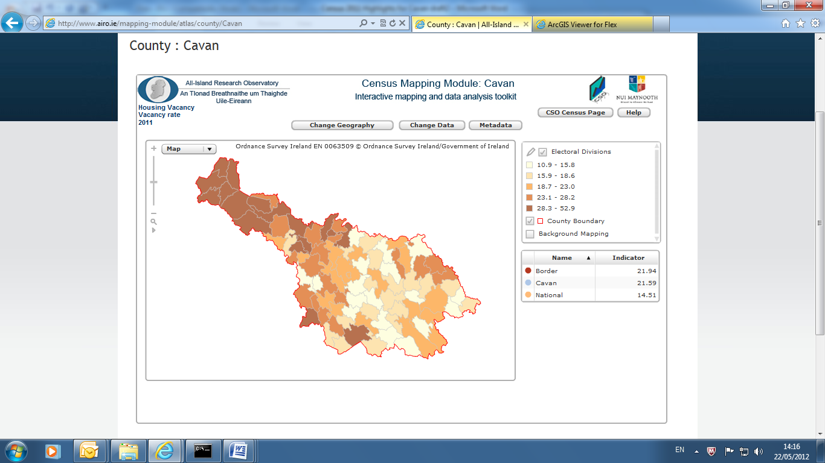
Map source: AIRO Maynooth.

The following illustration juxtaposes two maps of the housing vacancy rate (2011) and the Cavan Electoral Divisions that were eligible for the Upper Shannon Renewal Tax Incentive Scheme. This scheme encouraged development in the West of the County, an area where there are now higher rates of vacant property.

Figure 12 Maps of vacant housing rate (left) and electoral divisions eligible for the Upper Shannon Renewal tax incentive scheme (right).
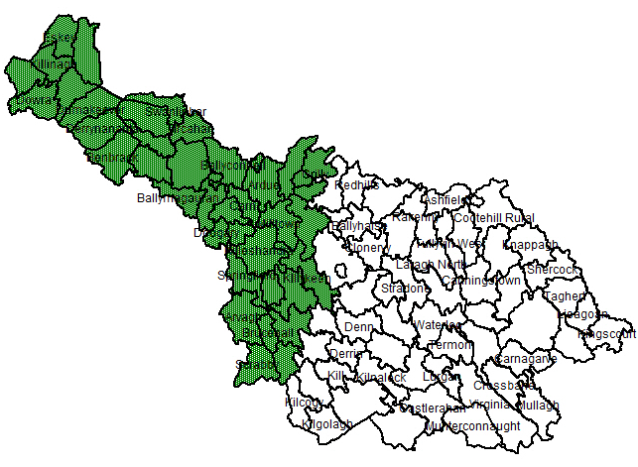

Figure 13 shows unfinished estates plotted from a survey by the Department of Environment, Community and Local Government.
Figure 13 Map of unfinished estates, National Housing Development Survey 2011
Source: AIRO Maynooth

Detached housing more common in Cavan

Most housing in County Cavan is detached housing (67 per cent). This compares favourably with elsewhere in the State where detached housing accounts for only 42 per cent of housing. We have proportionally far fewer flats, apartments and bedsits in Cavan than elsewhere in the State, as well as much lower rates of terraced and semi-detached housing.
Table 23 Private households in permanent housing units in County Cavan and the State by type of accommodation, 2011
2011 | Cavan (Number) | Cavan (%) | State (Number) | State  (%)
All households | 25,720 |  | 1,649,408
Detached house | 17,319 | 67.34 | 699,869 | 42.43
Semi-detached house | 4,947 | 19.23 | 456,651 | 27.69
Terraced house | 2,042 | 7.94 | 281,825 | 17.09
Flat or apartment in a purpose- built block | 658 | 2.56 | 149,921 | 9.09
Flat or apartment in a converted house or commercial building | 215 | .83 | 27,666 | 1.68
Bed-sit | 47 | .18 | 5,695 | 0.35
Not stated | 492 | 1.91 | 27,781 | 1.68

Ninety per cent of Cavan households are heated with fossil fuels

In county Cavan, over 70 per cent of households are heated with oil, 7 per cent are heated with natural gas, and over 10 per cent with coal or peat. In total, over 90 per cent of Cavan homes are heated with fossil fuels. This high dependency on such fuel sources may become an increasing concern as fossil fuel supplies diminish and prices continue to rise.
- 349 Cavan households had no central heating in 2011.

Table 24 Private Households in Permanent Housing Units (Number) in County Cavan by Type of Central Heating
2011
 | Cavan |  | State
 | Number | Percentage | Number | Percentage
All households | 25,720 | 100.00 | 1,649,408 | 100.00
No central heating | 349 | 1.36 | 26,952 | 1.63
Oil | 18,421 | 71.62 | 711,330 | 43.13
Natural Gas | 1,801 | 7.00 | 550,215 | 33.36
Electricity | 1,063 | 4.13 | 140,419 | 8.51
Coal (incl. anthracite) | 1,853 | 7.20 | 79,145 | 4.80
Peat (incl. turf) | 836 | 3.25 | 78,638 | 4.77
Liquid Petroleum Gas (LPG) | 271 | 1.05 | 10,452 | 0.63
Wood (incl. wood pellets) | 673 | 2.62 | 21,395 | 1.30
Other fuels | 131 | 0.51 | 8,524 | 0.52
All types of fuel | 25,049 | 97.39 | 1,600,118 | 97.01
Not stated | 322 | 1.25 | 22,338 | 1.35

Figure 14 Home heating sources in Cavan 2011

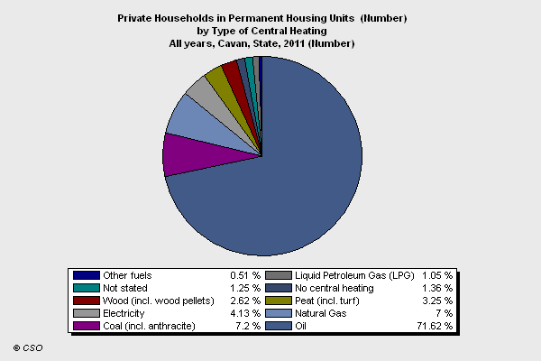

Less than half of Cavan households connected to public water mains

County Cavan has a much lower proportion of households connected to a public mains (43.48%) compared to the State (75.61%). The rate of connection to a local authority group scheme here is twice as high as in the State as a whole. Private group schemes are in 12.48 per cent of Cavan households compared to only 2.78 per cent in the State.
- Almost a quarter of Cavan households (23.66%) used another private source (twice the rate for the State)
- 74 households in Cavan stated they had no piped water supply.

Table 25 Private households in permanent housing units (number) in County Cavan by type of water supply, 2011
2011
 | Cavan |  |  | State
 | Number |  | Percentage | Number | Percentage
All types of water supply | 25,720 |  |  | 1,649,408
Public mains | 11,184 |  | 43.48 | 1,247,185 | 75.61
Local authority group scheme | 4,441 |  | 17.27 | 144,428 | 8.76
Private group scheme | 3,210 |  | 12.48 | 45,774 | 2.78
Other private source | 6,085 |  | 23.66 | 161,532 | 9.79
No piped water | 74 |  | 0.29 | 2,080 | 0.13
Not stated | 726 |  | 2.82 | 48,409 | 2.93

Almost half of all Cavan households have a septic tank

In the State as a whole, two thirds of households are connected to the public sewerage mains. However in County Cavan, less than two fifths are mains connected. The proportion of households using septic tanks in Cavan (46.96%) is much higher than the State (26.53%).
- 98 households in Cavan said they had no sewerage facility.
- 8.71 of households in Cavan had an individual treatment facility that was not a septic tank.

Table 26 Private households in permanent housing units (number) in County Cavan by type of sewerage, 2011
2011
 | Cavan |  | State
 | Number | Percentage | Number | Percentage
All types of sewerage | 25,720 | 100 | 1,649,408 | 100
Public scheme | 10,232 | 39.78 | 1,092,418 | 66.23
Individual septic tank | 12,078 | 46.96 | 437,652 | 26.53
Individual treatment not septic tank | 2,240 | 8.71 | 50,259 | 3.05
Other type of sewage | 159 | 0.62 | 9,370 | 0.57
No sewerage facility | 98 | 0.38 | 2,555 | 0.15
Not stated | 913 | 3.55 | 57,154 | 3.47

10,000 Cavan residents born in other EU countries

Among people living in County Cavan at the time of the Census, 60,348 had been born in Ireland, and 12,184 had been born in other countries. The largest group of those born abroad (9,976) were born in other EU 27 countries excluding Northern Ireland. Among those born outside of the EU:
- 567 people were born in Africa (the largest group of these were born in Nigeria).
- 644 people were born in Asia (the largest group of these were born in India).
- 660 were born in America (70% of these were born in the United States).
Table 27 Population usually resident and present in the State, resident in County Cavan by Birthplace
Cavan | 2011
Ireland | 60,348
Ireland - county of usual residence | 43,627
Ireland - county other than county of usual residence | 16,721
All countries excluding Ireland | 12,184
EU27 excluding Ireland | 9,976
Northern Ireland | 1,887
All countries | 72,532
Note: The above table refers to place of birth and not nationality.

Table 25 in the appendices provides a more detailed breakdown on the birthplace of Cavan residents. Further analysis on the nationality of Cavan residents will be provided in Profile 6: Migration and Diversity to be published by the Central Statistics Office on 11 October 2012.

Over 5,500 Dubliners live in Cavan

Among people who are now usually resident in County Cavan, the largest proportion of those born in other Irish counties were born in Dublin (5,557), followed by Meath (2,908), Monaghan (2,884) and Leitrim (997).
Table 28 Population usually resident and present in County Cavan by county of birth
County of birth of current Cavan residents | 2011
Carlow | 69
Dublin | 5,557
Kildare | 649
Kilkenny | 124
Laois | 127
Longford | 918
Louth | 706
Meath | 2,908
Offaly | 152
Westmeath | 567
Wexford | 166
Wicklow | 350
Clare | 179
Cork | 412
Kerry | 173
Limerick | 216
Tipperary | 168
Waterford | 103
Galway | 596
Leitrim | 997
Mayo | 246
Roscommon | 245
Sligo | 329
Cavan | 43,901
Donegal | 335
Monaghan | 2,884

1,785 people moved into the county between 2010 and 2011

The data show, that in the space of a one year period, 1,785 people moved into County Cavan from abroad and elsewhere in Ireland.
Among people (aged one year and over) who are usually resident in County Cavan:
- 67,420 were residing at the same address as they had been the previous year,
- 2,335 resided at a different address in Cavan one year previously
- 1,130 were residing in a different Irish county, and
- 655 were residing outside the State one year previously. Of these, 222 were Irish born, and 433 were born elsewhere.
Table 29 Population aged one year and over usually resident and present in County Cavan by usual residence one year previously
Cavan | 2011
Usual residence one year previously - All persons | 71,540
Usual residence one year previously - Same address | 67,420
Usual residence one year previously - Different address total | 4,120
Usual residence one year previously - Different address, same county | 2,335
Usual residence one year previously - Different address, other county | 1,130
Usual residence one year previously - Outside State, birthplace in Ireland (Republic) | 222
Usual residence one year previously - Outside State, birthplace elsewhere | 433

Over 600 Cavan residents lived in other countries one year previously

The Census shows recent movement into the county, with 655 current residents having lived in another country one year previously. Among these were 168 people who between them lived in Latvia, Lithuania and Poland one year previously. Over two hundred people moved to Cavan in one year from our nearest neighbours (a combined total of 214 from Scotland, England, Wales and Northern Ireland).
Over a thousand Cavan residents lived elsewhere in Ireland one year previously.
Table 30 Population usually resident in County Cavan and present in the State on Census night by former country of usual residence one year previously
Former country of usual residence on year previously | 2011
Ireland - county of usual residence | 69755
Elsewhere in Ireland | 1130
All countries excluding Ireland | 655
Northern Ireland | 73
England and Wales | 130
Scotland | 11
Austria | ..
Belgium | 1
Bulgaria | 2
Cyprus | ..
Czech Republic | ..
Denmark | ..
Estonia | ..
Finland | 1
France | 7
Germany | 8
Greece | ..
Hungary | 4
Italy | 4
Latvia | 37
Lithuania | 72
Luxembourg | ..
Malta | ..
Netherlands | 11
Poland | 59
Portugal | ..
Romania | 7
Slovakia | 1
Slovenia | ..
Spain | 15
Sweden | ..
United States | 42
Other countries (6) | 170
All countries | 71540

Conclusion

The Census data provide the most comprehensive insight into changes taking place in County Cavan over the last few years. Overall these data present a positive profile of Cavan as a county with a growing population, increasing diversity and a continuing strong rural tradition. Interestingly, we are the county with one of the lowest rates of marital breakdown. The population growth of Cavan town and environs has been particularly strong, as has that of Ballyjamesduff and Mullagh. Quality of life indicators (including a greater prevalence of detached housing and lower population density) are also high here. Our rate of migration into county is three time higher than the State. Our birth rate is higher than the State average. The county shows signs of increasing diversity with a continuing ability to attract people from other countries and other Irish counties, and changes in our religious composition. We had the highest rate of growth in the Traveller Community.
Issues that may present as a concern for the county include the higher than average rate of vacant housing here, and large increases in the youth population in particular that will place demands on service providers. The rate of older people who live alone is three higher than in the general population (all ages); again, this may have implications for social isolation and service provision. Our strong dependence on fossil fuels is also something that will need to be addressed as these are non-renewable supplies.
The remaining volumes of Census data will be published throughout 2012. Reports will be published across a range of census themes, each one examining a different topic in more detail (see next page for publication schedule). Cavan Local Authorities will continue to provide analyses of these data as they emerge. A new question on health was included for the first time in Census 2011, so there will be new data on the health of the Cavan population (to be published on 1 November).

Census 2011 Publication Schedule
Preliminary Report | 30 June 2011
This is Ireland, Highlights from Census 2011 Part 1 (formerly Principal Demographic Results) | 29 March 2012
Population by Area (formerly Volume One) | 26 April 2012
Profile 1 Town and Country – Population distribution and movements | 26 April 2012
Profile 2 Older and Younger – An age profile of Ireland | 24 May 2012
This is Ireland Highlights from Census 2011 Part 2 (formerly Principal Socio Economic Results) | 28 June 2012
*Small Area Population Statistics (SAPS) – All variables | TBA
Profile 3 At Work – Employment, occupations and industry in Ireland | 26 July 2012
Profile 4 The Roof over our Heads – Housing in Ireland | 30 August 2012
Profile 5 Households and Families – Living arrangements in Ireland | 20 September 2012
Profile 6 Migration and Diversity – A profile of diversity in Ireland | 4 October 2012
Profile 7 Irish Travellers and Ethnicity and Religion – Ethnic and cultural background in Ireland | 18 October 2012
Profile 8 Our Bill of Health – Health, disability and carers in Ireland | 1 November 2012
Profile 9 What we know - A study of education and skills in Ireland | 22 November 2012
Profile 10 Door to Door – Commuting in Ireland | 13 December 2012

References

Central Statistics Office, This is Ireland– Highlights from Census 2011, Part 1 (formerly Principal Demographic Results)
Central Statistics Office, Profile 1 Town and Country – Population Distribution and Movements
Central Statistics Office, Population by Area

Appendix I Population change in all counties

Table 31 Population by County or City, actual and percentage change 2011
 | 2011 Population (Number) | Actual Change Since Previous Census (Number) | Percentage Change Since Previous Census (%)
State | 4588252 | 348404 | 8.2
Carlow | 54612 | 4263 | 8.5
Dublin | 1273069 | 85893 | 7.2
Dublin City | 527612 | 21401 | 4.2
Dún Laoghaire-Rathdown | 206261 | 12223 | 6.3
Fingal | 273991 | 33999 | 14.2
South Dublin | 265205 | 18270 | 7.4
Kildare | 210312 | 23977 | 12.9
Kilkenny | 95419 | 7861 | 9
Laois | 80559 | 13500 | 20.1
Longford | 39000 | 4609 | 13.4
Louth | 122897 | 11630 | 10.5
Meath | 184135 | 21304 | 13.1
Offaly | 76687 | 5819 | 8.2
Westmeath | 86164 | 6818 | 8.6
Wexford | 145320 | 13571 | 10.3
Wicklow | 136640 | 10446 | 8.3
Munster | 1246088 | 72748 | 6.2
Clare | 117196 | 6246 | 5.6
Cork | 519032 | 37737 | 7.8
Cork City | 119230 | -188 | -0.2
Cork County | 399802 | 37925 | 10.5
Kerry | 145502 | 5667 | 4.1
Limerick | 191809 | 7754 | 4.2
Limerick City | 57106 | -2684 | -4.5
Limerick County | 134703 | 10438 | 8.4
North Tipperary | 70322 | 4299 | 6.5
South Tipperary | 88432 | 5211 | 6.3
Waterford | 113795 | 5834 | 5.4
Waterford City | 46732 | 984 | 2.2
Waterford County | 67063 | 4850 | 7.8
Connacht | 542547 | 38426 | 7.6
Galway | 250653 | 18983 | 8.2
Galway City | 75529 | 3115 | 4.3
Galway County | 175124 | 15868 | 10
Leitrim | 31798 | 2848 | 9.8
Mayo | 130638 | 6799 | 5.5
Roscommon | 64065 | 5297 | 9
Sligo | 65393 | 4499 | 7.4
Ulster (part of) | 294803 | 27539 | 10.3
Cavan | 73183 | 9180 | 14.3
Donegal | 161137 | 13873 | 9.4
Monaghan | 60483 | 4486 | 8

Appendix II Place of birth of Cavan residents

Table 32 Population Usually Resident and Present in County Cavan by Birthplace, 2011
County Cavan Residents / Place of Birth | 2011
Ireland | 60,348
Ireland - county of usual residence | 43,627
Ireland - county other than county of usual residence | 16,721
All countries excluding Ireland | 12,184
EU 27 excluding Ireland
Austria | 5
Belgium | 20
Bulgaria | 25
Czech Republic | 80
Denmark | 1
Germany | 119
Estonia | 16
Greece | 8
Spain | 25
France | 44
Italy | 22
Cyprus | 1
Latvia | 751
Lithuania | 1260
Luxembourg | 0
Hungary | 33
Malta | 3
Netherlands | 58
Poland | 1744
Portugal | 4
Romania | 134
Slovenia | 3
Slovakia | 102
Finland | 3
Sweden | 5
England and Wales | 3386
Scotland | 237
Northern Ireland | 1887
EU27 excluding Republic of Ireland | 9976
Other Europe (8) | 259
Russian Federation | 104
Ukraine | 79
Moldova, Republic of | 13
Other Europe (9) | 63
Africa (2) | 567
South Africa | 149
Nigeria | 243
Mauritius | 6
Zimbabwe | 24
Congo | 8
Other Africa (4) | 137
Asia (2) | 644
China | 68
India | 156
Philippines | 138
Pakistan | 133
Malaysia | 15
Bangladesh | 9
Hong Kong | 10
Other Asian countries (2) | 115
America (2) | 660
United States | 463
Brazil | 122
Canada | 46
Other America (4) | 29
Australia | 54
New Zealand | 22
Other Oceanic countries (1) | 2
All countries | 72532

Appendix III Summary Table

A summary of some of the headline results from Census 2011 for County Cavan, together with comparisons for Ulster (part of) and the State as a whole are presented in the table below.
 | Cavan | Ulster (part of) | State
Population 2011 | 73,183 | 294,803 | 4,588,252
% Change since 2006 | 14.3% | 10.3% | 8.2%
Males per 100 Females | 102.3 | 100.8 | 98.1
Average Age | 36.0 | 36.5 | 36.1
Age Dependency* | 55.4% | 55.7% | 49.3%
% separated and divorced** | 3.9% | 4.2% | 4.4%
Most common type of dwelling | Detached | Detached | Detached
% of this type of dwelling | 67.3% | 67.5% | 42.4%
No. of households | 25,818 | 105,046 | 1,654,208
Average no. of persons per household | 2.8 | 2.8 | 2.7
No. of vacant dwellings | 7,277 | 34,671 | 289,451
Vacancy rate | 21.6% | 24.3% | 14.5%

* Age dependency is the number of people aged under 15 and over 65 as a percentage of the population of working age.
** % separated and divorced is based on total population including children.

Owing to the definition used by the Central Statistics Office, the land area of Cavan town and environs can change from one Census to the next (for example, certain residential areas are included as they develop).
The ‘ever married’ category includes all married, separated, divorced and widowed.
Further details on ‘other stated religions’ will be published in the Migration and Diversity profile report from CSO in October 2012.

