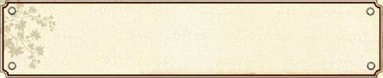
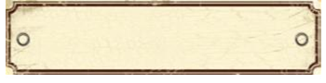
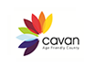
Members of the Cavan Town Women’s Group meet every Tuesday at 8:30 in the Bridge Street Centre in Cavan Town. Since the group’s inception, 20 years ago, it has engaged in many different types of activities to enable women to fully participate in the cultural and social life of Cavan. Members are also encouraged to explore the creative side of their personalities. Members participate in drama, crafts, and music and dance classes. It is one of the groups affiliated to Breffni Belles.
Guests often attend meetings to speak about various topics and visits are organized to places the members find interesting. Members also attend cultural events as a group providing a valuable social outlet for many women who may not feel comfortable if they were to attend the same event on their own.
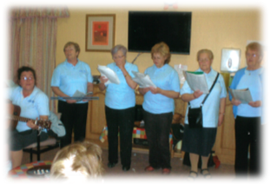

Members of the group like to contribute what and how they can to society. They raise funds for local charities and at Christmas they provide entertainment for residents in Nursing Homes.
Women of all interests and opinions are welcome to join in with the group when they meet in the Bridge Street Centre on Tuesdays at 8:30 in the evening.
February 2014
Issue 3
Age Conscious Times
Newsletter of the Cavan Older People’s Forum

Making Cavan a great place to grow old in

Cavan Town Women’s Group

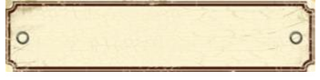

Cavan Social Services Group
Continue newsletter text here. Continue newsletter text here. Continue newsletter text here. Continue newsletter text here. Continue newsletter text here. Continue newsletter text here. Continue newsletter text here. Continue newsletter text here. Continue newsletter text here. Continue newsletter text here. Continue newsletter text here. Continue newsletter text here. Continue newsletter text here. Continue newsletter text here. Continue newsletter text here. Continue newsletter text here. Continue newsletter text here. Continue newsletter text here Continue newsletter text here

Continue newsletter text here. Continue newsletter text here. Continue newsletter text here. Continue newsletter text here. Continue newsletter text here. Continue newsletter text here. Continue newsletter text here. Continue newsletter text here. Continue newsletter text here.

Continue newsletter text here. Continue newsletter text here. Continue newsletter text here. Continue newsletter text here. Continue newsletter text here. Continue newsletter text here. Continue newsletter text here. Continue newsletter text here. Continue newsletter text here. Continue newsletter text here. Continue newsletter text here. Continue newsletter text here.

Continue newsletter text here. Continue newsletter text here. Continue newsletter text here. Continue newsletter text here. Continue newsletter text here. Continue newsletter text here.

Continue newsletter text here. Continue newsletter text here. Continue newsletter text here. Continue newsletter text here. Continue newsletter text here. Continue newsletter text here. Continue newsletter text here. Continue newsletter text here.

Continue newsletter text here. Continue newsletter text here. Continue newsletter text here. Continue newsletter text here. Continue newsletter text here. Continue newsletter text here. Continue newsletter text here. Continue newsletter text here. Continue newsletter text here.

Members of the Cavan Social Services Group meet in the Day Centre on the Cathedral Road in Cavan Town. They meet for a friendly chat and sessions which promote personal wellbeing as well as activities that fun and sociable. Cavan Social Services meet at the following times:
Monday 10:30 am Gentle exercises and dancing
Tuesday 10:30 am Relaxation and Thai Chi
Wednesday 3 – 5 pm Crafts
Thursday 8 pm Card playing, Whist

At the session on Wednesdays at least 20 ladies get together to knit, crochet, make cards and sing, amongst other activities. Members knit teddies, vests, handbags and squares which are combined into cot blankets. All of these handmade items are sent to a hospital in Livingstonia, a town northern Malawi a country located in Africa as shown in the map.
Reports back from doctors inform members that children who have been given a teddy seem to get well faster than their peers without a teddy. It is the custom of the hospital to give a blanket to mothers as they leave with their new babies. The blanket can become the prized possession of the family and in some cases can be the only covering they have for the babies.
In 2013 the group sent 100 blankets, 40 teddies and 60 vests to this hospital. Before being sent out this fine work is displayed, twice a year in May and June. During the year the group organises day trips and holiday breaks that can last up to four days.
If people wish to get involved they can contact:
Marie Lynch 049 436 1196
Connie Mc Entee 049 433 2136

Making Cavan a great place to grow old in
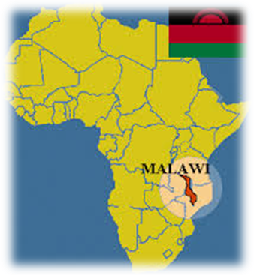

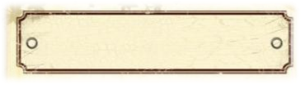
Shades of Life
Art Exhibition

Any individual can take up painting. Classes are held all around the county at varying times and places. Sometimes artists are fortunate enough to have their work displayed.
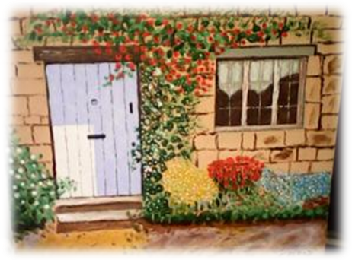
The paintings above showing the buildings have been painted by local artists in Cavan. For a person interested in seeing more there will be an exhibition later this spring in the Event Space in Johnston Central Library in Cavan Town. The artwork will be on display from Thursday the 24th of April for the following 2 weeks.
Anyone and everyone are welcome to come along and view.

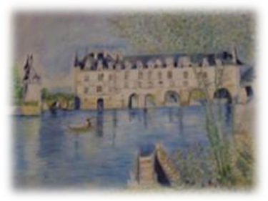

Painting is not a new activity. For many years this has been the method of preserving observations and ideas. The tools and paints have changed from the likes of red ochre as a pigment which were used to depict images by hand on to rocks and cave sides to brushes used with oil and acrylic paints on canvas. The first recorded examples of painting are to be found in rock shelters in Australia. It became common to record observations in caves with ancient tribes in Africa and America, just like this image:
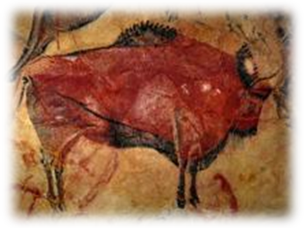

Making Cavan a great place to grow old in


Making Cavan a great place to grow old in

Emergency and Support Numbers



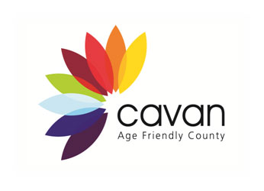

To submit an article or stop receiving this newsletter contact Aodhán Hudson at Cavan County Council ring 049 437 8584 or ahudson@cavancoco.ie

Emergency requiring immediate assistance 999 / 112
North East Doctor on Call 1850 777 911
Cavan Garda Station 049 436 8800
Senior helpline 1850 440 444
Citizen’s Information 076 1075 200
Alzheimer's Society – Cavan Branch 087 224 0963
Irish Wheelchair Association 049 437 1212
Health Service Executive Info 1850 24 1850
Cavan General Hospital 049 437 6183
Women’s Aid 1800 341 900
1 Life 1800 247 100
CUAN 086 223 2877
The Samaritans 1850 609 090
Garda Confidential 1800 666 111
Good Morning Positive Age 049 437 2838
National Association of Widows 01 872 8814
SOSAD (suicide prevention) 083 423 9090
CONSOLE 1800 201 890 (Support for those bereaved by suicide)

