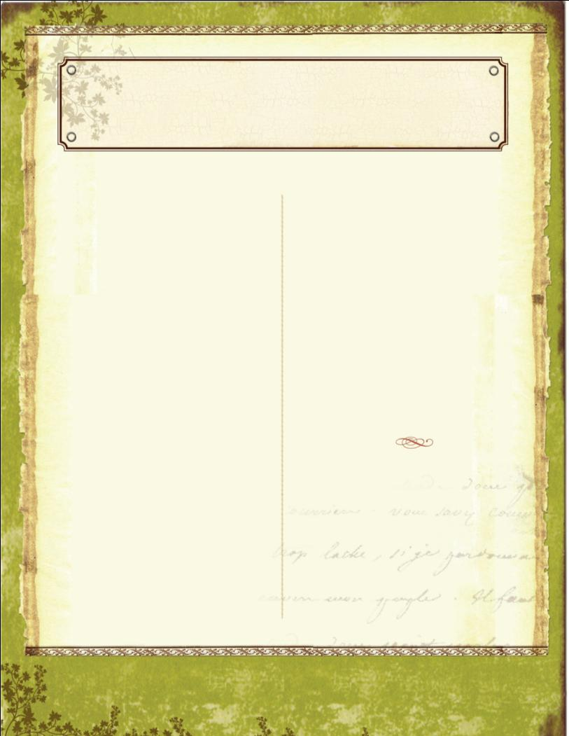
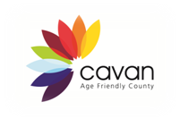
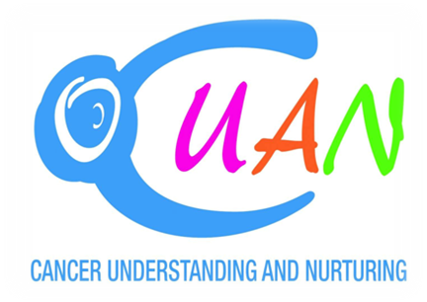

Kerry Mullen and Dearbhla O’Toole are two ordinary ladies living in Cavan. They both have had a diagnosis of cancer and currently hope they are cancer free. They live with the uncertainty of this.

There are cancer support groups but their focus has been on raising funds and providing financial assistance. In 2012 Kerry and Dearbhla identified a need for further support for people with cancer. Together they established something different – a cancer support and wellness group who would provide support for the people of Cavan and surrounding counties. CUAN – Cancer Understanding and Nurturing gradually came into existence over the summer months.

The Cootehill Community Cancer Support Group was approached and informed of the plans the 2 ladies had and they were very generously offered funds for activities for the first year. CUAN later became affiliated to the Irish Cancer Society.

The group is open to anyone who has had a cancer diagnosis at any stage in their life. The emphasis is on wellness, emotional support and wellbeing. Gentle exercise and therapies like massage and reflexology are on offer, free of charge. Equally important is the cup of tea and the chat. The activities will expand as members are encouraged to identify more activities and events that they feel will benefit them.

In a most positive development CUAN has recently been given the use of premises in the Cootehill Credit Union building.

Currently the group meets on Tuesdays, from 10.30 in the morning to 1pm. It is hoped that like the activities this will expand with time.

For further details contact:

- Kerry 086 455 6632
- Michael 086 074 7735
- cuancootehill@gmail.com

November 2013
Issue 2
Age Conscious Times
Newsletter of the Cavan Older People’s Forum

Making Cavan a great place to grow old in
Social Support & Wellness Group



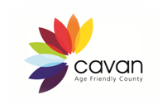


Your Local Library
Continue newsletter text here. Continue newsletter text here. Continue newsletter text here. Continue newsletter text here. Continue newsletter text here. Continue newsletter text here. Continue newsletter text here. Continue newsletter text here. Continue newsletter text here. Continue newsletter text here. Continue newsletter text here. Continue newsletter text here. Continue newsletter text here. Continue newsletter text here. Continue newsletter text here. Continue newsletter text here. Continue newsletter text here. Continue newsletter text here Continue newsletter text here

Continue newsletter text here. Continue newsletter text here. Continue newsletter text here. Continue newsletter text here. Continue newsletter text here. Continue newsletter text here. Continue newsletter text here. Continue newsletter text here. Continue newsletter text here.

Continue newsletter text here. Continue newsletter text here. Continue newsletter text here. Continue newsletter text here. Continue newsletter text here. Continue newsletter text here. Continue newsletter text here. Continue newsletter text here. Continue newsletter text here. Continue newsletter text here. Continue newsletter text here. Continue newsletter text here.

Continue newsletter text here. Continue newsletter text here. Continue newsletter text here. Continue newsletter text here. Continue newsletter text here. Continue newsletter text here.

Continue newsletter text here. Continue newsletter text here. Continue newsletter text here. Continue newsletter text here. Continue newsletter text here. Continue newsletter text here. Continue newsletter text here. Continue newsletter text here.

Continue newsletter text here. Continue newsletter text here. Continue newsletter text here. Continue newsletter text here. Continue newsletter text here. Continue newsletter text here. Continue newsletter text here. Continue newsletter text here. Continue newsletter text here.

Libraries have always been a treasured resource. In County Cavan we have the benefit of 3 full time libraries. They have come a long way since their humble beginnings in a room in Cavan Courthouse in 1930.
- The headquarters is Johnston Central Library in Cavan town has been opened since June 2006.
- Cootehill Library and Arts Centre opened in October 2001 and was given a facelift in 2008.
- Bailieborough Library opened in 1992 as a part-time library. Major structural and accessibility work has been completed since that. Staff levels and opening hours have been increased. The full-time computerised service was re-launched in October 2007.

There are 6 part time libraries in County Cavan. These operate in Arva, Ballyconnell, Belturbet, Ballyjamesduff, Virginia and Kingscourt. From these the following services are available:
- Free access to books, DVDs, newspapers, magazines, reading groups, cultural events, local studies, the county archives and information of every type and variety
- Study, photocopying and printing facilities
- Free Library membership for pensioners
- Free web access, including the use of a scanner
- e-Library services
- 3 multi-purpose spaces
- a prison library and a service to primary school pupils
- Tax forms and Relief forms are also available at the libraries
Helpful, friendly and knowledgeable staff are there to assist and enable a patron to get the most from their local library service.
Making Cavan a great place to grow old in
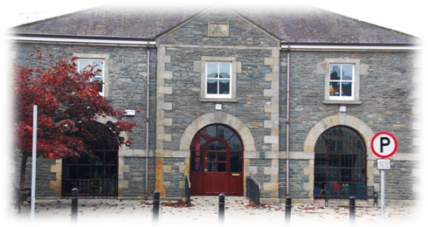
Bailieborough Library


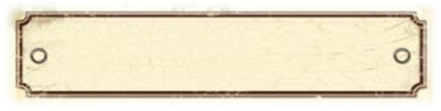
Men’s Sheds
“Talking shoulder to shoulder”
Men’s Groups:
Glangevlin Sandy Holland 087 2153545
Red Hills Older Men’s Organization John Smith 086 1693590
Killycarney Community Garden & Men’s Group Blacklion 087 2153545 Sandy Holland

Community Garden Groups:
CAMCAS Project & Allotments Ballyconnell info@camcas.ie 049 9527384
Fairgreen Cavan Town Ann Marie Johnston 087 2352761
Henry Street Bailieborough Barry Kavanagh 087 6552525 bandakav@gmail.com
Drumlane Declan Fitzpatrick 087 2367628 www.drumlane.ie

For more information on community gardens email Daniel Downey at ddowney@cavancoco.ie


It has been said that “Men don’t talk face to face; they talk shoulder to shoulder.” A place of sanctuary where men can work on a project and talk away separate from trouble and strife seemed to be needed.
The Irish Men’s Shed Association was set up in January 2011 with the purpose of supporting the development and sustainability of Men’s Sheds on the Island of Ireland. The lead has been taken from the Australians from where this concept has its roots. The first Irish Men’s Shed was set up in Tipperary Town in 2009. Now there are over 100 sheds in Ireland.
Projects can vary from woodwork to assisting charity organizations, making toys for children, restoring a railway carriage and vintage farm machinery.
Below is a contact list for different groups in County Cavan (some of which are gender specific)
Men’s Sheds:
Belturbet Tony Prior 087 2639764 Corlough Tony Byrne 086 6688710 Cavan Town Peter O Hanlon 086 8328369 Bailieborough Padraig Mc Breen 086 4057650





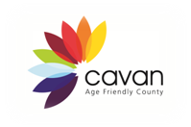
Making Cavan a great place to grow old in

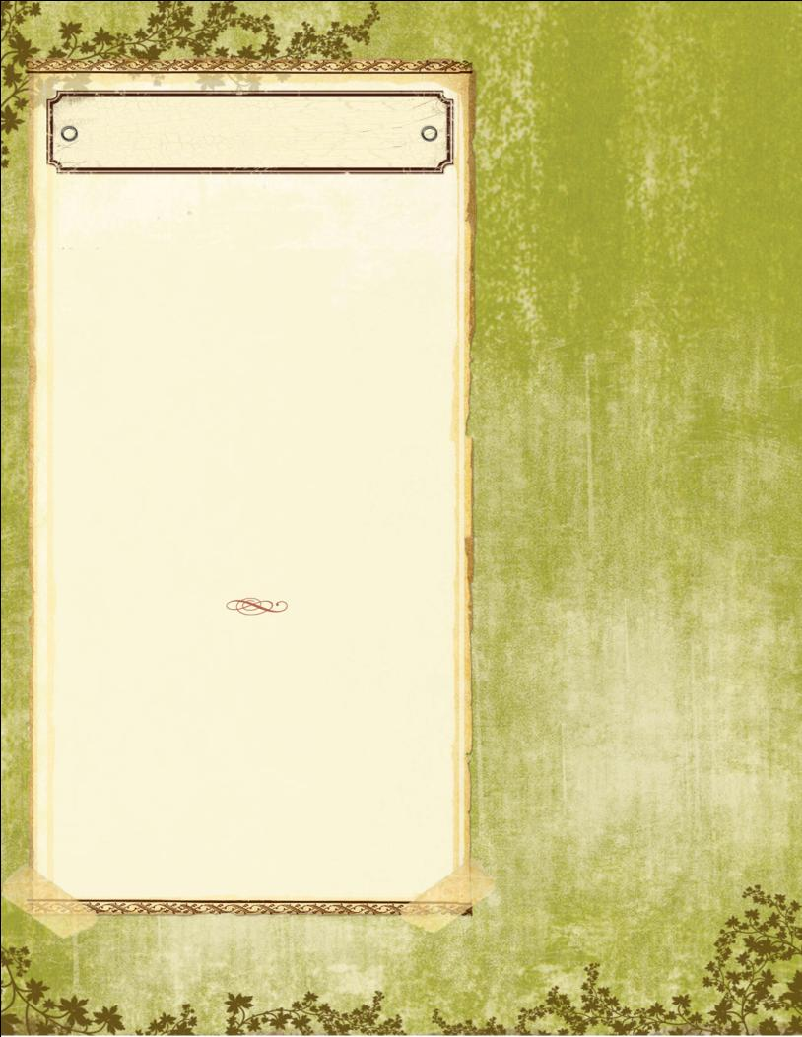

Making Cavan a great place to grow old in

Emergency and Support Numbers


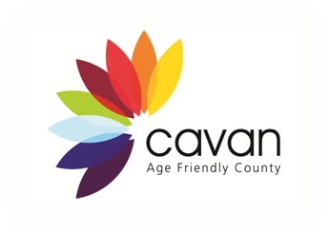

To submit an article or stop receiving this newsletter contact Aodhán Hudson at Cavan County Council – 049 437 8584 or ahudson@cavancoco.ie

Emergency requiring immediate assistance 999 / 112
North East Doctor on Call 1850 777 911
Cavan Garda Station 049 436 8800
Senior helpline 1850 440 444
Citizen’s Information 076 1075 200
Alzheimer's Society – Cavan Branch 087 224 0963
Irish Wheelchair Association 049 437 1212
Health Service Executive Info 1850 24 1850
Cavan General Hospital 049 437 6183
Women’s Aid 1800 341 900
1 Life 1800 247 100
CUAN 086 223 2877
The Samaritans 1850 609 090
Garda Confidential 1800 666 111
Good Morning Positive Age 049 437 2838
National Association of Widows 01 872 8814
SOSAD (suicide prevention) 083 423 9090
CONSOLE 1800 201 890 (Support for those bereaved by suicide)

