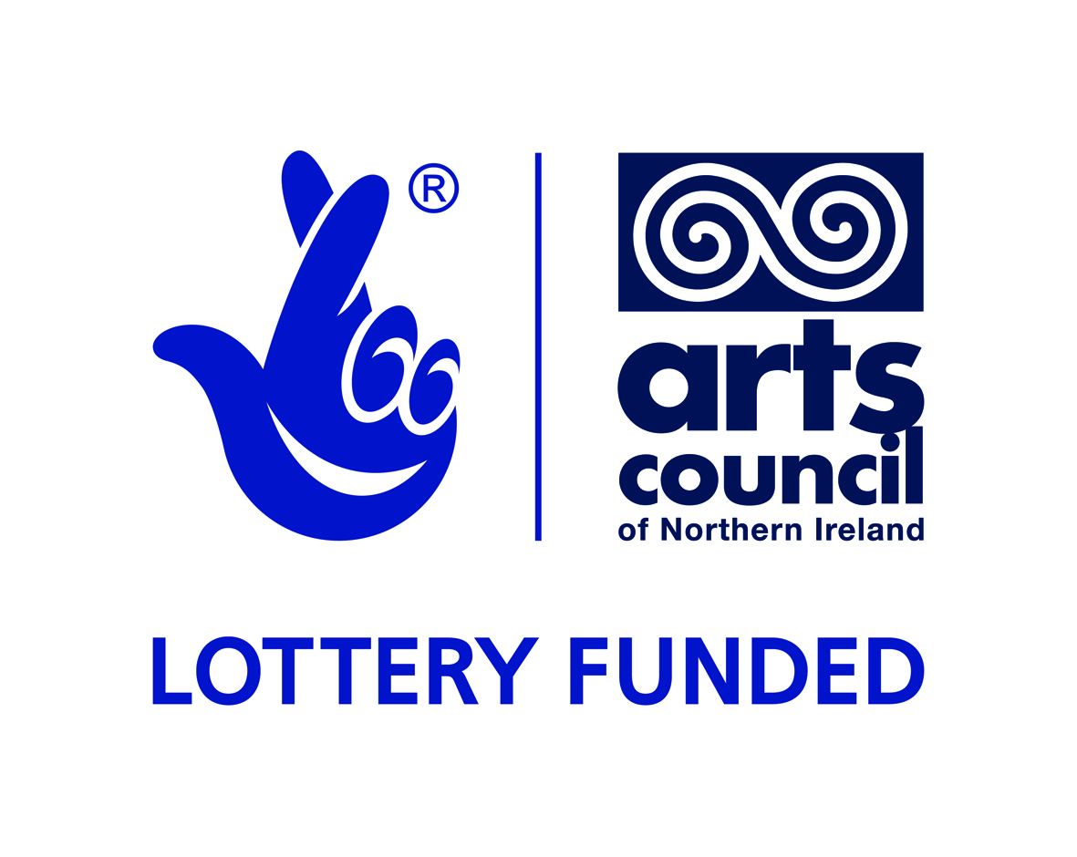 |  |  | 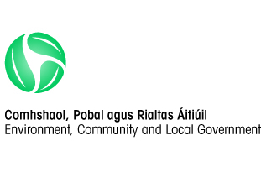 | 

This project is part-financed by the European Union’s Programme for Peace and Reconciliation (PEACEIII) managed by the Special EU Programmes Body; the Arts Council of Northern Ireland; and the International Fund for Ireland.
Ballyconnell BPttA Steering Committee
c/o Arts Office
Cavan Co Council, Courthouse, Cavan

Building Peace through the Arts - Public Art Commission

Tender to commission the appointment of an artist to design, produce and install an artwork in the public realm.

Ballyconnell BPttA Steering Committee seeks expressions of interest from experienced and suitably qualified artists or design teams in developing a new public artwork. The total budget available for the artwork is up to £48,000 (inclusive of VAT).
The deadline for expressions of interest is 5pm Wednesday 13 August 2014
Late submissions will not be accepted.
Applicants are requested to read the full content of this document carefully as it contains important information pertaining to all stages of the commission.

Contents
- Application process
- Background
- Artist’s Brief
- Public Art selection panel/Steering Group
- Stage 1 Expression of interest submissions
- Budgets, fees and expenses for shortlisted artists
- Arts/Design Team responsibilities
- ADA’s responsibilities
- Project Timeline
- Ownership
- Contractual Arrangements
- Submitting an Expression of Interest
- Further information
Appendices

1. APPLICATION PROCESS

Stage 1
Expressions of Interest are sought from artists (or a team of collaborating artists) to deliver a piece of Public Art. Shortlisting will be based on the information provided (see Appendix A) using the Evaluation Criteria set out in Appendix B. Please read Appendix A carefully and comply fully with the requirements.
The deadline for receipt of applications is Wed 13 August 2014. The selection panel will consider submissions received by this deadline and select up to three to go forward to Stage 2 of this process.

There is no payment for artists submitting expressions of interest. Artists who are selected from Stage 1 will proceed to Stage 2 and be asked to develop the idea further.

Stage 2
£500 will be made available to up to three artists / teams who will be invited to present their proposals to the selection panel. The proposal should include; sketch designs, visualisations and/or a maquette as well as an explanation of the concept for the artwork, how it relates to our vision (as outlined in Section 5) and how the artist/artist team would approach its design, fabrication and installation. Details of maintenance requirements and lifespan expectations should also form part of the presentation.
The artist/artist team must demonstrate how the work can be implemented within the allocated budget and details of the anticipated duration of the project with timescale broken down into research, production and delivery. The selection panel aims to select one artist / team to undertake the commission.
The Ballyconnell Community will be at the heart of this project and the selected artist/artist team must demonstrate how they will work with the community to develop a sense of ownership and pride in their environment – and most importantly help create a shared space for all. Therefore the artist/artist team must also outline the approach they will take to engage and work with the local community and showcase successful projects where they have done this in the past in a similar environment.
Selected artists / teams must submit their presentations to Catriona O’Reilly, Arts Office, Cavan County Council, Courthouse, Cavan by the stipulated deadline of 13 August 2014.

2. BACKGROUND
The project seeks to develop a legacy artwork reflecting the Ballyconnell community’s journey towards peace.
The Building Peace through the Arts – Re-Imaging Communities Programme themes are:
- community cohesion
- regeneration through the arts
- positive relations at local level
- peace and reconciliation, and
- connecting communities.

As a first phase of the project, the Ballyconnell Community developed a local steering group to help manage the process. An Artist/Facilitator was recruited to carry out creative community consultation with a wide range of stakeholders in the community including cross-community and cross-border groups. She presented a report of her findings to the steering group which included a number of themes and site locations for the proposed artwork. The local steering group agreed that “The Crossing Point” as the theme most open to artistic interpretation.
The preferred location for the public art is in front of the Market House building on Main Street, Ballyconnell town. Civil works are already planned for this site including the removal of car parking spaces.

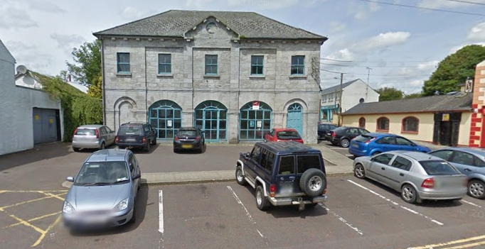
Market House on Main Street, Balyconnell.

3. ARTIST’S BRIEF

Theme: “The Crossing Point”
Ballyconnell is a large town in County Cavan on the border with County Fermanagh, situated in the West of the county and in the UNESCO geopark area.
Historically, Ballyconnell was considered the best place to cross the river - it was an important fighting place for the clans because of the access to the ford. The O’Donnell and O’Neill clans crossed the river at Ballyconnell during the Flight of the Earls. It was an important meeting place for 1500 years.
Ballyconnell is also historically renowned for:
- The University of Tomregan and the Tomregan stone which reputedly celebrates the first recorded brain surgery in Ireland on Cenn Faelad who stayed at the university and made considerable academic advances in translating old texts. This stone is now located at the Church of Ireland.
- St. Bricin and St. Dallan, the blind saint who wrote ‘Be Thou My Vision’ and ‘Remembrance to St. Colmcille’.
- Conall Cearnach’s (step brother/cousin of Cuchulainn) debacle with Queen Maeve of Connacht and eventual assassination in Ballyconnell.
- St. Mogue’s Clay from an ancient church built on a nearby island that is said to have clay from Calvary mixed into its mortar. As a result of this folklore a local tradition has grown, if anyone was leaving the area (and many did) they would be given a small token of this clay promising a safe passage.
- Water is of great importance to the town because of its location on the Shannon Erne Waterway. Much of the town’s prosperity came from this location. The water also represents a crossing point and a link between Northern Ireland and the Republic. The public art piece could reference water in some way, possibly though not necessarily with a water feature.

Another aspect of the ‘crossing point’ theme is that during the Troubles the local community in West Cavan kept a bridge open and the men who were responsible for this activity are celebrated in a local ‘sculptural’ piece, a yellow digger. The digger is maintained by the local community as a mark of their commitment to the hinterland in Fermanagh and a symbol of their defiance towards the British Army in using the digger to keep the an unpatrolled bridge (Gortoral Bridge) open despite British Army ongoing activity to disable the bridge.
Ballyconnell Community has achieved relative peace brought about through the balancing act that is the peace process and the desire of local people to accommodate differences for the sake of providing a safe environment for their children and grandchildren. The artwork will look to the future rather than the past, suggesting the metaphorical journey that has been taken by Ballyconnell since it was affected by checkpoints etc, etc. to reach the relative stability enjoyed today. This theme of ‘The Crossing Point’ is a fitting tribute to the way in which this community has kept extending the open hand of friendship across the border.

These direct quotes from participants in the Re-Imaging Communities consultation process reflect some of the thinking behind the proposed theme:
“All committee interested in drawing attention to importance of this crossing point of the river.”
“The river may be worth exploring”
“...people are interested in the ancient history of the town, its importance as a river crossing and that this could be celebrated”

Ballyconnell is called the ‘town of Conall’s ford’ as evident in the 1st century BC - Tain Bo Cuailnge. Conall Cearnach, a cousin of Cuchulainn and one of the Red Branch Knights, who defended Ulster against the armies of Connacht for many years. Conall was slain by Queen Maeve’s warriors at the ford crossing on the River Grainne - the place became known as the town of Conalls ford - Baile Atha Conaill - Ballyconnell.

In the Bronze Age the numerous lakes of Breiffne provided excellent shelter and security and the economic importance of the mineral wealth drew various races to the area in the early part of the Iron Age (400BC approx). Tribes from the mountainous regions of central Europe where attracted Fir Bolgs, Milesians, and the Tuatha De Danann. It was a period when Celtic paganism and Druidism were rife in the country. The presence of the Crom Cruaich, a shrine at which the Royal kings of Tara came to worship was considerable and invested the location with sacred Pagan symbolism.

Ballyconnell is a thriving economic town despite the economic hardships it has suffered (eg collapse of the Quinn Group) and a busy tourist destination thanks in part to the four star Slieve Russell Hotel and Golf Course that attracts Irish and foreign visitors.

There is a very strong community engagement in local development, evidenced through the renovation of the Church Street Centre and the plans to re-develop the Market House.

Project Specific Constraints: It is part of the artist’s brief to contact utilities companies and statutory agencies for advice in regard to nearby services i.e. electricity and water supply for any artist wishing to incorporate light or water as part of the art works, although this is not a pre-requisite of the brief. Any work involved in extending the services to the site will be part of the overall budget. The site is in front of the Market House, a building that is due to be renovated and on a public road so, consequently, the artist will need to ensure that materials used take road safety into consideration.
Materials: The brief does not specify the materials to be used, but the artwork is intended to be permanent and of high quality. Therefore it should be made of high quality, durable materials which require minimum maintenance.

Other Considerations: The successful artist will be expected to provide satisfactory drawings and elevations to satisfy planning procedures. On completion of the project, the successful artist will be required to provide an engineer’s certificate to satisfy the Steering Panel that the artwork has been designed, constructed and installed in accordance with current standards and judgments.

4. PUBLIC ART SELECTION PANEL/STEERING GROUP

The selection panel is comprised of representation from local community stakeholders, Cavan County Council and the Arts Council of Northern Ireland. This panel will be responsible for all short-listing and selection procedures as well as overall management of the project.

5. STAGE 1. - EXPRESSION OF INTEREST SUBMISSIONS
Submissions for Stage1 will be assessed against the following criteria:

Section | Scoring
1. Organisation Details | N/A
2. Insurance | N/A
3. Health & Safety | N/A
4. Requirement Specific Questions  - 4.1 Experience of working in public areas  - 4.2 Relevant Experience / Past Clients  - 4.3 Artistic Quality  - 4.4 Approach  - 4.5 Community and stakeholder engagement | (100% Total)  15%  30%  35%  10%  10%
*Please refer to Appendix A for the Format of Submission for Stage 1.

6. BUDGETS, FEES AND EXPENSES FOR SHORTLISTED ARTISTS
6.1 £500 will be paid to no more than 3 artists / artist teams short-listed to undertake Stage Two to develop a detailed design proposal including sketch designs, visualisations and create a maquette. This fee will include any postage or courier costs involved in transporting the maquette. Payment will be made on submission of an invoice. All travel costs to facilitate expenses associated with site visit(s) and presentation to the selection panel are included in this fee.
6.2 The successful artist/design team will be responsible for the design and creation of the artwork including foundations and final installation within the budget. The budget is inclusive of VAT and will include any further artists design fees, expenses, foundation costs, materials, insurances, production and manufacturing, engineer’s reports, any relevant consultations and installation fees, transport costs, and other necessary fees in order to finalise the installation of the public art piece. The successful artist/design team will be required to sub-contract and project manage all associated work for the public art piece, and to liaise with the group or their appointed representative in providing information required to secure all required statutory approvals such as planning and technical approval.
6.3 The overall fee also should include any re-landscaping of the site and additional lighting that the artwork may require.
6.4 Short-listed artists/ design teams will be expected to submit an itemised project budget that identifies all costs. It must cover all expenditure, design, documentation, materials, foundation costs, manufacturing, delivery to the site and installation of the finished art work, including all health and safety requirements.

7. ARTIST/DESIGN TEAM’S RESPONSIBILITIES:

The successful artist/design team will be responsible for:

7.1 Liaising with the group on all aspects of the project.
7.2 Providing all necessary drawings, elevations etc. required to secure statutory planning approvals.

7.3 Providing a detailed timetable/schedule of work

7.4 Documenting the project design and specifications

7.5 Supplying and funding all materials required for the project, including foundations, artwork materials, as well as all transport and works safety requirements

7.6 Ensuring appropriate work site safety procedures are undertaken throughout the preparation of the foundations and installation of the public art.

7.7 The fabrication and installation of the works

7.8 The provision of a structural engineer report for foundations and final installation, satisfying planners and the Council that the foundations and artwork comply with current engineering standards;
7.9 Completing the project within the timeframe and budget provided;
7.10 Contributing to marketing activities such as photo shoots, allowing use of concept drawings, providing artist statements and any other reasonable activity requested by the group to promote the project;
7.11 Contributing to reporting and evaluation at the conclusion of the commission;

7.12 Attending Public Art Steering Group as required and updating the group on project development;
7.13 Providing the group with operating and maintenance instructions and costs;

7.14 Provision of an integrated artist’s statement as part of completed art work;

7.15 A Lifecycle maintenance budget for the commission.

8. Organisation (the group) responsibilities:

The group is responsible for:
8.1 Monitoring the project through the Public Art Steering Group;
8.2 Providing the artist/design team with support through the Ballyconnell BPttA Steering Committee;
8.3 Overall Project Management and supervision;
8.4 Drafting the Commission Agreement and Contracts;
8.5 Primary artist/team contact;
8.6 Providing community contacts;
8.7 Project marketing and reporting;
8.8 Advising the artist/team if in the future the art work needs to be relocated or intentionally modified, or decommissioned;
8.9 Facilitating community relationships as requested and as suitable;

8.10 Overseeing the budget for the project;

8.11 Obtaining planning permission.

9. PROJECT TIMELINE

Timetable for Project
Event | Date
Advert for expression of interest | Monday 30 June 2014
Deadline for receipt of Expression of interest | Wednesday 13 August 2014 @ 5pm
Short listing of artists from expression of interest | 21 August 2014
Invitation Letters to Shortlisted Artists to move to Stage 2 | 25 August 2014
Detailed design phase of short listed artists | 24 September 2014
Presentation of detailed design proposals and maquettes to Public Art Selection panel | 26 September 2014
Anticipated delivery of project | 6 months

10. OWNERSHIP
The Public Artwork becomes the property of Cavan County Council after installation by artist/design team. A contract for this project will provide for the appropriate care and maintenance of the work, artist’s copyright and acknowledgement.

11. CONTRACTUAL ARRANGEMENTS
The successful artist will be engaged by the group and the payment schedule will be in the form of staged payments to be agreed prior to the development of contract.

12. SUBMITTING AN EXPRESSION OF INTEREST (EoI)
The group invites the submission of a completed EoI from suitably qualified and experienced artists for undertaking the provision of a public artwork.

The available funds of £48,000 (including VAT) are also to allow for all necessary design, treatment of surfaces, installation, the erection and all fixings to secure the feature and all making good to the surrounding surfaces and artwork disturbed during installation or development of the works.

The artist shall be deemed to have satisfied him/herself before submitting their response as to the accuracy and sufficiency of the information contained therein.

Submission requirements for Stage 1 are detailed in Appendix A please read these carefully. All submissions are to be sent to:
Ballyconnell BPttA Steering Committee
c/o Catriona O’Reilly, Arts Office, Cavan County Council, Courthouse, Cavan

The application must be submitted no later than 5pm on Wednesday 13 August 2014
Information submitted shall be checked for completeness and compliance with the instructions before evaluation.

It is the responsibility of applicants to obtain for themselves, at their own expense, any additional information necessary for the preparation of their submissions.

13. Further Information
13.1 Requests for clarification
All requests for clarification or further information in respect of this EoI, or any questions about the procurement, should be submitted by email to the nominated person from the group dealing with the project (this information will be included in the advertisement). No approach of any kind in connection with this commission should be made to any other person within, or associated with the group or by any other means.

If the group considers any question or request for clarification to be of material significance, both the question and the response will be communicated, in a suitably anonymous form, to all artists/ artist teams who have responded or have expressed an interest, or those that show an interest before the EoI return date and time.

Any such communication from applicants must be received no later than two days before the closing date and time. Communications shall be treated in confidence, but shall be subject to this paragraph.

Both successful and unsuccessful applicants will be notified in writing by the group.
13.2 Right to Issue Further Instructions
During the procurement period, the group reserves the right to make changes to the EoI documentation and any such changes shall be accepted by the applicants and incorporated into the finalised submission.

13.3 Expenses and Losses
The Group shall not be responsible for, or pay for, any expenses or losses that may be incurred by any applicant in preparing their submissions or abiding by the conditions outlined herein.

13.4 Confidentiality
All information supplied by the group in connection with this competition shall be treated as confidential by applicants, except that such information may be disclosed so far as is necessary for the purpose of obtaining sureties, guarantees and tenders necessary for the preparation and submission of the EoI or by operation of law.

13.5 Ownership of application documents
The documents comprising this application shall remain the property of the group. All Public Art Work and publications become the property of the group after installation/completion.

13.6 Return of specified documents
Failure to return all specified documentation by the closing date, or such subsequent date as may be prescribed, may result in the submission not being considered.

13.7 Qualified submissions
No amendments to the EOI documents issued will be considered valid, except as shall be explicitly required or admitted (in writing) by the group, qualification of submissions may result in rejection thereof.

13.8 Right to request additional information
The Group reserves the right to require any applicant to provide additional information supplementing or clarifying any of the information provided in response to the requests set out in this EOI. ADA may also seek independent financial and market advice to validate information declared, or to assist in the evaluation of the submission.

13.9 Evaluation Criteria
Evaluation criteria and scoring mechanism are set out below at Appendix B.

Only those applicants who achieve a minimum quality score of 60% may proceed to the tender stage.

13.10 Conflict of Interest
Artists will be required at all times to adhere to high standards of propriety, including impartiality, integrity and objectivity. This means that any private, voluntary, charitable or political interest that might be material or relevant to the work of the project should be declared. Both real and perceived conflicts of interest must be declared, as the appearance of conflict could be as damaging as the existence of actual conflict.

It is important that all potential conflicts of interest are declared at the beginning of the appointment process. All submissions will be assessed on merit and not treated more or less advantageously because of an actual or perceived conflict of interest.

13.11 Equality
The group is committed to equal opportunities for all and the submissions will be judged as seen, purely on merit and without prejudice.

Appendix A - Format of Submission
Interested artists are invited to submit an Expression of Interest to Ballyconnell BPttA Steering Committee, c/o Catriona O’Reilly, Arts Office, Cavan County Council, Courthouse, Cavan
The application must be submitted no later than 5pm on Wednesday 13 August 2014
 | ARTIST/ ORGANISATION DETAILS
 | Name of Applicant (or organisation)
 | Contact name for enquiries about this EOI:
 | Job Title:
Address:
Post Code:
 | Telephone number:
 | Fax number:
 | E-mail address: (if available)
 | Website address (if any):
 | Company Registration number (if this applies):
 | Date of Registration: (if this applies)
Registered address if different from the above:

Post Code:
Are you registered for VAT?
If so, please provide Registration number:

 | Are you: | i) a limited company?
 | Are you: | ii)a partnership/ team?
 | Are you: | iii) a self- employed sole trader
1.13b | Are you acting as the lead artist in the partnership/ artist team? | Yes/No

 | INSURANCE
2.1 | The minimum amount of Public and Products Liability Insurance required is £1m for each and every claim. Please enclose copy of current certificate. If you do not have this level of indemnity you will be required, upon award of contract, to put this in place. | Information only
2.2 | The minimum amount of Employer's Liability Insurance required is £5m for each and every claim. Please enclose copy of current certificate. If you do not have this level of indemnity you will be required, upon award of contract, to put this in place. | Information only
2.3 | Please confirm whether you would be willing to take out the appropriate level of insurance cover to comply with above contract conditions if you are successful in winning the contract? | Yes/No

 | bUSINESS PRACTICES
 | HEALTH & SAFETY
 | Does your organisation have a written health and safety at work policy? If “Yes” please enclose policy. | Yes / No
 | If “No”, please explain why:

 | Requirement Specific Questions
 | Experience of Working in Public Areas  Demonstrate a full understanding of problems which may be encountered whilst working in a busy operational public area and the approach to minimising the impact on operation of traffic and residents when carrying out the works. Outline relevant lessons learnt from other projects to this commission that demonstrate your understanding of public area working. | Please limit your response to 600 words
 | Relevant Experience and Past Clients  Provide a list of up to 3 examples (maximum) of work most relevant to this project which has been undertaken in the last 10 years. Include the commissioner’s name and contact details, site location, the commission period and value. | Complete and submit Appendix C.  Do not include generic Lists or projects which are not for similar works.  Please include 2 images per project (see below 4.3)
 | Artistic Quality  Artistic Quality will be judged on images provided for 3 examples of relevant past work. (see 4.2 above) | Please include 2 images per project on 3 examples listed in 4.2 (see above). Maximum size per image is 1 side A4 page.
 | Approach  Provide a document outlining the approach taken to the delivery of 1 of the artworks provided in 4.2 | Please limit your response to 600 words font size 11.
 | Community and Stakeholder engagement  With reference to up to 3 completed artworks, please demonstrate how the applicant has worked with and engaged the community and key stakeholders. | Please limit your response to 600 words font size 11.

Section | Weighting
1.Organisation Details  Basic details of applicant | N/A
2. Insurance | N/A
3. Health & Safety | N/A
4. Requirement Specific Questions  - 4.1 Experience of working in public areas  - 4.2 Relevant Experience / Past Clients  - 4.3 Artistic Quality  - 4.4 Approach  - 4.5 Community and stakeholder engagement | (100% Total)  15%  30%  35%  10%  10%

Assessment | Score | Indicators
Excellent | 5 | The response provided is fully detailed and of excellent relevance in response to the question.
Good | 4 | The response provided is well detailed and of good relevance in response to the question.
Satisfactory | 3 | The response provided is adequately detailed and of satisfactory relevance in response to the question.
Limited | 2 | The response provided is partially detailed and of limited relevance in response to the question.
Poor | 1 | The response provided is inadequately detailed and of poor relevance in response to the question.
Nil Response/ Very Poor | 0 | No response or unacceptable information provided.

Appendix C - Relevant Experience and Past Customers’ Record
Please list all relevant projects using the format below and include the following information; commissioner, commissioner contact name and telephone number, commission period, value, site location and commission description. Please limit your response to 1 side of A4 paper (font size 11) per commission. 2 images to be included, maximum size 1 side of A4 per image. Ballyconnell Steering Group reserves the right to contact the contact names provided.
Commissioner: ________________________________________________
Contact name and phone number: ________________________________
Commission period: ___________________________________________
Commission Value: ___________________________________________
Description of commission including site location of final piece:
__________________________________________________________________________________________________________________________________________________________________________________________________________________________________________________________________________________________________________________________________________________________________________________________________________________________________________________________________________________________________________________________________________________________________________________________________________________________________________________________________________________________________________________________________________________________________________________________________________________________________________________________________________________________________________________________________________________________________________________________________________________________________________________________________________________________________________________________________________________________________________________________________________________________________________________________________________________________________________________________________________________________________________________________________________________________________________________________________________________________________________________

