hous ing
CAVAN

c i v i c p a r t i c i p a t i o n & e m p l o y m e n t

Strategy Document

Strategy Document

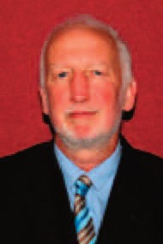
Foreword

Cavan is a great county to live in for many reasons. We can boast a very good quality of life, strong community engagement, and great diversity within our population, all set against a beautiful rural backdrop and clean environment. But we believe we can make it an even better place for the people who live here. We want to ensure that it is a great county for everyone to live in, whatever age they are. And we particularly want to ensure that the voices of older people are the prominent ones in decision-making about services and developments that affect them.

That is why I am delighted to present the Cavan Age Friendly County strategy, on behalf of
the Cavan Age Friendly Alliance. Formally established in early 2012, the Alliance is made up of senior people in public sector agencies, working closely with older people’s representatives
and other supporting organisations such as the Ageing Well Network, Netwell Centre and
Department of Health.

Over the past year, we have worked jointly to develop this strategy. The document is based on research gathered from a range of sources, including consultation sessions with older and younger people, surveys of older people and service providers, physical audits, interviews and focus groups. It has been developed with support from the Cavan 050 network, a county wide network of older people’s organisations, and other groups representing and working with older people in Cavan.

Publishing this document is a very significant step for us because it commits all of the partners involved to delivering on specific actions within a given timeframe.

Statistics both nationally and globally tell us that populations are ageing because people are living longer, healthier lives. We can expect significant demographic changes in the coming years, with unprecedented increases in the older populations anticipated. In Cavan, our population of older people has increased by 13.45 per cent in the space of 9 years, rising from
7,815 in 2002 to 8,866 in 2011. And we can expect further growth in the number of older people. In Cavan we want to be prepared for the future, for higher levels of demand on services, and for higher expectations among older people to be involved at community level, to be engaged with service providers and to be heard.

Being Age Friendly will mean that Cavan will strive to have fully accessible buildings, enhance opportunities for older people to engage with their communities, and overall a positive attitude will be developed towards ageing. It will also mean that older people in the county will understand and value the potential contribution older people can make to their communities.

We have already made great progress in enhancing the physical accessibility of the county through forging links with disability groups and in setting high standards for ourselves to be inclusive and accessible. There are some obvious complementarities between the work we have achieved so far with support from disability groups, and the work that is now planned with older people through the Age Friendly Strategy. But this new strategy, in having a focus on older people and in covering the 8 themes of the World Health Organisation’s programme,
will help us push the bar out even further in creating a county that is fully inclusive of all communities. Underpinning this is the longer term ambition to “be the best” in Ireland and to attract increased numbers of older visitors to Cavan. It will help us to achieve recognition as a county that prioritises equality, fairness and respect among our core values and we will be renowned as a county that is sensitive and responsive to the issues at the hearts of our diverse communities.

Jack Keyes
County Manager

Introduction ....................................................................................................... 1

Theme 1 Outdoor Spaces and Buildings .................................................. 7
Action 1.1 Age Friendly Buildings and Public Spaces ..................................................... 8
Action 1.2 Recreation and Amenity Areas ......................................................................11
Action 1.3 Age Friendly Local Communities .................................................................. 13

Theme 2 Transportation ........................................................................... 15
Action 2.1 Improved transport facilities countywide ....................................................... 16

Theme 3 Housing ...................................................................................... 18
Action 3.1 Enhanced Links with An Garda Síochána .................................................... 19
Action 3.2 Research on safety and security at home .................................................... 21
Action 3.3 Greater access to home support information................................................ 22

Theme 4 Social Inclusion ......................................................................... 24
Action 4.1 Creation of the Cavan Older People’s Forum ............................................... 25
Action 4.2 Delivery of the GAA Social Initiative in Cavan .............................................. 27
Action 4.3 Raise awareness across the public sector ................................................... 29
Action 4.4 Development of Men’s Sheds in County Cavan ........................................... 30
Action 4.5 Research on loneliness and isolation ........................................................... 32

Theme 5 Social Participation ................................................................... 33
Action 5.1 Opportunities to learn Information Technology skills .................................... 34
Action 5.2 Interactions at community level .................................................................... 36
Action 5.3 Participation in social, cultural and community activities .............................. 37

Theme 6 Communication & Information ................................................. 39
Action 6.1 Awareness raising about the Age Friendly approach ................................... 40
Action 6.2 Information supports for older people at home ............................................. 42
Action 6.3 Citizens Information Programme .................................................................. 44

Theme 7 Civic Participation ..................................................................... 45
Action 7.1 Garda Schools Programme .......................................................................... 46
Action 7.2 Participation of retired staff ........................................................................... 47
Action 7.3 Engagement with private sector ................................................................... 48
Action 7.4 Development of an Age Friendly Business Forum........................................ 49

Theme 8 Community Support and Health............................................... 50
Action 8.1 Research on the Doctor on Call Service....................................................... 51
Action 8.2 Implement national programmes to improve health outcomes ..................... 52
Action 8.3 Increased focus on preventative care ........................................................... 53
Action 8.4 Review of acute care pathways and outpatient referrals .............................. 54
Action 8.5 Targeted health promotion activities ............................................................. 55
Action 8.6 Telecare and telehealth initiatives ................................................................. 56

The way forward .................................................................................................... 57

Appendix A ..................................................................................................... 58

Introduction

This is the first Age Friendly Strategy for County Cavan. It is a strategy that gives commitments to improving key areas of infrastructure, services, information, and
our overall social response to older people’s issues in Cavan.

The strategy has been developed by the Cavan Age Friendly Alliance in consultation and co-operation with older people in Cavan. The Alliance was formally established in early 2012. It is made up of senior personnel in public
sector agencies, older people’s representatives and other organisations that

promote a positive approach to ageing.

Members are:

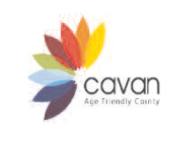


• Cavan County Council (County Manager)

• Health Service Executive (North East Area Manager)

• An Garda Siochana (Chief Superintendant for Cavan Monaghan)

• Cavan County Development Board (Cathaoirleach)

• The Netwell Centre, Dundalk Institute of Technology (Director)

• Ageing Well Network (National AF Programme Manager)

• Department of Health (Strategy Development Unit)

• Gaelic Athletics Association (Social Initiative)

• Cavan Monaghan Vocational Education Committee (Chief Executive Officer)
• Cavan 050 Network / Cavan Older Person’s Forum (Chair and individual members)

Each of the Alliance members has given commitments in this strategy that will significantly help to improve the quality of life of older people in Cavan in the
coming years.

An Age Friendly county has been described by the Ageing Well Network as a county that recognises the great diversity among older people and promotes their inclusion in all areas of community life. It is a county that respects their decisions and lifestyle choices and anticipates and responds related needs and preferences.

flexibly to ageing

Our ambition to be Age Friendly means that Cavan will:

• Become one of the greatest places to grow old in.

• Have easily accessible public buildings, shops and services;

• Incorporate older people’s views into significant decisions being made about the county;
• Promote a positive attitude to ageing and address stereotypes about older people;
• Create opportunities for older people to be engaged with their county socially, as employees and as volunteers.

This is a far-reaching strategy with 29 actions that will be delivered by 15 organisations over the three year period. Many of the actions will have a very tangible impact on the county, while others, such as those relating to awareness-raising work, will be more subtly felt.

Background

Before the Cavan Age Friendly Alliance was established, a network of older people’s organisations called the Cavan 050 Network was active in researching older people’s issues in Cavan. Its members have been powerful advocates of the ‘Age Friendly’ message and the importance of the older person’s voice in local developments. 050 members were supported in this work by Breffni Integrated Limited and by Age and Opportunity’s ‘Get Vocal’ Programme.

Research and consultation included:

• Surveys of older people

• One-to-one interviews

• Focus groups

• Physical audits of towns
• Broad consultation sessions

• Interviews with Alliance members

• Survey of service provider organisations

As a result of the research and data collection that has taken place through the

050 Network, there is a documented trail of issues faced by older people in the

county. issues.

Older people also provided creative suggestions for resolving these

Both the issues and the suggestions were collated and presented to

agencies involved in the Alliance.

Actions were subsequently developed with the

agencies in response to the issues raised. Because of the richness of these data, we are confident that this strategy is based on evidence of need.

Why we are adopting an age friendly strategy?

Statistics both nationally and globally tell us that populations are ageing as people are living longer, healthier lives. The Department of Health notes that by the year 2021, the number of older people1 living in the State is expected to increase to 775,000, representing an increase of 55 per cent in 11 years. In Cavan, our population of older people has increased from 7,815 to 8,866 in a ten
year period (13.45%).

The World Health Organization has been carrying out important work in this area through its ‘Age Friendly Cities’ programme. This programme is part of an international effort to address environmental and social factors that contribute to active and healthy ageing. The programme helps cities and communities to become more supportive of older people by addressing their needs across eight
themes:

• The built environment

• Transport

• Housing

• Social participation

1 This definition is based on aged 65 and over.

• Respect and social inclusion

• Civic participation and employment

• Communication, and

• Community support and health services.

In Cavan, we want to be prepared for the future.
We recognise that our

population of older people is increasing year on year, and that there will be

increasing demand on services into the future.

We also recognise that older

people today have higher expectations to be involved, to be heard and included. While it is necessary to plan for services, we are also focusing on the opportunities that an ageing society brings. Older people are a resource for their
communities and their inclusion will enrich the whole community.

Age Friendly work is taking place in many parts of Ireland. Nationally, the Age Friendly Counties Programme is being supported by the Ageing Well Network. Regionally, Cavan is linking with partner counties in Louth, Meath, Fingal and
Monaghan.

National Policy on Ageing

There are various policy documents of relevance to this area of work. Key among them is the National Positive Ageing Strategy which is soon to be published by the Department of Health. The Strategy will provide the blueprint for planning for an ageing population in Ireland into the future.

Another key policy document is the National Action Plan for Social Inclusion (2007-2016) ‘Building an Inclusive Society’, which is structured around a lifecycle framework with older people as a core category. High level goals for older people focus on community care and income support.

Other pertinent policy documents include the National Carer’s Strategy (2012)

and the National Dementia Strategy (forthcoming).

Numerous health-related

policies are also relevant, among them the national policy on elder abuse arising from the Report of the Working Group on Elder Abuse, Protecting Our Future (2002) and the 2009 Review of that Report, the Nursing Home Support Scheme, Fair Deal introduced in the Nursing Home Support Scheme Act 2009, and the standards, regulation and inspection of nursing homes introduced in the Health
Act 2007.

Outcomes-based planning

The Cavan Age Friendly Alliance will seek to ensure that this strategy achieves measurable outcomes for older people that demonstrate improvements in their quality of life. To guide us in this ambition, we will use an outcomes-based planning approach based on the framework developed by the Ageing Well
Network.

This approach begins with the end in mind and then determines the actions and activities, the means, which will best achieve that end. By beginning the planning process with broad outcomes, it quickly makes it clear that no one agency on its own can improve these outcomes, but that progress requires various agencies to contribute and work collaboratively in a creative way to improve the lives of older people. It therefore challenges the ‘silo’ approach to planning which encourages agencies to focus solely on what they see as their core roles and responsibilities rather than appreciating how they can contribute in a broader sense to the
achievement of a range of outcomes.

This approach will also allow the Alliance to demonstrate progress in implementing its action plan - to show that it is ‘making a difference’- by identifying relevant ways of measuring progress and tracking these indicators over the lifetime of the action plan. This is an increasingly important

consideration as resources have become scarcer and there is a more pressing need to account for their effective use.

Finally, the approach brings the needs of older adults right to the core of the planning process and ensures their views, opinions and experiences are given serious consideration in the planning process used by the Alliance.

‘Outcomes’ for older people in this context will mean that they:

1. Are valued as individuals for their unique life experiences and have meaningful opportunities to shape and enhance the communities in which they live;
2. Have opportunities for civic, social and economic participation and life- long learning;
3. Are supported to stay living in their own homes and connected to their communities;
4. Lead healthier and active lives for longer;

5. Are able to get to where they want to go, when they want to go;

6. Live in places where the social and physical environments are conducive to being out and about;
7. Feel and are safe in their own homes and their communities;

8. Have the required information and communications to support them achieve these outcomes.

In order for this approach to work it is important that policies, strategies and services are based on a positive ageing approach that is informed by the needs of older adults and evidenced from research.

Each action will contribute to the achievement of one or more of the above- named outcomes. Various data sources will enable us to track change in these outcome areas including but not limited to those listed in Appendix A.
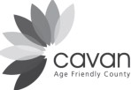

"There are some issues with accessibility to many of the public buildings and...in addition to this traffic was identified as an issue in both areas...certain aspects of the physical infrastructure were rated as unsatisfactory in both pilot areas such as footpaths and pedestrian crossing...Certain facilities are lacking in both areas, such as public toilets, community areas/village greens, and public seating and a lot of amenities seem to be outside the town, where accessibility can pose a problem."
Theme 1 Outdoor Spaces and Buildings

Action 1.1
Age Friendly Buildings and Public Spaces

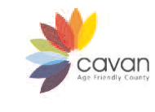
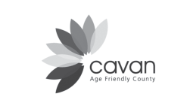

Issues Raised by Older People
Accessibility of streets and public buildings in towns and villages.
The physical environment in urban areas needs Age Friendly design (Pedestrian Crossings, pavements, seating).
Need for greater awareness of the concepts of universal design.
Limited library services in some rural area and no mobile library service. Seating and shelters needed at bus stops.

Action 1.1
Ensure an Age Friendly approach is embedded in all future capital projects including:
• Consultation with older people in specific urban areas – circulation of Part 8 information to older person’s representative forum.
• Provision of additional seating as per universal design guidelines.
• Training for planners on Age Friendly communities prior to the drafting of the new
Development Plan.
• Training for staff on Age Friendly housing issues.
• Apply Poverty Impact Assessment approach to new developments.
• Development of Age Friendly Guidelines for all new build projects.
• Enforcement of legislation regarding accessible streetscapes (eg removal of sandwich boards, signage, hoardings).
• Library infrastructure improvement including new building for Belturbet Library and mobile library.
• Explore options around providing Age Friendly seating and shelters as bus stops.

Output
Improved accessibility of streets in towns and villages for people with limited mobility. Buildings and public spaces are more accessible and age friendly.
More accessible environment.
Research to identify mobile library route.
Mobile library services available in areas of the county not currently served by library facilities. New library facility in Belturbet.
Physical access improvements to part time libraries. Increase in bus shelters.
Increase in public seating.

Lead Partner
Cavan County Council

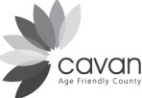

Support Partner
Architects I Planners I Engineers I Access Officers etc. Belturbet Development Association
Cavan Older Person's Forum Community and Voluntary Sector CRAIC Advisory Group I Access Officer International Fund for Ireland
Irish Prison Service I Loughan House

Indicator
Number of changes in the physical environment (seats installed, pavements dished, traffic lights installed etc.).
Number of staff who receive training.
Physical changes to library infrastructure.
Data on the number of older people using the library service. Increase in number of bus shelters.
Increase in number of public seats.

Supports Outcome Number | 2. Have opportunities for civic, social and economic  participation and life-long learning.  5. Are able to get to where they want to go, when they want to go.  6. Live in places where the social and physical  environments are conducive to being out and about.
Timeframe I key milestones | Consultation with older people- new policy for section  heads produced in 03 2013.  Training for planners and other staff Q4 2013. Poverty Impact Assessment checklist 2014. Age Friendly Guidelines for new builds 2014. Belturbet Library 04 2013.  Mobile Library- longer term.  Enforcement of legislation- starting 2013.  Explore development of bus shelters- by end of 2015. Produce a Poverty Impact Assessment checklist by 2014.

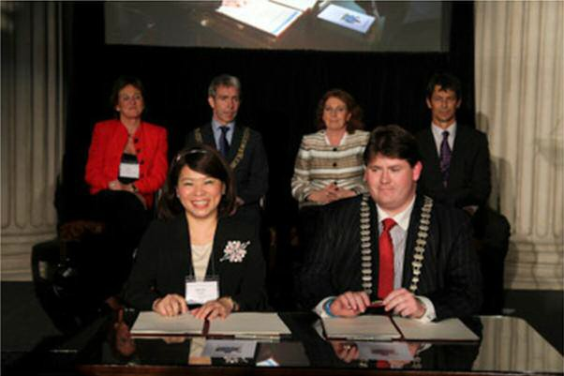
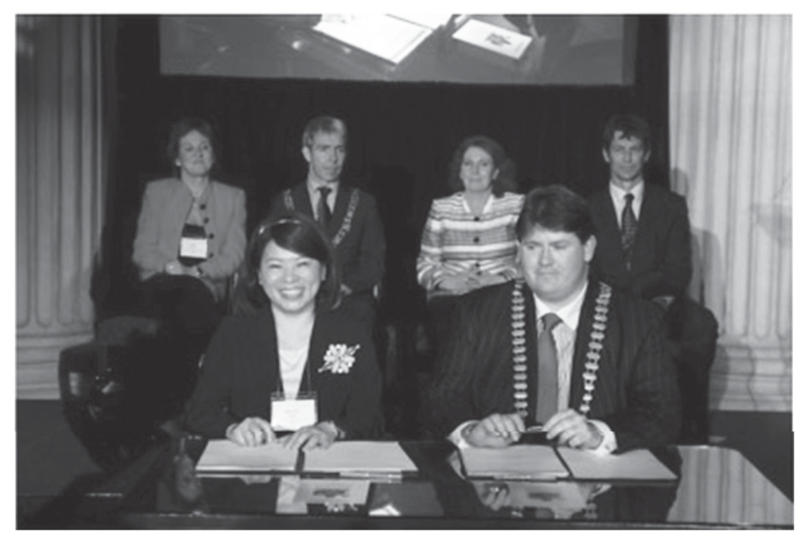

CCllllrr.. SSeeaann MMccKKiieerrnnaann ffrroomm CCaCaavvaann iinn tthheee pprreesseennccee ooff ((ll--rr)) AAnnnnee CCoonnnnoollllyy,, AgAgeigeeiingng WWelelll NNetetwwoorrkk,, MMaayyoorrr oooff DDublubliinn AnAnddrreeww MMoonnttaagguuee,, MMiinniisstteerr KKaatthhlleeeenn LLLyyynncncnnccchhh aaandndnd ttthhheee WWWHHHOOO DDDiiirrreeeccctttorooororrr JJJohnohnohn BeBeaarrdd ssigignniinngg tthhee hhiissttoorriicc DDuuubblliinn DeDDeeccllaarraattiioonn oonn bbeehhaallff ooff CCaavvvaann
CoCCoouunnttyy CCoouunncciill..

Cllr. Sean McKiernan from Cavan in the presence of
(l-r) Anne Connolly, Ageing Well Network, Mayor of Dublin Andrew Montague, Minister Kathleen Lynch and the WHO Director John Beard signing the historic Dublin Declaration on behalf of Cavan County Council.
The need for more recreation areas & parks.

Action 1.2
Development and enhancement of recreation and amenity areas to include:

• Development of Castlesaunderson as a landmark intergenerational public facility.
• Development of Green Lough Park.
• Development of Abbeylands Park.
• Development of a river walk in Cavan town including boardwalk.
• Development of bowling greens.
• Development of outdoor gym at Halton’s site in Cootehill.
• Development of bye-laws for public parks.
• Policy and actions around responsible dog ownership.

Output
Age Friendly design of public park areas to incorporate walking routes, signage and seating areas.
Funding sourced for new Age Friendly developments.

Lead Partner
Cavan County Council

Support Partner Business sector Cavan 050 Network
Cavan Community Resilience Cavan Multicultural Network Cavan Tidy Towns
Coillte
Community groups
Cootehill Development Association
LEADER Scouting Ireland

Indicator
Number of amenity spaces developed. Area size of amenity space developed.
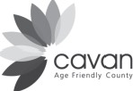

Supports Outcome Number | 4. Lead healthier and active lives for longer.  6. Live in places where the social and physical environments are conducive to being out and about.
Timeframe I key milestones | Castlesaunderson - ongoing from 2013.  Green Lough - completed by 2013. Abbeylands Park (funding dependent). River walk (funding dependent). Bowling green 2014.  Halton's site 2014.  Development of bye-laws for public parks Q1 2013. Policy on dog ownership- from 2013.

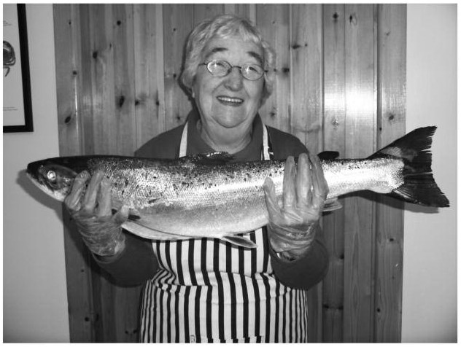
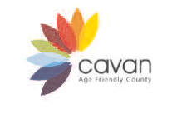
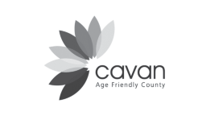
Lack of public toilets in certain areas. Certain public buildings are underused.
Access to and ease of use of key services in the community (banks, shops, restaurants).

Action 1.3
Work with further towns and villages to carry out Age Friendly audits, to include training of older people and communicating findings of audits.
Open up the use of existing buildings and spaces, including:
• Linking with businesses and community groups to identify opportunities for making toilets available to the public.
• Explore opportunities for using a National Recognition Symbol for Age Friendly services
(Ageing Well Network).
• Deliver an awareness programme through the Chamber of Commerce with the service sector.
• Make approaches to public sector bodies regarding the use of public buildings by older
people’s groups.

Output
Provide training for local communities in how to undertake audits. Complete audits in Gowna and Ballinagh.
Respond to a need for audits in other areas of Cavan (East / North West). Toilet facilities available to the public in towns and villages around the county.
Local businesses and services will have increased understanding of the needs of older people and improve customer service for this group.
Day care centres and other public buildings to be opened up to use by other groups / on
additional days.

Lead Partner
Cavan 050 Network

Support Partner Business community Cavan County Council
Cavan Older Person’s Forum Chamber of Commerce Community and Voluntary Groups
Department of Education (schools) Department of Health (day care services) GAA / Rugby Clubs
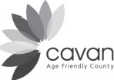
• Number of older people trained to carry out audits.
• Number of audits completed.
• Number of services providing toilet facilities to the public.
• Number of businesses in Cavan awarded the National Age Friendly recognition symbol.

Supports Outcome Number | 1. Are valued as individuals for their unique life experiences and have meaningful opportunities to shape and enhance the communities in which they live.  3. Are supported to stay living in their own homes and  connected to their communities.  6. Live in places where the social and physical environments are conducive to being out and about.
Timeframe I key milestones | May 2013 Audits completed Gowna & Ballinagh. Remaining sub-actions ongoing from 2013.

"... a large proportion of those who took part in this study do not have their own independent means
of transport. Yet living in a rural county such as Cavan, some form of transport is nearly always necessary simply to get to the shops, the pharmacy and the post office, to go to hospital and doctor's appointments, to take part in social and leisure activities, to meet up with friends, and to get to mass.
Those without their own means of transport are therefore dependent on an inadequate and patchy mixture of public transport, private transport, community/rural bus schemes and lifts from family and neighbors."

Theme 2 Transportation

Action 2.1
Improved transport facilities countywide

Issues Raised by Older People
Transport is very limited in the county.
Some areas have no access to public transport.
Taxis are the only option in some areas and they are very expensive and some taxis will not operate in very rural areas.
Interconnectivity - people living on the outskirts of town have no access to transport.
Some older people are unable to get to events and activities taking place locally.

Action 2.1
Establish transport committee to examine the following:
• Integrated transport services to make better use of school and HSE buses.
• Urban transport route (loop around Cavan town).
• Increased availability of information about CART services (eg using church newsletters).
• Piloting of additional rural transport services.
• Explore hospital link service.
• Review and seek to expand volunteer car scheme.
• Encourage community groups to make sure that transport is available to community events.

Output
Increase in frequency and volume of transport options available to older people. Increased passenger numbers.
Greater availability of transport in rural parts of County Cavan.
Discounts for older people.
Increase in number of older people being able to attend local events.

Lead Partner
Cavan and Monaghan Age Friendly Alliances – Transport Working Group

Support Partner Bus Éireann CART
Cavan 050 Network / Cavan Older Person’s Forum
Cavan County Council
Community and voluntary groups
Dept of Education and Cavan Monaghan VEC Health Service Executive
National Transport Authority Private transport operators Community and Voluntary Forum An Garda Siochana

Indicator
Increase in number of passengers. Increase in number of routes. Increase in areas of coverage.
Number of community and voluntary groups targeted with information. Evidence of community events incorporating transport.

Supports Outcome Number | 4. Lead healthier and active lives for longer.  5. Are able to get to where they want to go, when they want to go.
Timeframe I key milestones | Transport working group established 2013.  All actions to be completed by end 2015.

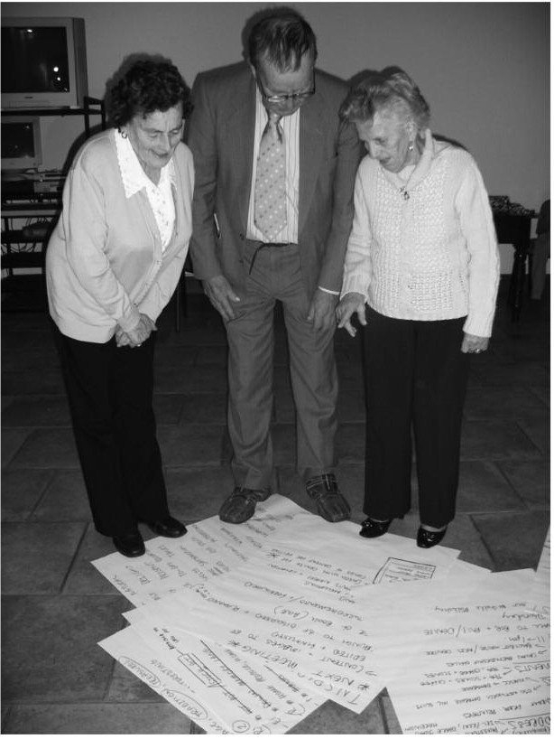

"...participants spoke of a great fear of being broken into and robbed. This fear and vulnerability was particularly notable in West Cavan, where at the time of writing, there was
a recent spate of robberies.
While a number of

participants have installed alarms - often with financial assistance from their families- a number spoke of not being able to afford to do so."

Theme 3 Housing

Action 3.1
Enhanced Links with An Garda Síochána

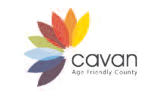

Issues Raised by Older People
Personal safety & security concerns.
Lack of knowledge about very marginalised older people who currently have no links with
Community Policing.
Feeling unsafe at home, in particular those living alone.
People want to live in their own homes for as long as possible. Isolation in the home and fear of living alone.

Action 3.1
Improve communication between An Garda Síochána and older people including:
• Develop station / district registers of older people (with consent) as a means of supporting engagement by community Gardaí.
• Deliver Community Policing Clinics in locations where older people meet.
• Garda talks on keeping safe at home for older people’s group.
• Introduce on a pilot basis the ‘Crime Prevention Ambassadors’ Initiative.
• Expand and promote Garda supported Community Alert / Neighbourhood Watch initiatives.

Output
Raise awareness of basic crime prevention measures.
Reduce perception of fear and provide practical information and safety advice. Greater knowledge among Gardaí of older people living alone in the community. Increase numbers on older persons registers.
Increase confidence and reduce perception of fear among older people. Allow Gardaí greater local knowledge of vulnerable older people. Opportunities to raise specific issues at local level with local Gardaí.
Older people will feel safe living in their own homes and in contact with their communities.

Lead Partner
An Garda Síochána

Support Partners
Cavan Older Person’s Forum
Community Forum Muintir na Tire Residents Groups TASC

Indicator
Increase in number of older people on station registers. Number of clinics delivered.

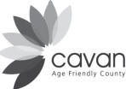
1 Pilot scheme introduced.
Number of older people volunteering. Number of older people benefitting. Number of schemes in operation.
Number of older people involved in the schemes. Number of talks.

Supports Outcome Number | 2. Have opportunities for civic, social and economic  participation and life-long learning.  6. Live in places where the social and physical environments are conducive to being out and about.  7. Feel and are safe in their own homes and their communities.
Timeframe I key milestones | Station I District registers- completed by early 2013 and  thereafter subject to quarterly reviews.  Community Policing Clinics- quantify the number of clinics delivered by end of 2013.  Crime Prevention Ambassadors- pilot to be reviewed after  30 June 2013.  Community Alert I Neighbourhood Watch - review number of new schemes established at end of 2013.

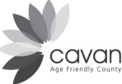
Action 3.2 Research on safety and security at home

Issues Raised by Older People Feeling unsafe at home. Perception of risk of crime.
People want to continue living in their own homes.
Perception of anti social behavior.

Action 3.2
Postgraduate research on safety and security issues with recommendations for service enhancement.

Output
Research study with older people in Cavan and Monaghan.

Lead Partner
Cavan and Monaghan County Councils and the Netwell Centre

Support Partners
Community Alert I Neighbourhood Watch Cavan and Monaghan Older Person's Forum An Garda Siochana
Community and voluntary sector
All Alliance members

Indicator
1 research document.
Recommendations for An Garda Siochana and local organisations.

Supports Outcomes | 3. Are supported to stay living in their own homes and  connected to their communities.  6. Live in places where the social and physical environments are conducive to being out and about.  7. Feel and are safe in their own homes and their communities.
Timeframe I key milestones | Studentships awarded by March 2013.  Initial research findings by September 2014. Postgrad qualification completed by 2015.

Action 3.3
Greater access to home support information

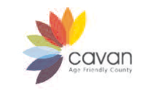

Issues Raised by Older People
Only a minority of older people are accessing particular services (such as home help, meals on wheels, grants for housing repair, Public Health Nurse, Occupational Therapy).
Personal safety concerns.

Action 3.3
Create greater access to information about services (home help, meals on wheels etc) through the following:
• An Information booklet.
• Talks.
• Information fair for older people.
• Awareness raising programme on accessing and using personal alarms and pendants.
• Raise awareness of the Senior Helpline.
• Raise awareness of bereavement supports available and promote them in rural communities.

Output
Greater awareness of various home support schemes. Increased uptake on personal alarm scheme. Increased uptake of meals on wheels, etc.

Lead Partner
Cavan Older Person’s Forum (Local Older People’s Groups)

Support Partner Cavan 050 Network Community Forum
Health Service Executive
Muintir na Tire

Indicator
Increase in the ownership of personal alarms by older people in Cavan. Numbers accessing home help.
Numbers using Meals on Wheels services. Number of talks/events.
Distribution of leaflets. Numbers attending events.
Number of groups/individuals targeted with information.

Supports Outcome Number | 2. Have opportunities for civic, social and economic  participation and life-long learning.  3. Are supported to stay living in their own homes and connected to their communities.  8. Are able to get to where they want to go, when they want to go.
Timeframe I key milestones | January to June 2014

Unprompted, participants

offered comments such as: "The nights are very long"; "I dread Christmas" and "the weekends are very lonely".

Theme 4 Social Inclusion

Action 4.1
Creation of the Cavan Older People’s Forum

Issues identified
The need for county-wide representation of older people and a mechanism for ongoing consultation.
The need for a ‘one stop shop’ model for access to information of relevance to older people.

Action 4.1
Creation of the Cavan Older People’s Forum.
Creation of an Age Friendly County website to become a central information hub for older people in Cavan.

Output
Expansion of the Cavan 050 Network to become the Cavan Older People’s Forum, with 050 acting as the executive. Broader representation on the network to include individuals, day care centres, nursing homes, advocacy groups, service providers, remote geographic areas. Creation of new content for the regional Age Friendly website.
Demonstrations of website at meetings of older people.

Lead Partner
Cavan 050 Network

Support Partners
Cavan and Monaghan Age Friendly Information and Communication Working Group
Breffni Integrated Limited
CAMCAS Carers’ groups
Cavan Age Friendly Alliance Community and Voluntary Forum County Development Board
Social Inclusion Groups

Indicator
Establishment of the Forum.
Increase in number of older people participating in county structure. Data on website usage and impact.

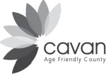

Supports Outcome Number | 1. Are valued as individuals for their unique life experiences and have meaningful opportunities to shape and enhance the communities in which they live.  8. Have the required information and communications to support them achieve these outcomes.
Timeframe I key milestones | Older Person's Forum to be established by April 2013.  Information and Communication subgroup established by  March 2013.

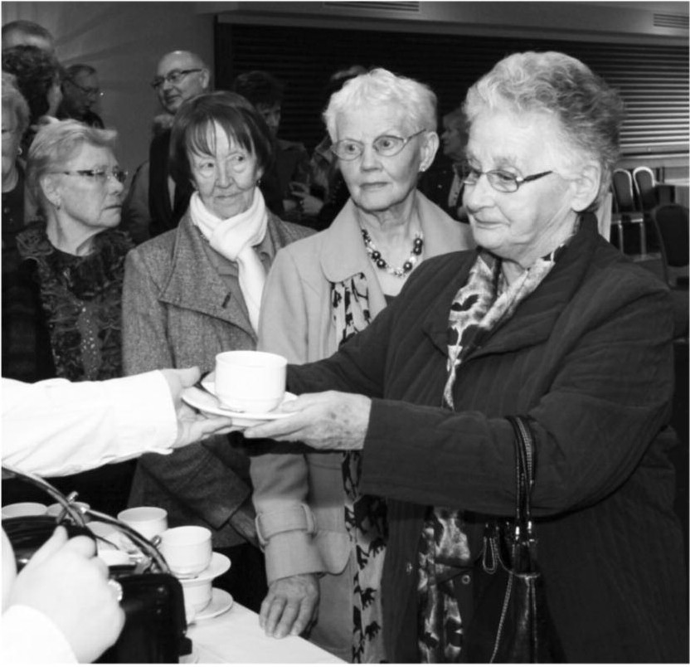

Action 4.2
Delivery of the GAA Social Initiative in Cavan

Issues Identified
The GAA Social Initiative had its genesis in the observations of then President Mary McAleese of a dearth of older men at events she attended across the island of Ireland. It has grown from a small pilot project in 2009 involving GAA clubs across four counties to one of the Association’s flagship community outreach projects. While its core focus remains reaching out to and enriching the lives of older men experiencing isolation and loneliness, it aspires to ensure GAA clubs offer opportunities for all older members of our communities to engage with their clubs for the betterment of all concerned. It is managed through the GAA Community &
Health Promotion section.

Similar issues identified by older people in consultation for this strategy were isolation, loneliness and lower participation rates by men.

Action 4.2
Continue to roll out the GAA Social Initiative across clubs in Cavan and support those already engaging with it.

Output
Assist clubs to actively engage with and reach out to all those experiencing isolation in their communities, especially the hard to reach cohort of isolated men living alone.
Coordinate and organise club events specifically designed to attract and cater for older members. Facilitate car pooling and arrange volunteer lifts to such events/home games. Encourage cross-generational interaction through in the GAA Social Initiative in Cavan. Link with other GAA Social Initiative clubs in Cavan and beyond.
Feed into Provincial and National Social Initiative events.
Assist clubs in organising GAA Social Initiative events such as drama performances and excursions to the GAA Museum/Croke Park.

Lead Partner
Gaelic Athletics Association

Support Partners
Local clubs
Local communities
Local community transport providers

Indicator
Number of clubs participating: 10. Number of older men benefitting.

Supports Outcome Number | 2. Have opportunities for civic, social and economic participation and life-long learning.  4. Lead healthier and active lives for longer.
Timeframe I key milestones | Events at club level: Ongoing throughout 2013.  County Cavan Social Initiative meeting for participating/interested clubs Q2 2013.  Running of provincial event with Cavan Social Initiative participation by Q3 2013.  6 Cavan clubs to host the GAA Social Initiative play 'For  Club & County' by the end of April 2013.

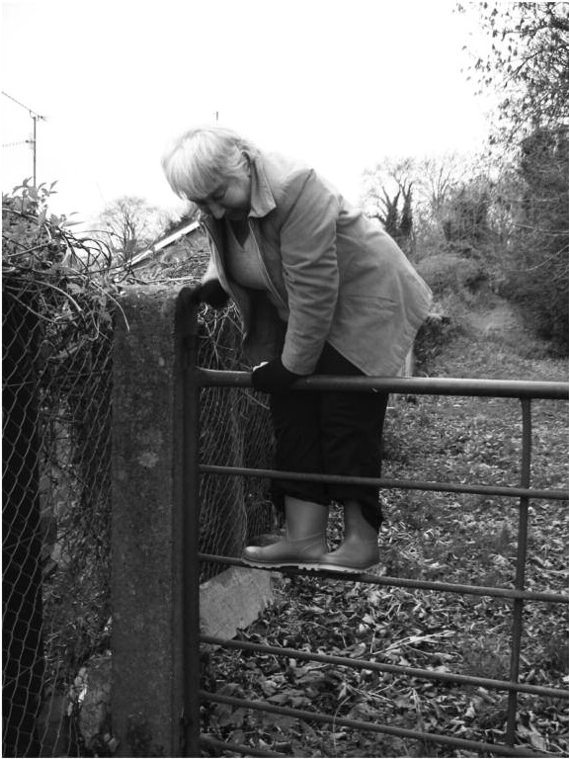
Action 4.3 Raise awareness across the public sector

Issues identified
Stereotyping, ageism and assumptions of need (for instance assuming older people are hard of hearing).

Action 4.3
Awareness raising programme for staff in public sector agencies:
• Agewise training.
• Publications.
• Ensuring that all public sector agencies specifically involve older people in consultation on any new programme or policy.

Output
Service provider organisations and community groups to have a better understanding of older people's issues.

Lead Partner
Cavan Age Friendly Alliance

Support Partners Public sector agencies Community Forum

Indicator
Number of staff undertaking training.
Number of elected members undertaking training. Number of agencies taking up training opportunities.

Supports Outcome Number | 1. Are valued as individuals for their unique life experiences and have meaningful opportunities to shape and enhance the communities in which they live.
Timeframe I key milestones | January 2013 to December 2015.

Action 4.4
Development of Men’s Sheds in County Cavan

Issues Raised by Older People
Loneliness & Isolation.
Lack of opportunities for older isolated men to participate in activities. High rate of mental health issues.
High rates of suicide among men.

Action 4.4
Establish a number of Men’s Sheds Projects in County Cavan.

Output
Participation of older men in community activity. Improved quality of life.
Improved mental health.
Opportunities for men to find out about and access services.

Lead Partner
Cavan Monaghan VEC

Support Partners
Community & Voluntary Forum
Cavan County Council
Cavan Older People’s Forum
HSE LEADER
Breffni Integrated Ltd.

Indicator
Number of men’s sheds established. Number of men participating.
Specific projects (such as health talks). Funding accessed for men’s sheds.
To establish 3 men’s sheds.
Number of men participating: 15 per shed.
Funds accessed: Peace Funding, Community Forum, Cavan VEC, Ireland Funds.

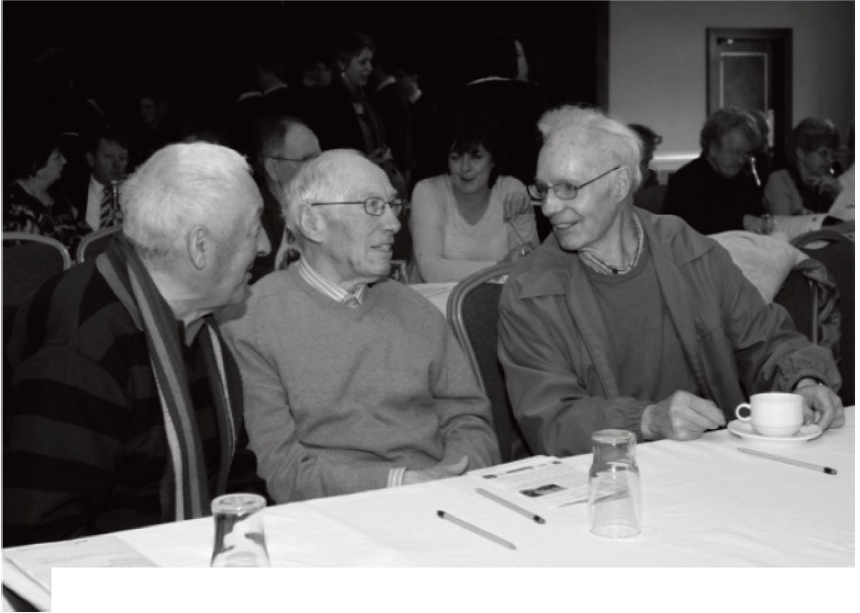

Supports Outcome Number | 1. Are valued as individuals for their unique life experiences  and have meaningful opportunities to shape and enhance the communities in which they live.  2. Have opportunities for civic, social and economic participation and life-long learning.  3. Are supported to stay living in their own homes and connected to their communities.  4. Lead healthier and active lives for longer.  6. Live in places where the social and physical environments are conducive to being out and about.  8. Have the required information and communications to support them achieve these outcomes.
Timeframe I key milestones | Establish 1 shed per year, from 2013 to 2015.

- --
Action 4.5 Research on loneliness and isolation

Issues Raised by Older People
Loneliness and isolation.

Action 4.5
Research on loneliness and isolation to document issues and make recommendations.

Output
Research findings and recommendations to address loneliness and isolation.

Lead partner
The Netwell Centre
Cavan and Monaghan County Councils

Support Partners
050 Network
Older Person's Forum Community and Voluntary Sector All Alliance members

Indicator
1 research document with recommendations for service improvement.

Supports Outcome Number | 3. Are supported to stay living in their own homes and  connected to their communities.  4. Lead healthier and active lives for longer.  7. Feel and are safe in their own homes and their communities.
Timeframe I key milestones | Studentshps awarded by March 2013.  Initial research findings by September 2014. Postgraduate qualification completed by end 2015.

"Many participants in the focus groups felt that some people may be too
shy or intimidated to come and join a group, especially if they have been living alone. The value of actually asking people to join (and perhaps asking them a number of times), of
calling for them or making sure they don't have to walk into the room on their own were all highlighted."

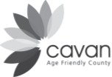
Theme 5 Social Participation

Action 5.1
Opportunities to learn Information Technology skills

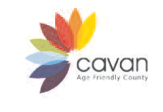

Issues Raised by Older People
Low levels using computer technologies. Few people using texts or emails.

Action 5.1
Classes in the use of technology for social and leisure purposes, to include:
• Skype
• Email
• Internet
• Facebook
• Mobile phones
• Digital cameras

Opportunities for intergenerational learning such as linking with youth clubs to learn how to use computers and mobile phones.

Output
Increase in the number of older people who are comfortably able to use digital technologies for social and leisure interactions.

Lead Partner
Cavan Monaghan VEC

Support Partners
Active Age Groups
Cavan Older Person’s Forum
Day Care Centres
Foroige
Nursing Homes
Positive Age
Secondary Schools (TY Years)

Indicator
To offer a minimum of 4 programmes per year for 4 years, aiming to attract 8 learners per programme (or subject to demand). 128 learners in total.

Supports Outcome Number | 2. Have opportunities for civic, social and economic  participation and life-long learning.  3. Are supported to stay living in their own homes and connected to their communities.  8. Have the required information and communications to support them achieve these outcomes.
Timeframe I key milestones | January 2013- December 2015.

Action 5.2 Interactions at community level

Issues Raised by Older People
Changing communities and the fact that people do not always know their neighbours. Little opportunity to meet people in other communities especially 'new' or ethnic minority communities.

Action 5.3
Create opportunities for older people to interact with other communities, including:
• Use opportunities after church services to bring people together and encourage integration.
• Host an event to support interaction between 'new communities' and older people.
• Explore opportunities for cross border and cross community work with older people especially in rural areas.

Output
Better understanding and integration between established and 'new'/minority communities.

Lead Partner
Breffni Integrated Limited

Support Partner
Cavan Cavan 050 Network Cavan Multicultural Network Cavan Older Person's Forum Ethnic minority groups Interfaith groups
Religious groups
LGBT Community

Indicator
Number of events hosted. Numbers participating.

Supports Outcome Number | 1. Are valued as individuals for their unique life experiences  and have meaningful opportunities to shape and enhance the communities in which they live.  2. Have opportunities for civic, social and economic  participation and life-long learning.  3. Are supported to stay living in their own homes and connected to their communities.
Timeframe I key milestones | 3 events per year.

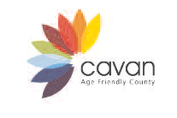
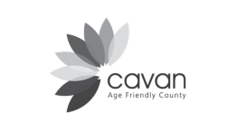
Scope for greater involvement of older people in the arts.
Benefits that accrue to older people from their participation in the arts. Very few activities for men.
Allotments & Community Gardens are a great resource for older people especially men.
Lower levels of older people accessing sporting opportunities.

Action 5.4
Enhancing opportunities for older people’s participation in social, cultural and community activities including:
• Specific initiatives that involve older people in the arts, including but not limited to an annual programme of activities for the Bealtaine Arts Festival.
• Sustaining library programmes and resources relevant to older people (such as workshops,
book clubs, storytelling, creative writing classes, audio books, assistive and adaptive technology). Continuation of block loan scheme for older person’s groups. Monthly coffee morning for people with a visual impairment. Age Friendly library resources and equipment (for example, audio books, zoomtext).
• Sustain existing and develop further allotments & Community Gardens.
• Delivery of specific Sports Partnership programmes to attract older people into sporting activities, such as sports festivals, New Age Kurling Games, Get Active Stay Active 55+, Line Dancing, Ten Pin Bowling, Walking Festival. Dedicated Sports Development Officer for
older people.

Output
Annual Bealtaine programme of events with opportunities for older people to be active as producers and consumers of the arts across a range of media.
Increase in number of older people accessing library services/library events of relevance to older people.
Developments in allotments/gardens.
Increased uptake of community activities by older men.
Increase in the number of older people engaged in sporting activities.

Lead Partner
Cavan County Council
Community Forum

Support Partners
Breffni Integrated (Smallholders Support) Cavan 050 Network
Cavan Arts Office
Cavan County Council

Cavan County Museum Cavan Library Service Cavan Sports Partnership Cavan Town Council Comhaltas
Community Forum
HSE Day Care Centres
Older person's organisations
Positive Age
Private and public nursing homes
Social Inclusion Unit

Indicator
Number of events.
Number of older people engaging in the arts. Number of older people accessing library services. Number of groups taking part in events.
Numbers using community gardens/allotments.
Number of older people taking part in sporting activities.

Supports Outcome Number | 12. Have opportunities for civic, social and economic  participation and life-long learning.  3. Are supported to stay living in their own homes and connected to their communities.  4. Lead healthier and active lives for longer.  6. Live in places where the social and physical environments are conducive to being out and about.
Timeframe I key milestones | Bealtaine -annual festivals in May.  Library programming -ongoing.  Allotments and community gardens- ongoing developments.  Sports Partnership programming- ongoing.

"Local radio is best. A lot of older people listen to the radio between 9 and
12 in the morning. This

tells them local news such as what road is closed and awareness of scams. Church leaflets also give information on the local community. Being part of Positive Age enables people to have access to information; word of mouth is very important. Being involved locally, such as through Tidy Towns groups."

Theme 6 Communication & Information

Action 6.1

Awareness raising about the Age Friendly approach

Issues Raised by Older People
The need to educate the public about the Age Friendly approach.
Language on forms is not user-friendly particularly for those who have literacy issues.
The need for more collaboration between community service providers (Family Resource
Centres, community centres etc.) on older people’s issues.
Complicated information, poor return of calls from service providers, and confusion over who to contact in services.

Action 6.1
Raise awareness of Age Friendly work throughout the county, region and at national level, including displays, presentations and events.
Promote the age friendly approach to community and voluntary groups for example through training and information.
Promote the use Plain English by all service providers.
Produce an Age Friendly Guide to inform service providers of barriers facing older people.

Output
Greater awareness of the Age Friendly process. Improved service delivery to older people.
Cavan Older Person’s Forum to make representation to all Departments about using Plain
English on forms.
Community and voluntary sector to have a better understanding of age friendly issues. Examine and promote NALA guidelines.
Training for service providers in Plain English.

Lead Partner Cavan 050 Network Cavan Community Forum

Support Partners
Cavan Community Forum
Cavan Older People’s Forum
Cavan Age Friendly Alliance

Indicator
Number of Age Friendly displays. Number of presentations.
Number of events.
Publication of guidelines / distribution numbers.

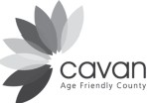

Supports Outcome Number | 1. Are valued as individuals for their unique life experiences and have meaningful opportunities to shape and enhance the communities in which they live.  2. Have opportunities for civic, social and economic participation and life-long learning.  3. Are supported to stay living in their own homes and connected to their communities.  6. Live in places where the social and physical environments are conducive to being out and about.  8. Have the required information and communications to support them achieve these outcomes.
Timeframe I key milestones | End 2013 for awareness raising.  Age Friendly Guide produced in 2014.

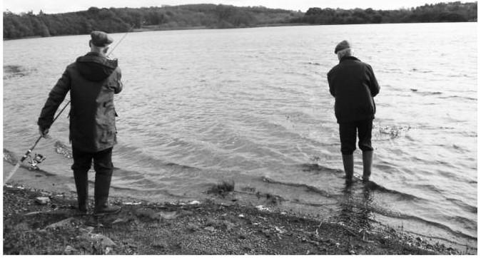

Action 6.2

Information supports for older people at home

Issues Raised by Older People
Lack of information about septic tank charge. Cost of heating - fear of fuel poverty.
Safety and security – rogue tradesmen.
Need for information on services, activities, events at local level.

Action 6.2
Deliver information actions to support older residents to remain in their homes including:
• Produce leaflet on the septic tank charge.
• Information sessions on fuel efficiency for older people’s groups.
• Information on grants for energy saving measures.
• Produce a list of average prices for various capital works.
• Produce a list of contact details for trusted tradespeople.
• Create wider access for older people to information from the local authority (review
Communication Strategy with consideration of texting service, mailshots, social media etc)

Output Information sheet. Media awareness.
Clear and accessible communication.
Older people will be able to manage and reduce the costs of heating their homes. Older people will have comparative price range for different items of work.
Older people can make contact with vetted, reliable tradespeople.

Lead Partner
Cavan County Council

Support Partner
CAMCAS
Environmental Protection Agency Cavan Older Person’s Forum Cavan Community Resilience Cavan Energy Team
Community development groups
An Garda Siochana

Indicator
Distribution numbers of information leaflets. Increase in registration of septic tanks.

Supports Outcome  Number | 3. Are supported to stay living in their own homes and connected to their communities.  8. Have the required information and communications to support them achieve these outcomes.
Timeframe I key milestones | Information leaflet on septic tank charge Q1  2013.  3 Information sessions on fuel efficiency, one per year 2013, 2014 & 2015.  Information on energy saving grants 2014. Prices for capital works 2013.  Contact list for trusted trades people 2013. Review communication strategy 2013.

Action 6.3 Citizens Information Programme

Issues Raised by Older People
The value placed by older people on Citizens Information Service and its outreach facility.

Action 6.3
Introduce a follow-up programme to the pilot scheme where Citizens Information Service, County Cavan, visited older people's groups.
Citizens Information training programme for older people- older people trained in taxation, pensions, form filling etc.

Output
Older people have greater access to information.

Lead Partner
County Cavan Citizens Information Service

Support Partners
Cavan Older People's Forum
County Cavan VEC

Indicator
Five Citizens Information sessions for older persons groups.
Number of older people taking part in Citizens Information Service training programme.

Supports Outcome Number | 8. Have the required information and communications to support them achieve these outcomes.
Timeframe I key milestones | September 2013 to October 2013

"You don't stop participating because you grow old- you grow old because you stop participating - opting out is not an option.
Participators have more influence than non participators."

Theme 7 Civic Participation

Action 7.1 Garda Schools Programme

Issues Raised by Older People
The need to encourage intergenerational respect and promote learning between children and older people.

Actions
As part of the Garda Schools Programme, develop a training module on Age Friendliness aimed at students in Primary and Secondary Schools which will be delivered by the Garda School Officers.

Establish an Action Group comprising of representatives from An Garda Siochana, Dundalk IT (Netwell Centre), Monaghan Community Forum Support, Youth Work Ireland and the Teaching Profession.

Output
Challenge stereotypical images and concepts of ageing. Encourage a positive culture around ageing.
Encourage transfer of wisdom and knowledge. Promote intergenerational activities.

Lead Partner
An Garda Siochana

Support Partner Netwell Centre (DkiT) Comhairle na nOg Cavan Monaghan VEC

Indicator
Number of school participating in the training module. Number of students participating in the training module.

Supports Outcome Number | 1. Are valued as individuals for their unique life experiences  and have meaningful opportunities to shape and enhance the communities in which they live.
Timeframe I key milestones | Project completion by September 2013.

Action 7.2 Participation of retired staff

Issues Raised by Older People
Older people want opportunities to participate in civic life.

Actions
Support for Age Friendly workplaces.
Encouraging retired staff to be involved in projects. Mentoring of staff approaching retirement.

Output
Create opportunities for retired staff to engage with the workplace, leading to skills transfer and positive roles models of older people.

Lead Partner
Cavan County Council

Support Partner
County Enterprise Board

Indicator
Number of retired staff participating in projects.
Number of staff receiving mentoring as they approach retirement.

Supports Outcome Number | 1. Are valued as individuals for their unique life experiences  and have meaningful opportunities to shape and enhance the communities in which they live.  2. Have opportunities for civic, social and economic  participation and life-long learning.  4. Lead healthier and active lives for longer.
Timeframe I key milestones | End of2013.

Action 7.3 Engagement with private sector

Issues Raised
Contribution of the private sector to the Age Friendly County Process. The need for incentives for older people to be out and about.

Actions
Develop a corporate social responsibility action with a private sector company.
Work with local businesses to provide incentives for older people (for example special offers in shops and restaurants) in collaboration with CART schedules.

Output
Action with a private sector firm.
Incentives for older people to be out and about.

Lead Partner
Ageing Well Network and Cavan Age Friendly Alliance

Support Partners
Businesses
CART
Cavan County Council Chambers of Commerce County Enterprise Board

Indicator
New Age Friendly project developed a private sector firm. Number of businesses participating in incentives. Commercial sector project in place.

Supports Outcome Number | 1. Are valued as individuals for their unique life experiences  and have meaningful opportunities to shape and enhance the communities in which they live.  2. Have opportunities for civic, social and economic participation and life-long learning.
Timeframe I key milestones | Completed by 2015.

Action 7.4 Development of an Age Friendly Business Forum

Issues Raised by Older People
Older people have a contribution to make to all aspects of the society including business and enterprise.

Actions
Development of a business forum through the Cavan Older Person's Forum. Senior Enterprise Courses.
Mentoring opportunities.
Age Friendly Trade Fair.

Output
Opportunities for older people to be involved in the business world. Better response by business sector to older people's needs.

Lead Partner
Cavan Older Person's Forum
Cavan County Council (Economic Development)

Support Partners County Enterprise Board Chamber of Commerce Private Sector
Academia

Indicator
Establishment of business forum.
Number of older people involved in business forum. Number of related events/projects/activities.

Supports Outcome Number | 1. Are valued as individuals for their unique life experiences  and have meaningful opportunities to shape and enhance the communities in which they live.  2. Have opportunities for civic, social and economic participation and life-long learning.
Timeframe I key milestones | Business Forum established by mid 2014.

"The old are especially vulnerable in the health service'...The lack of a fracture clinic at Cavan General Hospital - necessitating travel to Drogheda Hospital with such injuries- was raised at four of the seven focus groups."
Theme 8 Community Support and Health

Action 8.1 Research on the Doctor on Call Service

Issues Raised by Older People
Dissatisfaction with Doctor on Calli Service.
Older people want to live independently in their own homes for longer.

Action
Appointment of a postgraduate to carry out a study on the health issues of older people with a specific focus on the North East Doctor on Call service.

Output
Postgraduate level research study completed with recommendations for service improvement and to support independent living.

Lead Partner
The Netwell Centre

Support Partners
Cavan and Monaghan County Councils
Cavan Older Person's Forum

Indicator
1 research study.
Recommendations made to the Board of North East Doctor on Call.

Supports Outcome Number | 4. Lead healthier and active lives for longer.  3. Are supported to stay living in their own homes and connected to their communities.
Timeframe I key milestones | Studentships awarded by March 2013.  Initial research findings by September 2014. Post grad qualification completed in 2015.

Action 8.2 Implement national programmes to improve health outcomes

Issues Raised by Older People
Need to address particular health issues of older people.

Action
Implementation of National Priority Programmes to improve health outcomes for older people at local level to include:
• Programme for the management of frail elderly.
• Programmes for the management and prevention of falls.
• Positive Mental Health.
• Chronic Disease Management.

Output
Improved health outcomes for older people.

Lead Partner
Health Service Executive

Support Partners
GP's
Private Sector Care Providers (Residential & Home Based) Netwell Centre
Community & Voluntary Sector
Cavan County Council
Adult Mental Health Community Team

Indicator
Number of older people with increased access to specific services for chronic diseases.

Supports Outcome  Number | 4. Lead healthier and active lives for longer.
Timeframe I key  milestones | April 2013 to December 2015.

Action 8.3 Increased focus on preventative care

Issues Raised by Older People
Greater supports needed to prevent older people entering hospital and residential care.

Action
Increased focus on preventative care.

Output
Improved health outcomes for older people.

Lead Partner
HSE

Support Partners Netwell Centre GP's
Private Sector (Residential & Home Based) Primary Care Teams
Community & Voluntary Sector

Indicator
Decrease in the number of older people entering residential care prematurely.

Supports Outcome Number | 4. Lead healthier and active lives for longer.
Timeframe I key milestones | April 2013 to December 2015.

Action 8.4 Review of acute care pathways and outpatient referrals

Issues Raised by Older People
Access to hospital service- service is good once you get into the system. Waiting list to access health services, creating worry and stress on older people.

Action
Review patient pathways to acute care and referral process for Outpatient appointments for older people.

Output
Reduced waiting times for accessing services, more age friendly process adapted.

Lead Partner
Health Service Executive

Support Partners
Cavan Age Friendly Alliance Cavan Older People's Network Community & Voluntary Sector

Indicator
Decrease in waiting time for older people accessing hospital appointments. Timely and appropriate service delivery by measuring number of homecare packages delivered.

Supports Outcome  Number | 4. Lead healthier and active lives for longer.
Timeframe I key  milestones | April 2013 to December 2015.

Issues Raised by Older People
Lack of awareness of signs and symptoms of illness related to ageing. Lack of understanding about how to stay fit in healthy while ageing.

Actions
Delivery of health promotion activities targeting older people in Cavan:
• Roll out series of information workshops on common ailments relevant to older people (e.g. Stroke, Heart Attack etc).
• Design and roll out programme to promote health and well being.

Identifying and training leaders among older people to deliver training on health promotion.

Output
Greater awareness of the signs and symptoms of a range of illnesses and conditions.
Greater awareness among older people of healthy living in older age.

Lead Partner
HSE (Health Promotion)

Support Partners
Cavan Age Friendly Alliance Cavan Older Person's Forum Local Sports Clubs
Community & Voluntary Sector
Age Action Ireland I National Positive Ageing Week
Residential Care Settings

Indicator
The number of older people attending workshops and organised health promotion activities.
Number of workshops and activities organised.
The number of leaders identified.

Supports Outcome  Number | 3. Are supported to stay living in their own homes and connected to their communities.  4. Lead healthier and active lives for longer.
Timeframe I key  milestones | Initiated September 2013.  1 Key event by end of March 2013.

Action 8.6 Telecare and telehealth initiatives

Issues Raised by Older People
Difficulty managing conditions at home.
Fear of not being able to continue living in own home without proper access to health care.

Actions
Adopt more proven services that enable older people to continue living at home such as telehealth & telecare and support services such as the Home Support Worker (Cui Taca). Employ Clinical Nurse Specialist within Primary & Community Services linked to operation of Acute Services Short Stay Unit & Rehabilitation Bed Patient Pathway to support independent living.

Output
Targeted intervention in the management of chronic diseases.
Supports community based care approach thus reducing costs, reducing the number of A & E
admissions, improving health and quality of life.

Lead Partner
Health Service Executive

Support Partners General Practitioners Consultants
Primary Care Teams Community Nurse Specialists Netwell Centre (DkiT) Community & Voluntary Sector The Private Sector

Indicator
Number of older people accessing telehealth and telecare services. Number of older people accessing primary care services.

Supports Outcome Number | 3. Are supported to stay living in their own homes and connected to their communities.  4. Lead healthier and active lives for longer.
Timeframe I key milestones | January 2013 to December 2015.

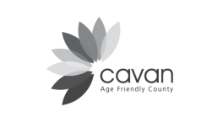
The Way Forward

This strategy has set out high level actions to ensure that older people in Cavan are included in all aspects of the community, and that their voices and opinions are recognised and incorporated into all relevant decision-making processes in the county.

This strategy will be implemented over a three year period. Its delivery will be overseen by the Cavan Age Friendly Alliance. The Alliance will meet on a quarterly basis and will review progress annually. A number of working
groups will be established to support the roll out of actions. These will include:

• A Transport Working Group

• An Information and Communication Working Group, and

• Other groups, as needed.

Older people will continue to be at the forefront of the implementation of this strategy through their participation in the Alliance and its working group structures.

A critical component of the delivery of this strategy will be the creation of the Cavan Older People’s Forum, which will be an extensive network of older people, their representative groups, day care/social services groups, and service providers such as nursing homes. Cavan 050 Network will act as the interim executive of the Older Person’s Forum once it is established. The Forum will actively seek to attract membership from older people from all geographic parts of Cavan and from organisations not currently represented on the network.

In a report called ‘The New Agenda on Ageing’, the Ageing Well states that we have an opportunity for Ireland to become one of the best countries in which to grow old.

In Cavan, we want to ensure that Cavan becomes the best county in Ireland in which to grow old. This strategy will be our guide in realising that goal.
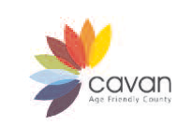
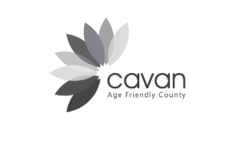

Appendix A

Indicator | Source | Survey | Frequency | Area
General health of older  people | Central  Statistics  Office | Census | Every 5  years | County
Number residing in  private/public nursing homes (per 1,000 pop) | Central  Statistics  Office | Census | Every 5  years | County
Number of day care  services in County Cavan | HSE | Admin data | Annual | County
Numbers attending day  care services in County  Cavan | HSE | Admin data | Annual | County
Number of older people  involved in volunteering | Central  Statistics  Office | Census | Every 5  years | County
Number of older people  involved in caring work | Central  Statistics  Office | Census | Every 5  years | County
Number of older people  participating in 050  Network/Older Person’s  Forum | Cavan 050  Network | Admin data | Annual | County
Number of older people  participating in Positive  Age groups | Positive Age | Admin data | Annual | County
Risk of poverty | Central  Statistics  Office | Survey on  Income and Living Conditions | Annual but  data available either by age or by regional authority, not both | Regional
Numbers and percentage  of older people with disability | Central  Statistics  Office | Census | Every 5  years | County
Local authority tenants by  age | Local  authority | Administrative  data | Annual | County

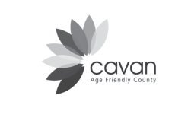

Indicator | Source | Survey | Frequency | Area
Numbers living in social  housing | Cavan  County Council / voluntary housing associations | Administrative  data | Annual | County
Numbers using Rural  Transport/Community/HSE Transport | CART /  NIRT | Administrative  data | Annual | County /  Region
Area size of amenity  space / number of parks and recreational areas (per 1,000 pop) | Local  authority annual reports | Administrative  data | Annual | County
Number of older people  taking part in Sports Partnership programmes (by type of programme) | Cavan  Sports  Partnership | Administrative  data | Annual | County
Number of changes in the  physical environment | Access  Officer reports | Administrative  data | Annual | County
Number of staff who  receive age awareness training | Either Age  and Opportunity (Agewise) or directly from public sector agencies | Administrative  data | Annual | County
Number of additional seats  installed | Cavan Local  Authorities | Administrative  data | Annual | County
Number of older people  trained to carry out audits | Cavan 050  Network | Administrative  data | Annual | County
Number of audits  completed | Cavan 050  Network | Administrative  data | Annual | County
Number of home  adaptations grants for older people | Cavan  County  Council | Administrative  data | Annual | County



.S. Q_Y.,,.ac

ou nty

Notes









Cavan County
GfAN
Development Board

50
NETWORK



Cnan Mona'IJ,han Vocatio11al
Education1CcimmiU
I




'l'ddhmoannodl na Scl>tblscSib
!1!:11111 Stnico Em>rtl..



